Sara White
CSD310
Assignment 3.2

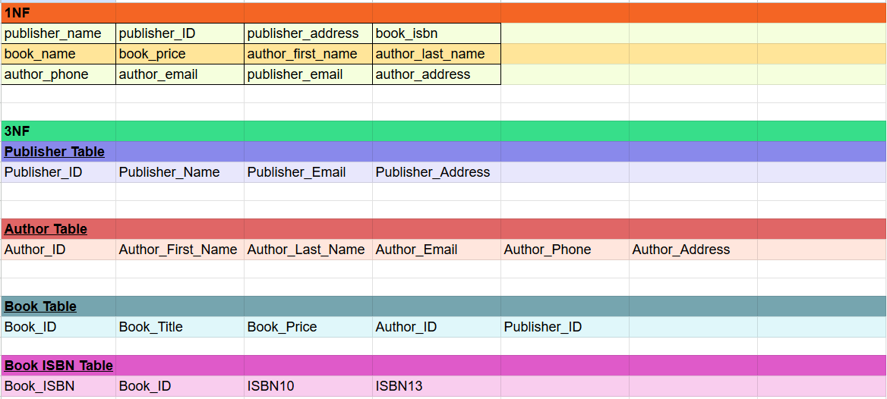

Assumptions:
- Book_ID will be a separate, unique identifier from the book’s ISBN since some books may not have ISBNs.
- The Book ISBN Table’s ISBN10 and ISBN13 attributes can be null, however, a constraint will be imposed so any characters entered must be equal to 10 or 13 (depending if the ISBN is before or after 2007). The purpose of this constraint is to prevent incomplete ISBNs and to prevent the wrong type of ISBN being entered in a field.
- Book_name from the 1NF table has been changed to Book_Title.
- ISBN10 and ISBN13 are assumed to be sufficient for determining the edition and format (paperback, hard cover, e-book) of the book, but if business rules emerge in the future that emphasize more need for edition information, an additional table might need to be created for book editions.

Other notes:
Initially I had attributes ISBN10 and ISBN13 in the Book Table, but I realized that it could create redundant records for the Book_ID since one book can have multiple ISBNs. I decided to create a separate table just for the Book ISBN so each instance is in that table is unique, though instances of the Book ISBN might share the same Book_ID (foreign key).

References

Forta, B. (2019). SQL in 10 minutes, Sams teach yourself (5th ed.). Sams Publishing.

Wikipedia contributors. (n.d.). ISBN. In Wikipedia, the free encyclopedia. Retrieved
November 9, 2025, from https://en.wikipedia.org/wiki/ISBN

