Sara White
CSD-310
Assignment 7.2

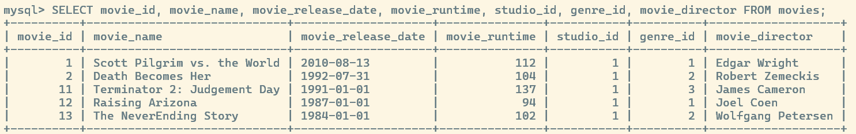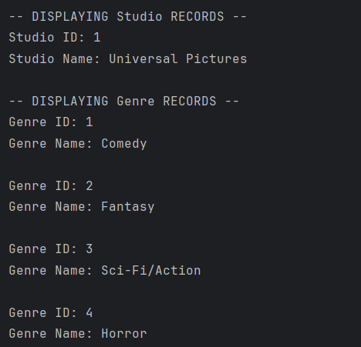

https://github.com/Sara-Renee/csd-310
