Sara White
CSD-310
Assignment 5.2

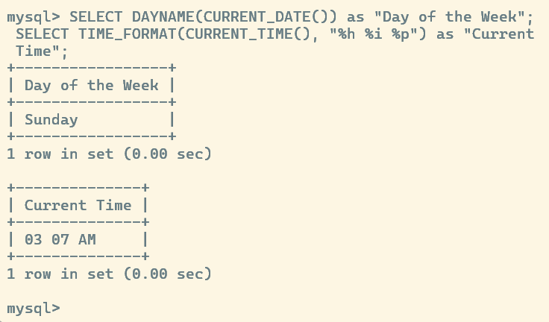

In addition to using the CURRENT_DATE and alias functions, I created a statement using the DAYNAME, TIME_FORMAT, CURRENT_TIME() functions.
DAYNAME extracts the name of the day of the week from a date. You can enter a specific date in quotations (ex. “2025-11-16”), or you can use a function, like CURRENT_DATE. The DAYNAME function can be used to display data grouped by the day of the week. For example, if you work for a retail company and want to know what the most profitable days of the week are, you could organize that data with DAYNAME.
The TIME_FORMAT function allows you to specify which measurements of time to display and whether the time will display as 12 or 24 hour format. It works the same as the DAYNAME function; you can enter a time (ex. “22:08:09”) or you can use a function that returns the current time, like the CURRENT_TIME function. The TIME_FORMAT function could be used to organize time stamps with a consistent format and display the times in a readable, user-friendly way. For example, if you wanted to organize data that contained time records, but the entries varied in format (ex. “00:00” and “12:00 AM”), you could use the TIME_FORMAT function to display the time records in the same format.
The CURRENT_TIME function could be used for accurate logging of information in a database. Using the retail example, the CURRENT_TIME function could record the time a transaction occurred. This would be very useful for auditing purposes or for gaining more business insights.

References
W3 Schools. (n.d.). MySQL Functions.
https://www.w3schools.com/mysql/mysql_ref_functions.asp

