Sara White
CSD 325-308A: Advanced Python
10/26/2025
Assignment 1.2

Link to GitHub Repository: https://github.com/Sara-Renee/csd-325.git
Screenshot of GitHub Repository:
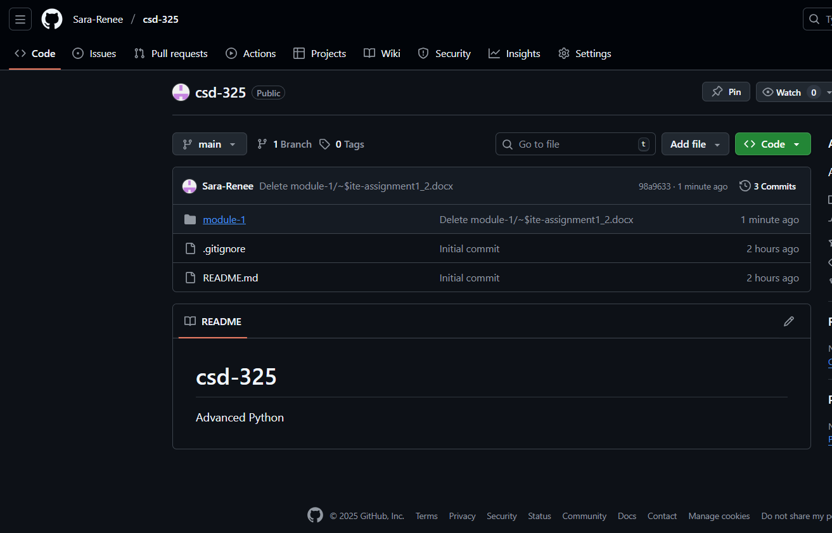
Screenshot of local directory:
