Project: Todo Application Functional Tests
Course: CSD-380 Mod 4
Description: Five functional test cases against the Todo web app, mapped to the CSD-380 Business Requirements Document.
Date: 2026/06/26
To complete the test case plan, fill out the information for Project, Course, Description and Date in the header below.
.
TABLE OF CONTENTS
Page Load via Standard URL (Req 10) 2
Add a New Todo Item (Req 2) 2
Edit an Existing Todo Item (Req 3) 3

For each test, the developer should: provide a test description, a test objective, the developer name and date tested. For each step, fill out the actions to be taken and describe the expected results, and indicate yes or no for each step depending upon the result. The peer tester should provide their name, date tested, indicate yes or no for each step depending upon the result, and a screenshot (thumbnail) of the result.

Test 1 | Page Load via Standard URL
 | Test Objective: Verify that the Todo application loads correctly when accessed through its standard public URL. | Developer: Max Jankowski  Date tested: 2026/06/26 | Peer tester: Sara White  Date tested: 2026/06/28
Step | Action | Expected results: | Developer pass/fail | Tester pass/fail  + Screenshot
1 | Open a web browser and go to https://buwebdev.github.io/todo/ | The Todo application page loads without any browser errors, network errors, or blank content. | Yes | Yes  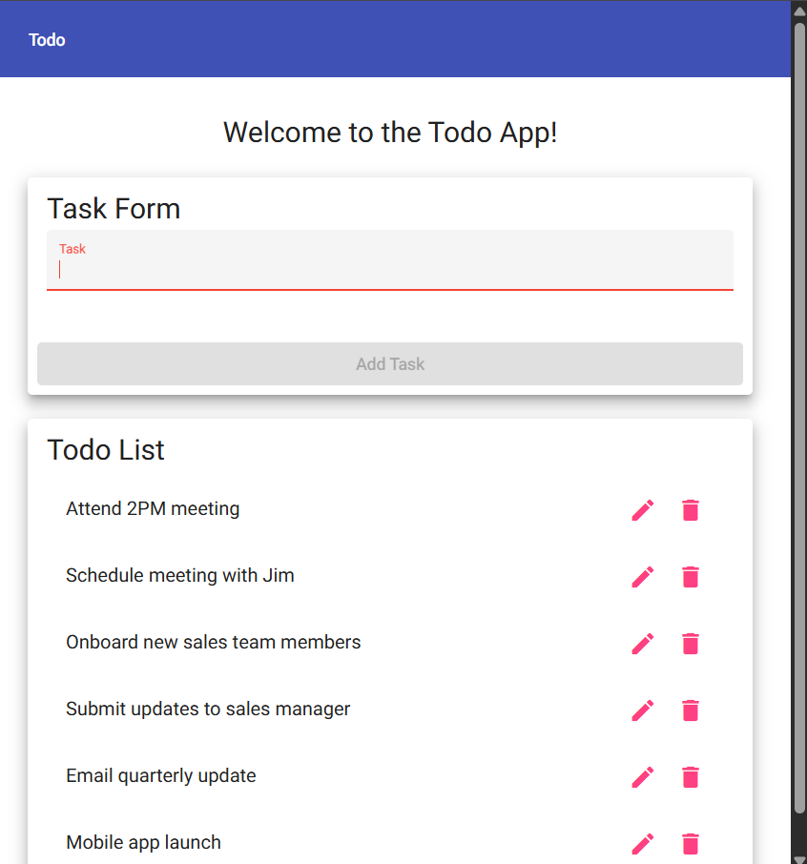
2 | Inspect the page title displayed in the browser tab | The browser tab title reads Todo. | Yes | Yes  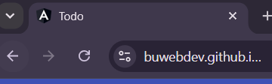
3 | Verify the page contains a visible input field for adding tasks | An input field or text box is visible and available on the page. | Yes | Yes  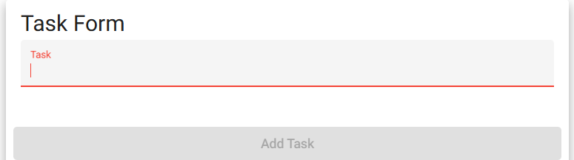
4 | Press F5 or click the browser Refresh button to reload the page | The page reloads successfully without errors and returns to its default state. | Yes | Yes  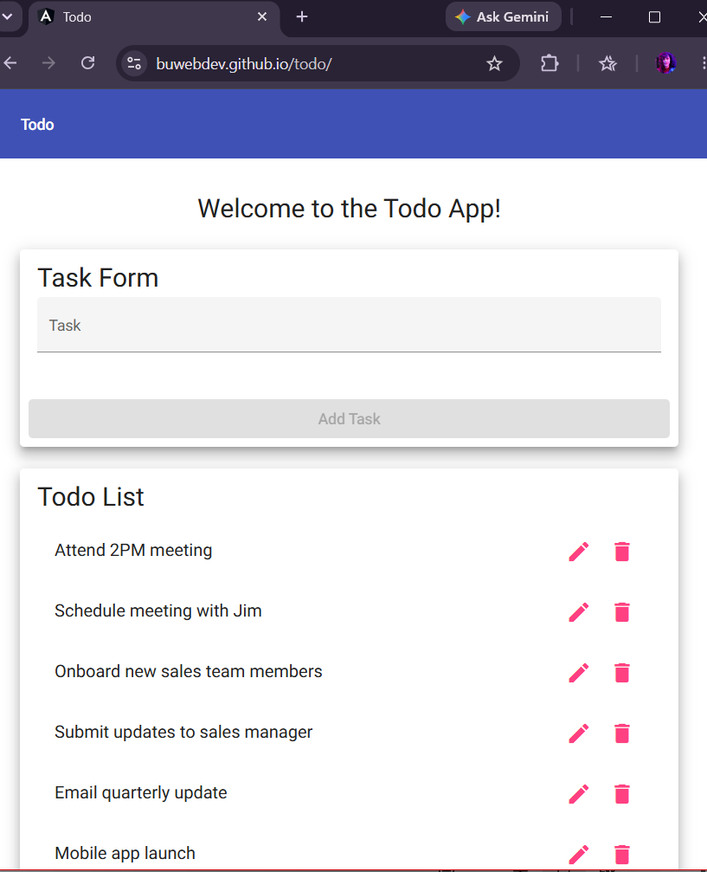
5 | Copy the URL, open a new browser tab, paste the URL, and press Enter | The Todo application loads in the new tab in the same way as the original tab. | Yes | Yes  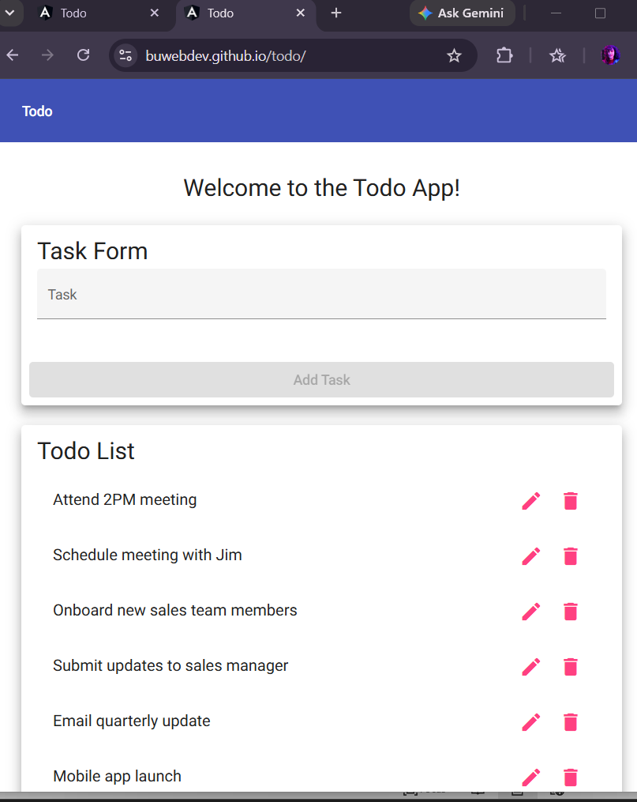
Comments | Everything loaded correctly. I verified the website loaded successfully in a Google Chrome browser.

Test 2 | Add a New Todo Item
 | Test Objective: Verify that a user can enter text into the input field and successfully add a new task to the todo list. | Developer: Max Jankowski  Date tested: 2026/06/26 | Peer tester: Sara White  Date tested: 2026/06/28
Step | Action | Expected results: | Developer pass/fail | Tester pass/fail
1 | Starting at https://buwebdev.github.io/todo/ and confirm the page has loaded | The page loads and the input field is visible and empty. | Yes | Yes  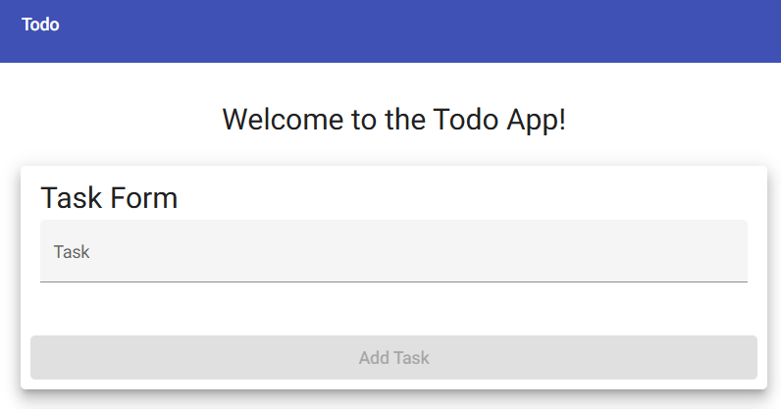
2 | Click inside the input field and type: Complete CSD-380 assignment | The typed text appears inside the input field as it is entered. | Yes | Yes  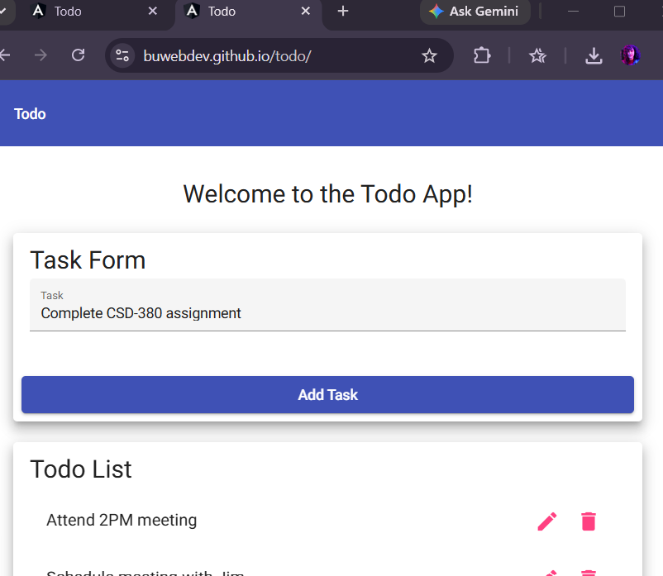
3 | Press the Enter key or click the Add button to submit the task | The new task Complete CSD-380 assignment appears in the task list below the input field. | Yes | No/Yes  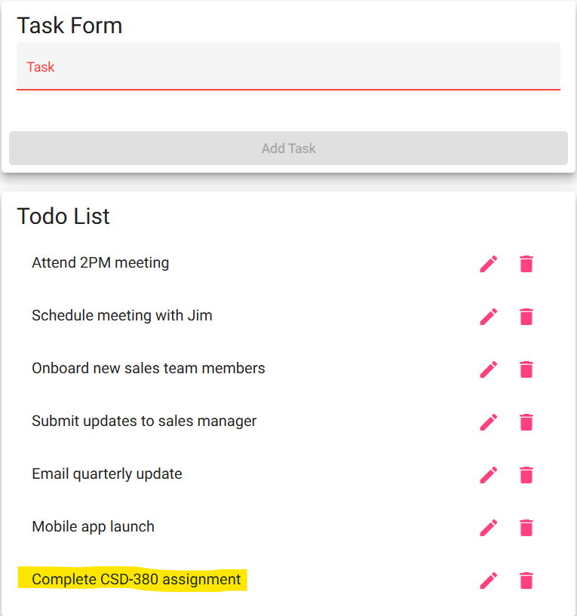
4 | Confirm the input field is cleared after submission | The input field returns to an empty state after the task is added. | Yes | Yes (see above screenshot)
5 | Add a second task by typing Review test plan and pressing Enter | The second task Review test plan appears in the list below the first task. | Yes | No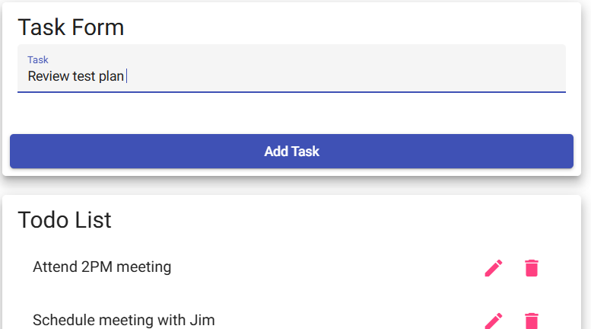
Comments | Regarding step 3: pressing the Enter key does not add the task, but clicking the ‘Add Task’ button worked.  Regarding step 5: pressing the Enter key does not add a task; nothing happened after pressing Enter.

Test 3 | Edit an Existing Todo Item
 | Test Objective: Verify that a user can open an existing task for editing, modify its text, save the changes, and confirm the updated text is reflected in the task list. | Developer: Max Jankowski  Date tested: 2026/06/26 | Peer tester: Sara White  Date tested: 2026/06/28
Step | Action | Expected results: | Developer pass/fail | Tester pass/fail
1 | Go to https://buwebdev.github.io/todo/ and add the task: Original task text | The task Original task text appears in the list. | Yes | Yes  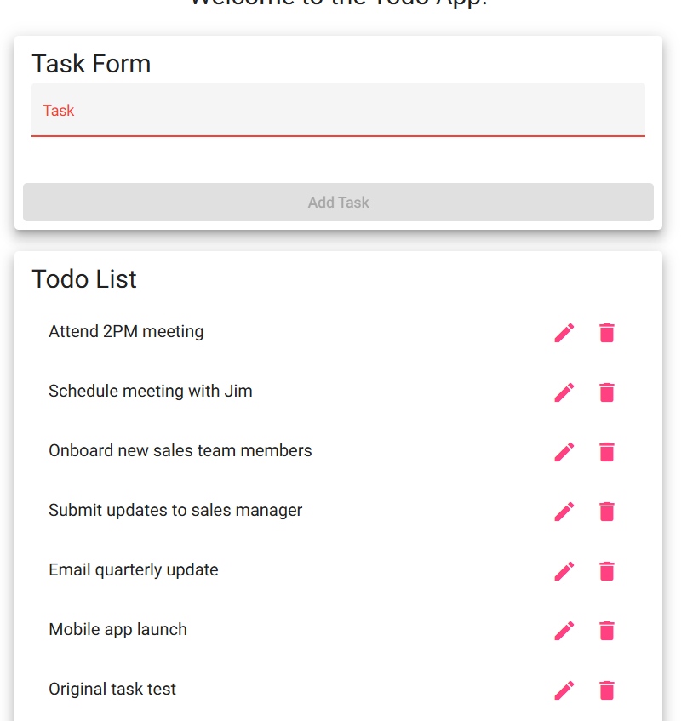
2 | Locate and click the edit control for Original task text (typically a pencil icon or double-click) | Task enters an editable state, displaying an input field pre-filled with Original task text. | Yes | Yes  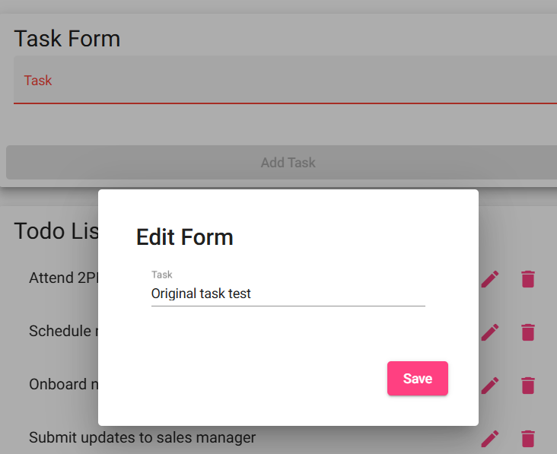
3 | Clear the existing text and type: Updated task text | Input field now contains only Updated task text. | Yes | 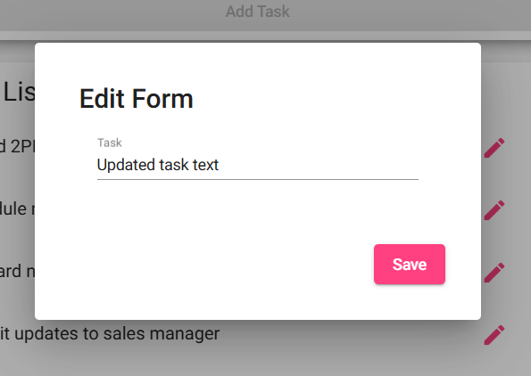
4 | Save the edit by pressing Enter or clicking the save/confirm button | The task list displays Updated task text in place of Original task text. The edit input is no longer visible. | Yes | No/Yes  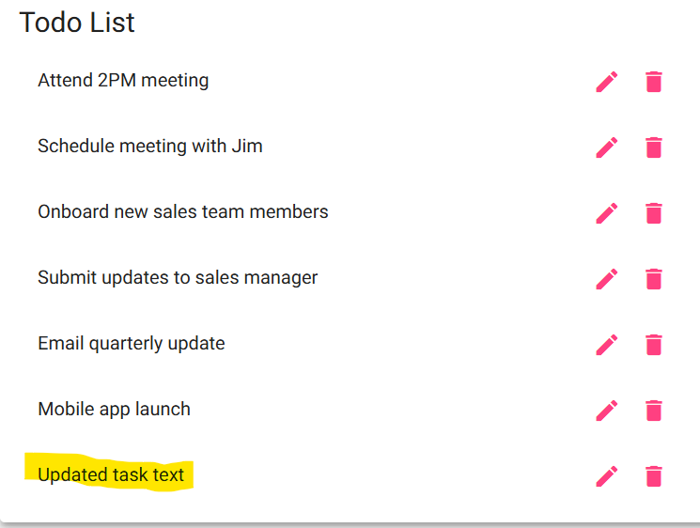
5 | Verify no duplicate entry was created by the edit | The list contains exactly one item reading Updated task text. Original task text no longer appears. | Yes | Yes (see above screenshot)
Comments | Regarding step 4: Pressing Enter does not work, but clicking the ‘Save’ was successful.

Test 4 | Delete a Todo Item
 | Test Objective: Verify that a user can permanently remove a task from the todo list and that only the targeted item is deleted. | Developer: Max Jankowski  Date tested: 2026/06/26 | Peer tester: Sara White  Date tested: 2026/06/28
Step | Action | Expected results: | Developer pass/fail | Tester pass/fail
1 | Go into https://buwebdev.github.io/todo/ and add two tasks: Task to keep and Task to delete | Both tasks appear in the task list. | Yes | Yes  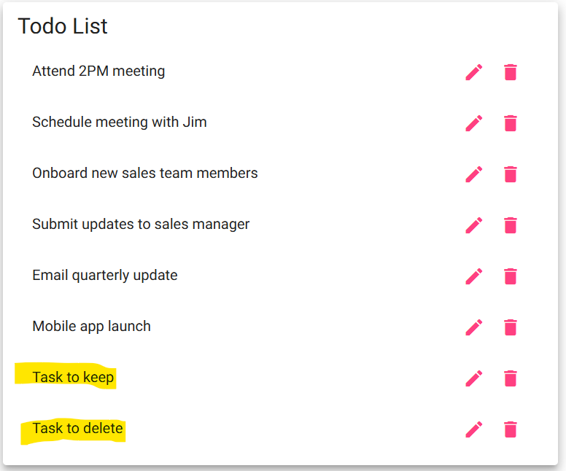
2 | Locate the delete button or control (often an X icon) for Task to delete and click it | The Task to delete entry is removed from the list immediately. | Yes | Yes  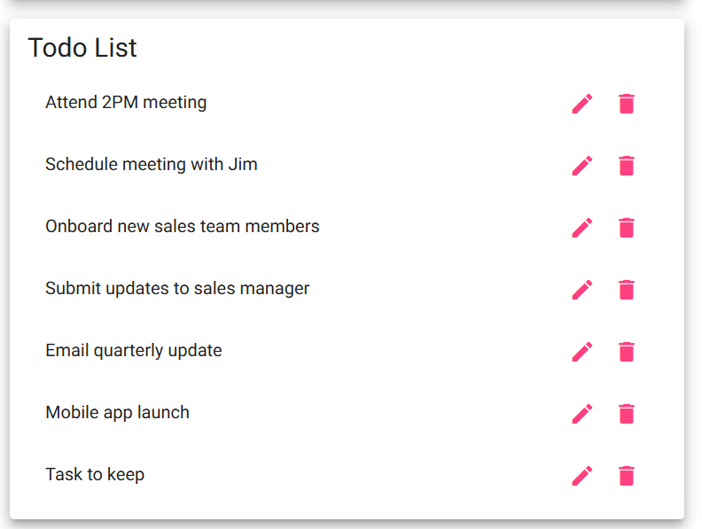
3 | Confirm that Task to keep is still present in the list after the deletion | Task to keep remains in the list and is unaffected by the deletion of the other item. | Yes | Yes (see above screenshot)
4 | Refresh the browser page | delete remains gone after the refresh. Task to keep is still present. | Yes | No  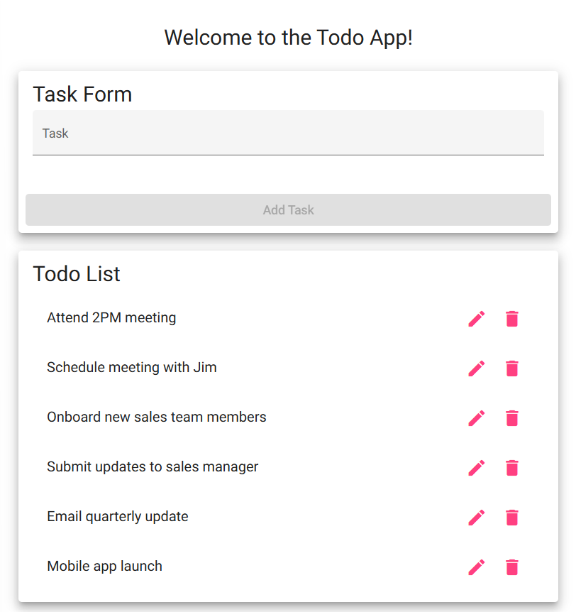
5 | Delete Task to keep using the same delete control | Keep is removed from the list, leaving the list empty. | Yes | No
Comments | Regarding step 5: after refreshing the page, ‘Task to keep’ was gone from the list. You can see this in the screenshot documented for step 4.

Test 5 | Empty Form Validation
 | Test Objective: Verify that the application prevents users from submitting a blank entry on both the create form and the edit form. | Developer: Max Jankowski  Date tested: 2026/06/26 | Peer tester: Sara White  Date tested: 2026/06/28
Step | Action | Expected results: | Developer pass/fail | Tester pass/fail
1 | Go to https://buwebdev.github.io/todo/ and click inside the new task input field without typing anything | The input field is empty and focused. | Yes | Yes  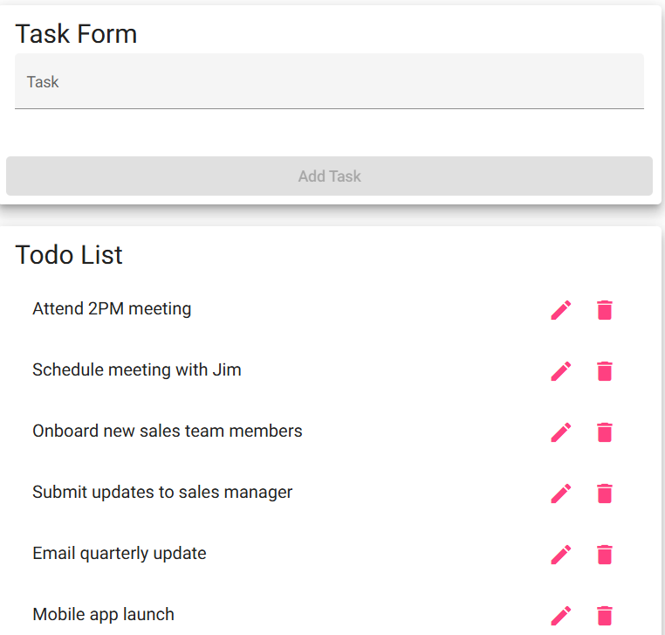
2 | Press the Enter key or click the Add/Submit button without entering any text | The application does not add a blank item to the list. An error indicator or simple prevention of submission is shown. | Yes | Yes  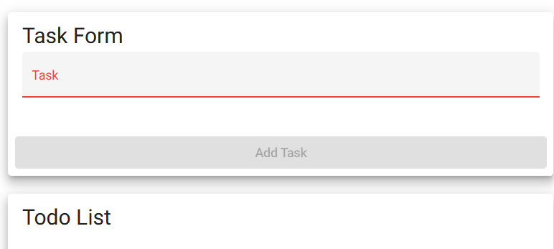
3 | Add a valid task: Test validation task. Then click its edit control to open the edit form | Thee task enters edit mode with its current text pre-filled in the edit input field. | Yes | Yes  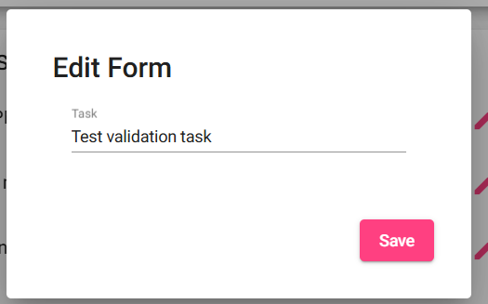
4 | Clear all text from the edit input field so it is empty, then attempt to save by pressing Enter or clicking confirm | Application does not save the blank edit. An error indicator is shown and the original text is preserved. | Yes | No  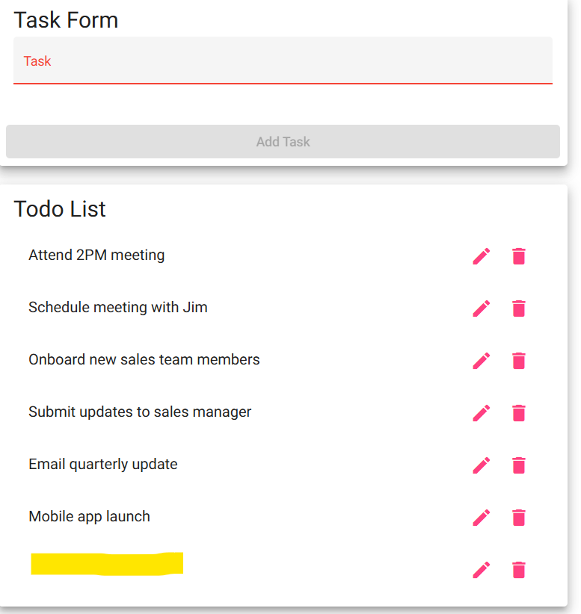
5 | Type Validated edit text into the edit field and save | The task is updated to Validated edit text, confirming that valid edits still save correctly after the empty entry prevention is in place. | Yes | No (see screenshot above)
Comments | Regarding step 2: no error message displays, but I was prevented from clicking the ‘Add Task’ button with an empty field.  Regarding step 5: I was able to save an empty task field, there was no prevention of doing so.

