Project: | Rodriguez Test Todo Case Plan (Sara White completing peer testing)
Course: | CSD-380 DevOps
Description: | Functional test cases based on the Todo Business Requirements document for the Todo website.
Date: | 06/25/2026

Table of Contents-
Create a new todo task item 2
View a list of todo task items 3
Edit a todo task item 4
Delete a todo task item 5
Prevent users from submitting a task form without entering a todo item 6

For each test, the developer should: provide a test description, a test objective, the developer name and date tested. For each step, fill out the actions to be taken and describe the expected results, and indicate yes or no for each step depending upon the result. The peer tester should provide their name, date tested, indicate yes or no for each step depending upon the result, and a screenshot (thumbnail) of the result.

Test 1 | Create a new Todo task item
 | Test Objective:  Verify that a user can add a new Todo item using the task form. | Developer: Carolina Rodriguez  Date tested: 06/25/2026 | Peer tester: Sara White  Date tested: 2026/06/28
Step | Action | Expected results: | Developer pass/fail | Tester pass/fail
1 | Visit https://buwebdev.github.io/todo/. | The Todo page loads successfully. | Yes | Yes  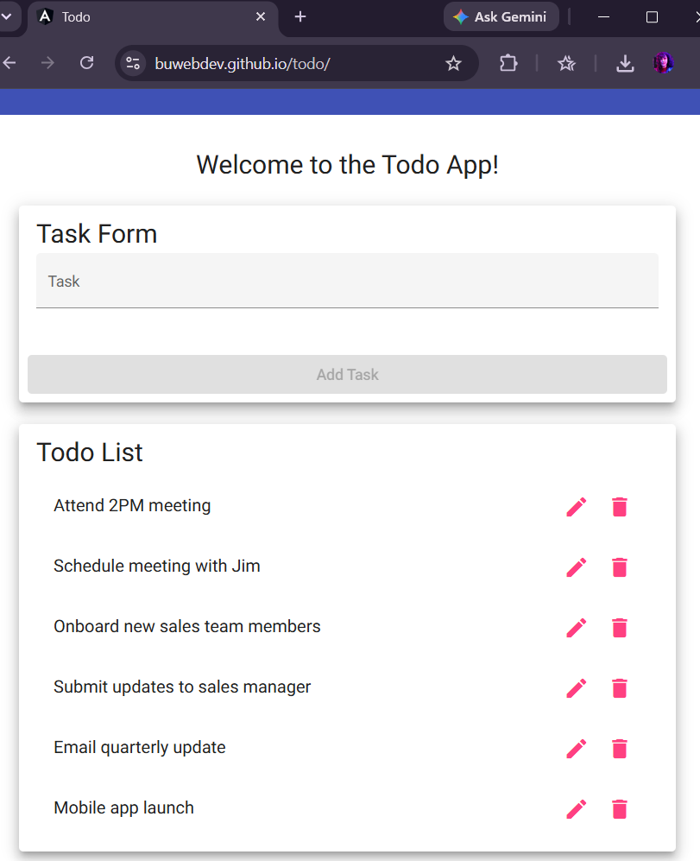
2 | Click inside the task input field. | The cursor appears inside the task input. | Yes | Yes  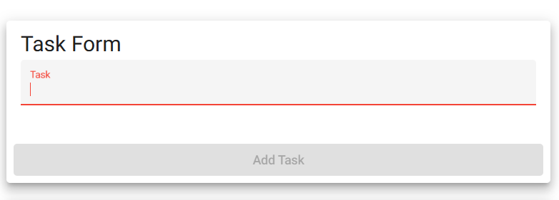
3 | Type “Complete homework assignment” into the task input. | The task appears in the input field. | Yes | Yes  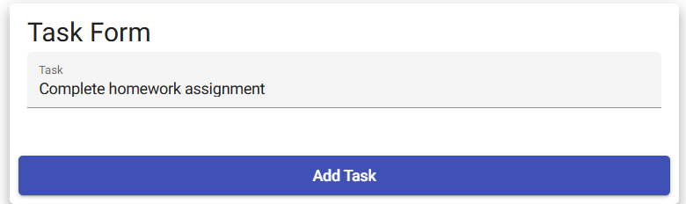
4 | Click the Add Task button. | The new task is submitted. | Yes | Yes  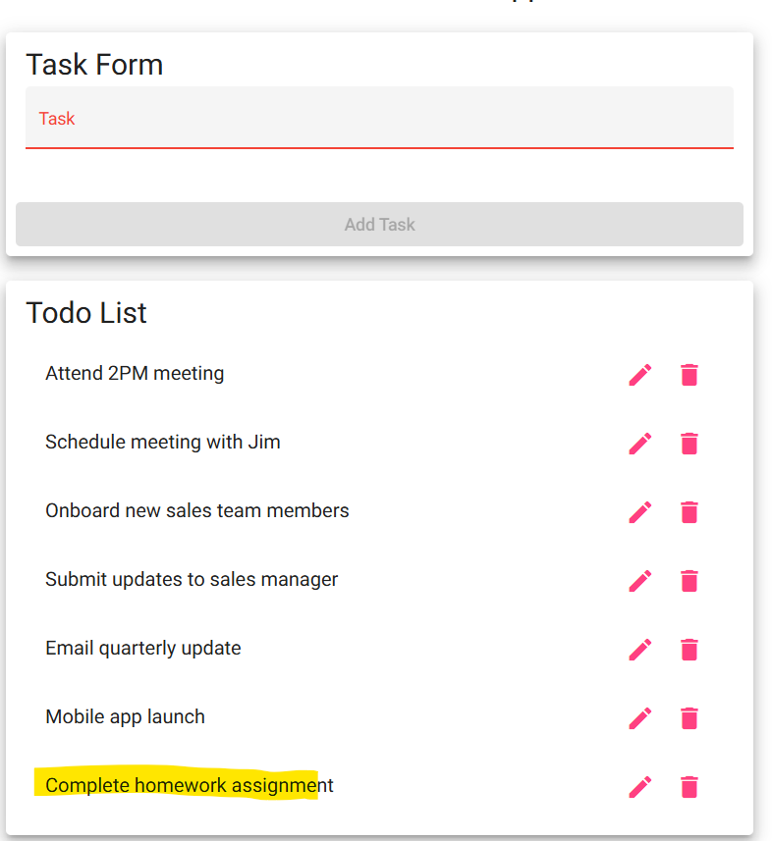
5 | Review the Todo List section. | “Complete homework assignment” appears in the Todo List. | Yes | Yes (see screenshot above)
Comments | I was able to add a new task item to the Todo List successfully.

Test 2 | View a list of Todo task items
 | Test Objective: Verify that Todo items display in the Todo List after they are created. | Developer: Carolina Rodriguez  Date tested: 06/25/2026 | Peer tester: Sara White  Date tested: 2026/06/28
Step | Action | Expected results: | Developer pass/fail | Tester pass/fail
1 | Visit https://buwebdev.github.io/todo/. | The Todo page loads successfully. | Yes | Yes  
2 | Add a task named “Attend 6pm Teams meeting” | The task is added successfully. | Yes | Yes  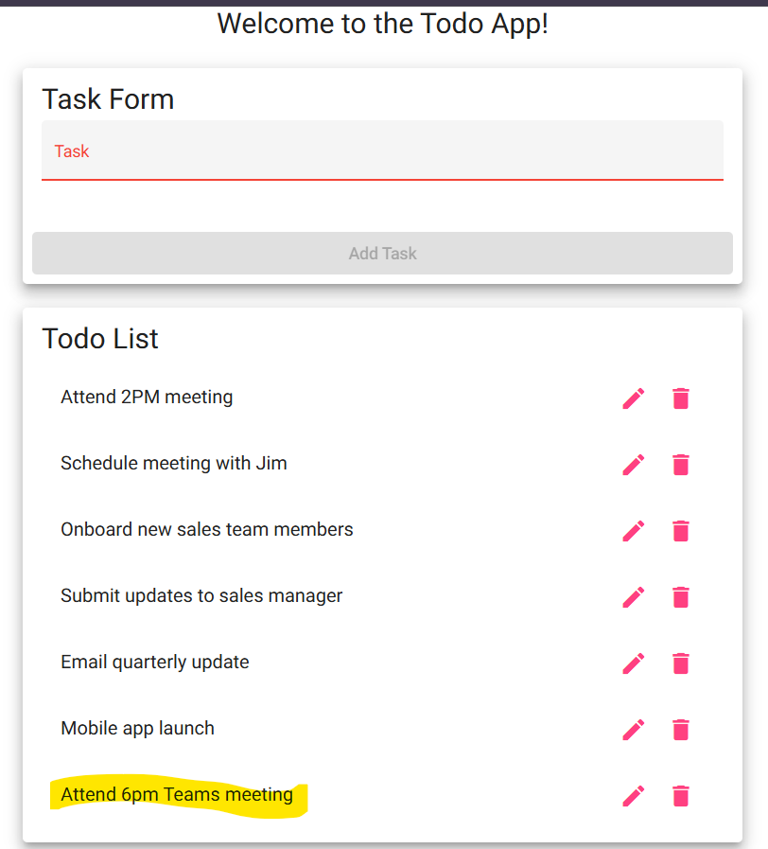
3 | Add a second task named “Schedule meeting with Cassie.” | The second task is added successfully. | Yes | Yes  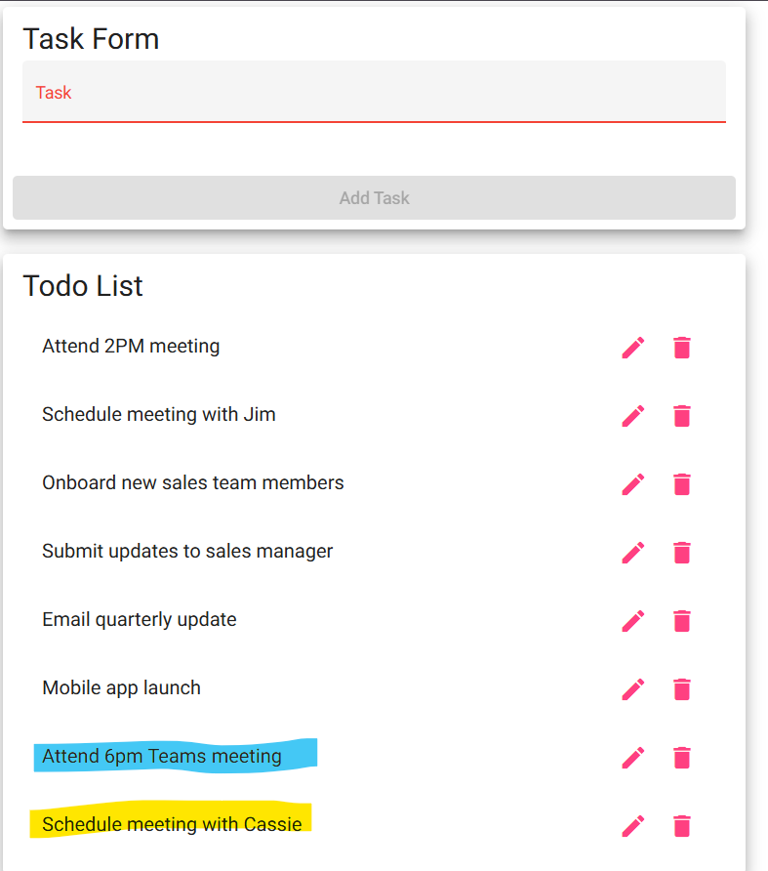
4 | Look at the Todo List section. | Both tasks appear in the Todo List. | Yes | Yes (see above screenshot)
5 | Confirm each task displays readable text. | The task names are visible and easy to read. | Yes | Yes (see above screenshot)
Comments | Regarding step 5: the tasks were easy for me to read, but I have 20/20 vision and no visual impairments. It might be valuable to test this with users who have visual impairments. The contrast of the text and background was good.

Test 3 | Edit a Todo task item
 | Test Objective: Verify that a user can edit a Todo item and save the updated text. | Developer: Carolina Rodriguez  Date tested: 06/25/2026 | Peer tester: Sara White  Date tested: 2026/06/28
Step | Action | Expected results: | Developer pass/fail | Tester pass/fail
1 | Visit https://buwebdev.github.io/todo/. | The Todo page loads successfully. | Yes | Yes  
2 | Add a task named “Attend meeting.” | The task appears in the Todo List | Yes | Yes  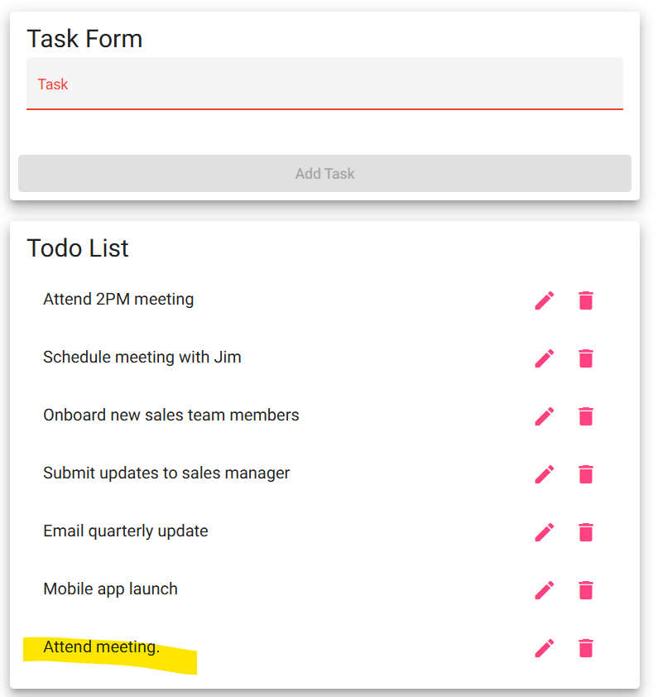
3 | Select/Click the pencil to edit task. | The edit form opens and displays the selected task text. | Yes | Yes  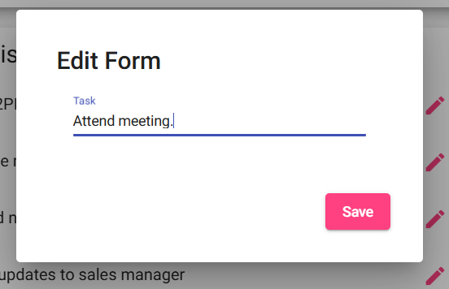
4 | Change task to state “Attend 5pm meeting.” | The updated text appears in the edit input field. | Yes | Yes  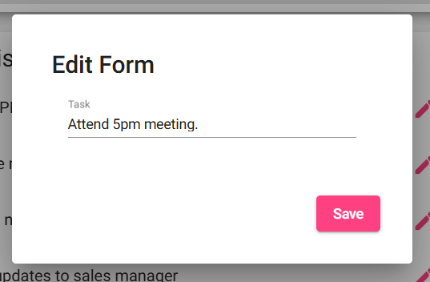
5 | Click Save | The Todo List updates and shows “Attend 5pm meeting.” | Yes | Yes  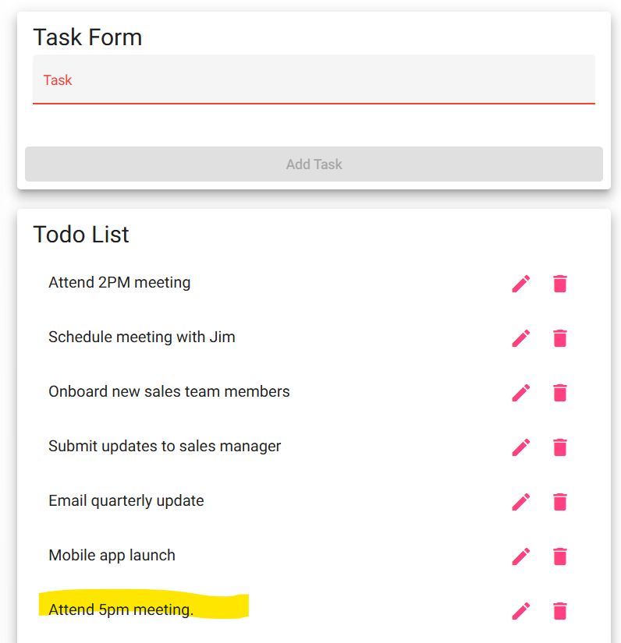
Comments | Everything worked smoothly with editing and updating the task.

Test 4 | Delete a Todo task item
 | Test Objective:  Verify that a user can delete a Todo item from the Todo List. | Developer: Carolina Rodriguez  Date tested: 06/25/2026 | Peer tester: Sara White  Date tested: 2026/06/28
Step | Action | Expected results: | Developer pass/fail | Tester pass/fail
1 | Visit https://buwebdev.github.io/todo/. | The Todo page loads successfully. | Yes | Yes  
2 | Add task called “Test” | The task appears in the Todo List. | Yes | Yes  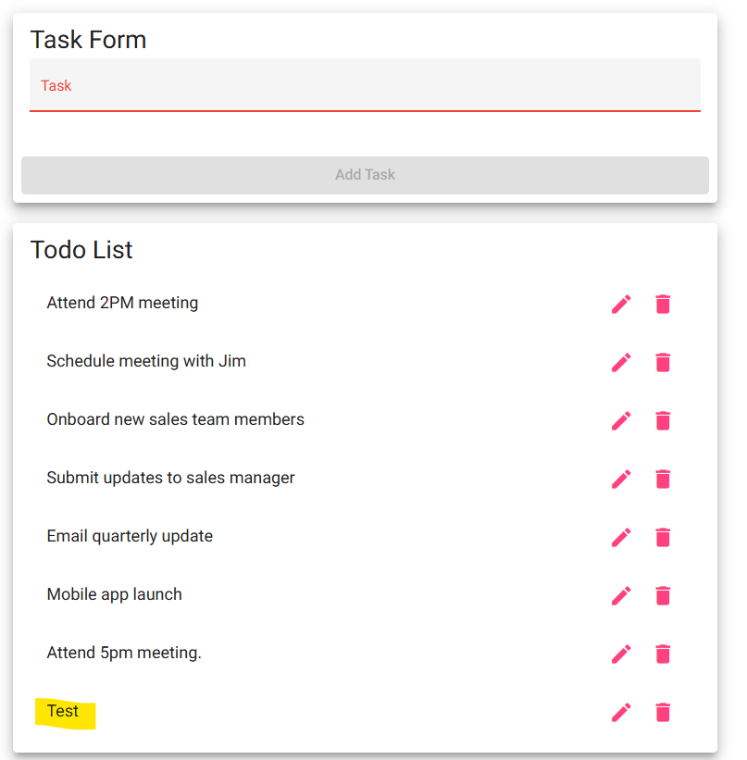
3 | Locate the delete option for the task. | The delete option is available for the selected task. | Yes | Yes (see screenshot above)
4 | Click the delete option | The application removes the selected task. | Yes | Yes  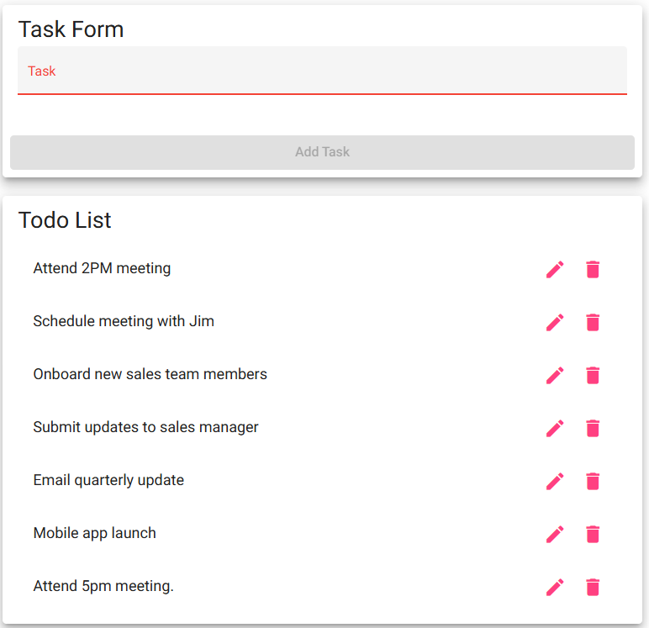
5 | Review the Todo List section | “Test” task is no longer on the Todo List. | Yes | Yes (see above screenshot)
Comments | Regarding step 3: the trashcan icon was present (as seen in the screenshot for step 2).

Test 5 | Prevent users from submitting a task form without entering a Todo item
 | Test Objective: Verify that the application does not allow a blank task to be added from the task form. | Developer: Carolina Rodriguez  Date tested: 06/25/2026 | Peer tester: Sara White  Date tested: 2026/06/28
Step | Action | Expected results: | Developer pass/fail | Tester pass/fail
1 | Visit https://buwebdev.github.io/todo/. | The Todo page loads successfully | Yes | <yes/no>  
2 | Leave the task input field blank. | No text is entered into the task input. | Yes | Yes  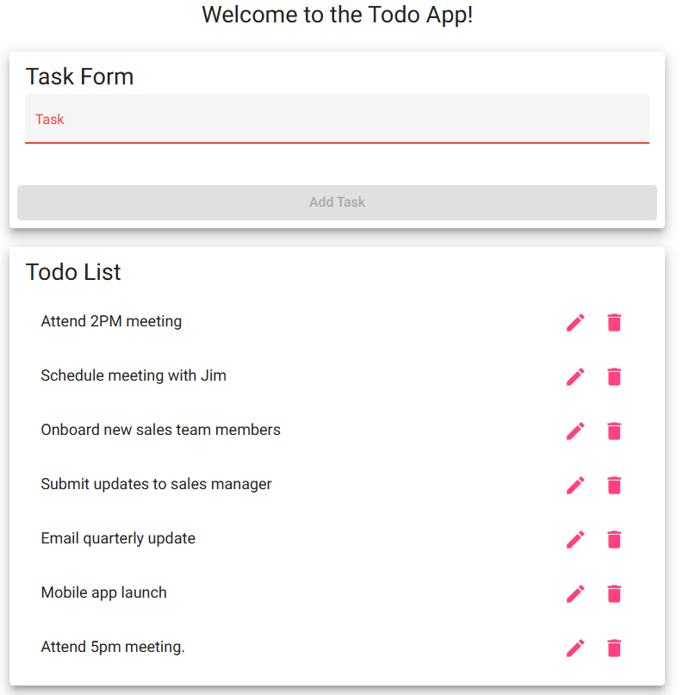
3 | Click the Add Task button | The application does not add a blank Todo item. | Yes | Yes  
4 | Review the Todo section | No empty task appears in the Todo List | Yes | Yes  
Comments | Confirmed – a blank task item cannot be added from the main task form.

