Sara White
Assignment 1.2
CSD-420
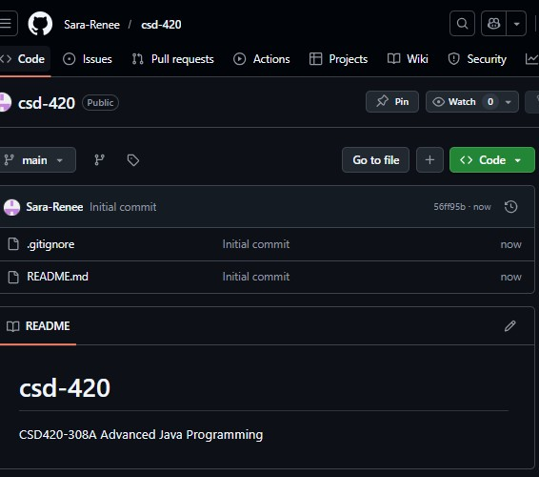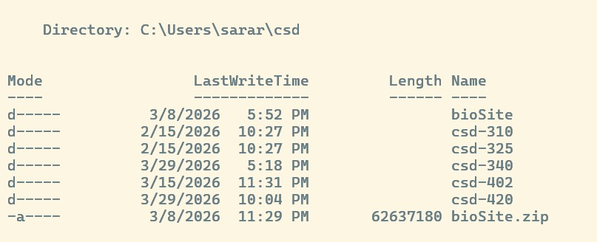

Url: https://github.com/Sara-Renee/csd-420

