Sara White
CSD-420
Assignment 10.2 (Output screenshots)

Initial window display:
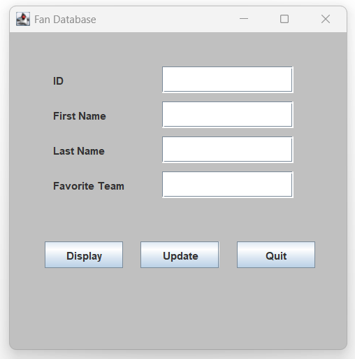

Output after ID is entered:
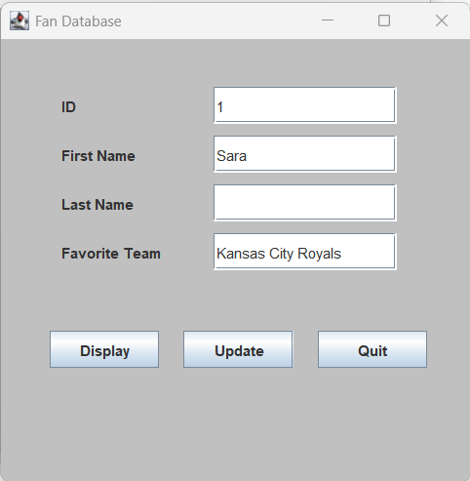

Updating record:
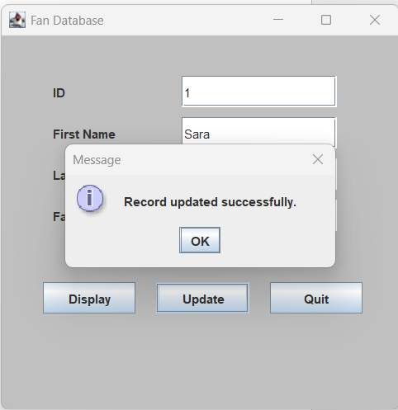

Displaying updated record:
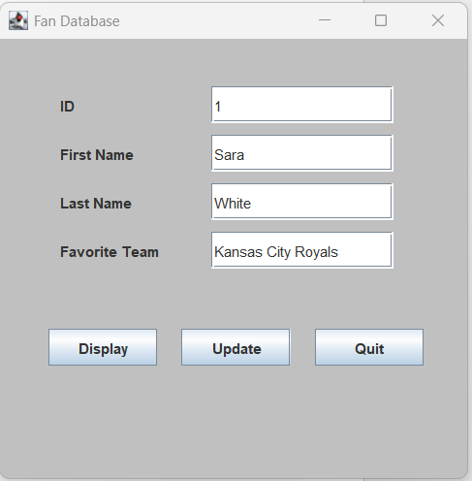
Output if ID entered that is not in the database:
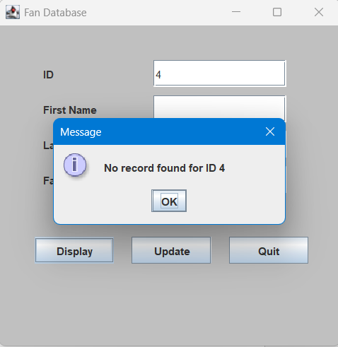

Pop-up confirming user wants to quit the program:
