Sara White
CSD-430
Assignment 9.2

Delete a movie:
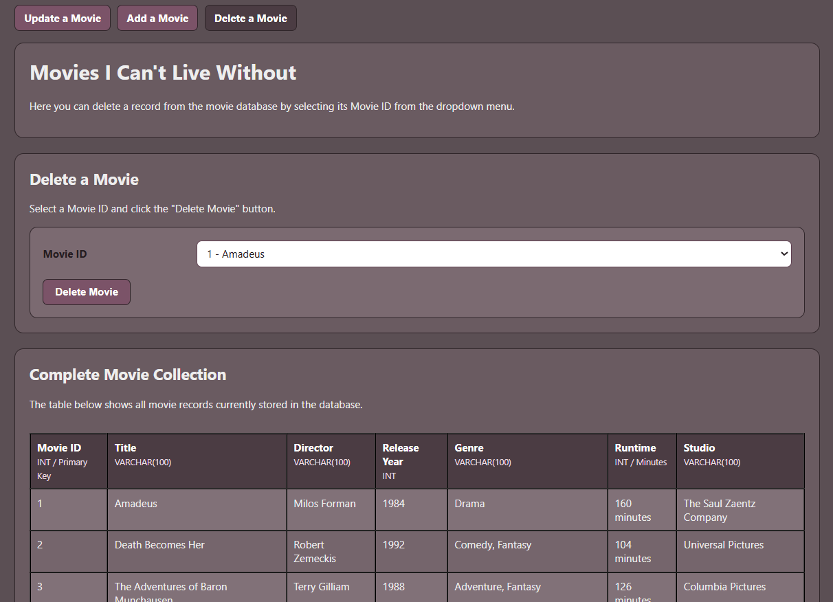

Dropdown menu showing all movie records, selecting movieID 1 (Amadeus) for deletion:
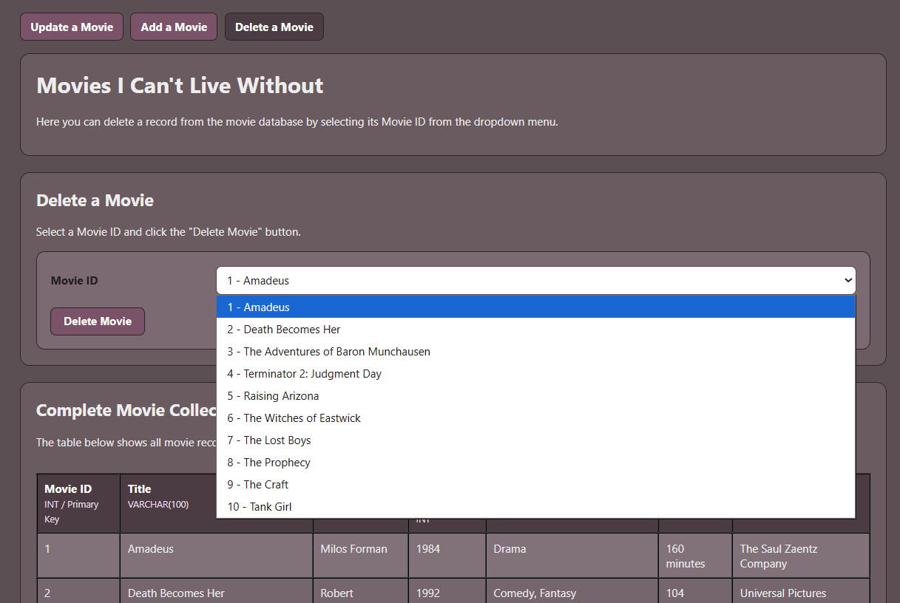

After clicking the “Delete Movie” button (see two screenshots below):
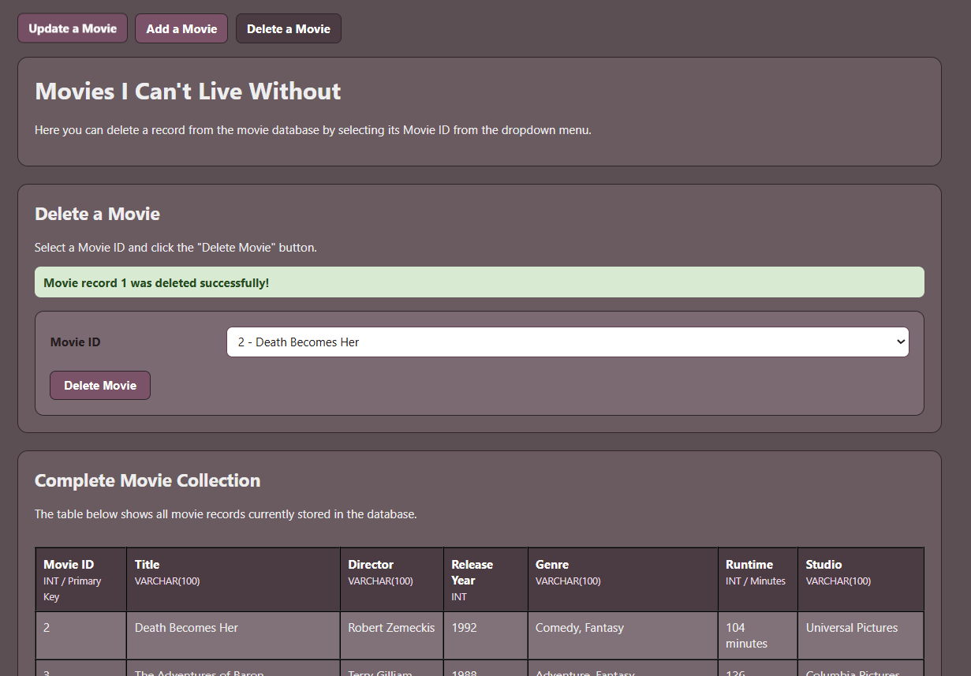
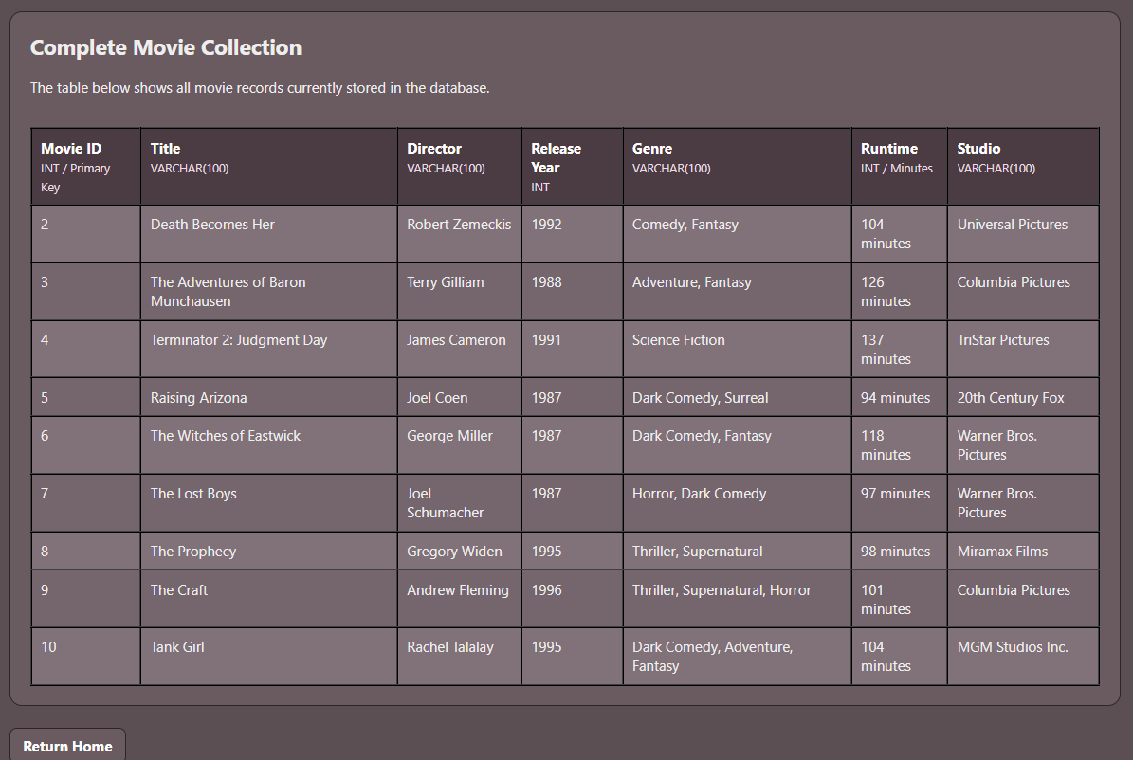
After deleting all movie records:
