Sara White
CSD-430
Assignment 8.2

Select a movie drop down menu:
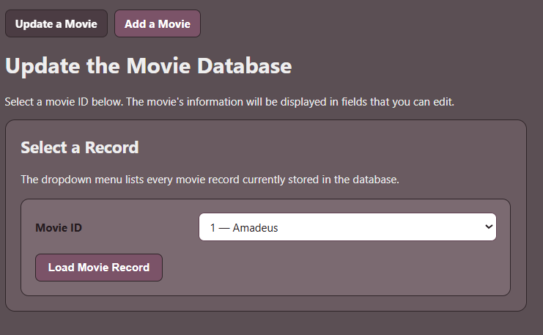

Fields displayed after movie record is selected:
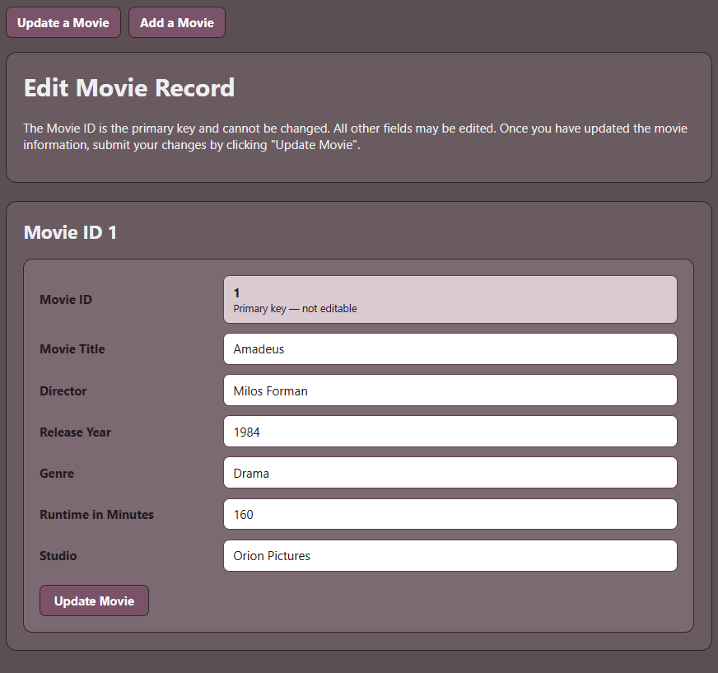

Changing the ‘Studio’ field:
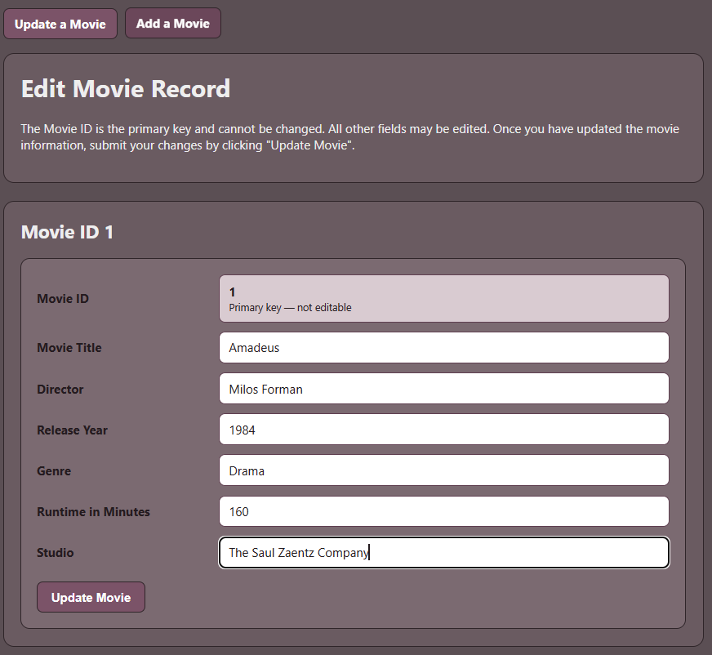

After submitting the change (field types shown in the table):
