Sara White
CSD-430
Assignment 1.2

Github repository clone:
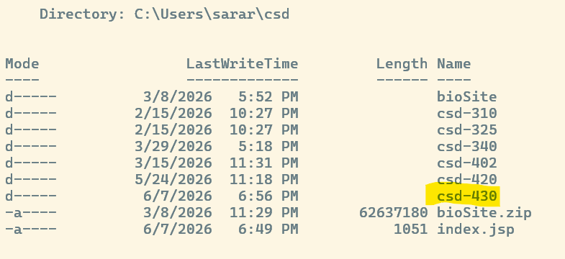

Github url: https://github.com/Sara-Renee/csd-430

