Sara White
CSD-430
Assignment 3.2 – Screenshots

Form:
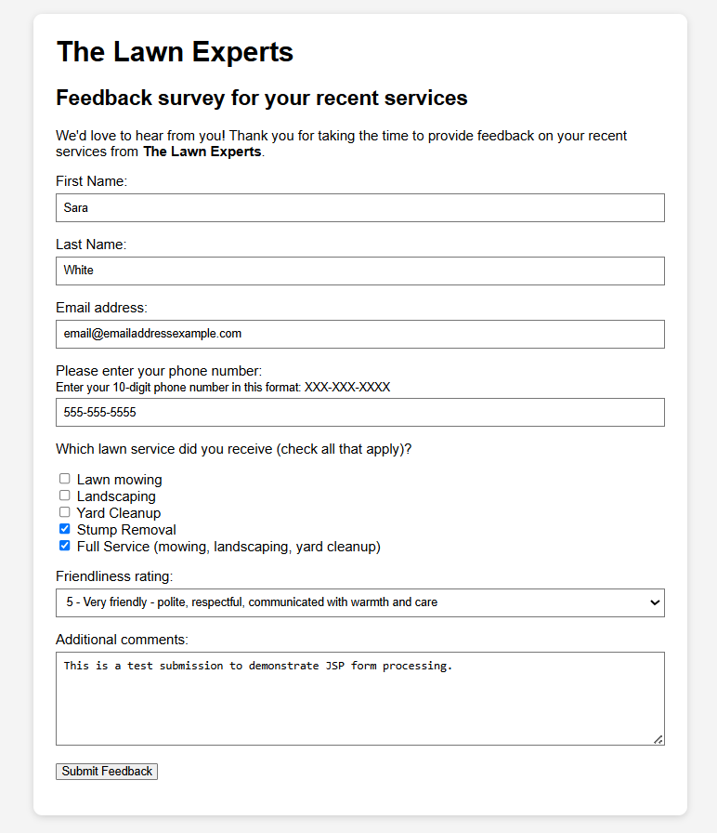

JSP page displaying results from HTML form:
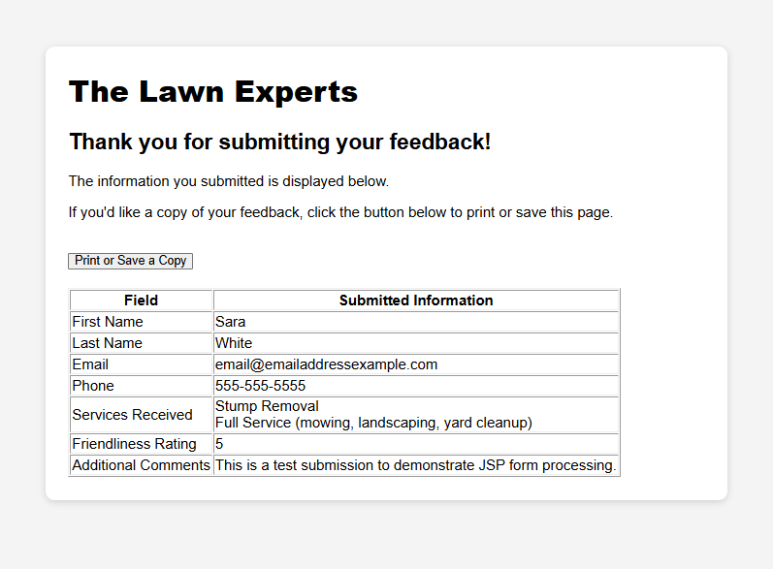
Print/save option:
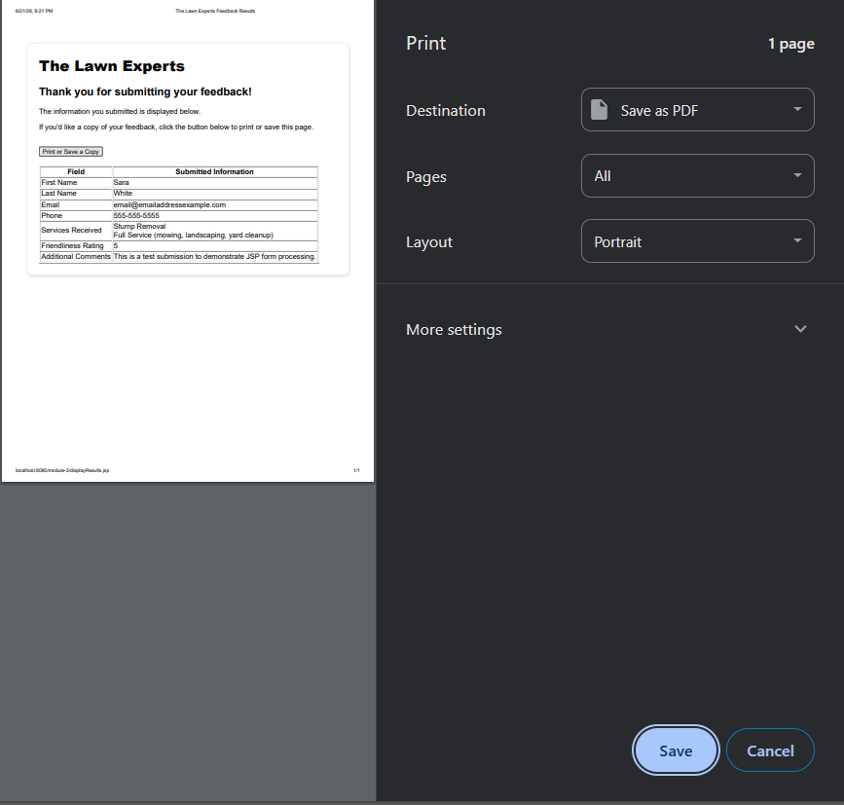
References

GeeksforGeeks. (n.d.). JSP – Form Processing.
https://www.geeksforgeeks.org/advance-java/jsp-form-processing/

W3 Schools. (n.d.). HTML Input Types.
https://www.w3schools.com/html/html_form_input_types.asp

