Sara White
CSD-440
Assignment 1.2
8.16.26

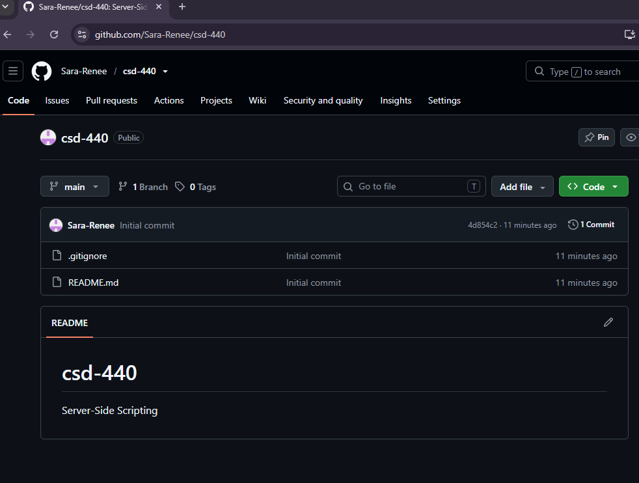

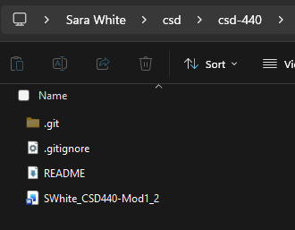
Github url: https://github.com/Sara-Renee/csd-440

