Sara White
CSD-440
Assignment 1.3 – Screenshots

PHP output in browser:
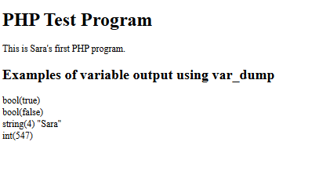

XAMPP Control Panel with Apache running:
