Sara White
CSD440 – 8.2/9.2 Screenshots
September 27, 2026

Module 8:
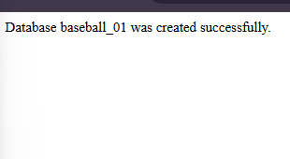
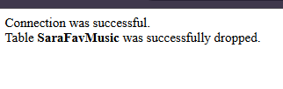
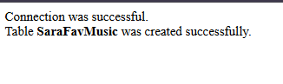

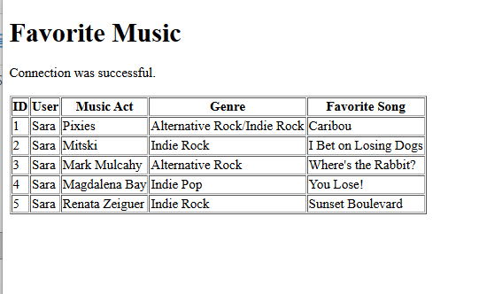

Module 9

Index:

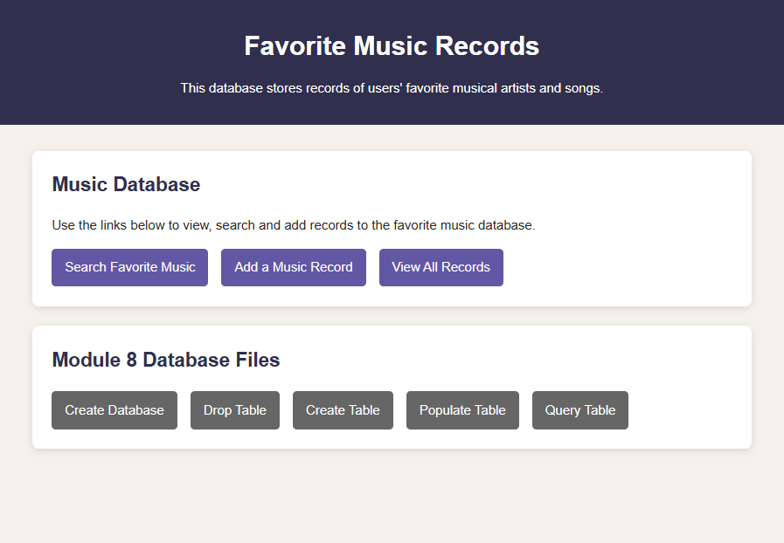
*I added a button for the Create Database, but that can be skipped if the database already exists

Search database:
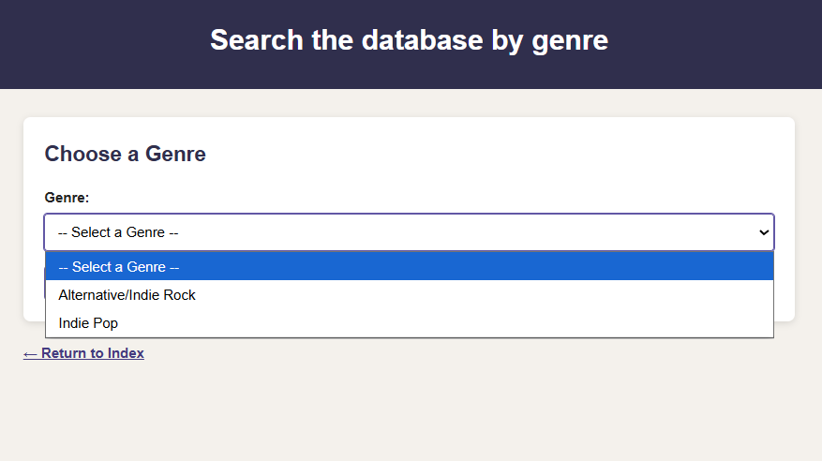

Add record/form:
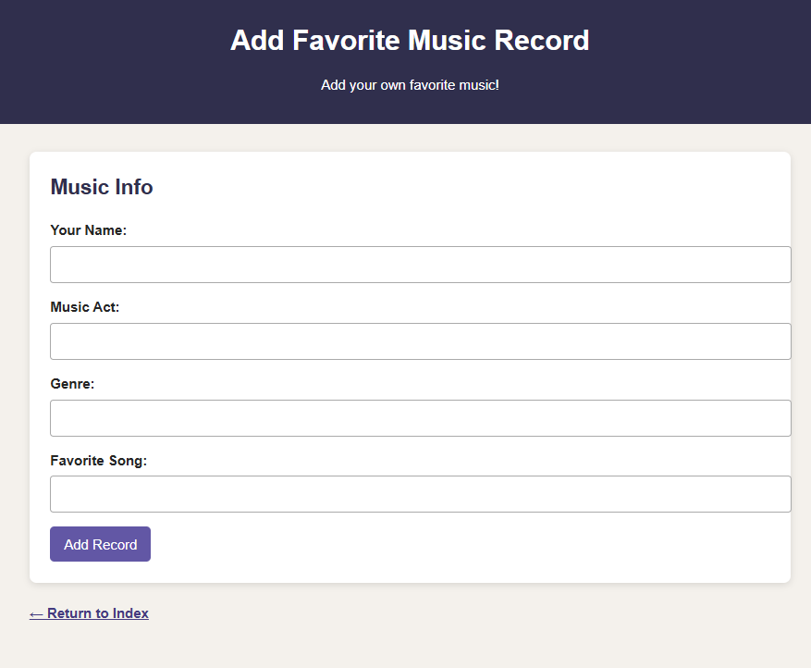

All results displayed in a table:

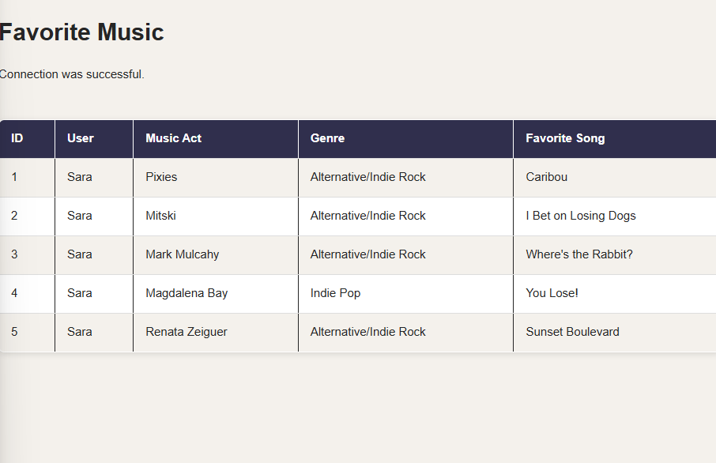

References

PHP Delusions. (n.d.). How to connect properly using mysqli.
https://phpdelusions.net/mysqli/mysqli_connect

The PHP Documentation Group. (n.d.). mysqli_stmt::bind_param.
https://www.php.net/manual/en/mysqli-stmt.bind-param.php

The PHP Documentation Group. (n.d.). Predefined Constants.
https://www.php.net/manual/en/mysqli.constants.php

