Sara White
CSD440
October 4, 2026
Assignment 10.2 – Screenshots

HTML Form:
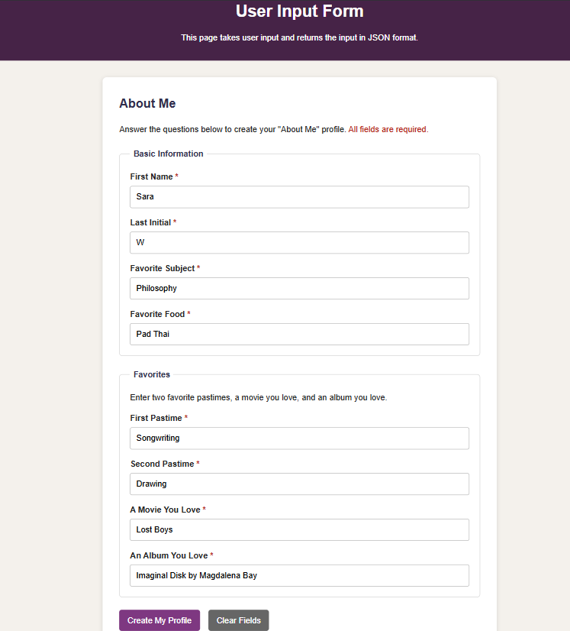

JSON Results:
