Experiment no : 7

Aim: Familiarisation of Linux commands

Co2: Perform System Administration tasks

Procedure:

1 .$expr 12+8



$expr 12 – 2



$expr 12 \* 2



$exp 12 / 2

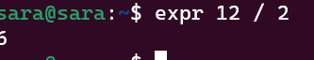

2.$expr and read  
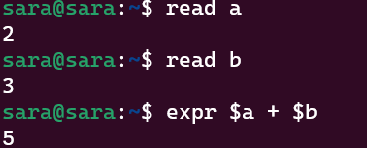

3.$df   
 To check how much space a file or directory takes in current directory

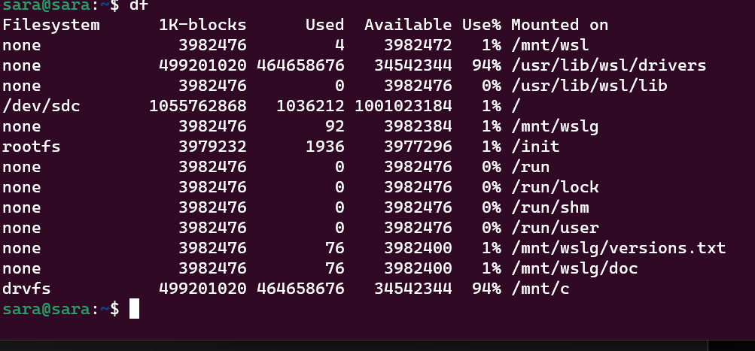

4.$du filename

To check how much space a file takes in current directory



5.$sudo useradd newusername

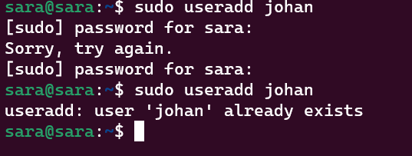

6.$sudo passwd username

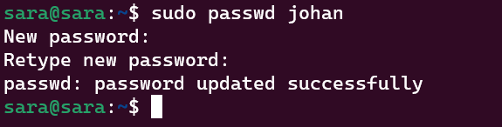

Experiment no :8

CO2:

Aim: Familiarisation of Linux commands

Procedure:

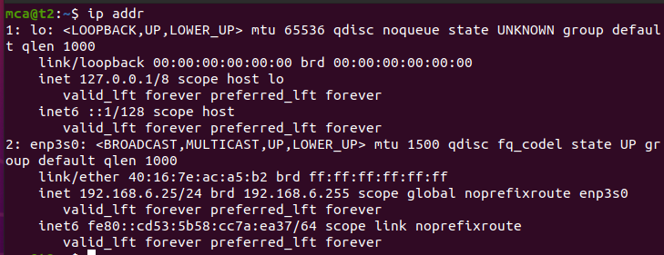

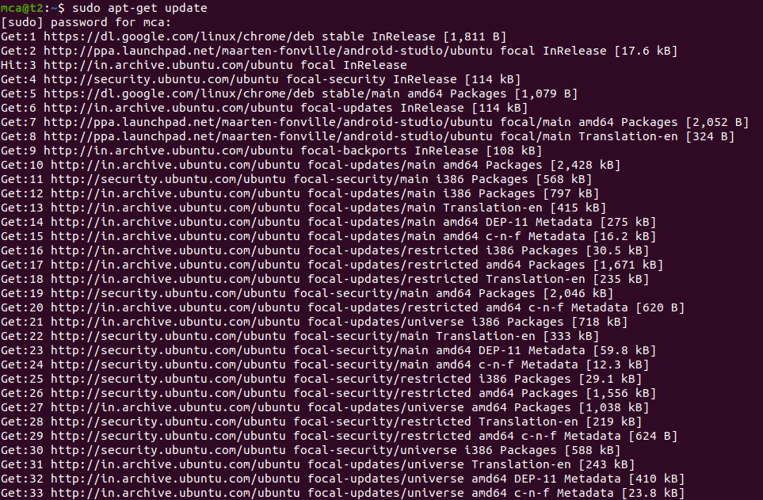

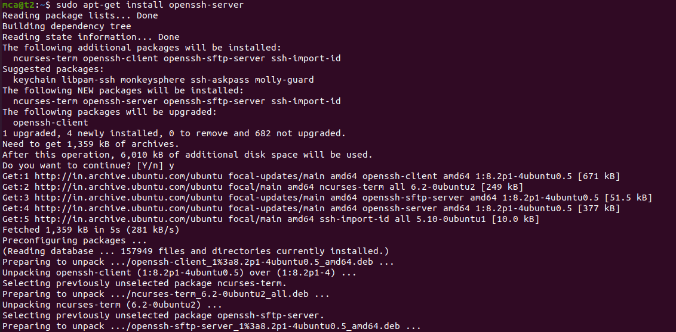

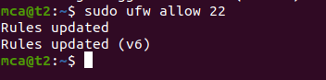

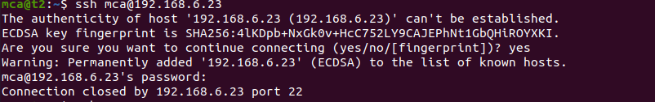

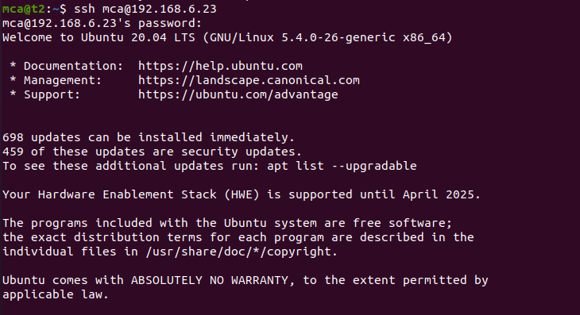



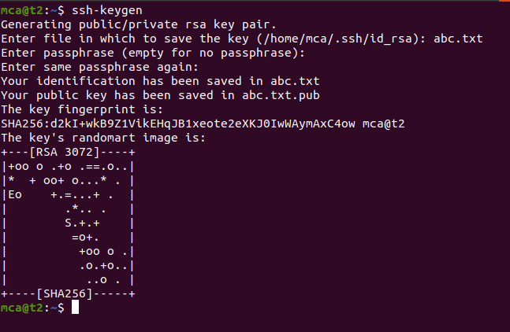

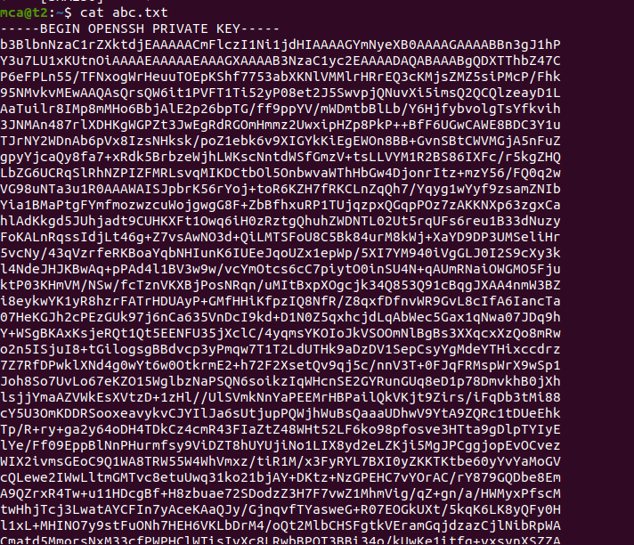

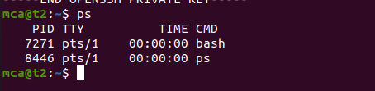

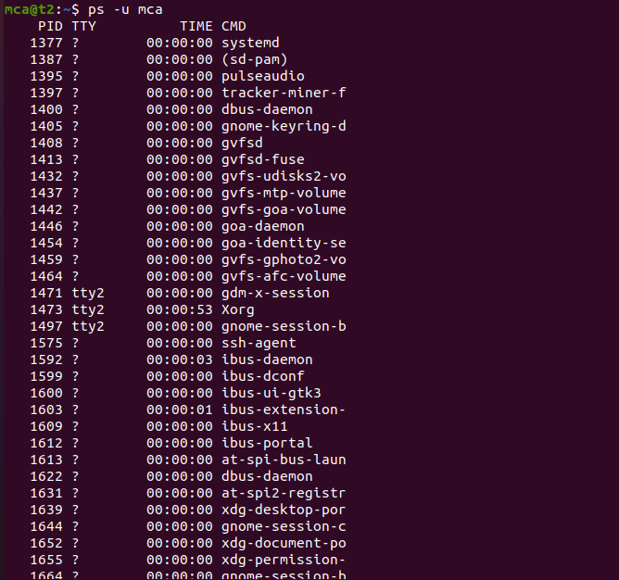

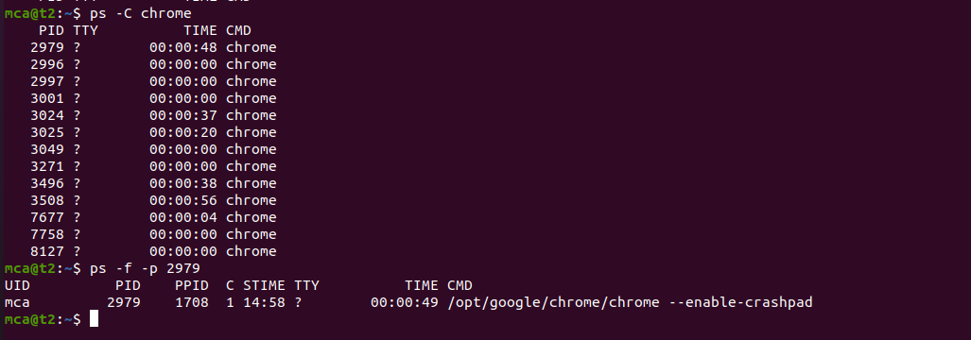

**Result**

The program was executed and the result was successfully obtained. Thus CO2 was obtained.

Experiment no: 9

CO:

Aim: Shell Scripting

Procedure:

1.Shell script to display the date

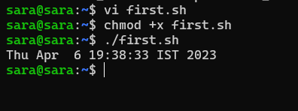

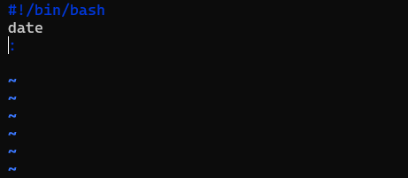

2.Shell script to display your name

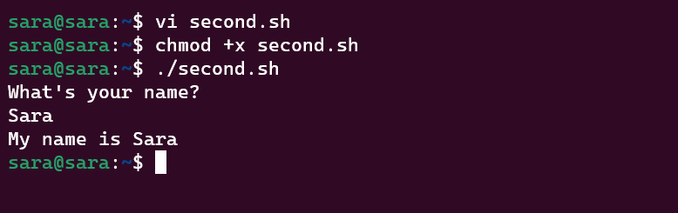

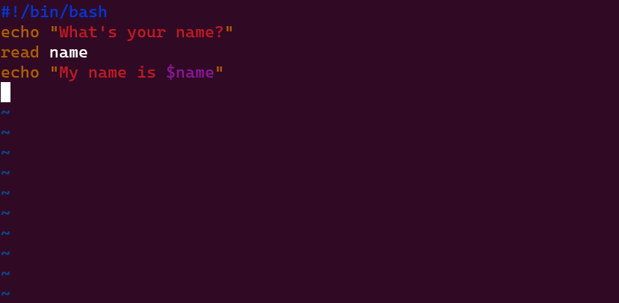

3. Shell script to display date, pwd, ls(multiple command)

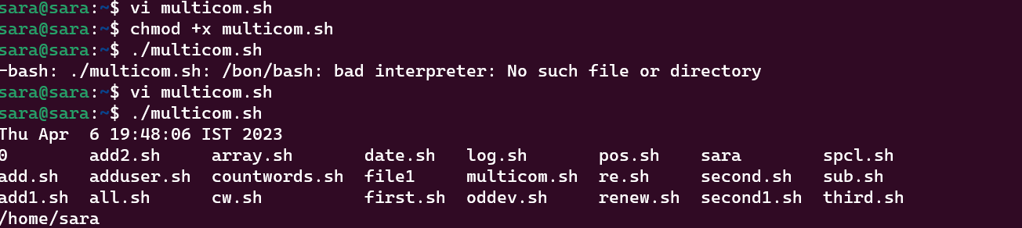

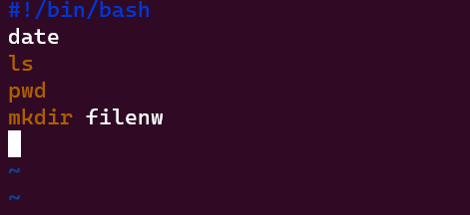

4.Shell script to demonstrate special variables

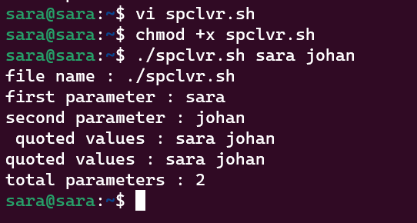

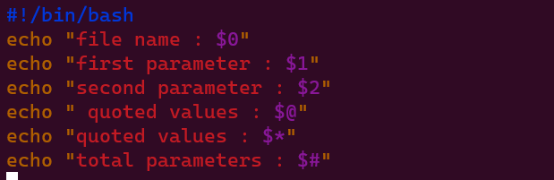

5.Shell script to count lines and words of a file

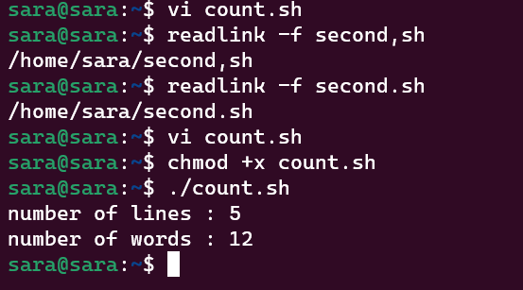

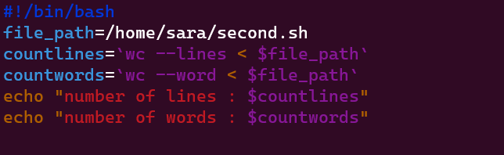

6.Shell script to display array index

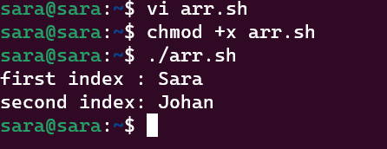

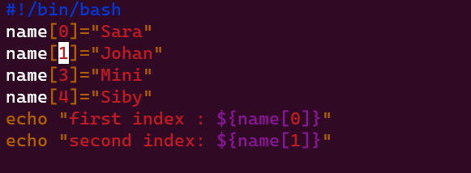

Experiment 10

Aim: Shell scripting (Basic operations)

Procedure:

Shell Script to add two numbers

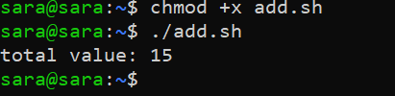

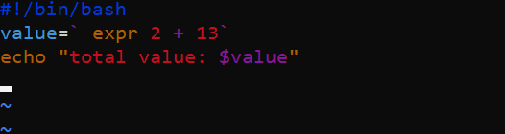

**2.Write an example shell script to intialize two numeric variables . then perform an addition operation on both values and store the result in the third variable**

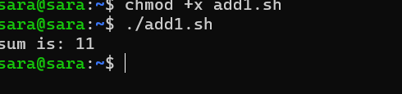

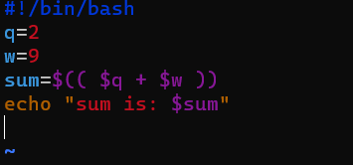

**3. Shell script to read two num,bers as command line parameters and perform the addition operation**

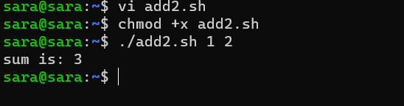

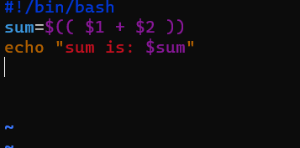

**4.Shell script which takes input from the user at run time . Then calculate the sum of given numbers and store to variable amd show the result**

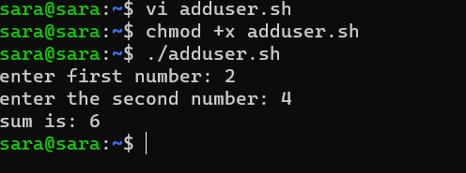

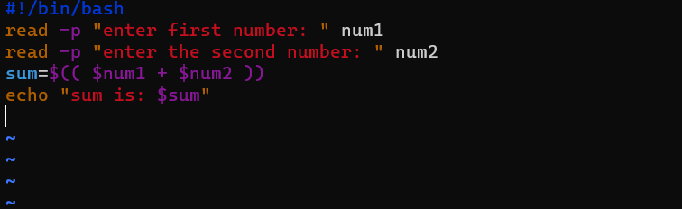

**Experiment 11 04-04-2023**

**Aim : Shell scripting (basic operations)**

**Procedure**

**Shell script to demonstrate arithmetic operations**