whiInstalling docker

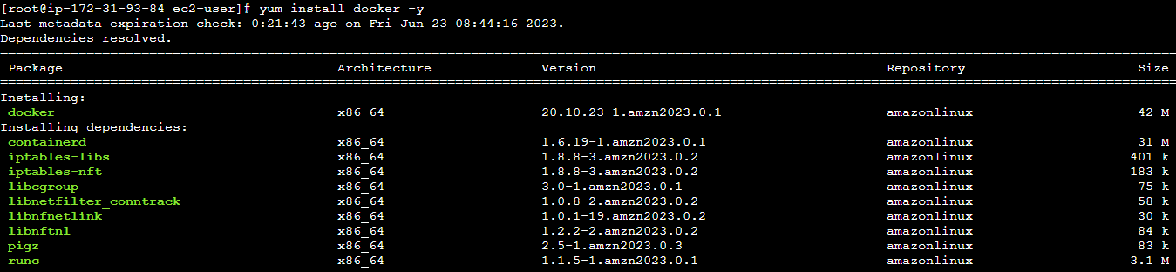

To check whether the docker is installed, finding its info

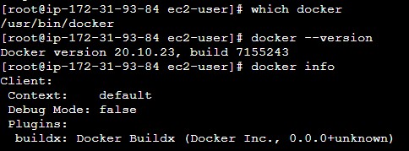

TO CHECK WHETHER THERE ARE IMAGES



To know the status

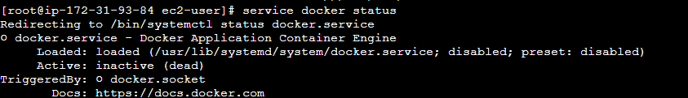

To start the the docker

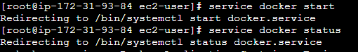

To pull the images

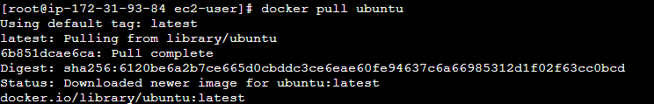

To see the pulled images



To see the active



To run the image



To exit



To see all the images the processes



To start a container , create a file and listing

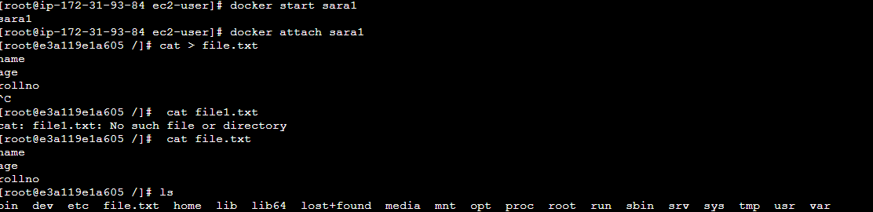

To update ubuntu

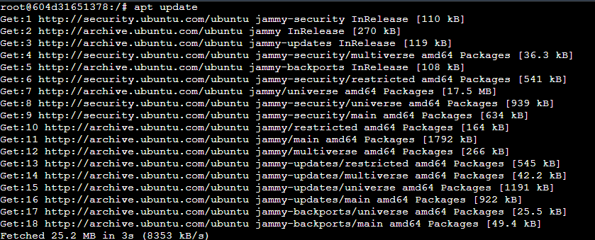

To install apache

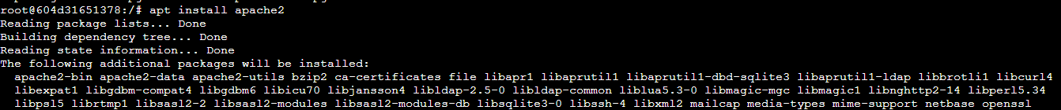

To see the list of all running items

