Cairo University  
Faculty of Computers and Information



**CS251**

**Software Engineering I**

SDS project 3

Software Design

December 6, 2019

Contents

Instructions [To be removed] 3

Team 3

Document Purpose and Audience 3

System Models 3

I. System Decomposition 3

II. Class diagrams 6

Important Algorithm 7

III. Sequence diagrams 7

Class - Sequence Usage Table 9

Ownership Report 10

Policy Regarding Plagiarism: 10

References 10

Authors 10

# Team

|  |  |  |  |
| --- | --- | --- | --- |
| **ID** | **Name** | **Email** | **Mobile** |
| 20170372 | Ahmed Wessam Fathy | ahmed.wessam.1999@gmail.com | +201227647347 |
| 20170110 | Sara Samer Moustafa | ss.titanic199@stud.fci-cu.edu.eg | 01026991646 |
| 20170115 | Salma Essam Soliman | Ssalma.essamm@gmail.com | 01008097149 |

# Document Purpose and Audience

What's this Document?

# What's this Document? - This document is to present a detailed description to the related readers of this document about "Social Network back-end API". It will explain the purpose and features of the system, its interfaces, all functionalities of the system, constraints and restrictions that's agreed among stakeholders and developers and how the system actors interact with the system, and it will be proposed to the product owner for its approval.

# Audience list: • Project owner • Project manager • System architect • Development team

# System Models

## I. System Decomposition

## II. Class diagrams

**List down your classes and describe them**

| **Class ID** | **Class Name** | **Subsystem ID** | **Description & Responsibility** |
| --- | --- | --- | --- |
|  |  |  |  |

* **In the above table make sure that each class belongs to a subsystem.**
* **In the above table ALL classes should belong to subsystems. And each subsystem should at least contain one class.**

## III. Sequence diagrams

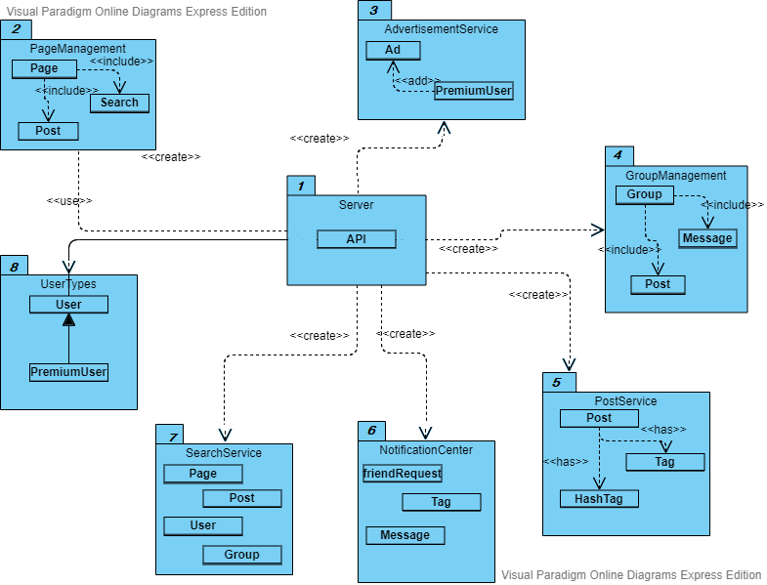

### Class - Sequence Usage Table

* **In this table, we will list EVERY class in class diagram and which sequences used this class diagram. This helps in avoiding either unused classes or extra classes appears in sequence diagrams. In "Overall used methods" section, put all functions appeared in all sequences. If this table was built in ignorance of actual class / sequence diagrams = REJECTED for whole document.**

| **Class Name** | **Sequence Diagrams** | **Overall used methods** |
| --- | --- | --- |
| E.g. Employee | 1, 3, 5 (means Seq Ids 1, 3, 5 used Employee class) | Save, GetData |
|  |  |  |

|  |  |  |
| --- | --- | --- |
| **BR# ( business/functional requirement number )** | **Sequence Diagram ID** | **Package(es) Name(s)** |
| **Create Ad** | **1** | **Advertisement Service** |
| **Friend Request** | **2** | **Notification Center** |
| **Create Page** | **3** | **Page Management** |
| **Sign Up** | **4** | **User** |
| **Upgrade to premium** | **4** | **Free user** |
| **Writing a post** | **5** | **Post** |
| **Create page** | **6** | **Page** |
| **Create group** | **7** | **Group** |
| **Messages** | **8** | **Message** |
| **Friend request** | **9** | **Friend request** |
| **Get notifications** | **10** | **Notification** |
| **Retrieve posts** | **11** | **Post, User** |
| **Search for hashtag** | **12** | **Post, Hashtag** |

# Ownership Report

|  |  |
| --- | --- |
| **Item** | **Owners** |
|  |  |
|  |  |
|  |  |