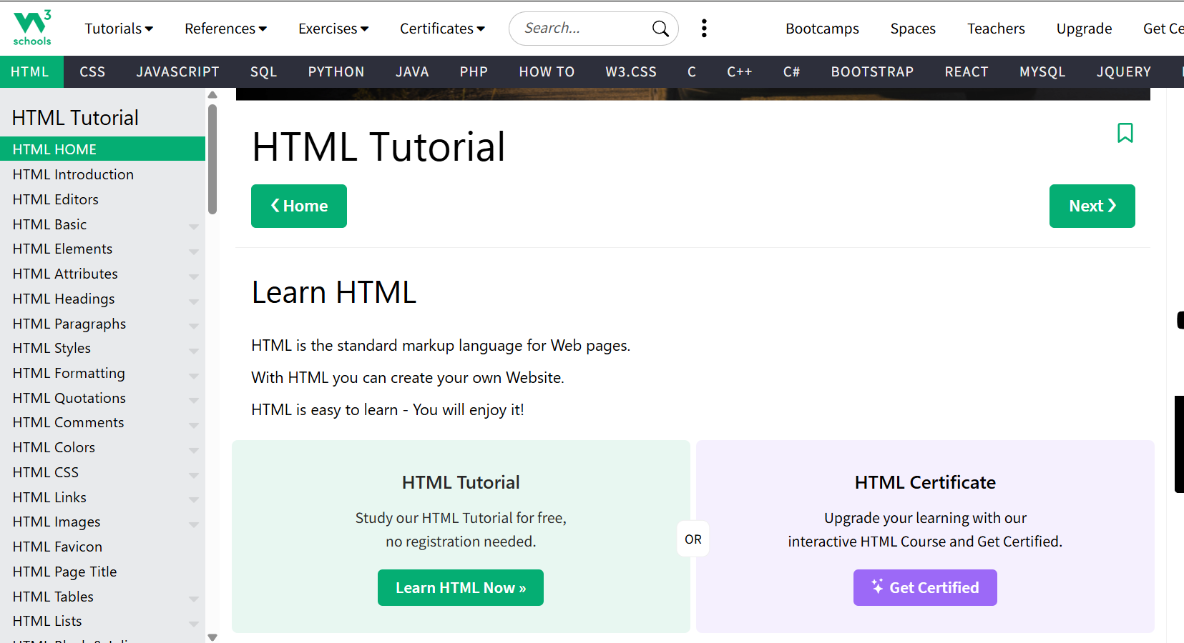
- Title, header
- headings
- Top Nav bar
- div containers
- links
- Top navigatin bar, sub navigation bar
- side navigation bars
- menus
- menu items
- menu dropdowns
- buttons
- paragraph
- bootstrap css
- script
- image
- footer

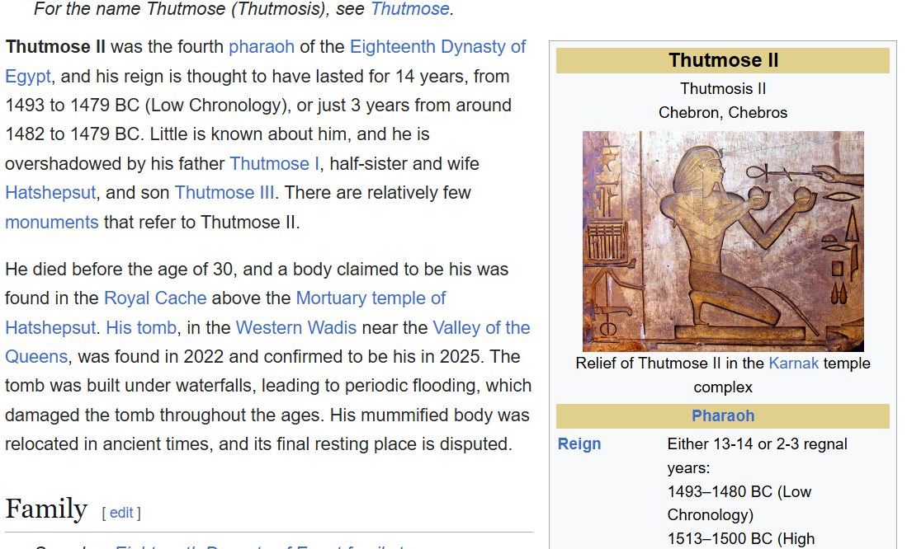

Head, Title, body, div, nav, headings, img, links, paragraph, figure, blockquote, unordered list, footer.
<head>, <title>, <body>,<div>, <a href=>,<link rel=>, <h1>,<nav>, <img>, <p>, <figure>, <ul>, <ol>, <blockquote>, <footer>

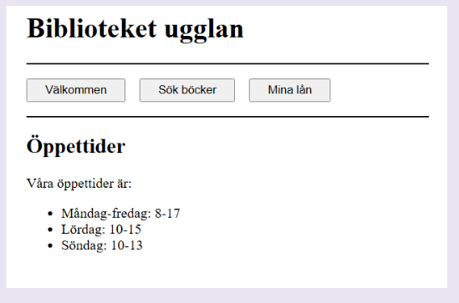

- <header>
- <h1> Biblioteket ugglan </h1>
- </header>
- <nav>
- <div> Välkommen </div>
- <div> Sök böcker </div>
- <div> Mina lån </div>
- </nav>
- <main>
- <h2> Öppettider </h2>
- <p> Våra öppettider är: </p>
- <ul>
- <li> Måndag-fredag: 8-17 </li>
- <li> Lördag: 10-15 </li>
- <li> Söndag: 10-13 </li>
- </ul>
</main>
1d Hitta så många fel som möjligt i följande HTML. Tips: minst 4
<main>
<section>
<h1> Find the error
<p> This is an example of an HTML file. It contains several errors.
<img Let's show a nice image. />
<p> Can you find them all? </p>
</p>
</main>
- Section tag doesn't have an end tag
- heading <h1> doesn't have an end tag
- <img> tag syntax is wrong

