University of Layyah
Name: Sara Manzoor
Roll No: UL-BSCSM-A-24-01
Course Title: Web Technologies
Course code: CS ELECTIVE -1
Instructor: Sir Safi Ullah
Topic 1:
Developer Tools
Chrome Developer Tools (DevTools) is a set of built-in web development and debugging tools in Google Chrome. It allows developers to inspect, test, debug, and analyze websites directly in the browser.
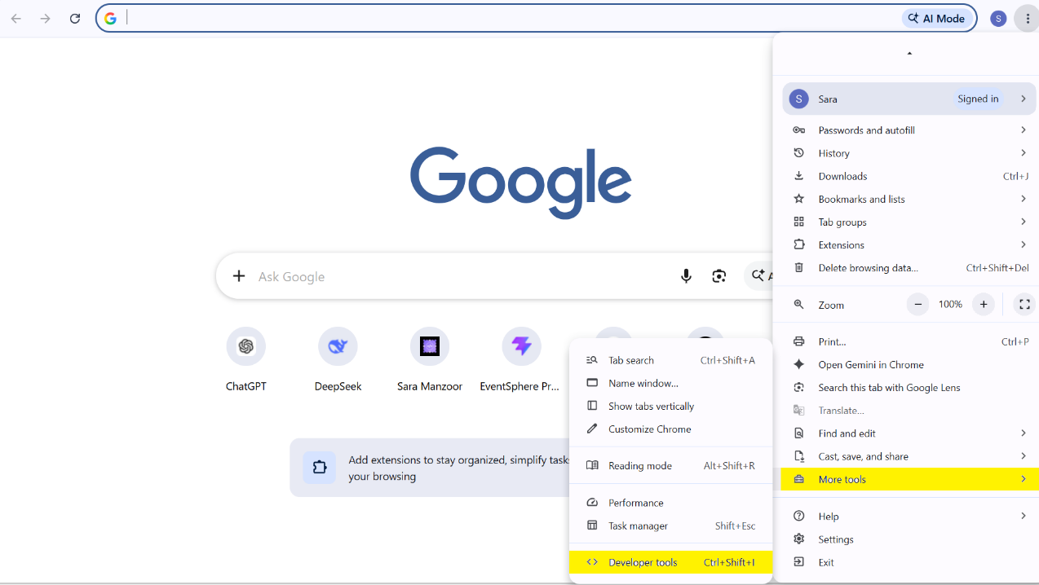

Analysis of “University of Layyah” Website Using Chrome Developer Tools
- Elements Panel Analysis:
The Elements panel was used to inspect the HTML structure and CSS styling of the university website. It displayed the DOM hierarchy, HTML tags, attributes, classes, and IDs of different webpage components. By selecting individual elements, their applied CSS rules, computed properties, and box model could be analyzed. The Elements panel also allowed temporary modification of HTML and CSS directly in the browser.

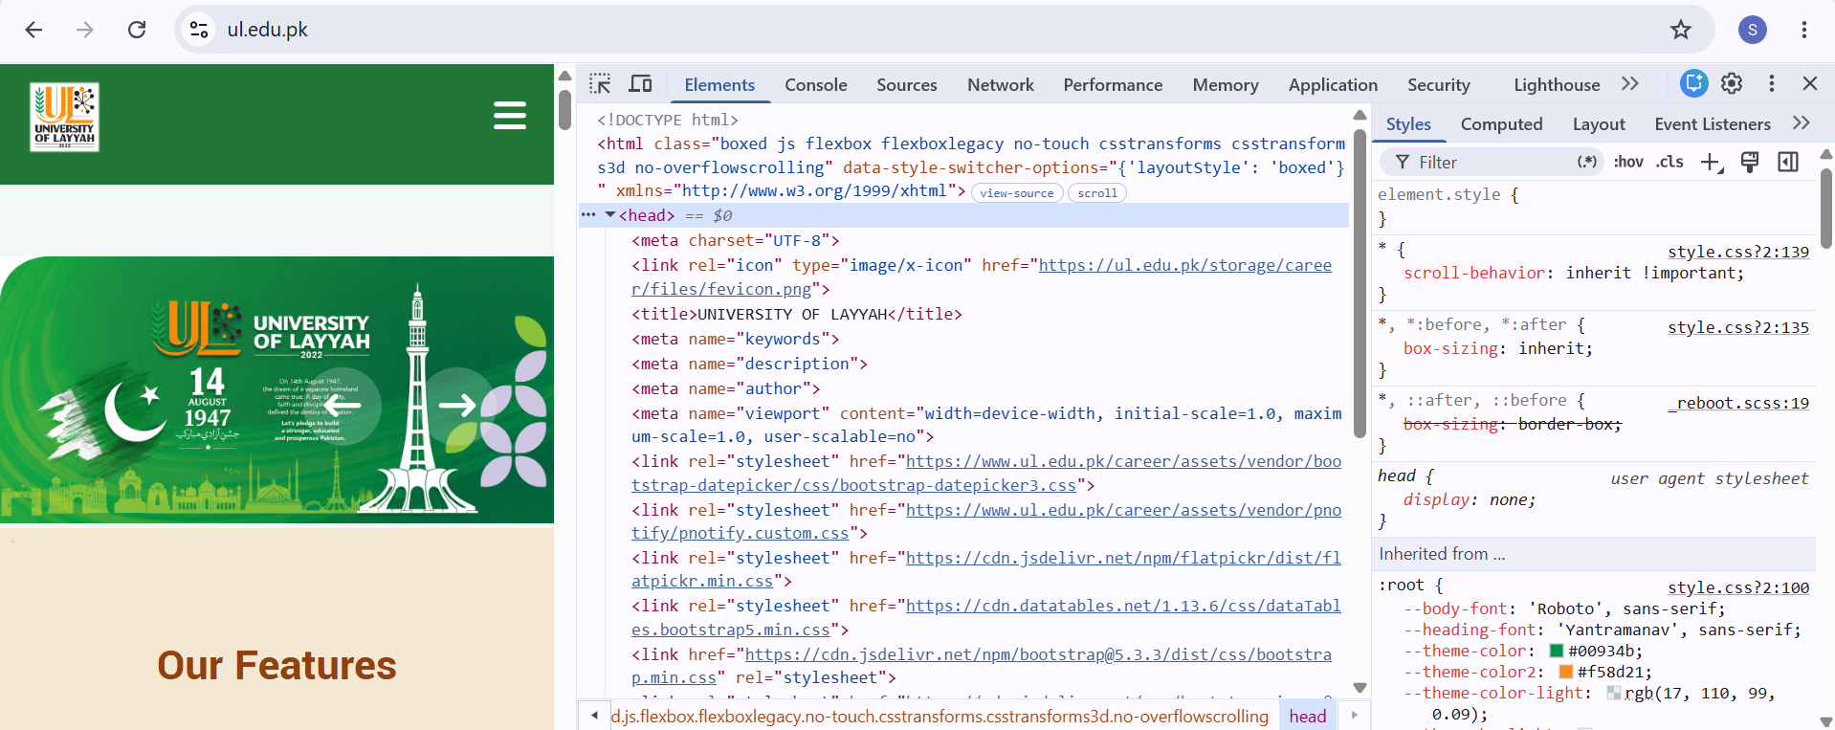

- Console Panel Analysis
The Console panel is used to execute JavaScript code and view messages generated by the website. It helps developers identify JavaScript errors, warnings, logs, and other runtime information.
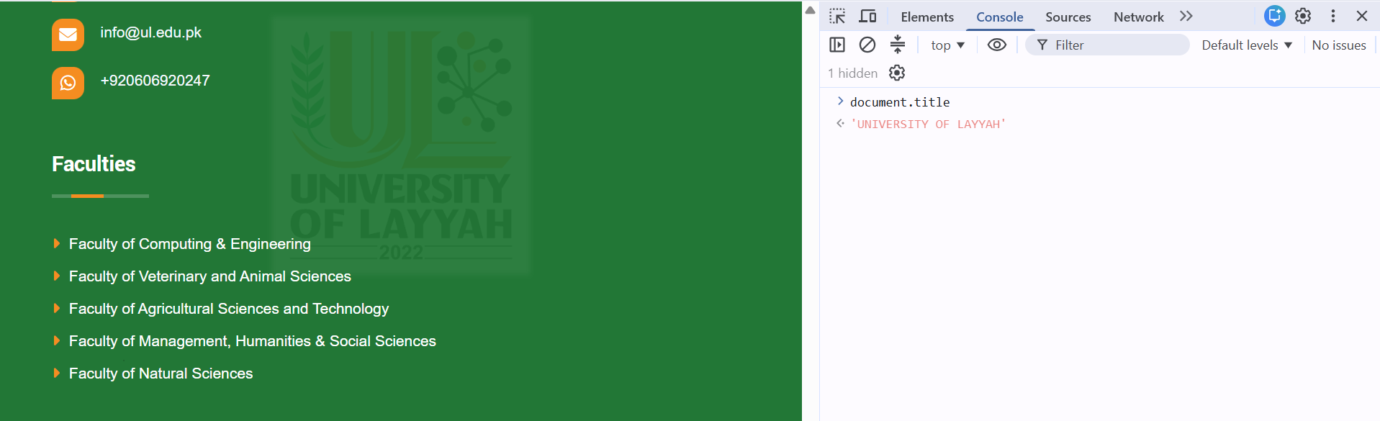

3. Sources Panel Analysis
The Sources panel is used to view and debug the different files and resources loaded by a website. It allows developers to examine the website's HTML, CSS, JavaScript, images, and other source files.
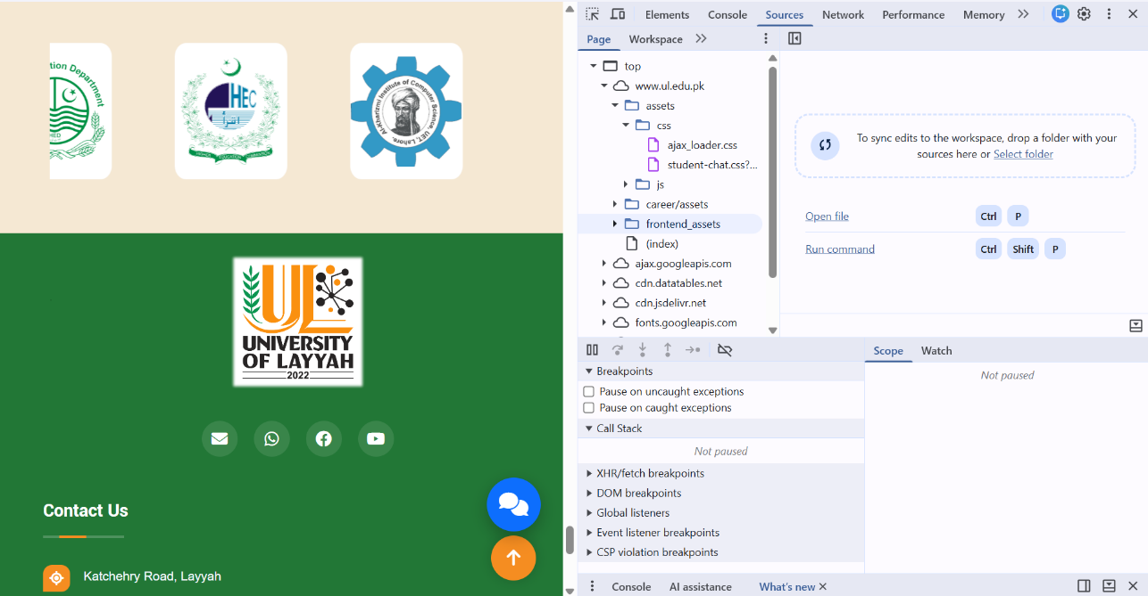

4.Network Panel Analysis

The Network panel is used to monitor and analyze all the network requests made by a website while it is loading or being used. It helps developers understand how the browser communicates with web servers and how different resources are fetched.
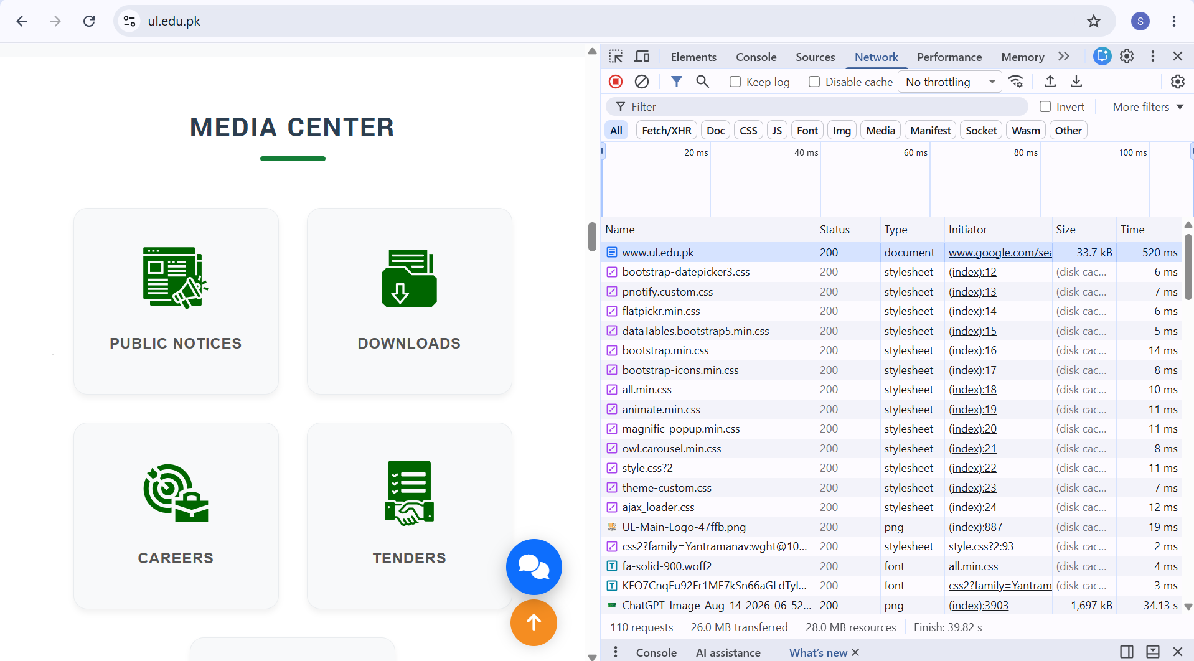

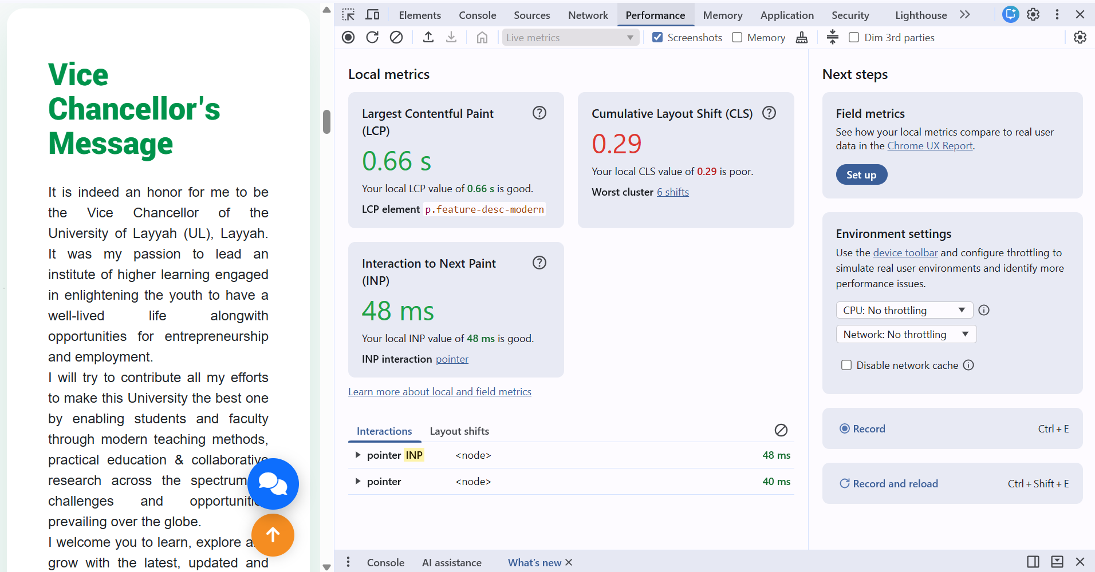
5. Performance Panel Analysis
The Performance panel is used to analyze the loading speed and runtime performance of a website. It helps developers identify which activities consume time and resources while a webpage is loading or running.
6.Lighthouse
Lighthouse is a built-in auditing tool in Chrome DevTools used to evaluate the quality and performance of a website. It checks important areas such as Performance, Accessibility, Best Practices, SEO, and Progressive Web App (PWA) features.
Step 1:
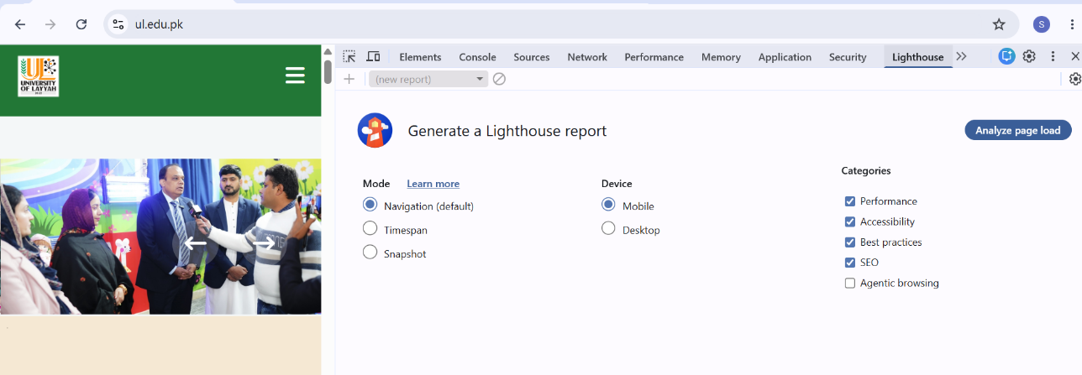

Step 2:
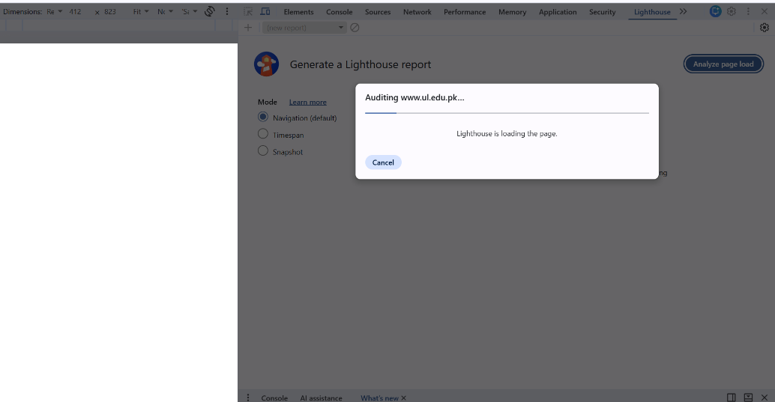

Result:
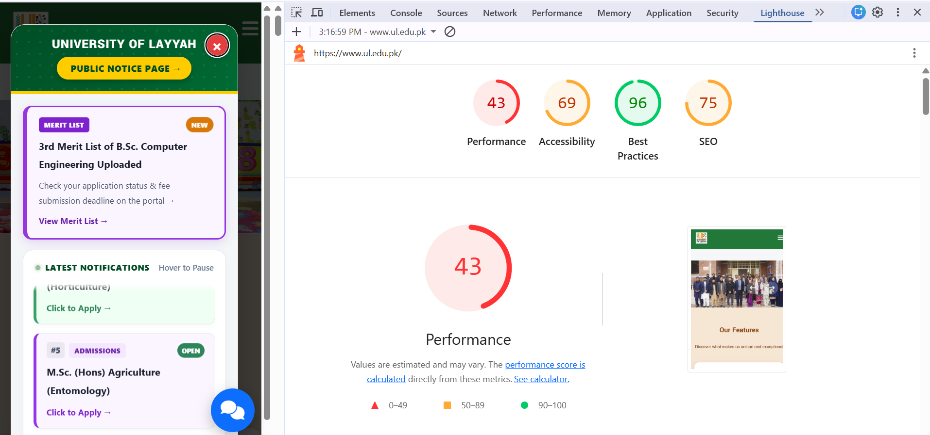

7.Rendering

The Rendering panel provides options for examining how the browser renders and repaints webpage content. Paint flashing was enabled to identify the areas of the webpage that were repainted during user interaction. This helped in understanding the browser's rendering process and visual performance.

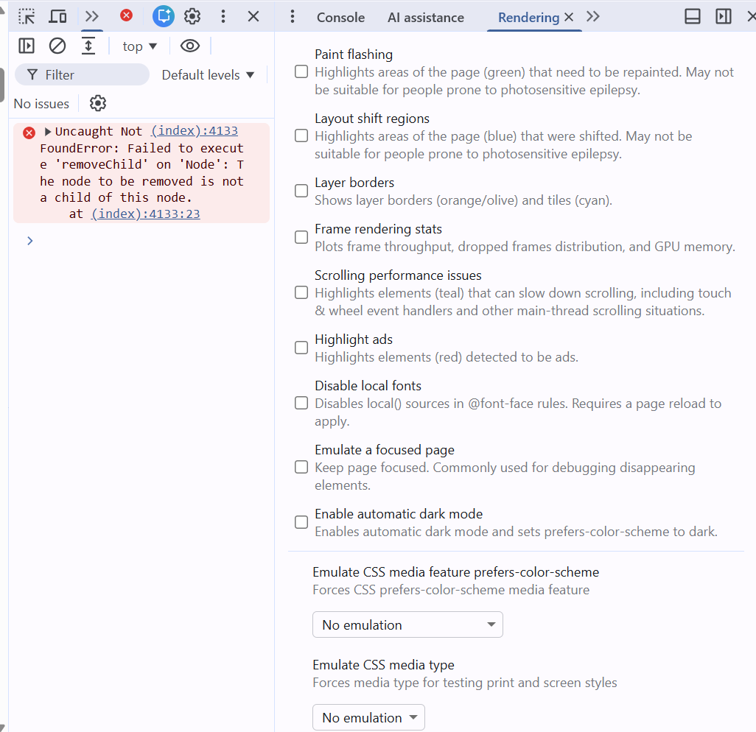

Topic 2:

GTmetrix Website Analysis
GTmetrix is a web-based website performance testing tool. It analyzes a webpage and provides information about its loading performance, page size, requests, and performance-related issues.

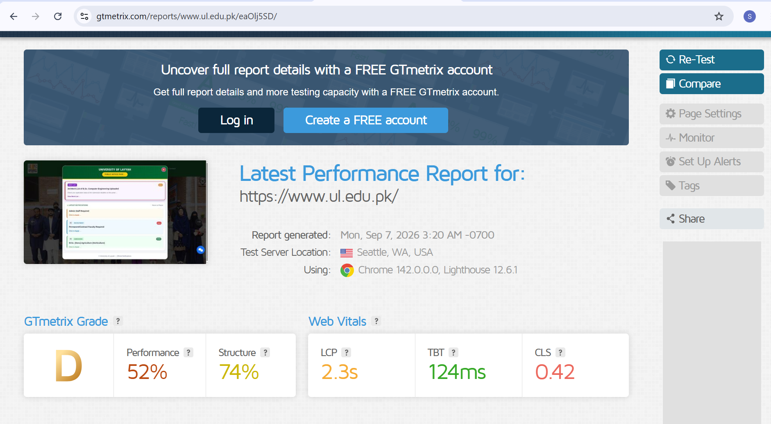

Screaming Frog:
Screaming Frog: Screaming Frog SEO Spider is an SEO auditing tool used to crawl websites and identify technical SEO issues. It can analyze important elements such as URLs, HTTP status codes, page titles, meta descriptions, headings, broken links, redirects, and duplicate content. It is especially useful for understanding how search engines can access and interpret a website.

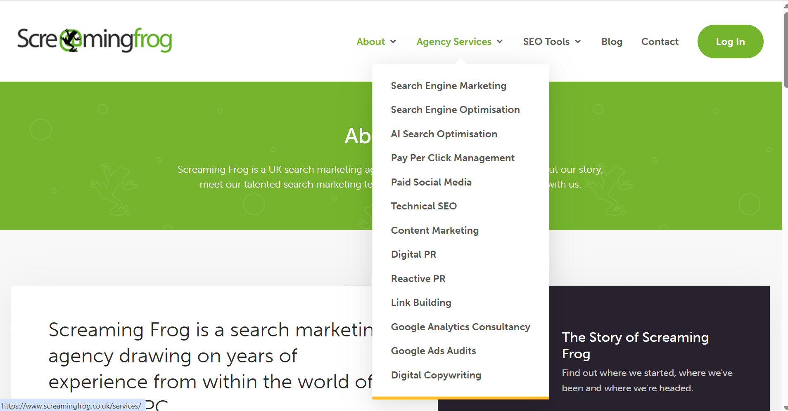

Tasks Lab 1
Task 1:
Copying HTML/CSS of a Div from University of Layyah Website :

Code snippet(Vs Code):
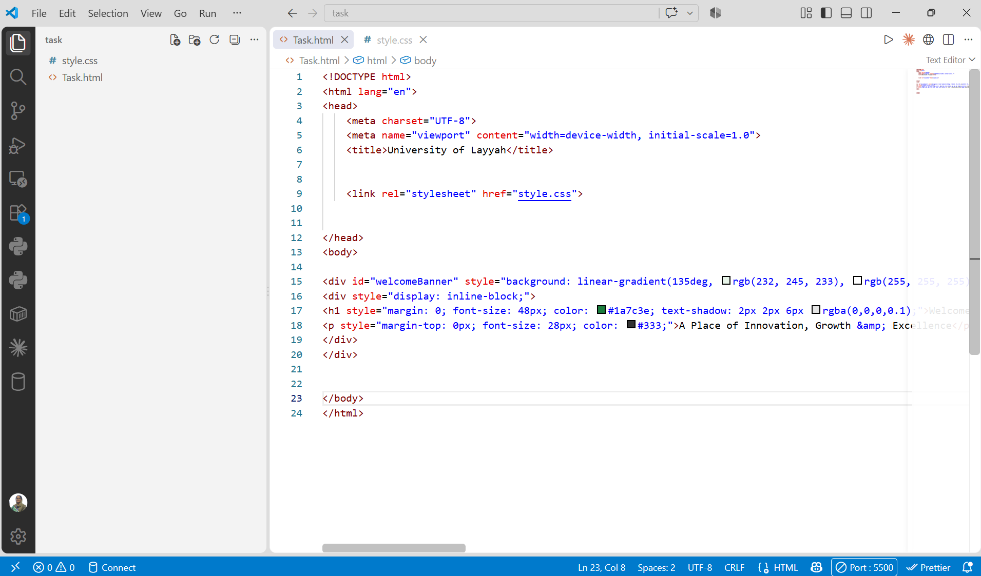
Inspect:
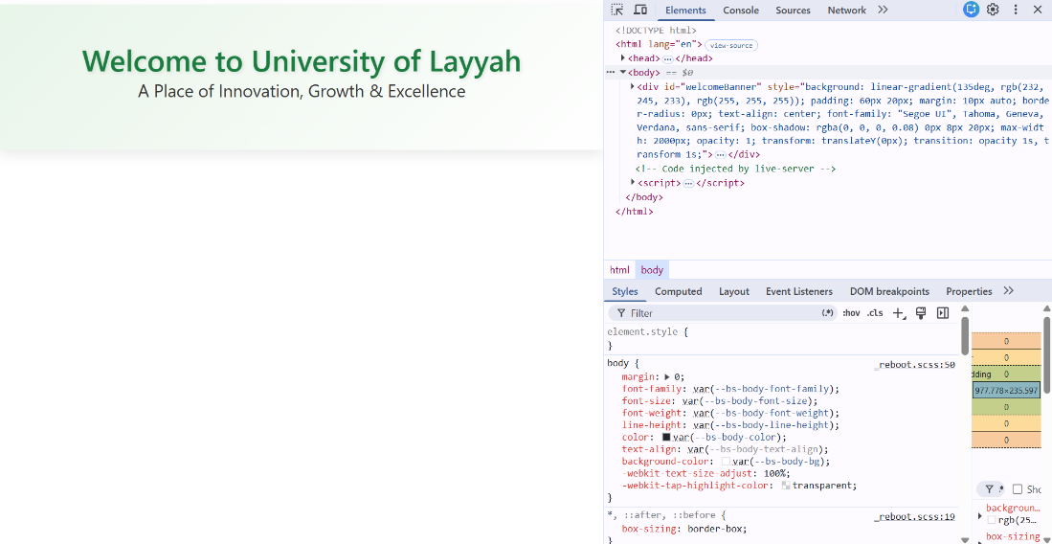

Output:


Task 2:

Analyzation of Network Tab: URL Request, GET Method & 200 OK Status code:
A URL request (or HTTP request) is the full message your browser (or any client) sends to a server to ask for something. The URL is just one part of that request.

GET is an HTTP request method used to retrieve information from a website/server. 200 OK is an HTTP status code.
It means:
“The request was successful, and the server successfully returned the requested page”.

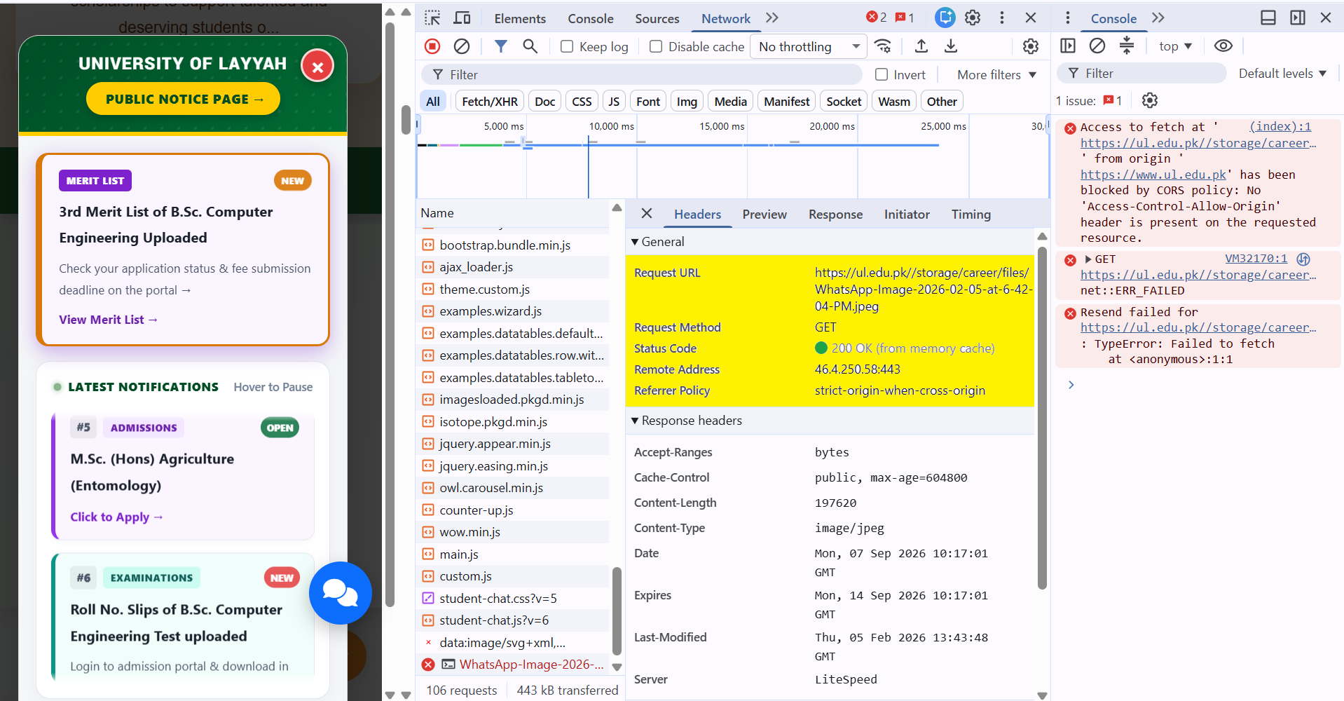

Other status codes:
- 301 Moved Permanently – The URL has been permanently redirected to another URL.
- 302 Found – The URL is temporarily redirected to another URL.
- 404 Not Found – The requested page does not exist.
- 403 Forbidden – The server understood the request but refuses access.
- 500 Internal Server Error – There is a problem with the website's server.
- 503 Service Unavailable – The server is temporarily unable to handle the request.

