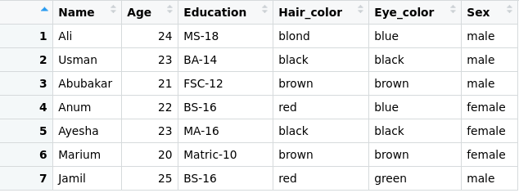
Mutate:

- Mutate is a function of dplyr package.
- This function allows to Add new columns to data frame.
- Following is the code used to mutate data.
mutate(StudentsInfo , Age2 = Age / 10)
- Filter function takes Data Frame name and column names and values (you want to add) as arguments.
- In the above code StudentsInfo is Data Frame name and Age2 is the column name.
- After writing this code in R, A new column will be added to data frame. Column name is Age2 it will take values from Age column and divide it to 10.
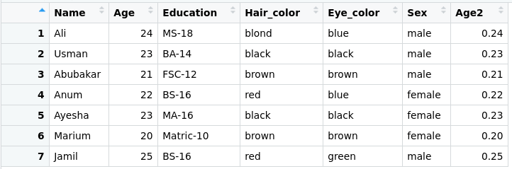

Another way to add column is to write column name along with its value.
mutate(StudentsInfo , City = c("LHR", "FSD","RWP","ISB","LHR","MZD","KAR"))
- After writing this code in R, A new column will be added to data frame. Column name is City and its values are "LHR", "FSD","RWP","ISB","LHR","MZD","KAR".
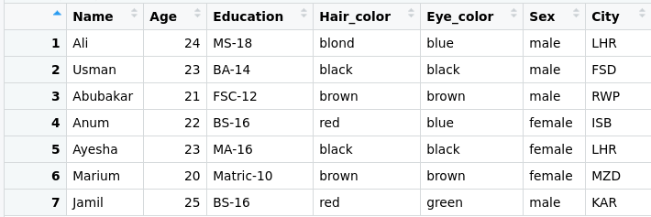
For multiplication you have to write 10 * 10 its answer will be 100
For division you have to write 100 / 10 its answer will be 10
For subtraction you have to write 100 -10 its answer will be 90
For addition you have to write 100 +10 its answer will be 110

