1. Create a pod with the name “imperative-nginx” and with the image nginx and latest tag. using Imperative command (not yaml).

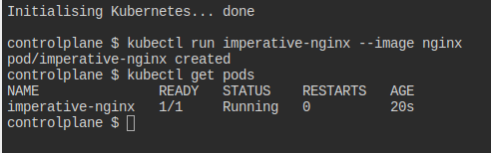

1. Create a pod with the name webserver and with the image “nginx123”Use a pod-definition YAML file.

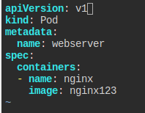

1. What is the nginx pod status?

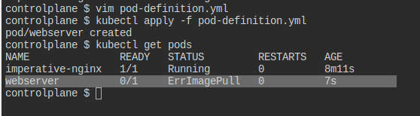

1. Change the nginx pod image to “nginx” check the status again

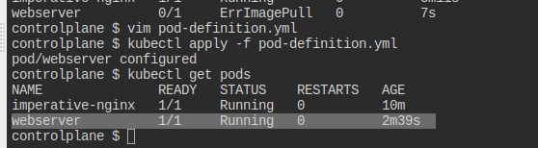

5- How many pods are running in the system? Type the command to show this

Ans: 2 pods

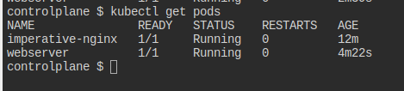

1. What does READY column in the output of get pods command indicate?

Ans: The READY column indicates the readiness of containers in each pod.

1. Delete first pod named imperative-nginx you just created. Type the command to do this

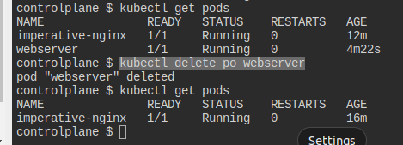

1. Which node is pod named webserver running on (list two commands to do this)

Ans: 1) command: kubectl describe pod webserver

output:

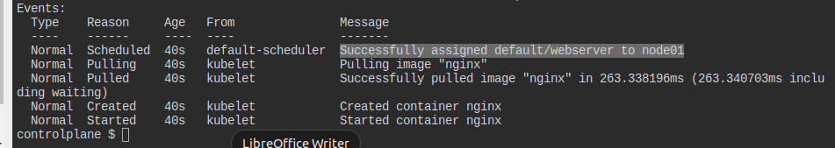

2) command: kubectl get pod webserver -o=yaml

output:

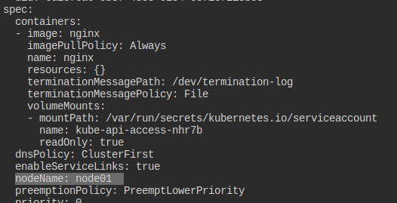

1. Get a shell to the running container i.e ssh into it (figure out the command)

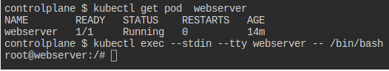

1. Run cat /etc/os-release inside the container

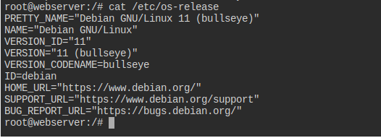

1. Exit from the shell (/bin/bash) session



1. Get logs of pod, what are logs and what they are used for?

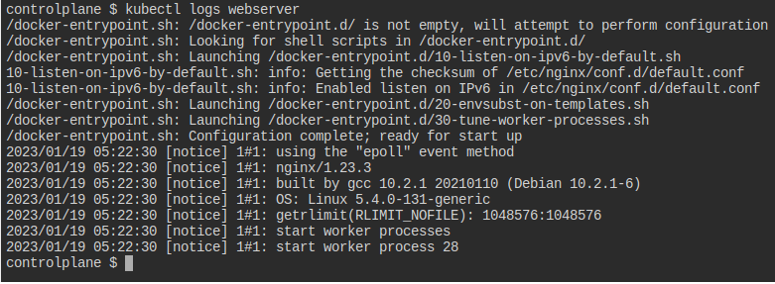

1. How many ReplicaSets exist on the system?

Ans:

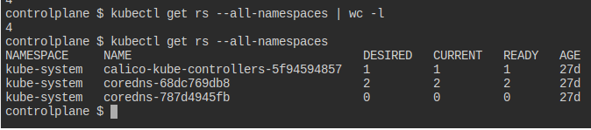

1. create a ReplicaSet withname= replica-set-1 image= busybox replicas= 3

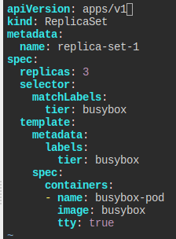

1. Scale the ReplicaSet replica-set-1 to 5 PODs.

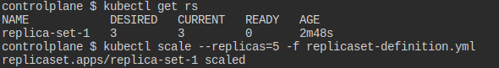

1. How many PODs are READY in the replica-set-1?

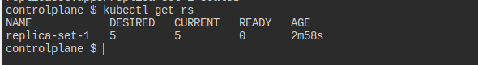

1. Delete any one of the 5 PODs then check How many PODs exist now?

Why are there still 5 PODs, even after you deleted one?

Ans: when a pod get deleted replica-set creates another one to make the replicas=5

