1. How many Namespaces exist on the system?

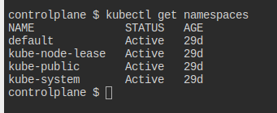

1. How many pods exist in the kube-system namespace?

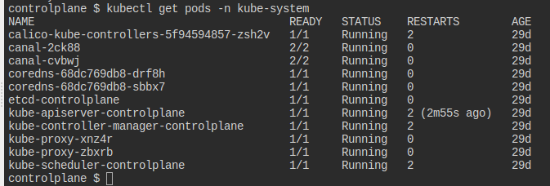

3- create a Deployment with

name= deployment-1 image= busybox replicas= 3

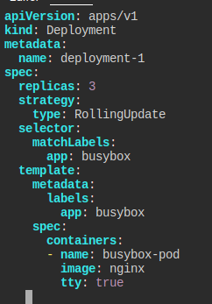

4- How many Deployments and ReplicaSets exist on the system now?

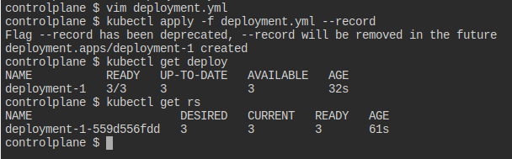

5- How many pods are ready with the deployment-1?

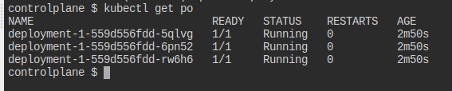

6- Update deployment-1 image to nginx then check the ready pods again

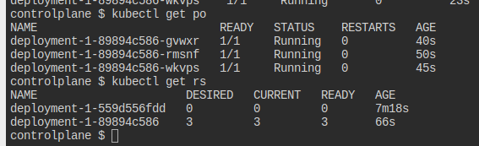

7- Run kubectl describe deployment deployment-1 and check events What is the deployment strategy used to upgrade the deployment-1?

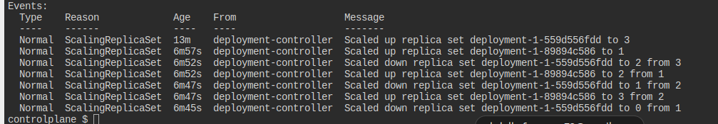

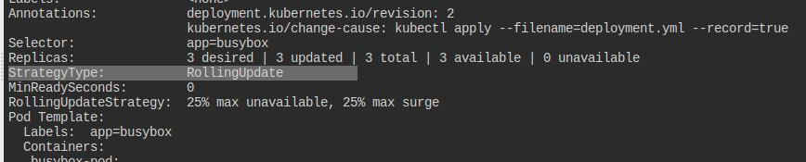

8- Rollback the deployment-1

What is the used image with the deployment-1?

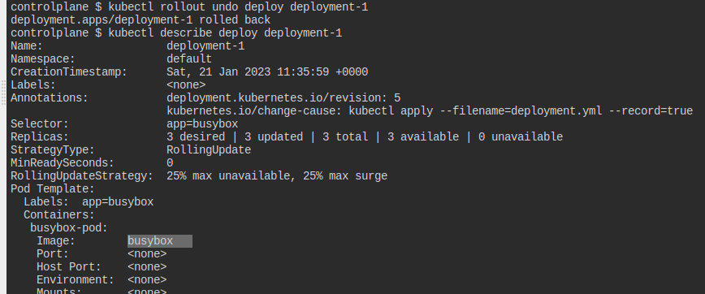

10- Create a deployment with

Name: dev-deploy Image: redis Replicas: 2 Namespace: dev Resources Requests: CPU: .5 vcpu

Mem: 1G Resources Limits: CPU: 1 vcpu Mem: 2G

