Product Design Requirements
Siraj
AI-powered personal finance advisor for the Saudi market
Field | Details
Document type | Product Design Requirements (PDR)
Version | 1.0
Date | July 9, 2026
Product | Siraj - سراج
Design palette | Deep navy, copper, lavender, off-white
Primary audience | Hackathon judges, product team, designers, developers

Executive summary
Siraj is a Saudi-focused AI financial advisor that analyzes banking data, classifies spending, calculates financial health, and turns everyday money behavior into actionable recommendations, savings plans, proactive alerts, and guided transaction flows.

1. Product Overview
Siraj helps users understand where their money goes and what to do next. The product combines a financial dashboard, transaction intelligence, Saudi Arabic AI chat, proactive financial alerts, and secure banking workflows into one guided personal finance experience.
- Problem: users have access to bank data but often lack clear, personalized interpretation.
- Solution: transform account and transaction data into understandable insights, plans, and actions.
- Market fit: Arabic RTL UX, Saudi dialect support, and recommendations aligned to local financial behavior.
- Trust requirement: no financial operation should execute without clear user confirmation.

2. Product Goals
- Give users a clear, real-time view of income, spending, savings, and financial health.
- Classify transactions automatically and explain spending behavior in simple Arabic.
- Provide AI recommendations that help users save more and avoid financial shortfalls.
- Support conversational commands in Saudi dialect, including transfer, spending inquiry, and savings requests.
- Create a polished, credible UX suitable for a hackathon demo and future banking integrations.

3. Target Users
User segment | Need | Siraj value
Everyday banking customer | Understand spending and savings quickly. | Dashboard KPIs, charts, and simple insights.
Young professional | Plan monthly expenses and avoid overspending. | Savings plans, alerts, and category tracking.
Arabic-first user | Use natural Saudi phrases instead of formal banking language. | Saudi dialect NLP and intent detection.
Banking/fintech partner | Demonstrate AI value on transaction data. | API-ready dashboard, agent workflow, and measurable tests.

4. UX/UI Direction
The UI should feel premium, calm, and trustworthy. The Amad palette informs the product identity: deep navy for trust and structure, copper for primary actions and financial highlights, lavender for AI moments, and off-white for approachable surfaces.
Color | Role | Usage
Deep navy | Trust / structure | Sidebar, headings, primary text, chart anchors.
Copper | Action / warmth | Primary CTA, active finance indicators, key highlights.
Lavender | AI / guidance | Siraj AI states, assistant chips, secondary accents.
Off-white | Calm surface | Dashboard cards, background, empty states.

UI Concept A - Mobile Light Dashboard
A compact mobile-first dashboard direction focused on quick financial understanding and AI guidance.
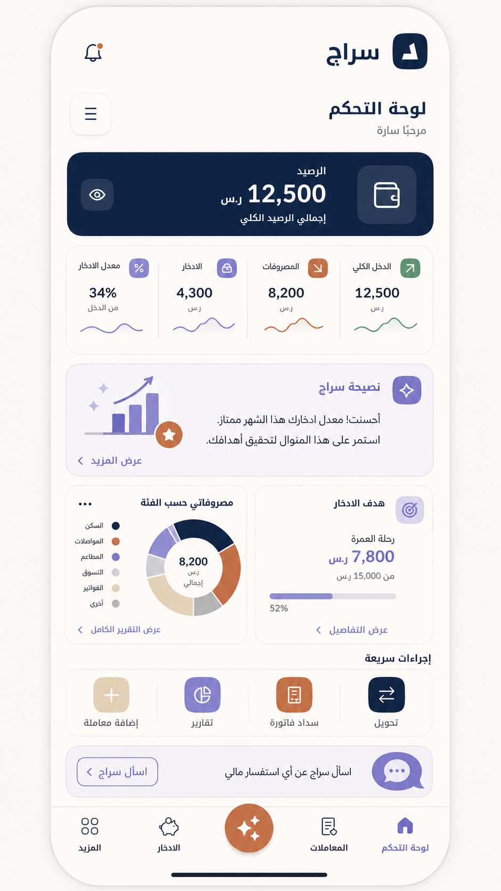

UI Concept B - Desktop Dark Analytics
A richer analytics dashboard direction for product demos, reports, and power-user workflows.
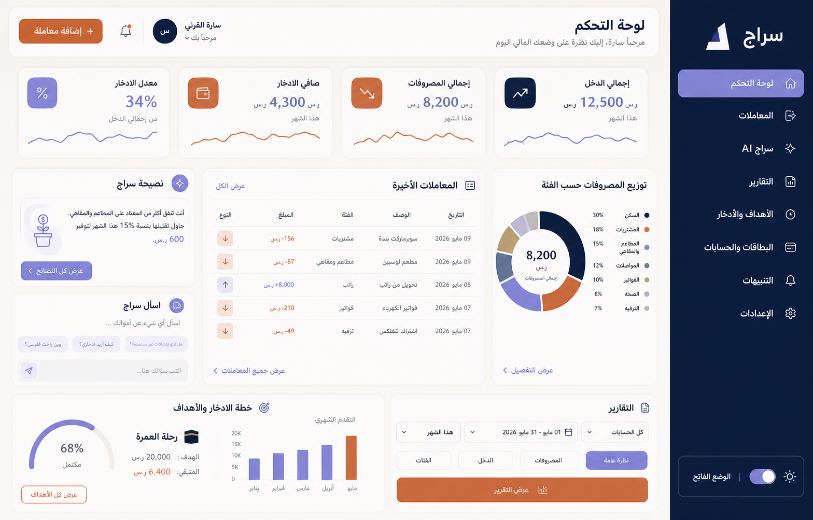

5. Feature Requirements
Feature | Description | Priority
RTL dashboard | Arabic interface with summary cards, charts, navigation, and quick actions. | MVP
Financial summary cards | Show total income, total expenses, net savings, and savings rate. | MVP
Expense analytics | Top expenses chart and spending distribution by category. | MVP
Transactions | View, add, categorize, and track financial transactions. | MVP
Siraj AI assistant | Chat interface that answers questions using account and transaction context. | MVP
Saudi dialect NLP | Detect intent from phrases such as transfer requests, spending questions, and savings goals. | Advanced
Financial health score | Calculate and display a score based on spending, saving, and account behavior. | MVP
Savings plan | Suggest personalized monthly and seasonal saving plans. | Advanced
Proactive alerts | Warn about overspending, unused subscriptions, risks, and opportunities. | Advanced
Transfer confirmation | Require confirmation before executing financial operations. | MVP

6. AI and Agent Requirements
- The LLM must answer from available financial data and avoid inventing account facts.
- The agent must classify user intent before suggesting a workflow.
- Money movement must require a confirmation step before execution.
- The assistant should route users to the right screen when a task needs UI interaction.
- The NLP layer should support informal Saudi Arabic phrases and mixed Arabic/English banking terms.

7. Data and Integration Requirements
Component | Requirement
Bank data | Use experimental accounts, transactions, payment cards, and banking products for demo data.
Database | Store balances, transaction history, card state, transfers, and AI interaction metadata securely.
API layer | Connect frontend to backend for balances, transfers, AI recommendations, and reports.
Processing | Clean data, normalize transaction descriptions, classify categories, and calculate financial health.
Security | Protect user data privacy, validate actions, and minimize sensitive data exposure.

8. Key User Flows

Flow 1 - Understand spending
- User opens the dashboard.
- Siraj shows income, expenses, savings, and savings rate.
- User reviews top expenses and category distribution.
- User opens Siraj insight to receive a short recommendation.

Flow 2 - Ask Siraj where money went
- User types: وين راحت فلوسي؟
- NLP detects spending inquiry intent.
- System retrieves recent transactions and category trends.
- Siraj responds with a concise explanation and suggests next action.

Flow 3 - Transfer money
- User asks to transfer money.
- Agent extracts amount, recipient, and source account.
- System displays confirmation details.
- Transfer executes only after explicit confirmation.
- Balances and transaction history update immediately.

9. Success Metrics
Metric | Target
Transaction classification accuracy | At least 90% on experimental data.
Saudi dialect intent extraction | Maintain or exceed the prototype result of 91%.
Dashboard comprehension | Users can identify income, expenses, and savings in under 10 seconds.
Transfer safety | 100% of money movement flows include confirmation before execution.
API reliability | Successful responses for balance, transaction, and AI calls during demo flow.

10. Scope and Roadmap
Phase | Scope
MVP | Dashboard, transaction data, charts, AI recommendations, financial health score, transfer confirmation.
Phase 2 | Deeper Saudi dialect coverage, subscription detection, seasonal predictions, richer reports.
Phase 3 | Real banking integrations, long-term planning, partner ecosystem, advanced privacy controls.

11. Risks and Open Questions
- Transaction descriptions differ across banks, which can reduce classification accuracy.
- Financial recommendations must be carefully worded to avoid unsafe or overconfident advice.
- Banking integrations will require strong security, permissions, audit trails, and compliance review.
- Arabic text rendering and RTL layout need dedicated QA across desktop and mobile breakpoints.
- Future product definition should clarify whether Siraj is bank-owned, standalone, or partner-integrated.

12. Acceptance Criteria
- Dashboard displays the four core financial KPIs and at least two analytics charts.
- User can add or view transactions and see category-level spending.
- Siraj AI can answer at least three core intents: transfer, spending explanation, and savings request.
- Transfer flow includes confirmation and updates balances after completion.
- Design uses the agreed palette consistently and supports Arabic RTL presentation.
- Prototype can demonstrate the full story from data ingestion to AI recommendation.

