experimental website main page design:

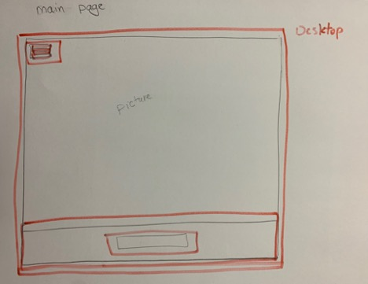

experimental website main page open side navigation design:

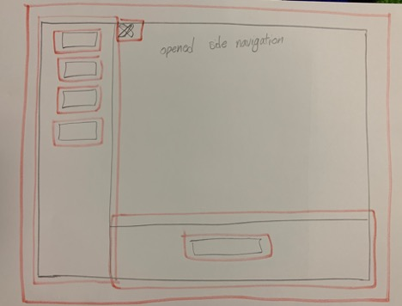

All devices(desktop, Tablet, Phone) will be same design

experimental website 3D Gallery page design:

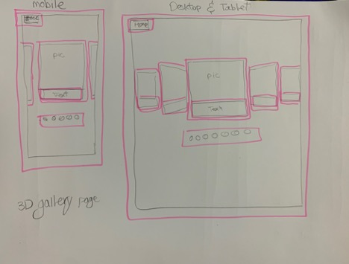

experimental website about page design:

