**Elisa Coding Test**

This project was generated with [Angular CLI](https://github.com/angular/angular-cli) version 12.2.8.

1. **Run Project**

* Run **npm install** to install all required packages then run **ng serve** for a dev server.
* Navigate to **http://localhost:4200/.** The app will automatically reload if you change any of the source files.

1. **Description**

# This project gets all trams departing from Mårtensdal station heading towards Gullmarsplan station within the next hour.

1. **Files**

Here files which I changed/added to build the project

* app.component.ts ( main component .ts file)
* app.component.html (view template)
* app.component.css (styles)
* app.module.ts ( to use HttpClient we need to import HttpClientModule in this file )
* trams.service.ts (which have the getTrams() method)
* ITrams.ts (tram model)

1. **Test Cases**

After checking the response, I found that all trams which heading to Gullmarsplan, have **JourneyDirection** property equal one, so returned response has been filtered to get only trams which have **JourneyDirection** equal one.

* **There are 3 cases**

1. If there are trams :

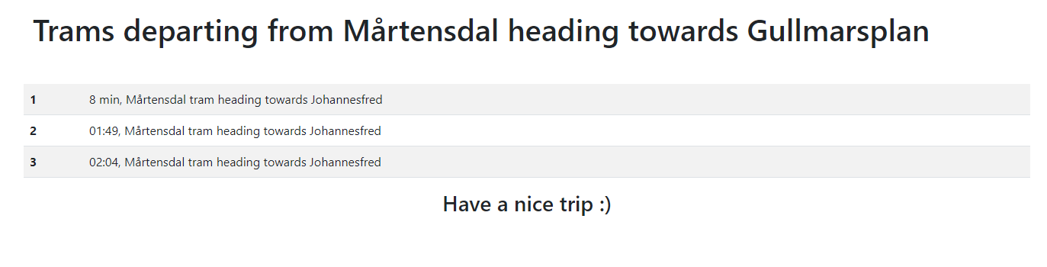

1. If there are no Trams :

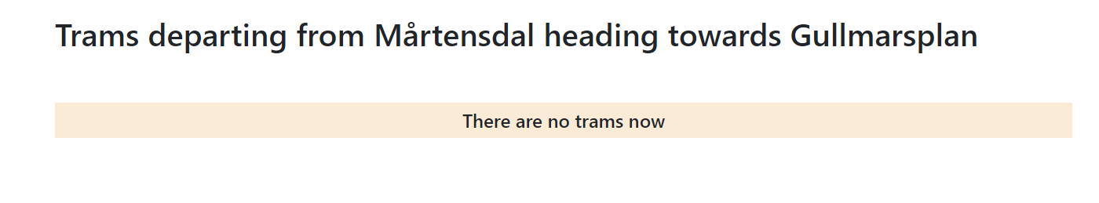

1. If error happened while calling api :



**\*\*\*\*\* End of Document \*\*\*\*\***