**OUTPUTS:**

* Input values entered

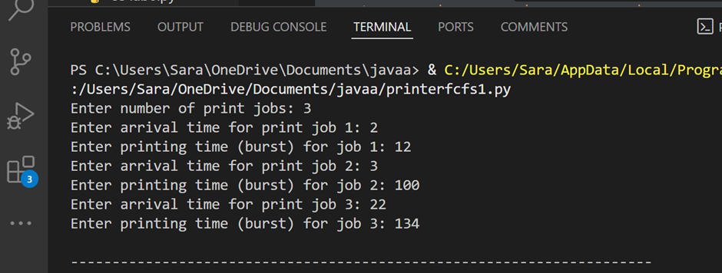

* Result table with Completion, Turnaround, Waiting Times

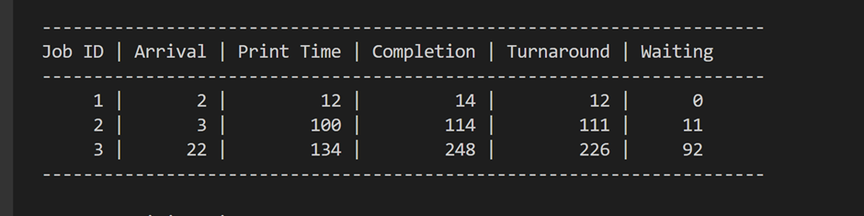

* Final calculated waiting and turnaround times

