Sampleprepp: proteinextraction, assey and standardise to 2 ug/ul protein.

Add loading buffer to dilute samples to 1.5 ug/ul

* Loading buffer test:

Pool protein from several samples to create a representable average of all samples to test loading buffers and antibodies.

Compare 4 different loading strategies:

1. SDS-urea w/inhibitors and tiny amount of bromophenol blue @ room temp
2. SDS-urea w/inhibitors and tiny amount of bromophenol blue @70 celcius for 10 min
3. Laemmli loading buffer @ 70 celcius for 10 min
4. Laemmli loading buffer @ 95 celcius for 5 min

SDS-PAGE:

1. Place precast gel in rack with running buffer

Running buffer (1 Liter):

* 100 ml 10X Tris-Glycine buffer
* 10 ml of 10% SDS
* Add ddH2O to final volume 1000ml

10X Tris-Glycine runnning buffer (1 Liter):

* 30.3g Tris (MW 121.14) (final concentration 250 mM, 25 mM in 1X solution)
* 144.1g Glycine (MW 75.07) (Final concentration 1.92 M, 192 mM in 1X solution)
* 10g SDS
* Add ddH2O to final volume 1000ml

1. Load ~15ug per lane + ladder

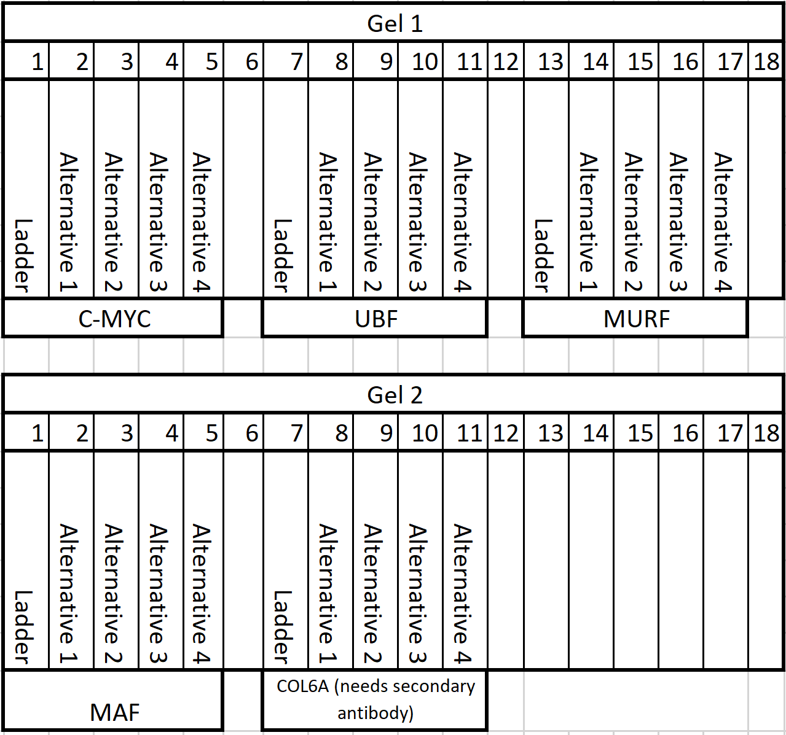

1. Run gel 250V for ~1h (untill blue line exits the gel) @ RT on icebath

Protein transfer to PVDF membrane:

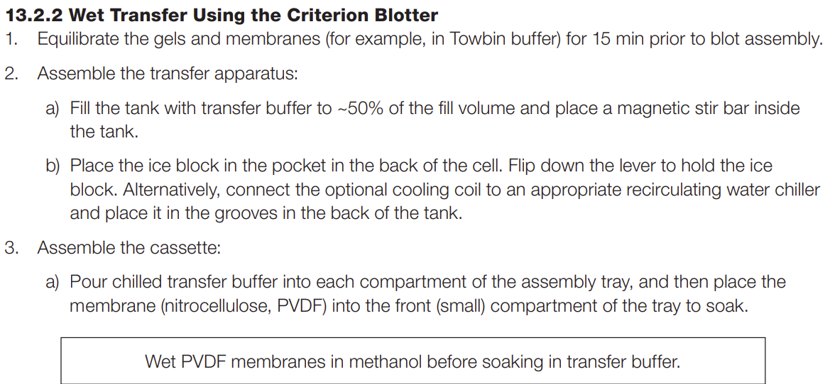

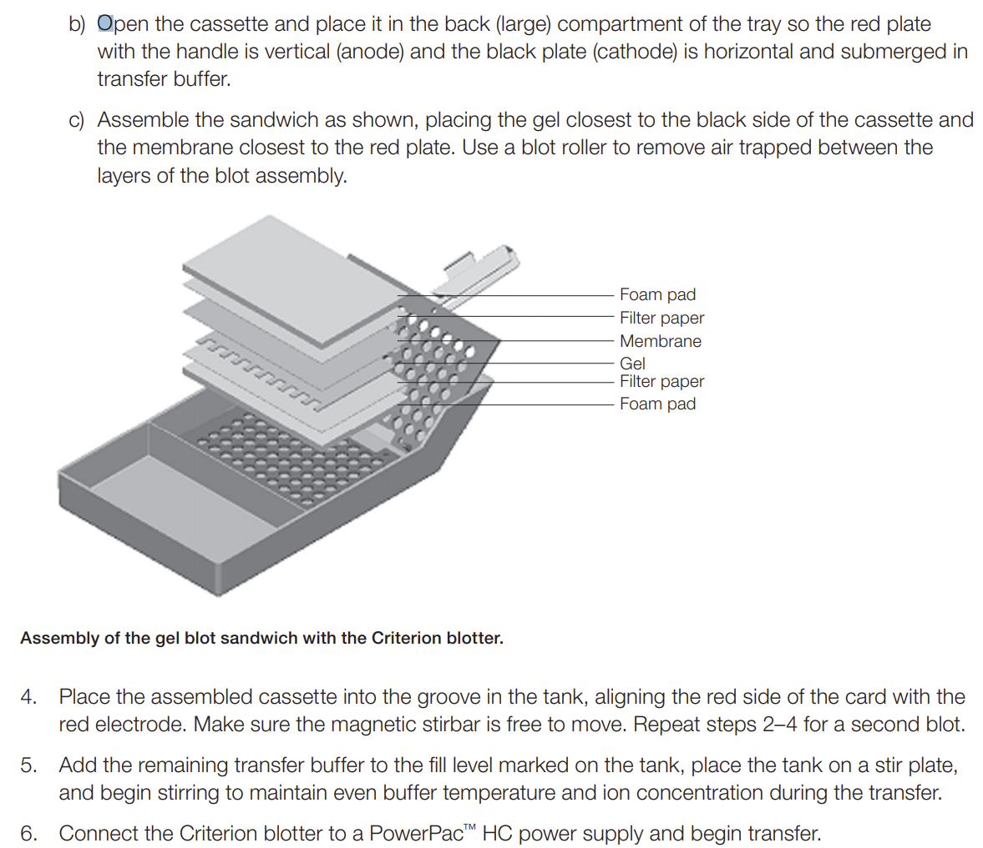

(cutPVDF membrane to 8.5 cm x 14 cm, don’t touch white membrane!!! , actvate PVDF membrane by incubating 5 min in MeOH, and in transfer buffer for 5 min)

* Run transfer @400 mA for 1h @ 4 celcius

Protein visualization on PVDF membrane using MemCode:

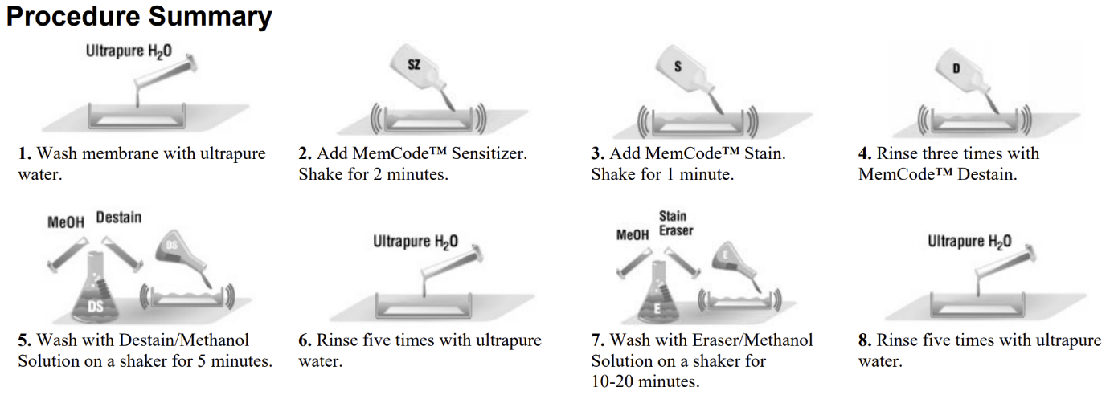

(Keep PVDF membrane side that was facing the Gel during transfer up at all times, and do not let PVDF membrane dry!

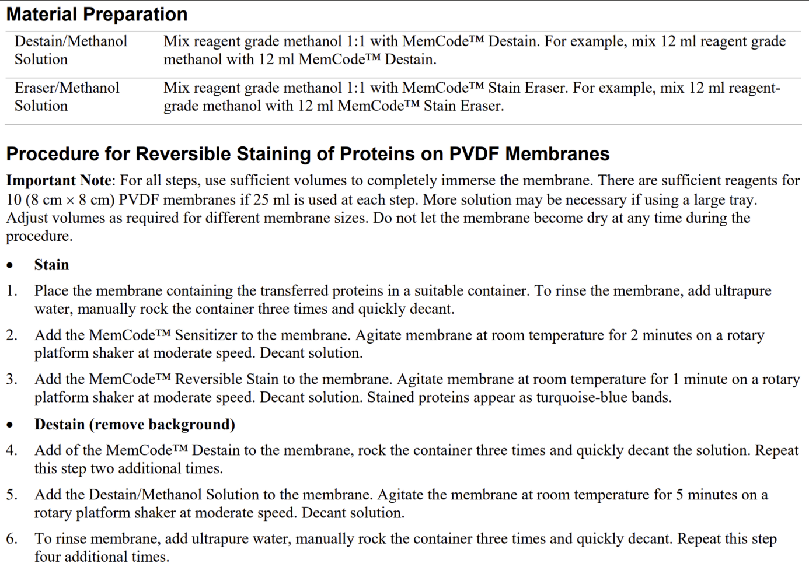

* Photograph the Stained PVDF membrane in G:BOX on clear plastic sheet
* Cut PVDF membrane into desirable strips (vertically and horizontally at desirable kDa)

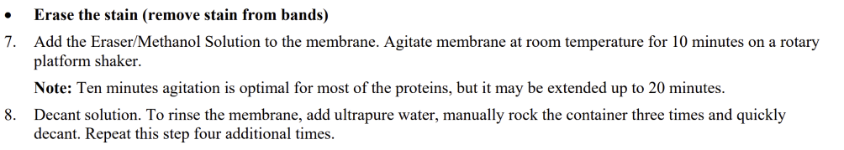

Protein identification with antibody

* Block PVDF membrane for 1h in 1X TBS-T / 5% nonfat dried milk
  + Blocking solution (500ml):
    - 50 ml 10X TBS
    - 500 ul Tween
    - 25g nonfat dry milk powder
    - Add ddH2O to total volume 500 ml

* Incubate in primary antibody over night @ 4 celcius with lid
  + Primary antibody solution (can be reused ~5 times):
    - UBF (1:200): dilute UBF antibody in 1X TBS-T / 5% nonfat dried milk

For 1 whole PVDF membrane you need 30 ml.

Take 30ml/200 = 150 ul antbody and the rest is diluent

* + - C-MYC (1:200): dilute C-MYC antibody in 1X TBS-T / 5% nonfat dried milk

For 1 whole PVDF membrane you need 30 ml.

Take 30ml/200 = 150 ul antbody and the rest is diluent

* + - MAF (1:100): dilute MAF antibody in 1X TBS-T / 5% nonfat dried milk

For 1 whole PVDF membrane you need 30 ml.

Take 30ml/100 = 300 ul antbody and the rest is diluent

* + - MuRF (1:100): dilute MuRF antibody in 1X TBS-T / 5% nonfat dried milk

For 1 whole PVDF membrane you need 30 ml.

Take 30ml/100 = 300 ul antbody and the rest is diluent

* + - COL6A1 (1:100): dilute COL6A1 antibody in 1X TBS-T / 5% nonfat dried milk

For 1 whole PVDF membrane you need 30 ml.

Take 30ml/100 = 300 ul antbody and the rest is diluent

* Wash 3 x 10 min in 1X TBS-T
  + 1X TBS-T solution (1 Liter):
    - 100 ml 10X TBS
    - 1 ml Tween
    - Add ddH2O to total volume 1000ml

* Incubate in Secondary antibody for 1h @ Room temperature (NB: Only needed for COL6A1)
  + Secondary antibody solution:
    - Mouse (1:10 000): dilute Mouse antibody in 1X TBS-T / 5% nonfat dried milk

For 1 whole PVDF membrane you need 30 ml.

Take 30ml/10000 = 3 ul antbody and the rest is diluent

* Wash 4 x 10 min in 1X TBS-T (3-6 x 5-10 min)

Enhanced Chemiluminesence:

* Mix 50/50 Luminol/peroxide for ECL for 5-7min
  + ~30ml for whole PVDF membrane (less if cut)
  + Can be reused intraday, but does not keep over night!

* Photograph with G:BOX on clear plastic sheet and black

* Dry @ RT untill completely dry

* Store in ziplock bag @ -20 celcius