tables

# A tibble: 12 x 6

timepoint group calories carbohydrates fat protein  
   
1 Day 1 glucose 2428.8 (688.2) 275.7 (142) 78.6 (23.5) 141.1 (45.2) 2 Day 1 placebo 2312.4 (770.2) 274.2 (141.8) 73.7 (20.1) 140.3 (50.5) 3 Day 2 glucose 2454.8 (825.6) 287.5 (142.3) 77 (44) 151.9 (61.5) 4 Day 2 placebo 2355.3 (773.2) 292.4 (136.9) 64 (24.8) 139.6 (52.7) 5 Day 3 glucose 2225.5 (705.7) 243.3 (68.3) 74.8 (30) 128 (57.3)  
6 Day 3 placebo 2287.6 (663.8) 247 (67.9) 76.4 (26.7) 128.2 (56.3) 7 Day 4 glucose 2244.9 (806) 279.1 (130.5) 69.7 (29) 119.1 (54.1) 8 Day 4 placebo 2244.6 (810.6) 261.5 (150.2) 71.9 (27.9) 119.8 (54.5) 9 Day 5 glucose 2467.1 (994.7) 288.6 (133.5) 81.9 (46.1) 131.2 (59.3) 10 Day 5 placebo 2540.6 (924) 298.8 (128.2) 86.3 (43.9) 135.6 (59)  
11 Day 6 glucose 2201.1 (650.3) 235.7 (89.6) 87.9 (32.8) 106.9 (28.4) 12 Day 6 placebo 2232 (624.7) 249.9 (67.5) 83.3 (34.7) 103.7 (27.6)

|  |  |  |  |  |  |
| --- | --- | --- | --- | --- | --- |
| timepoint | group | calories | carbohydrates | fat | protein |
| Day 1 | glucose | 2428.8 (688.2) | 275.7 (142) | 78.6 (23.5) | 141.1 (45.2) |
| Day 1 | placebo | 2312.4 (770.2) | 274.2 (141.8) | 73.7 (20.1) | 140.3 (50.5) |
| Day 2 | glucose | 2454.8 (825.6) | 287.5 (142.3) | 77 (44) | 151.9 (61.5) |
| Day 2 | placebo | 2355.3 (773.2) | 292.4 (136.9) | 64 (24.8) | 139.6 (52.7) |
| Day 3 | glucose | 2225.5 (705.7) | 243.3 (68.3) | 74.8 (30) | 128 (57.3) |
| Day 3 | placebo | 2287.6 (663.8) | 247 (67.9) | 76.4 (26.7) | 128.2 (56.3) |
| Day 4 | glucose | 2244.9 (806) | 279.1 (130.5) | 69.7 (29) | 119.1 (54.1) |
| Day 4 | placebo | 2244.6 (810.6) | 261.5 (150.2) | 71.9 (27.9) | 119.8 (54.5) |
| Day 5 | glucose | 2467.1 (994.7) | 288.6 (133.5) | 81.9 (46.1) | 131.2 (59.3) |
| Day 5 | placebo | 2540.6 (924) | 298.8 (128.2) | 86.3 (43.9) | 135.6 (59) |
| Day 6 | glucose | 2201.1 (650.3) | 235.7 (89.6) | 87.9 (32.8) | 106.9 (28.4) |
| Day 6 | placebo | 2232 (624.7) | 249.9 (67.5) | 83.3 (34.7) | 103.7 (27.6) |

kg fra dxa - inner_join(dxadata) under nutrition %>%

# A tibble: 6 x 3

variable female male  
   
1 Age 24.6 (4.8) 23.7 (1.8) 2 Fat mass 17 (5.7) 14.9 (6.1) 3 Fat free mass 52.2 (6.8) 64.4 (4.6) 4 Height 172.1 (5.8) 176.7 (5) 5 Lean mass 49.5 (6.5) 61.1 (4.5) 6 Weight 68.5 (3.5) 78.4 (6.1)

|  |  |
| --- | --- |
| variable | stat |
| Age | 23.7 (2.4) |
| Fatt mass | 16 (6.2) |
| Fat free mass | 59.7 (7.6) |
| Height | 175.3 (5.8) |
| Lean mass | 56.6 (7.3) |
| Weight | 74.9 (7.2) |

# A tibble: 3 x 3

variable left right  
   
1 fatmass 3.3 (1.4) 3.4 (1.4) 2 leanmass 9.7 (1.4) 9.9 (1.4) 3 totalmasskg 13.7 (1.5) 14 (1.4)

|  |  |  |
| --- | --- | --- |
| variable | left | right |
| fatmass | 3.3 (1.4) | 3.4 (1.4) |
| leanmass | 9.7 (1.4) | 9.9 (1.4) |
| totalmasskg | 13.7 (1.5) | 14 (1.4) |

nutrition table with pro pr kg pr bw # A tibble: 12 x 7 timepoint group calories carbohydrates fat protein proprkg   
1 Day 1 G 2453.5 (614.1) 306.8 (98.1) 78.6 (23.5) 162.2 (41.~ 2.4 (0.~ 2 Day 1 P 2273.2 (636) 307.5 (87.7) 73.7 (20.1) 159.2 (45.~ 2.3 (0.~ 3 Day 2 G 2412.5 (490.9) 352.5 (73.8) 77 (44) 165.2 (33.~ 2.4 (0.~ 4 Day 2 P 2365.5 (490.7) 344 (72.7) 64 (24.8) 158.5 (39.~ 2.3 (0.~ 5 Day 3 G 2447 (519.9) 340.2 (48.8) 74.8 (30) 165.8 (45.~ 2.4 (0.~ 6 Day 3 P 2381.8 (535.7) 343.5 (54.1) 76.4 (26.7) 167 (40.6) 2.4 (0.~ 7 Day 4 G 2438.8 (653.3) 325.2 (105.1) 69.7 (29) 168.8 (37.~ 2.5 (0.~ 8 Day 4 P 2394 (670.3) 315.8 (108.2) 71.9 (27.9) 164.5 (42.~ 2.4 (0.~ 9 Day 5 G 2136.8 (403.7) 295.2 (67.1) 81.9 (46.1) 151.8 (36.~ 2.2 (0.~ 10 Day 5 P 2221.2 (376.1) 316.8 (84) 86.3 (43.9) 160 (36.5) 2.3 (0.~ 11 Day 6 G 1903 (94.2) 279.7 (62.3) 87.9 (32.8) 146 (17.5) 2.2 (0.~ 12 Day 6 P 2022.3 (244.4) 277.7 (58.9) 83.3 (34.7) 143 (14.5) 2.1 (0.~

|  |  |  |  |  |  |  |
| --- | --- | --- | --- | --- | --- | --- |
| timepoint | group | calories | carbohydrates | fat | protein | proprkg |
| Day 1 | G | 2453.5 (614.1) | 306.8 (98.1) | 78.6 (23.5) | 162.2 (41.3) | 2.4 (0.5) |
| Day 1 | P | 2273.2 (636) | 307.5 (87.7) | 73.7 (20.1) | 159.2 (45.5) | 2.3 (0.6) |
| Day 2 | G | 2412.5 (490.9) | 352.5 (73.8) | 77 (44) | 165.2 (33.3) | 2.4 (0.4) |
| Day 2 | P | 2365.5 (490.7) | 344 (72.7) | 64 (24.8) | 158.5 (39.2) | 2.3 (0.5) |
| Day 3 | G | 2447 (519.9) | 340.2 (48.8) | 74.8 (30) | 165.8 (45.2) | 2.4 (0.6) |
| Day 3 | P | 2381.8 (535.7) | 343.5 (54.1) | 76.4 (26.7) | 167 (40.6) | 2.4 (0.5) |
| Day 4 | G | 2438.8 (653.3) | 325.2 (105.1) | 69.7 (29) | 168.8 (37.2) | 2.5 (0.5) |
| Day 4 | P | 2394 (670.3) | 315.8 (108.2) | 71.9 (27.9) | 164.5 (42.2) | 2.4 (0.5) |
| Day 5 | G | 2136.8 (403.7) | 295.2 (67.1) | 81.9 (46.1) | 151.8 (36.5) | 2.2 (0.4) |
| Day 5 | P | 2221.2 (376.1) | 316.8 (84) | 86.3 (43.9) | 160 (36.5) | 2.3 (0.4) |
| Day 6 | G | 1903 (94.2) | 279.7 (62.3) | 87.9 (32.8) | 146 (17.5) | 2.2 (0.1) |
| Day 6 | P | 2022.3 (244.4) | 277.7 (58.9) | 83.3 (34.7) | 143 (14.5) | 2.1 (0.1) |

Session score and RPE and traning table # A tibble: 12 x 6 timepoint group ke lp rpe sc  
   
1 Day 1 glucose 1105.4 (207.2) 4156.7 (1651) 1.3 (2) 8.2 (1.7) 2 Day 1 placebo 1106.7 (298.2) 4244.6 (1405.7) 1.5 (1.9) 9.1 (1)  
3 Day 2 glucose 1199.5 (312.7) 4422.5 (1366) 4 (2) 8.8 (1.5) 4 Day 2 placebo 1177.8 (293.4) 4293.7 (1415) 3.7 (1.5) 9.2 (1.1) 5 Day 3 glucose 1219.5 (373.8) 4278.1 (1323.9) 3.4 (1.3) 9.1 (1.7) 6 Day 3 placebo 1188.7 (315.6) 4424.8 (1505.4) 3.4 (1.8) 9.2 (0.6) 7 Day 4 glucose 1298 (462.6) 4851.5 (1697) 2.8 (1) 9.1 (1.6) 8 Day 4 placebo 1237.8 (387.6) 4894.2 (1924.2) 2.7 (1.7) 9.4 (1)  
9 Day 5 glucose 1268 (397.1) 4731.9 (1739.2) 2.7 (0.9) 9.3 (1.7) 10 Day 5 placebo 1282.2 (359.7) 4979.2 (2128.1) 2.3 (0.9) 9.6 (0.7) 11 Day 6 glucose 1380.6 (374.8) 4938.8 (2016) 2.4 (1.4) 9.5 (1)  
12 Day 6 placebo 1415.1 (423.3) 5023.1 (1831.2) 2.4 (1) 10 (0)

|  |  |  |  |  |  |
| --- | --- | --- | --- | --- | --- |
| timepoint | group | ke | lp | rpe | sc |
| Day 1 | glucose | 1105.4 (207.2) | 4156.7 (1651) | 1.3 (2) | 8.2 (1.7) |
| Day 1 | placebo | 1106.7 (298.2) | 4244.6 (1405.7) | 1.5 (1.9) | 9.1 (1) |
| Day 2 | glucose | 1199.5 (312.7) | 4422.5 (1366) | 4 (2) | 8.8 (1.5) |
| Day 2 | placebo | 1177.8 (293.4) | 4293.7 (1415) | 3.7 (1.5) | 9.2 (1.1) |
| Day 3 | glucose | 1219.5 (373.8) | 4278.1 (1323.9) | 3.4 (1.3) | 9.1 (1.7) |
| Day 3 | placebo | 1188.7 (315.6) | 4424.8 (1505.4) | 3.4 (1.8) | 9.2 (0.6) |
| Day 4 | glucose | 1298 (462.6) | 4851.5 (1697) | 2.8 (1) | 9.1 (1.6) |
| Day 4 | placebo | 1237.8 (387.6) | 4894.2 (1924.2) | 2.7 (1.7) | 9.4 (1) |
| Day 5 | glucose | 1268 (397.1) | 4731.9 (1739.2) | 2.7 (0.9) | 9.3 (1.7) |
| Day 5 | placebo | 1282.2 (359.7) | 4979.2 (2128.1) | 2.3 (0.9) | 9.6 (0.7) |
| Day 6 | glucose | 1380.6 (374.8) | 4938.8 (2016) | 2.4 (1.4) | 9.5 (1) |
| Day 6 | placebo | 1415.1 (423.3) | 5023.1 (1831.2) | 2.4 (1) | 10 (0) |

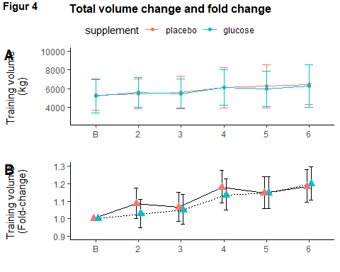

Total volume line plot. mean between groups, sd through timepoint.

#total volume lilneplot  
#this one is to be used.  
readRDS("./data/derdata/analysis_training/totvol_lineplot")

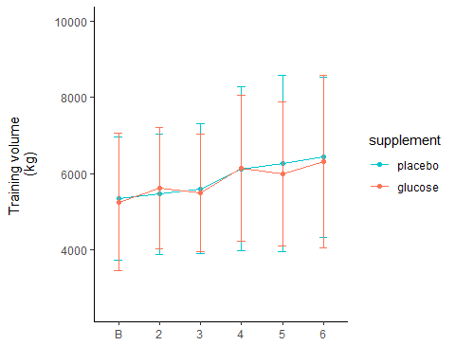

#Total volume total and fold change

glucose during T3 and T4 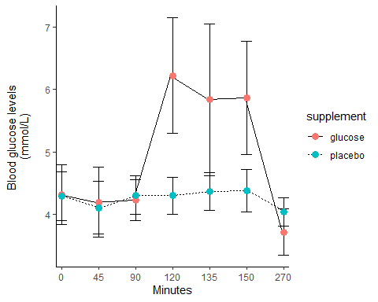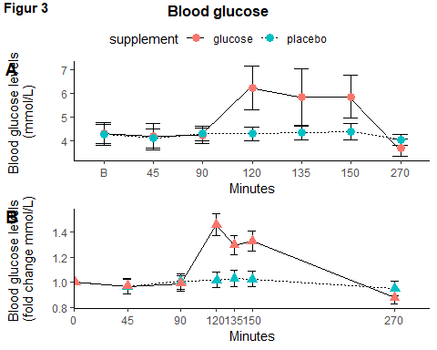

Humac

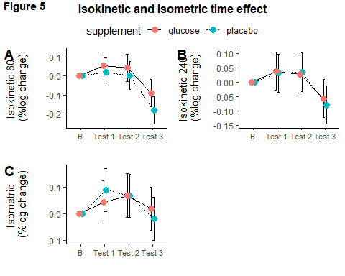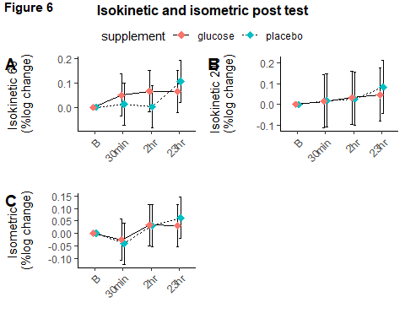

Protein analysis from pre-post 