

**ISDM_October_Assignment**

**Module B8IT114**

**Sara Silva - 1669329**

**Contents**

1. **Executive Summary**
2. **Background and Preliminary research** 
   1. *Estimate costs*
   2. *Systems development methodology*
3. **Proposal for the New System**
4. **Vision and Goals**
   1. *Identification of stakeholders*
   2. *Constraints and assumptions made*
   3. *Outline your preferred design strategy option*
5. **Project Plan**
   1. *Process Model : Iterative/Agile approach Gantt Chart*
6. **Requirements Specification**
   1. *Functional Requirements*
   2. *Non-Functional Requirements*
   3. *Use Cases Diagram*
   4. *Use Case X Description*
   5. *Use Case Y Description*
   6. *System Analysis and Design-System Specification*
   7. *Sequence Diagram*
   8. *System Design*
   9. *Activity Diagram*
7. **System Development/Implementation**
   1. *Class Diagram*
8. **Conclusion**
9. **Bibliography**

**Executive Summary**

We have been requested to build and implement an online system that will store customer data, business data and be used to generate management reports. The system will need to be intuitive and make recommendations to customers based on viewing and purchasing history. The system will contain information on clients, new and used vehicles, rental vehicles and services.

It is vital that the system is built using UX and UI best practice that takes account of all actors that will use the system. The system needs to be functional and practical but also be easy to use and navigate. Customers must be able to search and find the information they need in the least possible clicks, while back end users must be able to update and generate reports that are useable with ease. This will reduce training time and adoption of the system.

To build the system, the team are using a hybrid mix of agile and waterfall and we will lay out the first 3 week sprint build estimates in the report.As the system will be to be robust and secure as well as being cost effective, we are recommending the use of a cloud service in place of a static server.

We expect the build to take approximately 6 months, with key deliverable features delivered in 3 week sprints. In order to keep good control over the costs we have researched a number of existing technologies and software packages already available in the market that will be able to perform a number of the requirements and that we can readily adapt to our needs. This has the benefit of being able to put a fixed price on some aspects of the build and the client can already see these features working in real environments.

**Background and Preliminary research**

The current system being used by the client is a paper based system which is very cheap but offers no benefits in terms of report generating or integration to online services. The Data entry in the current system is manual and labour intensive. We believe that moving to an online system will save both time and money and also offer management reporting tools that will be business critical.

Implementation of the system can be done parallel to the existing system without any interruption in day to day business activities

We estimate the cost of the build to be €30-€35K with a further €5K planned to

implement training on the system. This estimate is based on research conducted

against prices for similar build by two companies in Dublin

Some aspect of the system will be bespoke builds using SQL and Javascript and

for some parts of the build we will integrate with existing systems.

Such systems will include;

The vehicle data storage and selection software - There are a few different

Software packages available for this activity include vehicle registry information

which ties in with Dept of the Environment vehicle listings - Vehicles are

selectable by registration and vehicle model/type.

There a numerous booking software applications which tie in with current pay

models such as Paypal, Credit/Debit Card, Stripe and it makes sense to utilize

one of these rather than build from new and look for licencing separately.

The approach we are taking is to utilize a mix of the Waterfall and Agile build methods. We feel this is the right approach for this project because;

Having an overall project plan means we can detail to the client the steps

involved, the time it will take and the expected outcomes. The Agile method allows us to develop and test key deliverables and demonstrate them to the client in real time so changes can be made during the build. This will save time and money as we will never be too far down the timeline to effect change.

We are recommending a public cloud storage solution because it is safer and more effective than having a static server in one location. This will also give the added benefit of outsourcing support of the server.

**Vision and Goals**

The current system makes it very difficult to maintain car information individually and to have that information ready for the customers who are eager to buy them. The customer has to contact Horizons Motors in order to know information about a specific car such as manufacturing year, car model and other valuable information in a single domain. Our main idea is to develop a system where all the required information is available to the user in order to effectively interest him in the process of buying a car. In the Proposed System, application can maintain car details like manufacturer, year of manufacturing, price and model etc. We can also view all the car details which are kept for sale and search for the desired car. The Customer can register and his information will be stored quickly, effectively and securely. This application mainly consists of 6 modules: user module, admin module, dealer module, login module, viewing all cars module, adding cars module.

**Administrator Module**: This module is purely for an administrator of the site and will be kept out of access to others. He can view the customers and sellers. He will be able to upload different car details for which customers can ask.

**Customer Module:** the customer can view all the car details which are uploaded by the administrator as well as by the seller. He can give the feedback to the administrator as well as to the seller. He can also pay a deposit for the car.

**Seller Module**: sellers can view all the car details which are uploaded by the administrator. They can view the entire buying request done by the customers. He can give feedback to the administrator as well as to the customer.

**Login Module:** the customer will log in to his account based on a registered username. After logging in the customer will be redirected to the home page. The car list and details is shown on this page to customers , who can select a specific car , review its details and pay a deposit for the car if he wishes to do so.

**Adding Car Details:** Here Administrator and sellers can add car details which will be useful for customers as well as to calculate which car is more beneficial and best suited for them.

**Viewing All Car Details**: In this module, the customer can view car details in order to buy the car. This information will be helpful and valuable for the customers to know.

**Results:** In comparison to the existing system, the proposed system will be much more efficient in providing a market for various sellers to sell cars through Horizon Motors in a single platform and will also give the customer a simple but efficient platform to communicate, comment, express his views on the various cars offered by the seller.

**Conclusions:** The project can be expanded into a domain for reviews and comparing models of cars.

**Project Plan**

We will be using the Agile software methodology to develop and implement our project.

|  |  |  |
| --- | --- | --- |
| **Project Name** | Horizons Motors Ltd. |  |
| **Project Manager** | Mark B. |  |
| **Project Deliverable** | Automated Information System |  |
| **Scope Statement** | Car dealer information system and web platform |  |
|  |  |  |
| **Start Date** | 03-Sep |  |
| **End Date** | 05-Nov |  |
| **Overall Progress** | 20% |  |

|  |  |  |  |  |  |  |  |
| --- | --- | --- | --- | --- | --- | --- | --- |
| Task Name | Responsible | | Start | End | Days | Status |  |
| Sprint 1 | Mark B. | 9/11 | | 13/9 | 10 | Complete |  |
| Feature 1 | Robert C. | 9/3 | | 9/7 | 4 | Complete |  |
| Feature 2 | Luke S. | 9/7 | | 9/12 | 5 | Complete |  |
| Feature 3 | Finn S. | 9/9 | | 9/13 | 4 | Complete |  |
| Sprint 2 | Jacob S. | 10/16 | |  | 8 | In progress |  |
| Feature 4 | Alex B. | 10/16 | | 9/17 | 1 | In progress |  |
| Feature 5 | Frank C. | 10/17 | | 9/21 | 4 | Not started |  |
| Feature 6 | Shari W. | 10/22 | | 9/24 | 2 | Not started |  |
| Sprint 3 | Shari W. | 11/05 | |  | 10 | Not started |  |
| Feature 7 | Alex B. | 11/07 | | 11/19 | 4 | Not started |  |
| Feature 8 | Kennedy K. | 11/19 | | 11/2 | 8 | Not started |  |
| Feature 9 | Jacob S. | 11/2 | | 11/5 | 3 | Not started |  |

|  |  |  |  |  |
| --- | --- | --- | --- | --- |
| **Task Name** | **Feature Type** | **Duration** | **Start** | **Finish** |
| **AGILE PROJECT** |  | 60d | 05/09/17 | 06/11/17 |
| **Sprint 1** |  | 15d | 06/09/17 | 09/27/17 |
| Requirements | Build 1 Development | 1d | 06/09/17 | 07/09/17 |
| Wireframe/Prototype design | Development | 1d | 07/09/17 | 08/09/17 |
| Visual Design | Unit test | 4d | 11/09/17 | 12/09/17 |
| Front-End production | Handover to test | 4d | 09/15/17 | 09/16/17 |
| Database development | Build 2 Development | 4d | 09/19/17 | 09/20/17 |
| API development | Development | 2.5d | 09/21/17 | 09/22/17 |
| Back-end development | Unit test | 1.5d | 09/22/17 | 09/23/17 |
| Integration | Handover to test | 4d | 09/22/17 | 09/23/17 |
| Unit testing | Interactive test | 2.5d | 09/24/17 | 09/25/17 |
| Bug 1 | Previous release | 1d | 09/25/17 | 09/26/17 |
| Bug 2 | Client report bugs | 1.5d | 09/25/17 | 09/27/17 |
| **Sprint 2** |  | 7d | 06/10/17 | 10/13/17 |
| Feature 1 | Build 1 Test | 5d | 06/10/17 | 11/10/17 |
| Feature 2 | Test Planning | 1d | 11/10/17 | 06/10/17 |
| Feature 3 | Test Analysis/Design | 1d | 12/10/17 | 10/13/17 |
| **Sprint 3** |  | 7d | 06/11/17 | 06/11/17 |
| Feature 1 | Build 2 Test | 5d | 06/11/17 | 11/11/17 |
| Feature 2 | Test Execution/Recording | 1d | 11/11/17 | 12/11/17 |
| Feature 3 | Test Completion | 1d | 12/11/17 | 12/11/17 |
| **Backlog** |  |  |  |  |
| Feature 1 | Quality Assurance (QA) |  |  |  |
| Feature 2 | User Acceptance Test(UAT) |  |  |  |
| Feature 3 | Launch |  |  |  |

**Sprint Milestones for the project:**

1. The completion of requirement gathering for project.

* *Overview of the Car Centralize System. Status – Delivered.*

2. Detailed study of the Car-Centralize System

* *Main Modules of the system.*
* *Comparing with the existing system. Status – Delivered.*

3. Design the system and represent the system in the form of diagrams.

* *Use Case Diagram*
* *Activity Diagram*
* *Sequence Diagram*
* *Class Diagram*
* *Status – Delivered.*

4. Database Design

* *Status – Delivered*

5. Home Page Design.

* *Status – Delivered.*

6. Registration and Login Module.

* *Input:*
* *Personal information of the user such as username, password, gender, e-mail ID,*
* *address, phone number and other authenticable details.*
* *Output:*

7. Confirmation of user registration

* *Status – Delivered*

8. Buyer/Seller and Admin Module.

* *Administration module:*
* *Input:*
* *Administrator name and password.*
* *Output:*

9. Modify and update the database by the administrator.

* *Status – Delivered.*

8. Car Details Module.

* *Input:*
* *Log in information such as username and password.*
* *Output:*
* *Display the List of cars with details.*
* *Status – Delivered*

**Requirements**

**Functional Requirements:**

**Vehicles-List new and used :**

* *Cars*
* *Commercials*
* *Rentals*
* *+ their associated services*

**Must be available to prospective Customers -> Specifications**

* *number of seats*
* *doors*
* *engine capacity*
* *power*
* *range*
* *speed*
* *price*
* *tax (on purchase*
* *and annual), etc.*

**Rentals require the terms of the contract such as;**

* *duration*
* *required deposit*
* *and so on.*

**Collect buyer information such as;**

* *preferences*
* *price range*
* *name*
* *address,*
* *etc.*

**Preferences include;**

* *size*
* *style*
* *power*
* *and the like.*
* *Match buyers’ preferences with new cars available, or sellers’ offerings and, if it cannot find an exact match, should offer the closest matches*
* *Assist buyers and sellers alike*

**Choosing a local service agent;**

* *name*
* *phone number*
* *and credentials*

**They might also need help with;**

* *getting finance*
* *choosing a car*
* *making an offer*
* *getting insurance*
* *closing the deal.*

**Sellers would need advice on;**

* *setting the price*
* *marketing the car*
* *selling the car*
* *closing the sale.*

**Non Functional Requirements:**

* *secure*
* *reliable-robust*
* *fit for purpose; functionality meets end users and staff needs*
* *Cloud Computing services-SasS-Software as a Service, PasS-Platform as a Service*
* *Security-*
* *Registration-All licenses current and correct*
* *SEO-search engine optimisation*
* *SLA’s- Service Level Agreements for outages*
* *Multiple devices*
* *Multiple platforms (software and operating systems eg Android, Windows Phone, iOS, Windows 7 to 10, etc.*
* *UI-User Interaction is facilitated with well-designed components*
* *UX-User Experience is clear and intuitive*
* *Graceful degradation for older systems currently supported*
* *Compliant with latest Data Protection laws, as Data Controller -> Data Subject relationship*

Functional requirements are requirements that are used to illustrate the internal working nature of the system, describing its features and explaining its subsystems. It consists of what task the system performs, processes involved, which date should the system hold and interfaces with the user. There are several functional requirements identified such as customer’s registration, automatic update to database once new customer registers and a means for customers to leave feedback.

Non functional requirements describe aspects of the system that are concerned with how the system provides the functional requirements. Those include security, performance and response time, error handling, availability and ease of use.

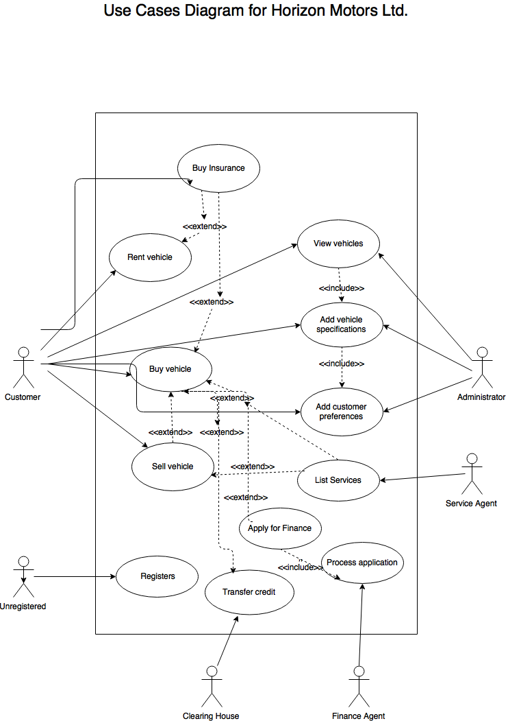

**Use Case Name:** Buy Vehicle

**Use Case ID**: UC-3

**Scope:** Vehicle Sales Management System

**Priority:** High

**Description**

After selecting a vehicle user submits choice. Payment options displayed. User selects one. Payment is confirmed or denied.

**Level:** High

Buy a Vehicle

**Primary Actor:** Customer

**Supporting Actors:** Clearing House, Finance Agent for Extensions

**Stakeholders and Interests**

Horizons Motors Ltd: Wants data to generate reports on sales, sales targets, which determines models which models have high and low volume of sales.

**Preconditions**

Customer has logged in, selected a vehicle.

**Success Guarantee** **(or Post-conditions)**

Sale processed successfully, stored inventory is updated, sales tax correctly calculated and customer issued with electronic receipt to screen and customer email.

**Minimal Guarantee**

User prompted to log out, or timed out after a specific period.

**Trigger**

Submitting vehicle choice

## **Main Success Scenario**

1. Prompt to confirm correct vehicle choice.
2. User confirms choice
3. Prompt to select payment type
4. User selects payment type
5. Confirmation payment was successful.
6. Prompt to log off.
7. User logs off.

## **Extensions (or Alternative Flows)**

4. User selects payment type. NB: Any sequence of payment choice is valid,

UC- 11 to UC- 13 or UC- 13 to UC-11

5. Confirmation payment was successful

5.1. Payment type was unsuccessful

1.a User given 3 options

1.a.a Return to payment options.

a.b.a UC 11: Apply for finance., or (depends on prior choice)

a.b.b UC-13: Transfer credit

a.c. Log out.

## **Technology & Data Variations List:**

**Frequency:** 20 per week

**Assumptions**

All online print instruction, are in Standard English.

## **Special Requirements**

**Performance**

**User Interface**

1. Standard English in all text

2. The height of letters displayed on the display console shall not be smaller than 11point font.

Security

1. System shall display that session will terminate in 20 seconds if not logged off. To prevent further transactions.

2 System will offer user to cancel transaction. User changed mind. Insufficient funds available.

3. Confirmation receipt to user’s account.

Usability

## **Open Issues**

Extension: 5.1a.b.a Apply for Finance

**Use Case Name:** Apply for Finance

**Use Case ID**: UC-11

**Scope:** Vehicle Sales Management System

**Priority:** High

**Description**

Use enters personal details. Enters amount of finance required in Euro. Submits details. Waits for reply.

**Level:** Low

Apply for Finance

**Primary Actor:** Finance Agent

**Supporting Actors:**

**Stakeholders and Interests**

Horizons Motors Ltd: All customers to achieve a buy. Maintain or increase sales.

**Preconditions**

Customer has unsuccessful payment type confirmation.

**Success Guarantee** **(or Post-conditions)**

Sale processed successfully, store’s inventory is updated, sales tax correctly calculated and customer issued with electronic receipt to screen and customer email.

**Minimal Guarantee**

User prompted to log out, or timed out after a specific period.

**Trigger**

Selecting finance option.

## **Main Success Scenario**

1. Prompt to enter personal details.
2. User enters personal details.
3. Prompt to confirm personal details.
4. User confirms personal details.
5. Prompt to enter Finance amount required.
6. Prompt to confirm success.
7. User returns to payment type.

## **Extensions (or Alternative Flows)**

3.Prompt to confirm failure UC- 12, Accept/reject Application.

3.a. Return to payments option

3b. Logout.

## **Technology & Data Variations List:**

**Frequency:** 100 per week

**Assumptions**

All online print instruction, are in Standard English.

## **Special Requirements**

**Performance**

**User Interface**

1. Standard English in all text

2. The height of letters displayed on the display console shall not be smaller than 11 point font.

**Security**

1. System shall display that session will terminate in 20 seconds if not logged off.

**Usability**

## **Open Issues**

Extension: 5.1a.b.b Credit Transfer

**Use Case Name:** Credit Transfer

**Use Case ID:** UC-13

**Scope:** Vehicle Sales Management System

**Priority:** High

**Description**

Use enters personal details. Enters amount of credit required in Euro. Submits details. Waits for reply.

**Level:** High

Credit Transfer

**Primary Actor:** Clearing House

**Supporting Actors:**

**Stakeholders and Interests**

Horizons Motors Ltd: All customers to achieve a buy. Maintain or increase sales.

**Preconditions**

Customer has unsuccessful payment type confirmation, UC- 11 Apply for Finance.

**Success Guarantee** **(or Post-conditions)**

Sale processed successfully, stores inventory is updated, sales tax correctly calculated and customer issued with electronic receipt to screen and customer email.

**Minimal Guarantee**

User prompted to log out, or timed out after a specific period.

**Trigger**

Selecting transfer credit option.

## **Main Success Scenario**

1. Prompt to enter personal details.
2. User enters personal details.
3. Prompt to confirm personal details.
4. User confirms personal details.
5. Prompt to enter credit amount required.
6. Prompt to confirm success.
7. User returns to payment type.

## **Extensions (or Alternative Flows)**

6.Prompt to confirm failure.

6.a. Return to payments option

6.b. Logout.

## **Technology & Data Variations List:**

**Frequency:** 100 per week

**Assumptions**

All online print instruction, are in Standard English.

## **Special Requirements**

**Performance**

**User Interface**

1. Standard English in all text

2. The height of letters displayed on the display console shall not be smaller than 11 point font.

**Security**

1. System shall display that session will terminate in 20 seconds if not logged off.

**Usability**

## **Open Issues**

**Use Case Name:** Registers

**Use Case ID**: UC- 1

**Scope:** Vehicle Sales Management System

**Priority:** High

**Description:**

User prompted to register. Gives details. Chooses a password and issued an id.

**Level:** Medium

Registers

**Primary Actor:** Unregistered

**Supporting Actors**

**Stakeholders and Interests**

Horizons Motors Ltd: Wants data to attract new customers to generate high volume of sales across their range of vehicle models.

**Preconditions**

Unregistered customer, looking to buy, sell, or rent a vehicle.

**Success Guarantee** **(or Post-conditions)**

User has become a registered customer.

**Minimal Guarantee**

User declines to register

**Trigger**

None

## **Main Success Scenario**

1. User prompted to register.
2. User initiates registration.
3. Prompted for personal details.
4. User enters personal details.
5. Prompted to confirm details.
6. User confirms details.
7. Prompted for password.
8. User enters password.
9. Prompted to confirm password.
10. Issued with an id.
11. Prompted to confirms.
12. User confirms.

## **Extensions (or Alternative Flows)**

6. User confirms details.

6.1. User confirms details unsuccessful.

1.a. Prompted to re-enter

1.b. Quit.

8.User enters password.

8.1. User enters password failure

1.a. Prompted to re-enter

1.b. Quit.

9. User enters password.

9.1 User enters password unsuccessful.

1.a. Prompted to re-enter

1.b. Quit.

**Technology & Data Variations List:**

**Frequency:** 50 per day

**Assumptions**

* User wished to buy, sell, or rent a vehicle

## **Special Requirements**

**Performance**

**User Interface**

* Standard English in all text
* The height of letters displayed on the display console shall not be smaller than 11 point font.
* Security
* System shall display that session will terminate in 20 seconds if user does not want to register. To prevent further transactions.
* System will offer user to cancel transaction. User changed mind.
* Usability

**System Analysis and Design**

* Sequence Diagram

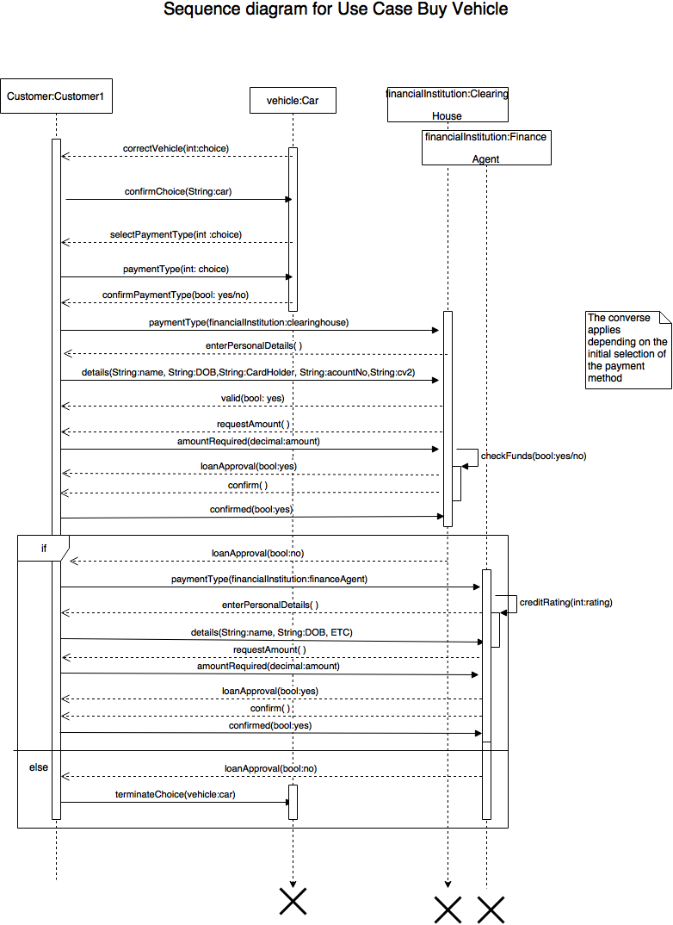

**System Design**

* Activity Diagram

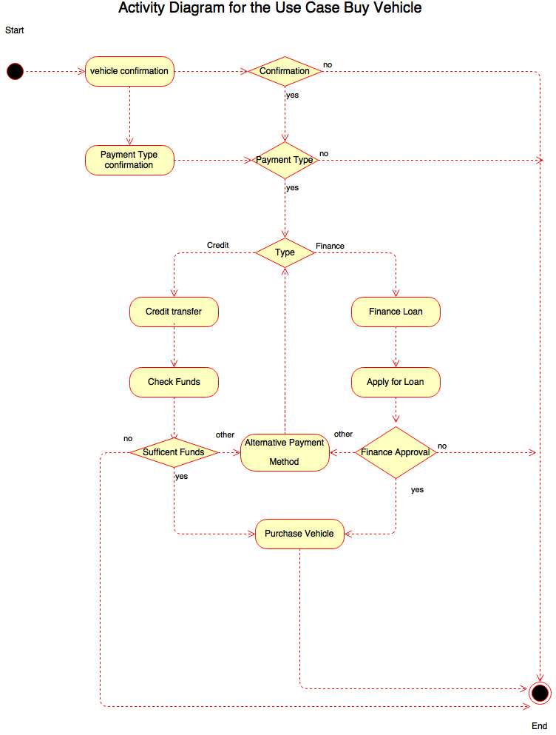

**System Development /Implementation -** Class Diagram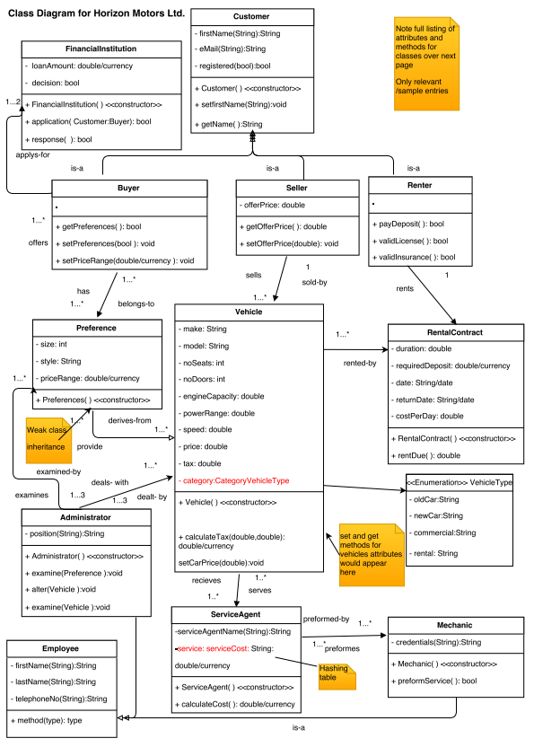

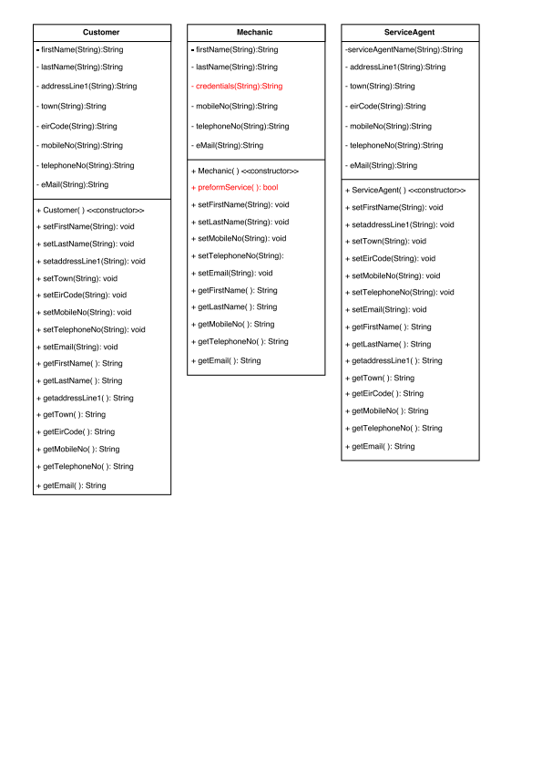

**Conclusion**

**Future possibilities i.e. how the solution might evolve with the business in the near to mid future.**

We believe the best system for this client is one that can evolve and grow as the client’s needs change over time. There will be the possibility to build structures into the system that will allow the client to offer additional services such as Insurance products or to sell motor parts directly to clients based on information held on the system.

The procurement of existing software and utilization of new build will be the most cost effective solution for the provision and maintenance of the system.

In the short term, the system will offer our client to ability to be proactive in sales of vehicles and vehicle servicing by anticipating the customer’s needs based on previous purchasing history, this would be very cumbersome on the existing paper based system.

The new system will allow for automatic notifications to be sent to customers to

generate new sales and service possibilities.In the long term, other products such and tyres, motor parts or even vehicle insurances could be built into the system

**Bibliography**

Analysis, S. (2014) Process specifications and structured decisions. Available at: http://www.w3computing.com/systemsanalysis/activities-resources-practices-agile-modeling/ (Accessed: 12 October 2016).

In-line Citation:

(Analysis, 2014)

Capers Jones, 2009. Software Engineering Best Practices: Lessons from Successful Projects in the Top Companies. 1 Edition. McGraw-Hill Education.

Pressman, R.S. (2009) Software engineering: A practitioner’s approach. 7th edn. Boston: McGraw Hill Higher Education.

In-line Citation:

(Pressman, 2009)

Rastogi, V., G, S., E, A.L. and M, P. (2015) ‘AN ENHANCED CLIENT CENTRIC SOFTWARE DEVELOPMENT LIFE CYCLE MODEL WITH COST AND EFFORT ESTIMATION’, *ICTACT Journal on Management Studies*, 1(4), pp. 190–197. doi: 10.21917/ijms.2015.0027.

Sharma, P. and Singh, D. (2015) ‘Comparative study of various SDLC models on different parameters’, *International Journal of Engineering Research*, 4(4), pp. 188–191. doi: 10.17950/ijer/v4s4/405.

*An empirical framework for learning (not a methodology)* (2013) Available at: http://www.scrummethodology.com

Sommerville, I. (2010) Software engineering (9th edition). 9th edn. Boston: Addison-Wesley Educational Publishers.

**Appendices**

**Individual Contribution**

We as a group initially convened to analyse the scenario of the Virtual client, Horizon Motors Ltd. . Then we parsed the CA requirements, to see what strengths and weaknesses were in the group as a whole, and match them with the activities in the assignment.

All contributions were uploaded to Google Docs, and peer review was employed to assist each contributor.

Individual Contributions;

James Kavanagh

Tasks

* Requirements
* Use Cases Diagram + 2 Use Case Descriptions
* System Sequence Diagram
* Activity Diagram
* Class Diagram

Paul Mahon

Tasks

* Executive Summary
* Background and Preliminary Research
* Conclusion
* Formatting of document

Sara Silva

Tasks

* Functional vs Non Functional Requirements Definition
* Detail the proposal for the new system: visions and goals, identification of stakeholders, constraints and assumptions, preferred design strategy option.
* Project Plan : Gantt chart, task list, detailed sprint and modules.
* Bibliography