BDA400 – Data Science Tools and Techniques
Assignment 2: Technical Analysis Using R
Student Name: Sara Dahlan
GitHub Link: https://github.com/SaraDahlan2026/TechnicalAnalysis?utm_source=chatgpt.com

Assignment Report.
Step 1: Creating a GitHub Repository
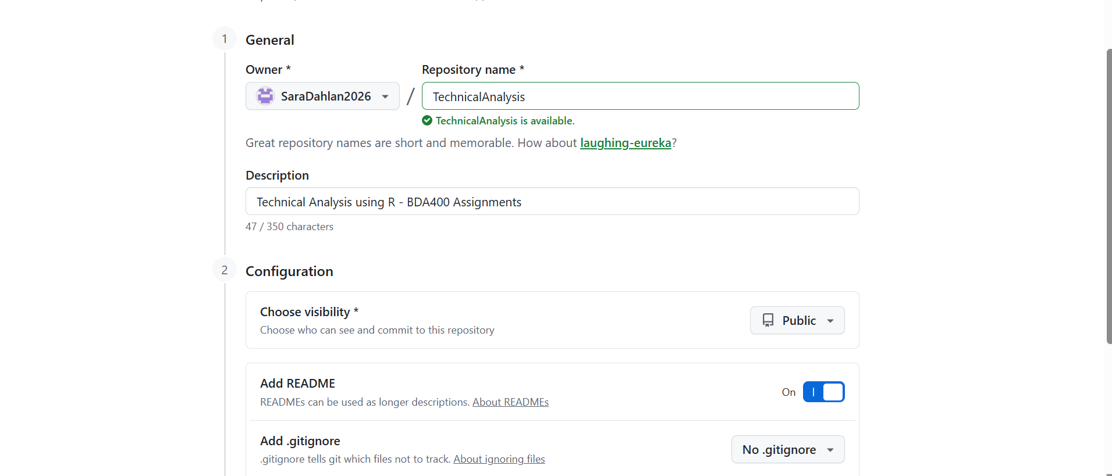
I created a public GitHub repository named "TechnicalAnalysis" to store my BDA400 assignment files.
Step 2: Creating the README File
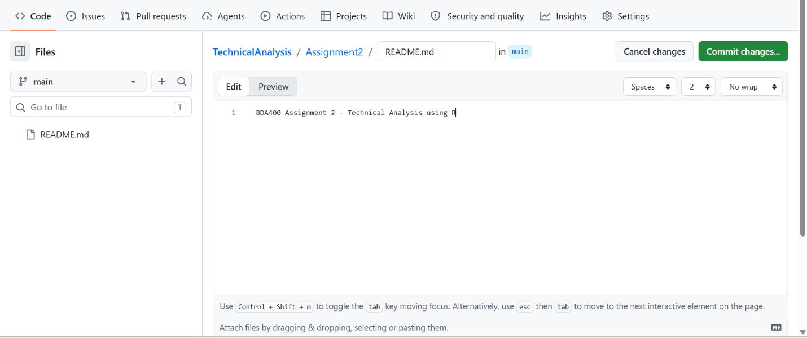
I created a README.md file inside the Assignment2 folder in my GitHub repository to describe the Technical Analysis Using R assignment.
Step 3: Saving the README File on GitHub
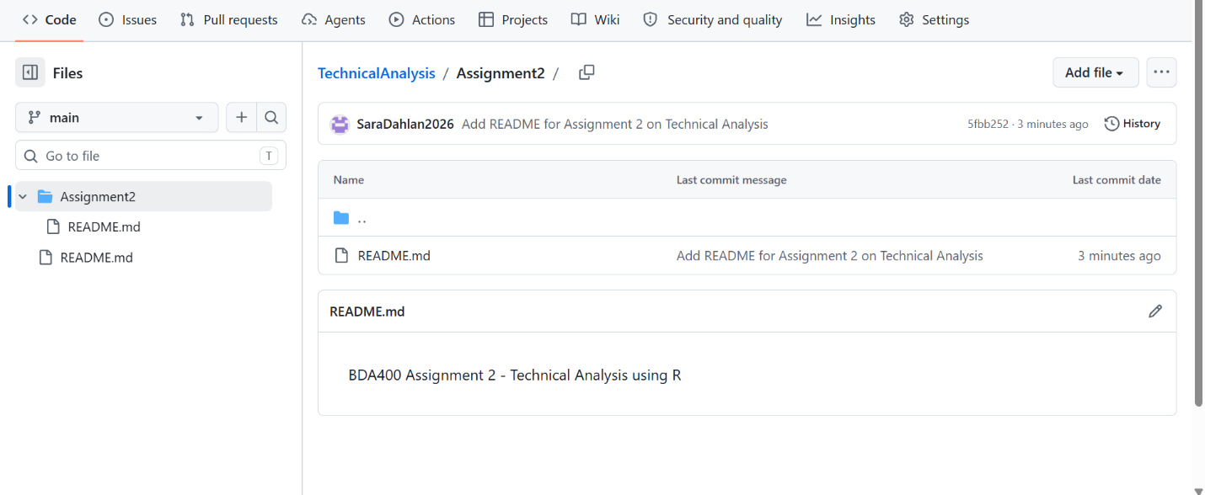
I successfully saved the README.md file in the Assignment2 folder on GitHub. The file contains the assignment title and description.
Step 4: Downloading R for Windows
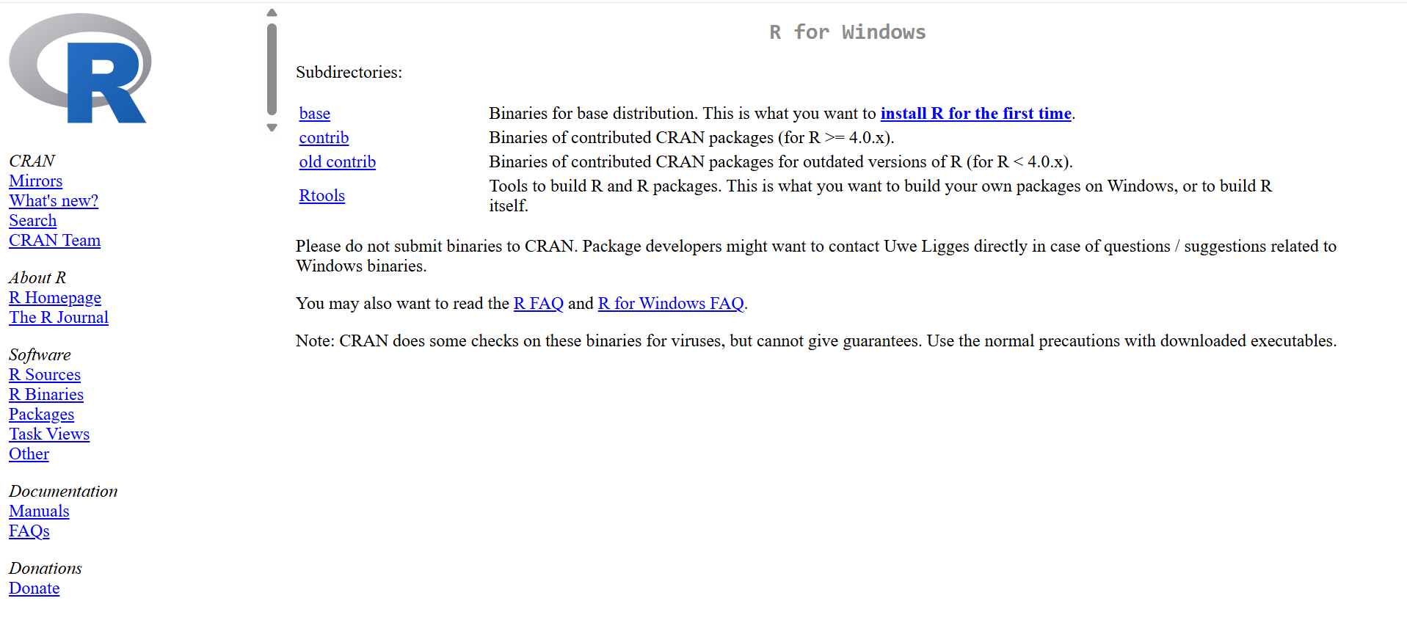
I visited the official CRAN website to download R for Windows. R is used to analyze stock market data and calculate statistics.
Step 5: Downloading R Version 4.6.1
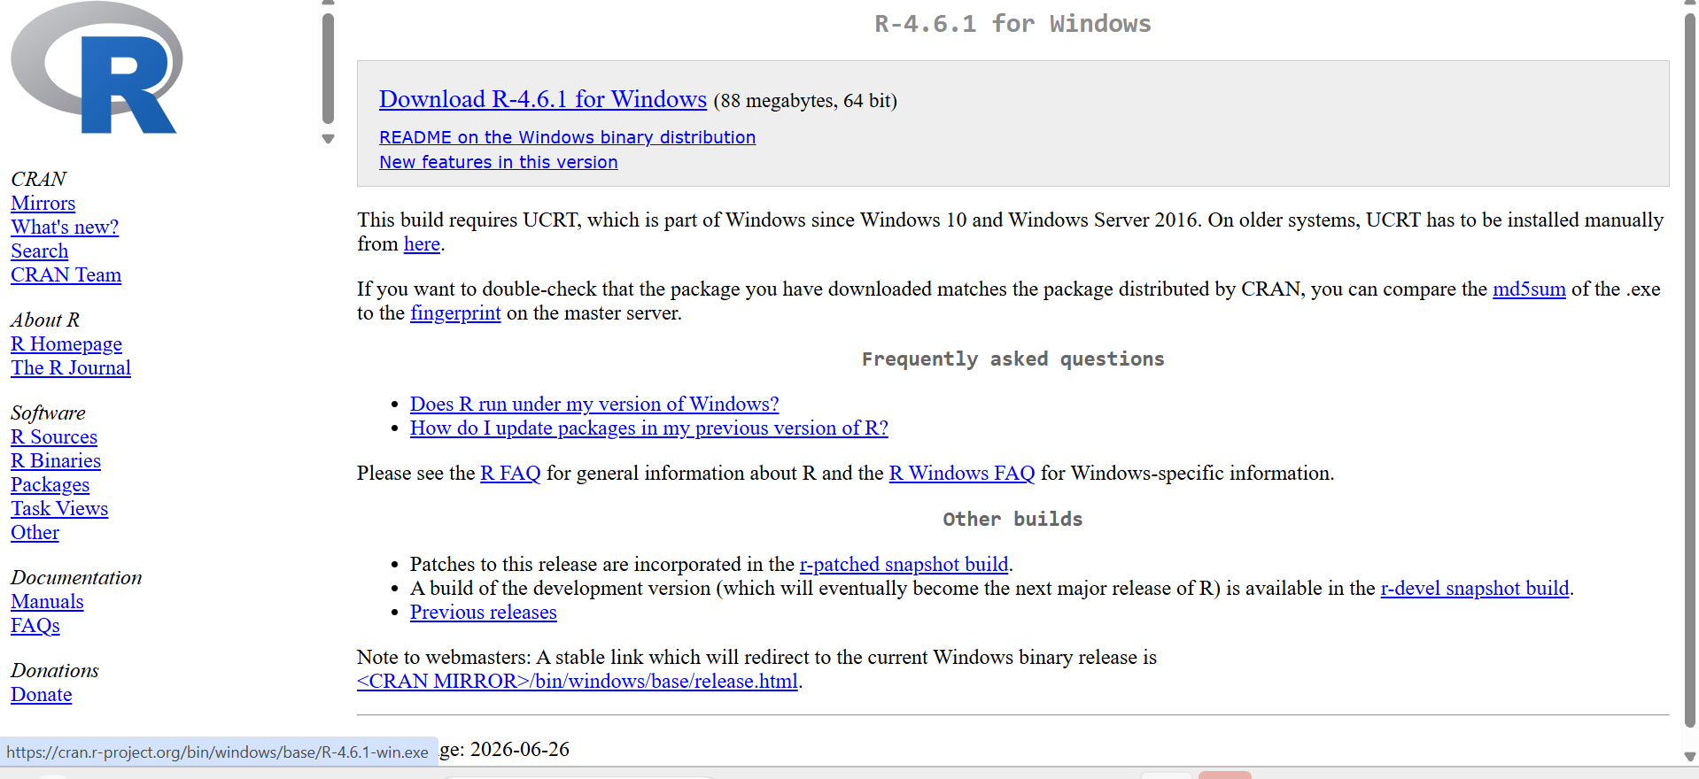
I selected R version 4.6.1 for Windows (64-bit) from the official CRAN website to use for my stock analysis assignment.
Step 6: Installing R Software
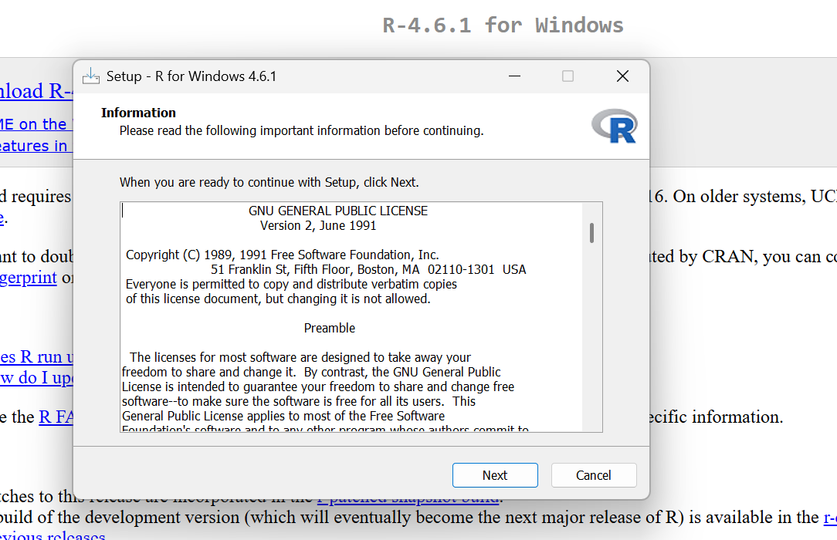
I started the installation of R 4.6.1 on Windows and followed the setup instructions to install the software.

Step 7: Selecting the Installation Location
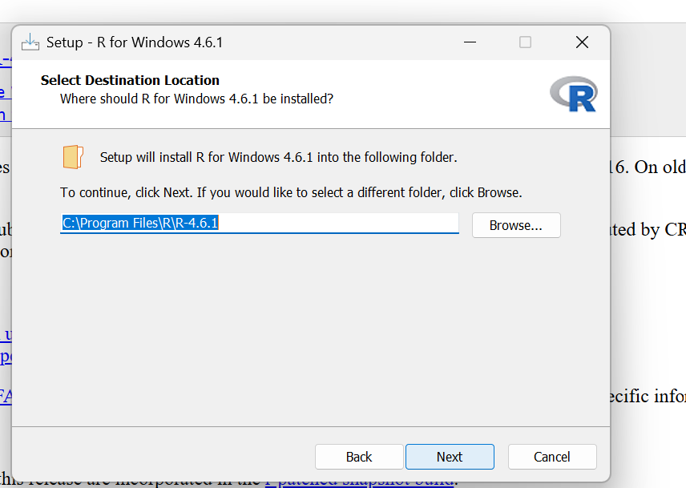
I selected the default installation folder for R 4.6.1 and clicked Next to continue.
Step 8: Selecting R Installation Components
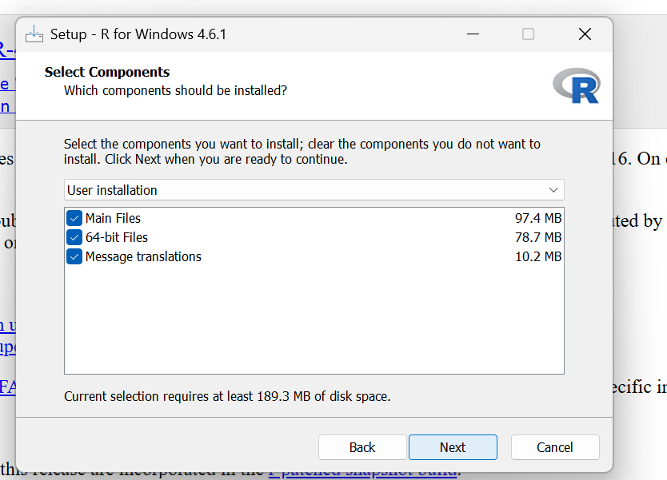
I kept the default installation components, including the main files, 64-bit files, and message translations, then clicked Next to continue.

Step 9: Completing R Installation
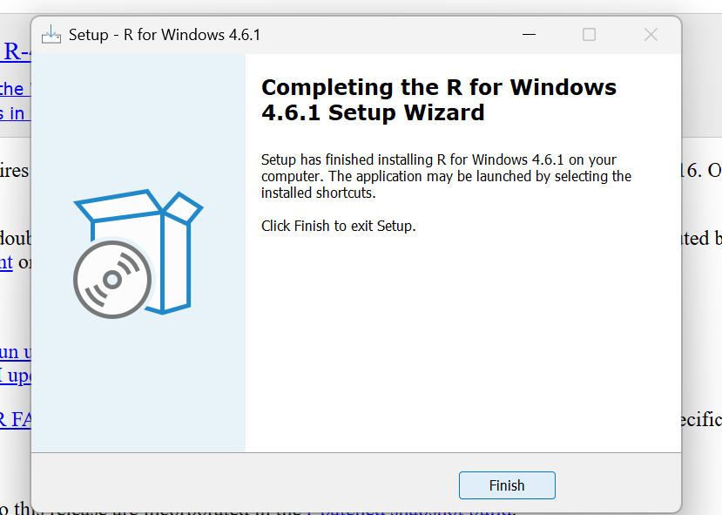
I successfully completed the installation of R 4.6.1 on Windows.
Step 10: Running R Successfully
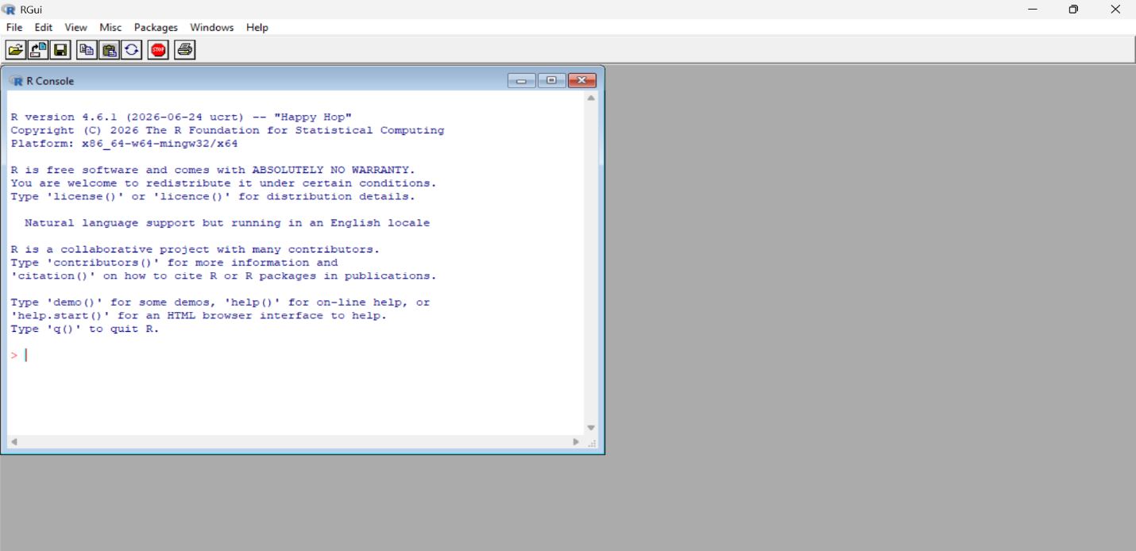
I opened R 4.6.1 successfully and verified that the R Console was working.

Step 11: Downloading RStudio
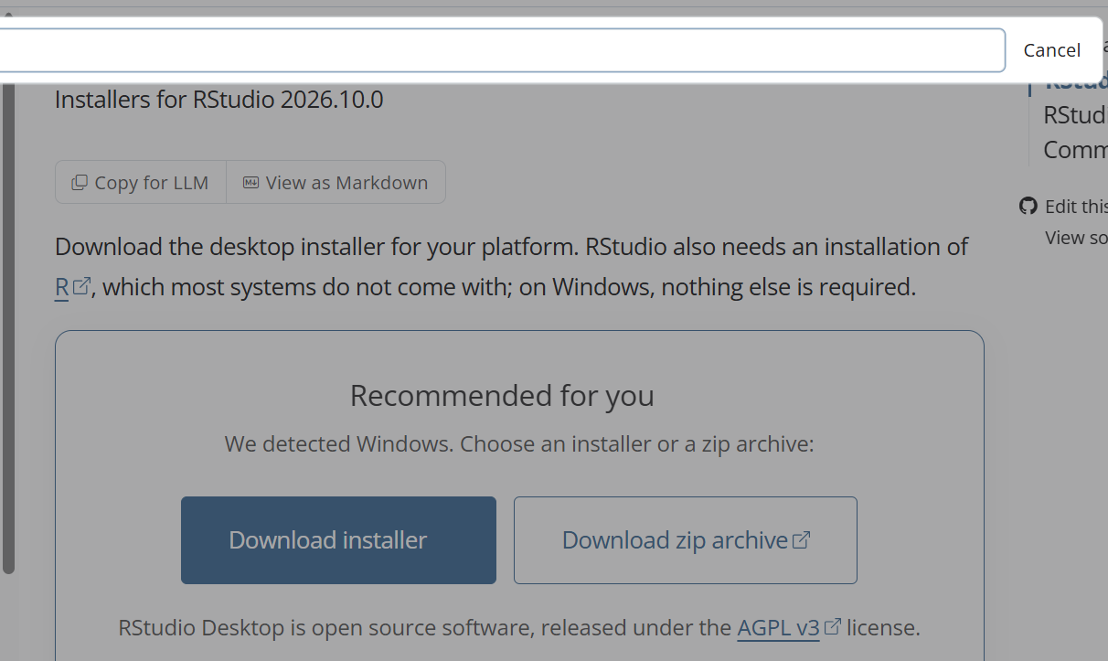
I visited the RStudio download page and selected the Windows installer to download RStudio Desktop.
Step 12: RStudio Installation Completed
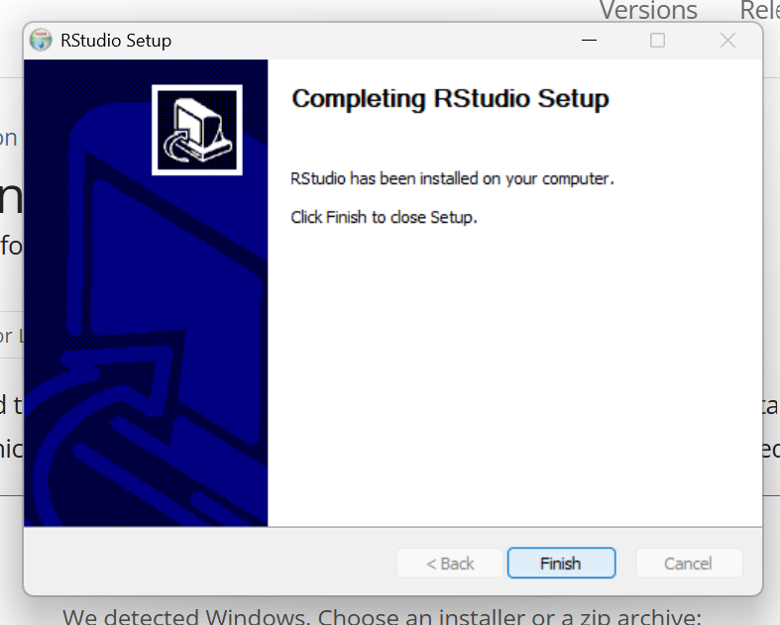
I successfully installed RStudio on my computer. The setup wizard confirmed that the installation was completed.

Step 13: Opening RStudio
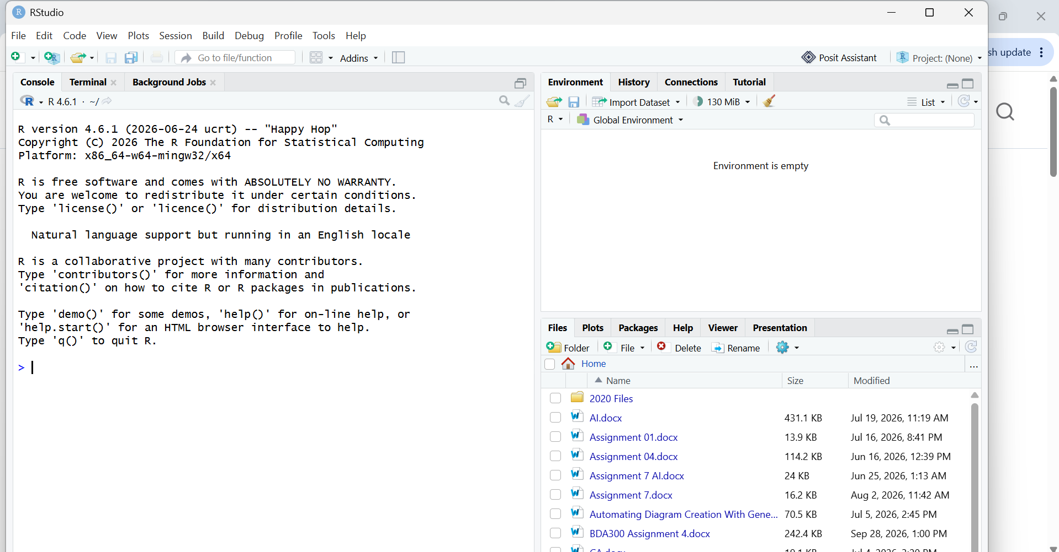
I opened RStudio successfully after installation. The R Console and workspace appeared, confirming that RStudio was ready to use.
Step 14: Installing Required R Packages
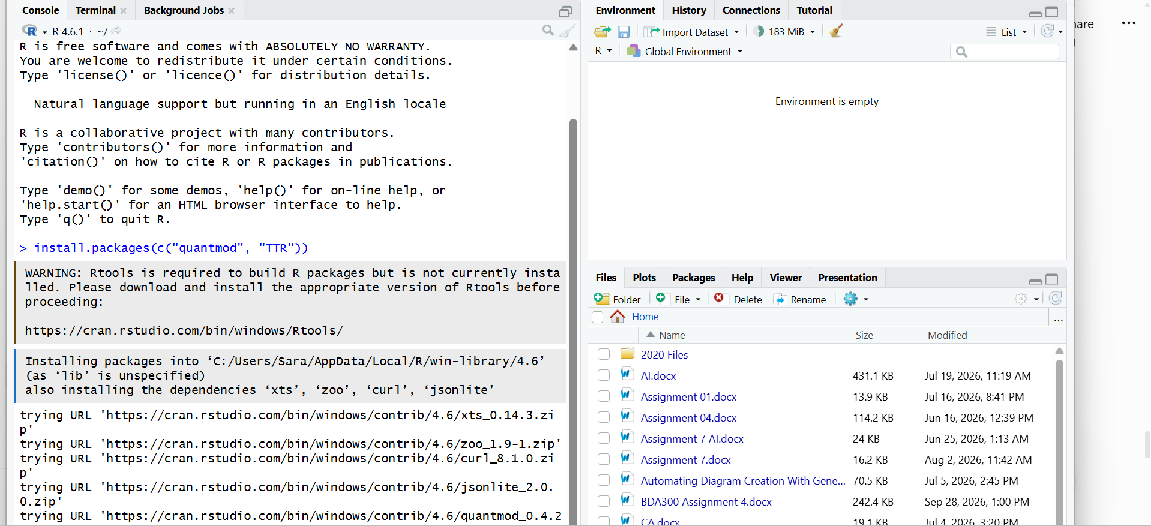
I used the RStudio Console to install the quantmod and TTR packages. These packages are needed for stock market data analysis and technical indicators.

Step 15: Verifying R Packages Installation
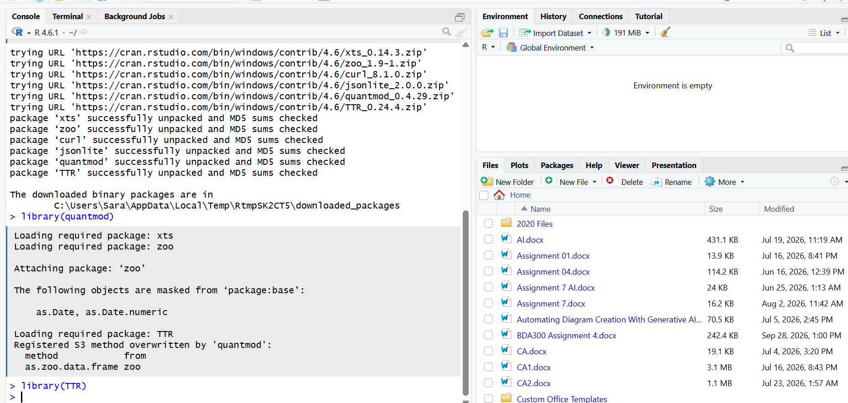
I successfully installed and loaded the quantmod and TTR packages in RStudio. The console confirmed that the packages were ready to use for technical analysis.
Step 16: Creating the Portfolio File
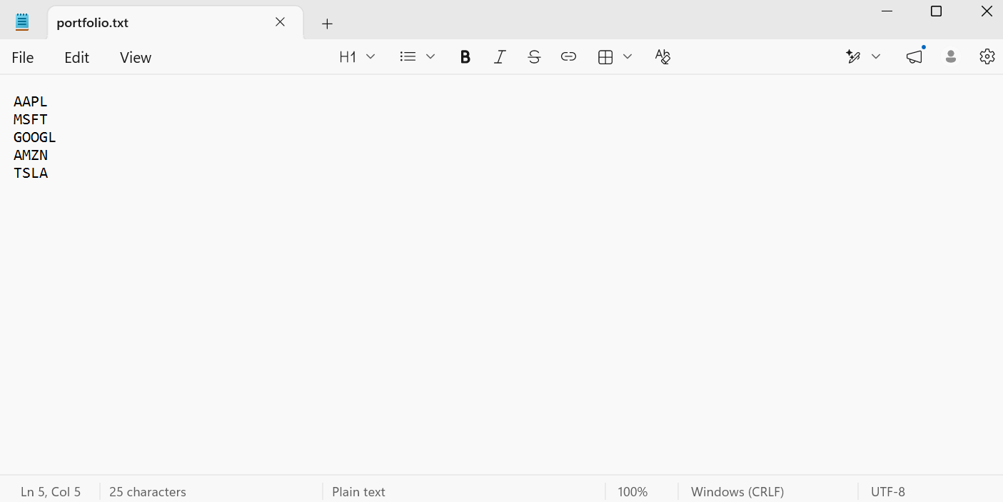
I created a file named portfolio.txt containing five stock symbols: AAPL, MSFT, GOOGL, AMZN, and TSLA. This file will be used for stock market data analysis in R.

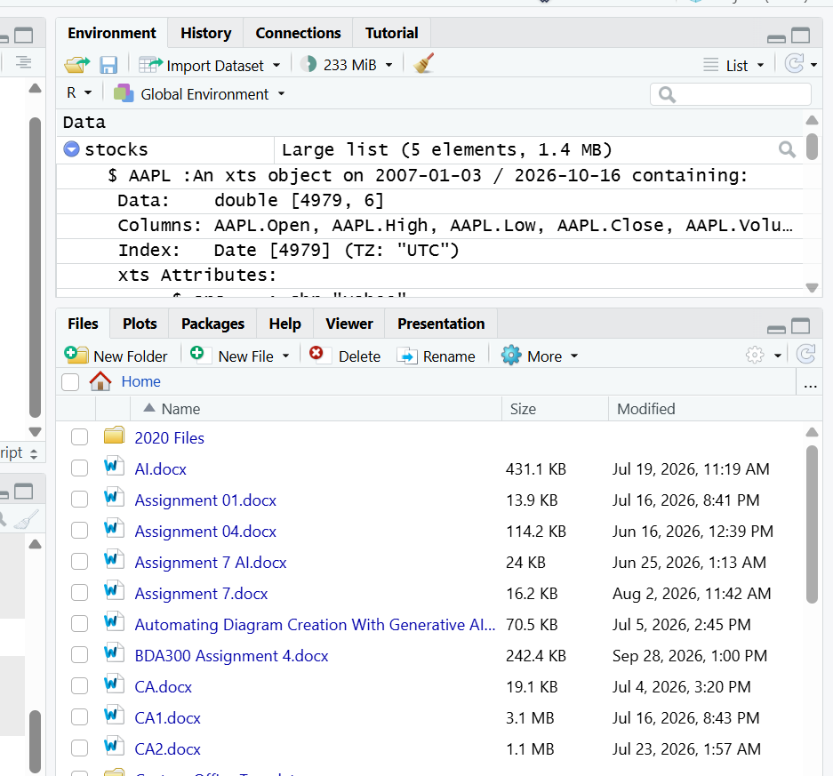
Stock Data Successfully Loaded in RStudio
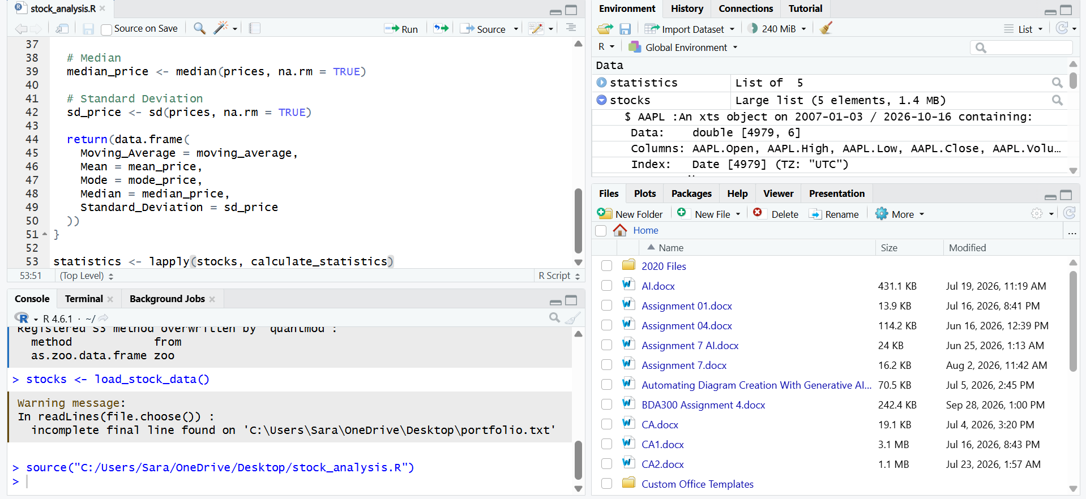
Stock Statistics Calculated Successfully in RStudio

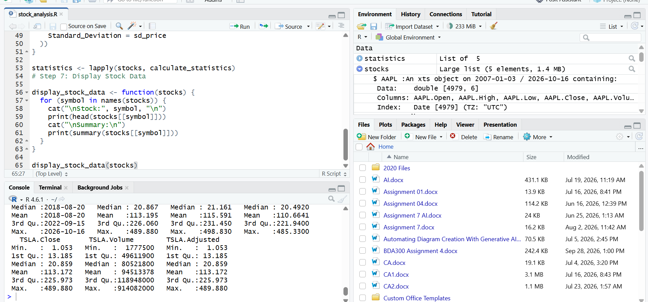

Stock Data Summary Displayed Successfully in RStudio

