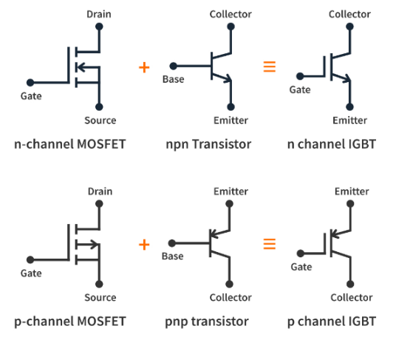**IGBT**

IGBT “Insulated Gate Bipolar Transistor is a three terminal semiconductor device mostly used in power electronics for switching and amplifying signals. It combines the advantages of both MOSFETs (Metal-Oxide-Semiconductor Field-Effect Transistors) and BJTs (Bipolar Junction Transistors). It consists of four alternating layers (P-N-P-N) that are controlled by a MOS gate structure input and a bipolar output which helps it utilize two types of carriers, electrons and holes, making it a transistor that can achieve low saturation voltage (similar to low ON resistance MOSFETs) with relatively fast switching characteristics.

* *IGBT Operating regions:*

1. *Cut-off region:*

Similar to MOSFET, no current flows between collector and emitter.

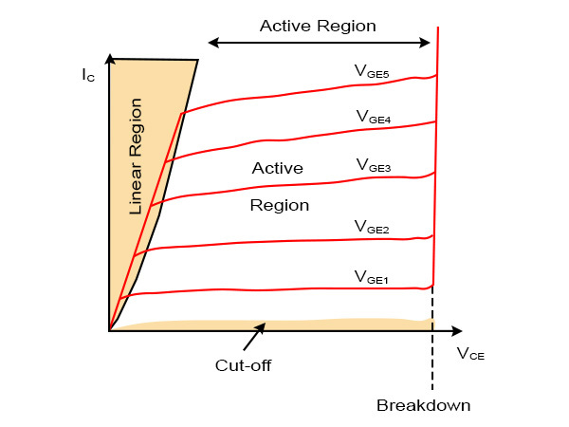Vge (gate emitter voltage) <Vth (threshold voltage)

1. *Active region:*

The IGBT operates in a linear amplification mode, but this region is typically avoided in power applications due to its lower efficiency than the sat. region.

Ic (collector current) is proportional to Ib (base current)

1. *Saturation region*:

The IGBT acts as a low-resistance switch, similar to the MOSFET's saturation region.

Vge > Vsat

Vce is minimum.

* *IGBT Key Parameters:*

On-State Resistance (Rds(on)): The resistance of the IGBT when it is turned on, affecting power losses.

CHATGBT

1. *Collector-Emitter Voltage (Vce):*

The maximum voltage that can be applied between the collector and emitter terminals when the IGBT is off.

1. *Collector Current (Ic):*

The maximum current that can flow through the IGBT from collector to emitter when it is on.

1. *Gate-Emitter Voltage (Vge):*

The voltage required between the gate and emitter to turn the IGBT on.

1. *Saturation Voltage (Vce(sat)) :*

The voltage drop across the collector-emitter terminals when the IGBT is fully on (in saturation mode).

1. *Switching Time:*

The time required for the IGBT to switch from off to on (turn-on time) and from on to off (turn-off time). These times are critical in determining the switching speed of the IGBT.

1. *On-State Resistance (Rds(on)):*

The resistance of the IGBT when it is turned on, affecting power losses.

1. *Power Dissipation (Pd):*

The amount of power that the IGBT dissipates as heat during operation. It is crucial for thermal management.

1. *Temperature Ratings (Tj, Tstg):*

The maximum junction temperature (Tj) and storage temperature (Tstg) that the IGBT can safely operate within.

1. *Input Capacitance (Ciss):*

The capacitance between the gate and emitter, affecting the amount of charge required to switch the IGBT.

1. *Reverse Recovery Time (trr):*

The time required for the IGBT's internal diode to recover from conducting in reverse, affecting performance in applications like rectifiers.