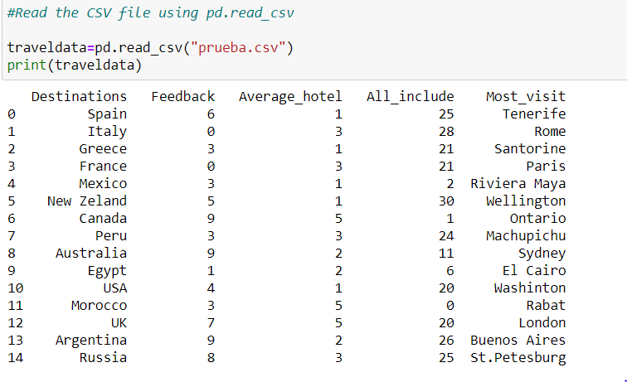

Feedback, Average_hotel, and number of all_inclusive have been created with random numbers.

1. **How many rows and columns are there in your file?**

In the file created we have 15 rows and 5 columns.

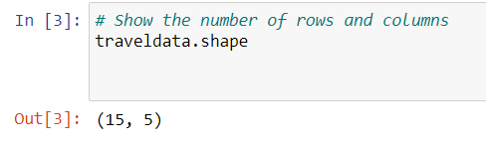

1. **Print row 3-8 (using iloc/loc)**

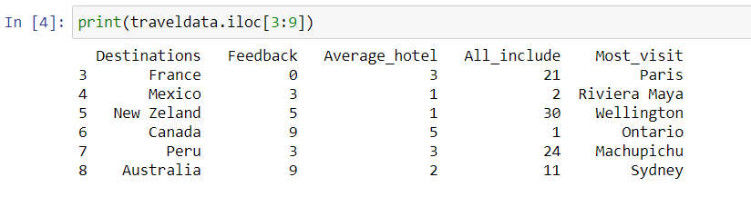

1. **Find the mean number of all-inclusive hotels across all destinations.**

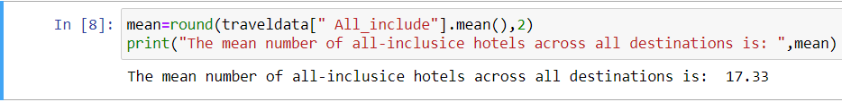

1. **Find the lowest scoring destination.**

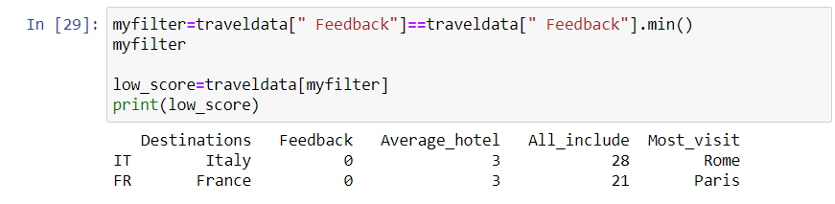

1. **Find the highest scoring destination.**

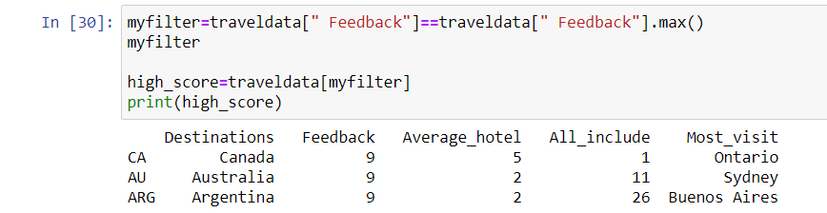

1. **Find all the destinations where there are more than 9 all-inclusive hotels.**

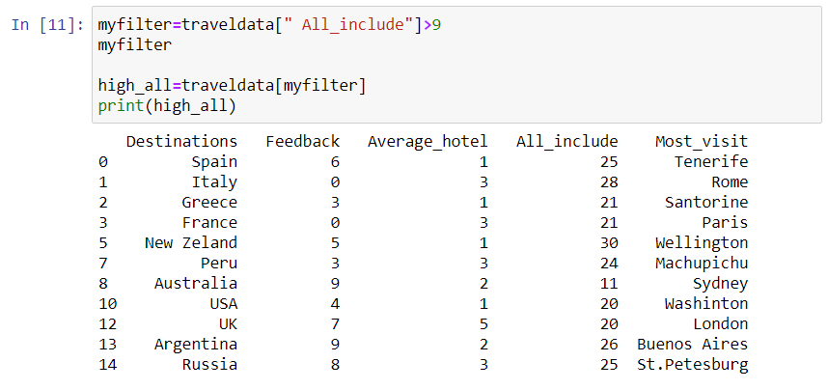

1. **Filter the data by score above 8.**

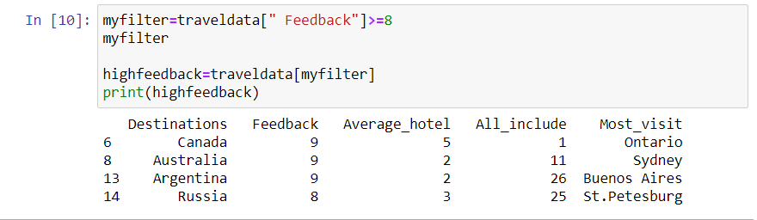

1. **Filter the data score below 2.**

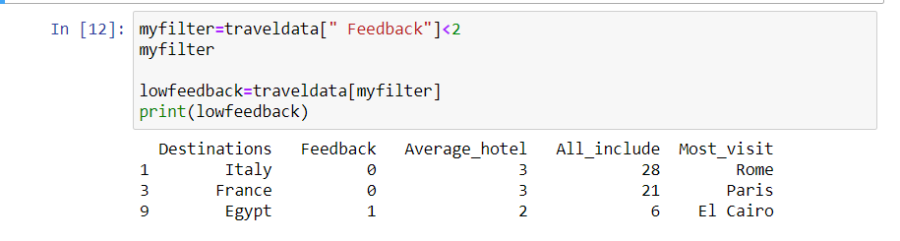

1. **Is there a correlation between number of all-inclusive hotels and score?**

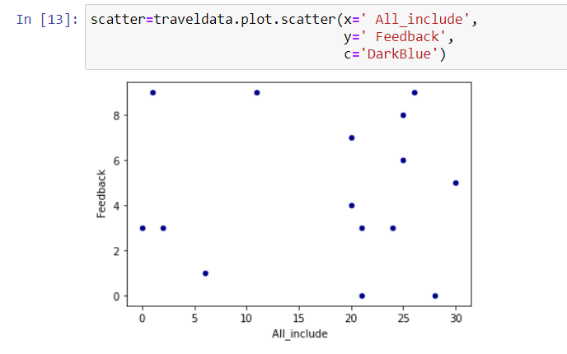

1. **Create a data visualization diagram to show destination and highest scores?**

