SQL QUERIES SOLUTION

-- Before executing all SQL queries switch to the ‘movies’ database
USE `movies`;

--
-- List all information from each table separately
--

SELECT *
FROM movie;
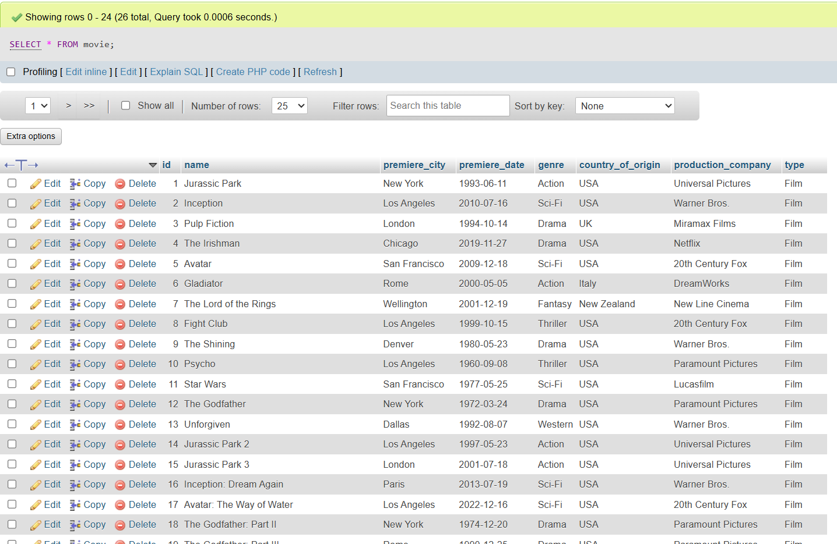

SELECT *
FROM film;
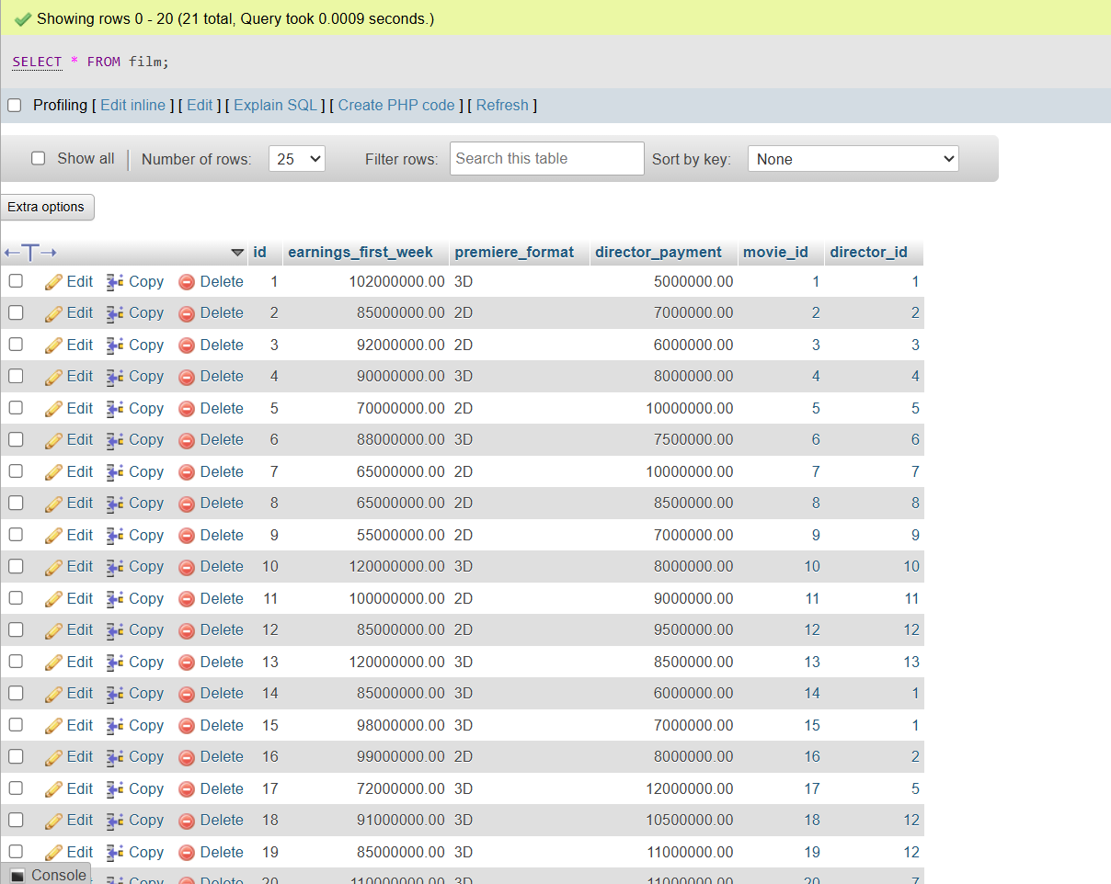

SELECT *
FROM tv_serie;
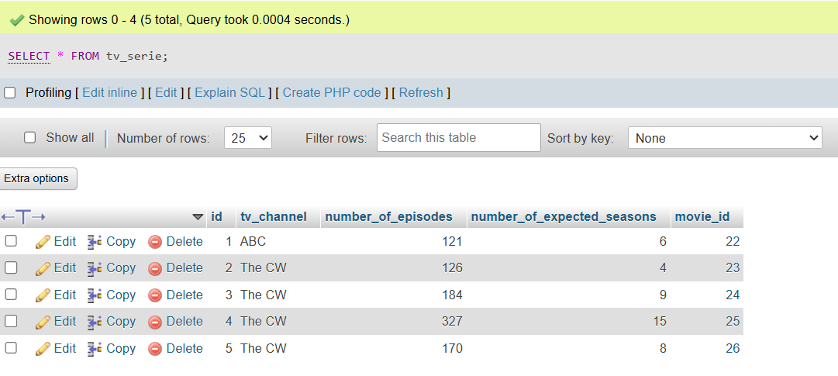

SELECT *
FROM actor;
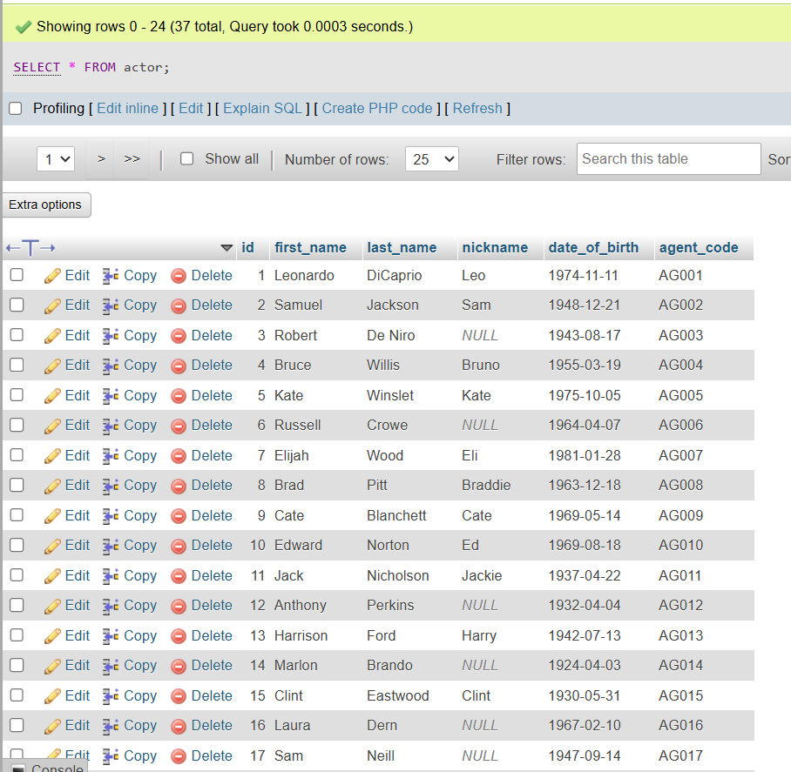

SELECT *
FROM director;
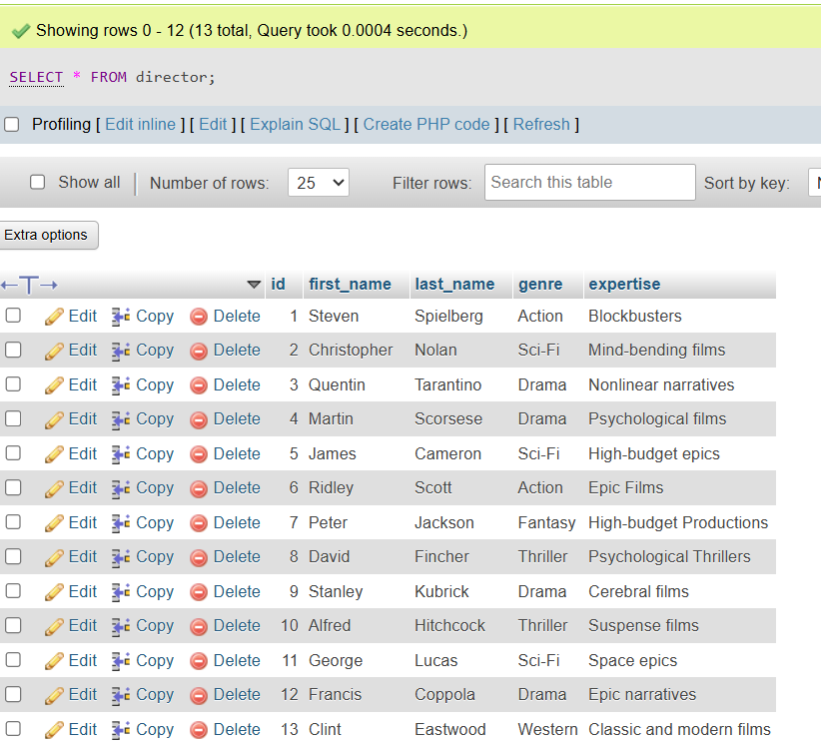
SELECT *
FROM sequel;
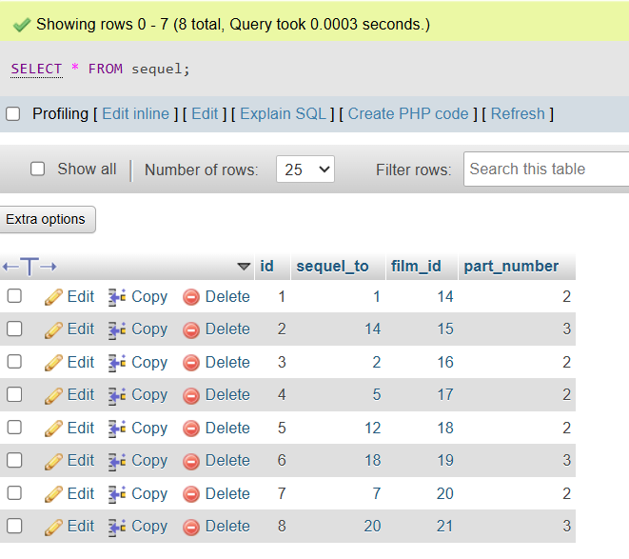

SELECT *
FROM critic;
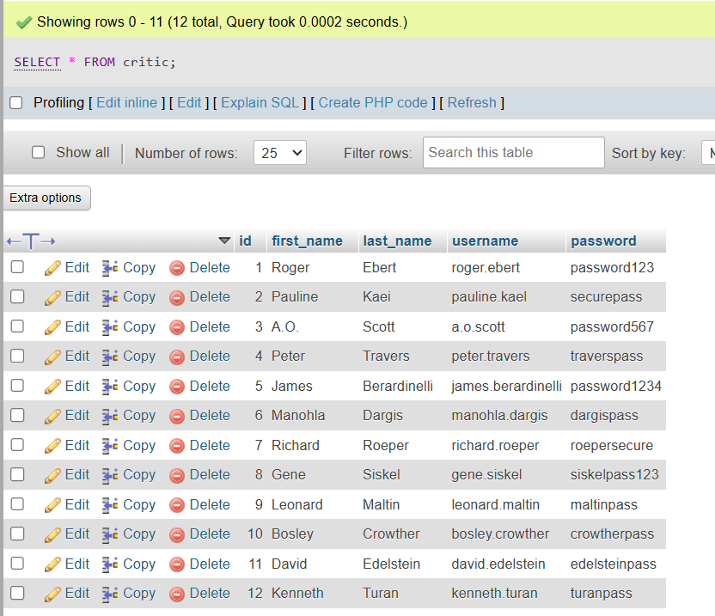
SELECT *
FROM oscar_winner;
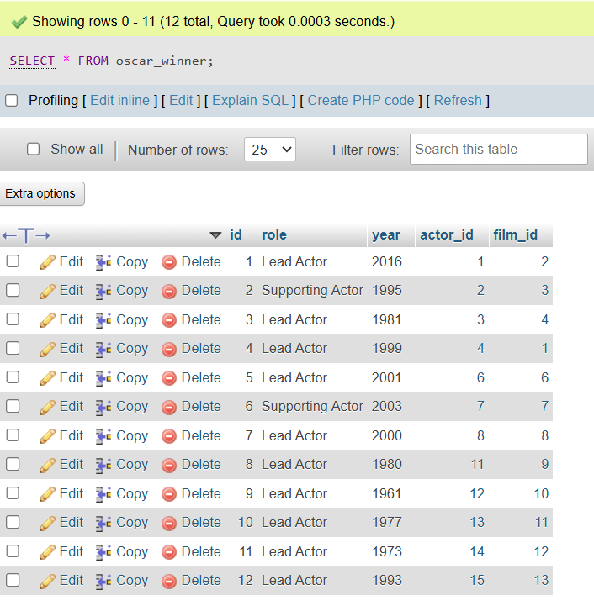

SELECT *
FROM movie_actor;
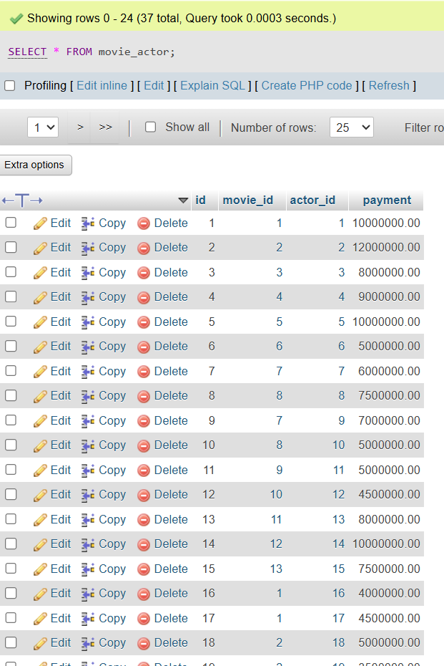
SELECT *
FROM movie_critic;
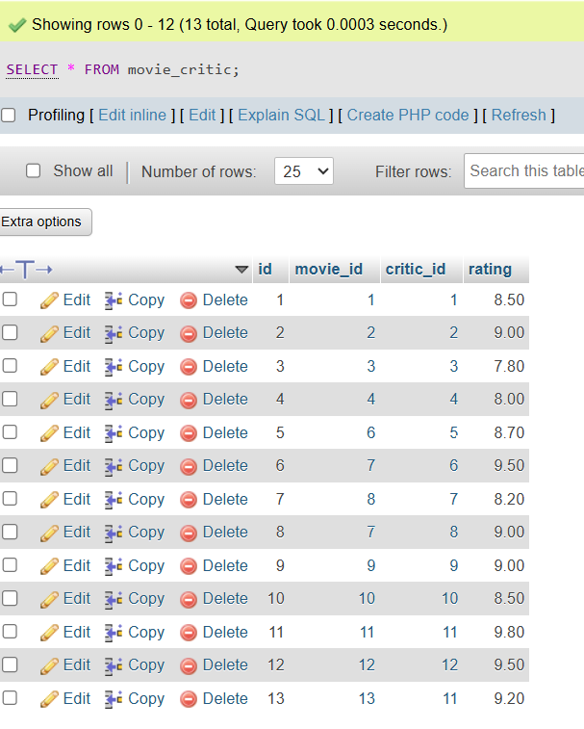

SELECT *
FROM actor_critic;
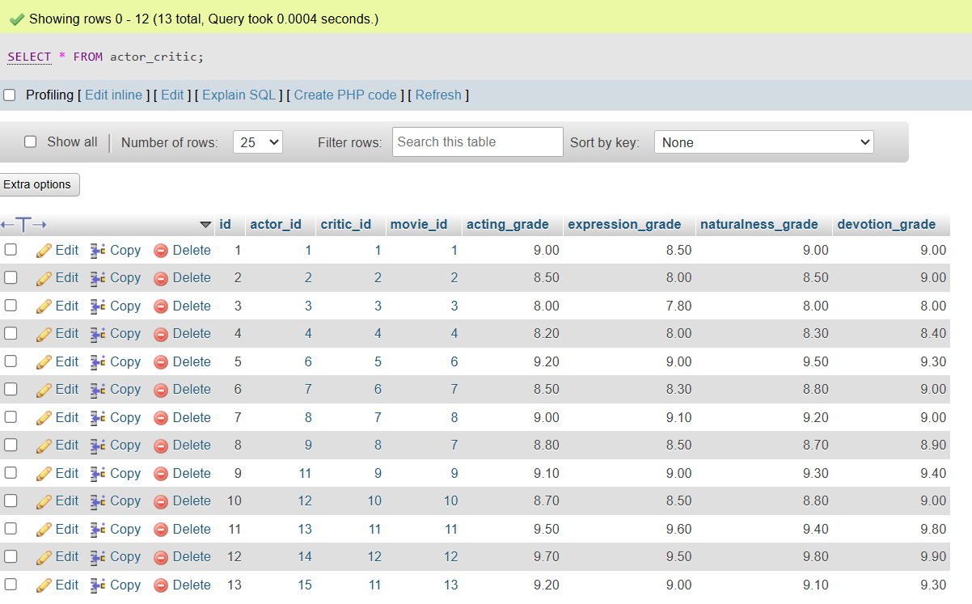
--
-- List information about the movies (name of movie, premiere date, genre, country of origin, production, number of actors
--

SELECT movie.name, movie.premiere_date, movie.genre, movie.country_of_origin, movie.production_company, COUNT(movie_actor.actor_id) AS number_of_actors
FROM movie
JOIN movie_actor ON movie.id = movie_actor.movie_id
GROUP BY movie.id;
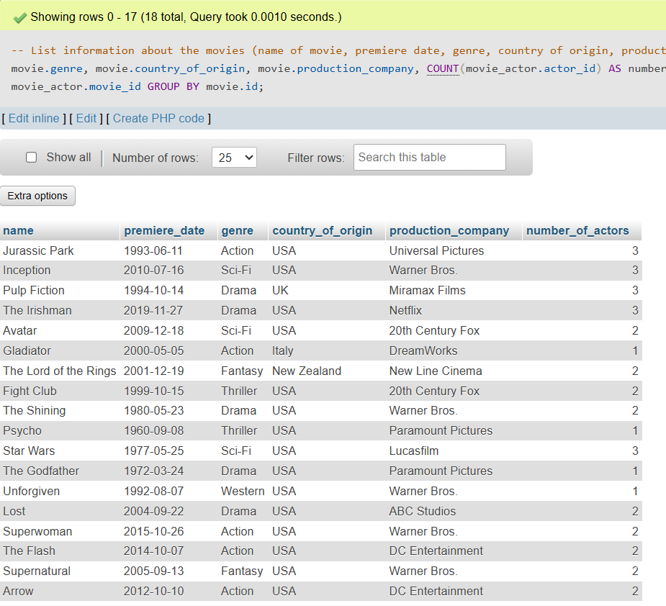
--
-- List all information for the actors (first name, last name, nickname, date of birth, agent code and number of movies in which have acted)
--

SELECT actor.first_name, actor.last_name, actor.nickname, actor.date_of_birth, actor.agent_code, COUNT(movie_actor.movie_id) AS number_of_movies
FROM actor
JOIN movie_actor ON actor.id = movie_actor.actor_id
GROUP BY actor.id;
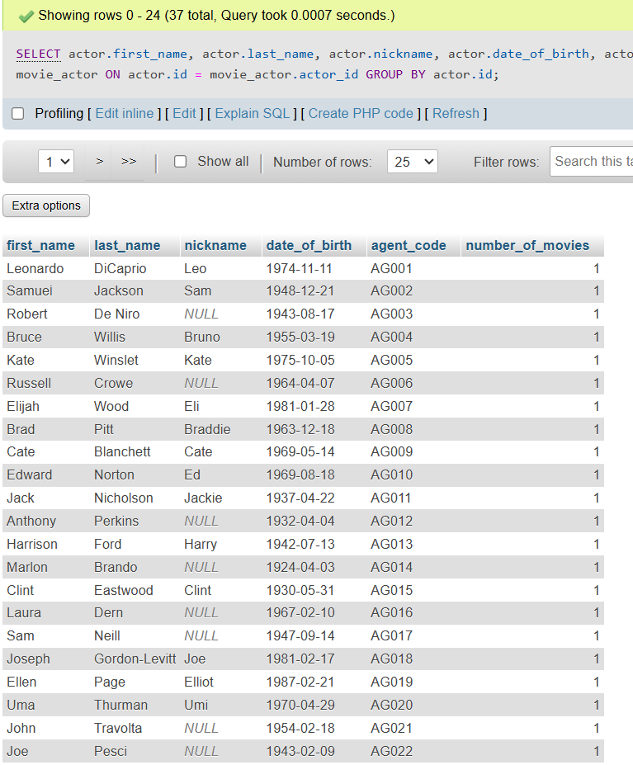
--
-- List all movies with their information (premiere city, how much money they have made during the first week of premiere, and premiere format (2D - 3D), ordered by premiere format)
--

SELECT movie.premiere_city, film.earnings_first_week, film.premiere_format
FROM movie
JOIN film ON movie.id = film.movie_id
ORDER BY film.premiere_format;
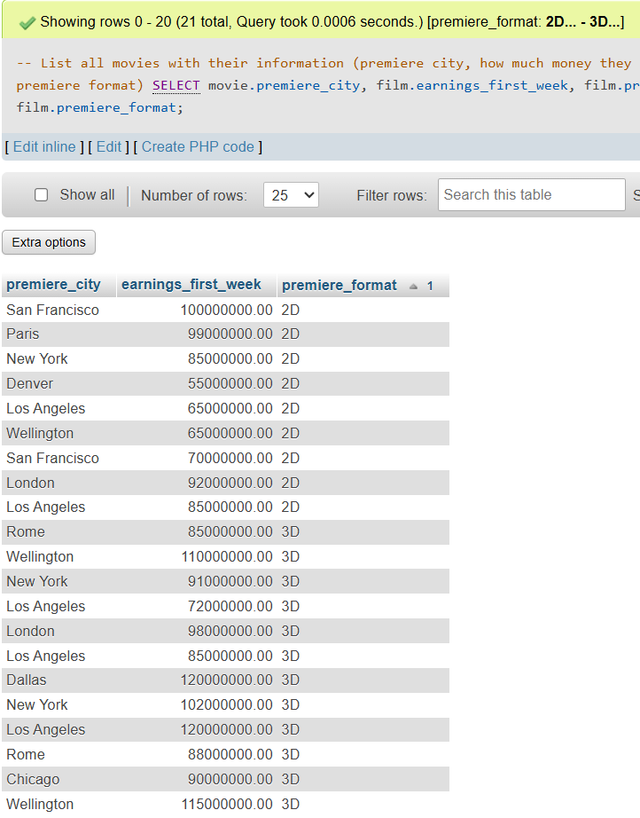
--
-- List all information about the Oscar winners (for which movie they have won an Oscar, for which role in that movie and in which year, as well as the first name of the actor, last name, nickname, date of birth and agent code). List all this information sorted by the year in which they have won the Oscar, so that the newest will be first
--

SELECT movie.name AS movie_name, oscar_winner.role, oscar_winner.year, actor.first_name AS actor_first_name, actor.last_name AS actor_last_name, actor.nickname AS actor_nickname, actor.date_of_birth, actor.agent_code
FROM oscar_winner
JOIN actor ON oscar_winner.actor_id = actor.id
JOIN film ON oscar_winner.film_id = film.id
JOIN movie ON film.movie_id = movie.id
ORDER BY oscar_winner.year DESC;
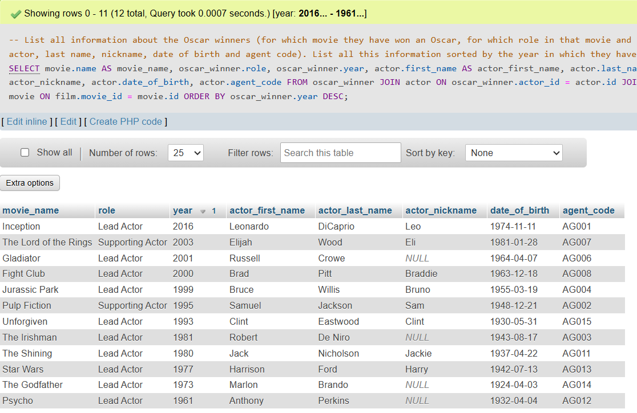
--
-- List all information about the films, along with the actors that have acted in them and the directors who have directed them, ordered by the directors’ names
--

SELECT movie.name, movie.premiere_city, movie.premiere_date, movie.genre, movie.country_of_origin, movie.production_company, film.earnings_first_week, film.premiere_format, film.director_payment, CONCAT(director.first_name, ' ', director.last_name) AS director_full_name, GROUP_CONCAT(CONCAT(actor.first_name, ' ', actor.last_name) SEPARATOR ', ') AS actors_full_names
FROM film
JOIN movie ON film.movie_id = movie.id
JOIN director ON film.director_id = director.id
JOIN movie_actor ON movie.id = movie_actor.movie_id
JOIN actor ON movie_actor.actor_id = actor.id
GROUP BY movie.id, director.id
ORDER BY director.first_name, director.last_name;
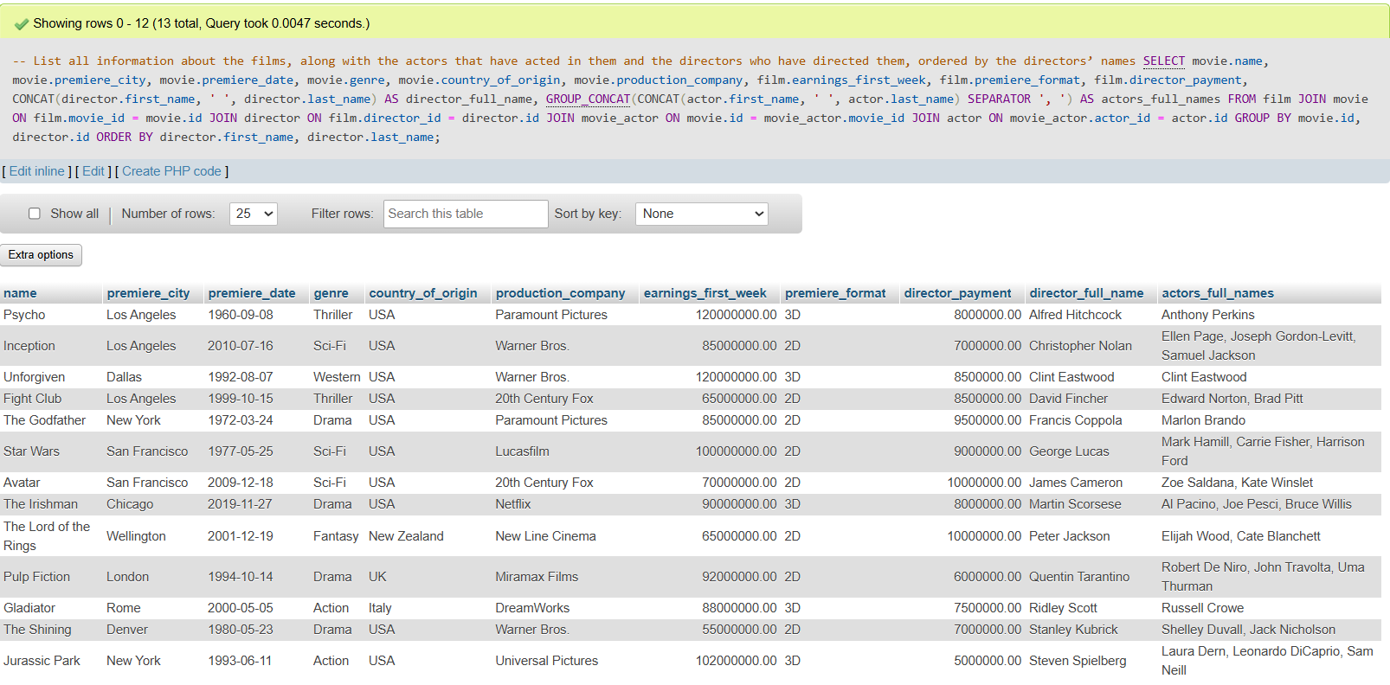
--
-- List all information about the actors who have a lower-than average grade given by the critics, and order them from highest to lowest
--

WITH AverageGrade AS (
SELECT AVG((actor_critic.acting_grade + actor_critic.expression_grade + actor_critic.naturalness_grade + actor_critic.devotion_grade) / 4) AS overall_average
FROM actor_critic
)

SELECT actor.id, actor.first_name, actor.last_name, actor.nickname, actor.date_of_birth, actor.agent_code, ((actor_critic.acting_grade + actor_critic.expression_grade + actor_critic.naturalness_grade + actor_critic.devotion_grade) / 4) AS average_actor_grade
FROM actor
JOIN actor_critic ON actor.id = actor_critic.actor_id
GROUP BY actor.id
HAVING average_actor_grade < (
SELECT overall_average
FROM AverageGrade
)
ORDER BY average_actor_grade DESC;

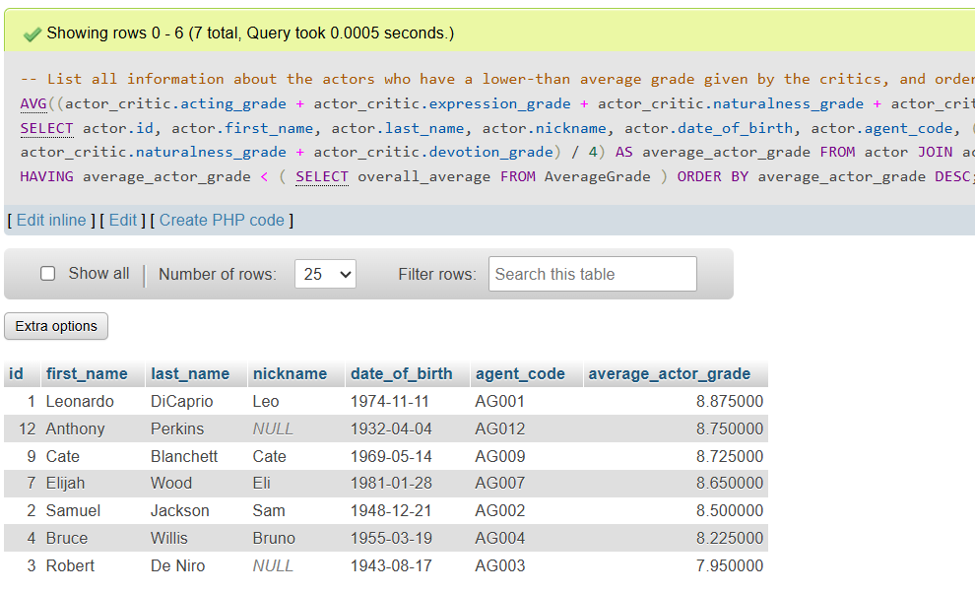

--
-- List all Oscar winners who are older than the average age of all actors
--

WITH AverageAge AS (
SELECT AVG(FLOOR(DATEDIFF(CURDATE(), actor.date_of_birth) / 365.25)) AS average_age
FROM actor
)

SELECT CONCAT(actor.first_name, ' ', actor.last_name) AS actor_full_name, FLOOR(DATEDIFF(CURDATE(), actor.date_of_birth) / 365.25) AS age, oscar_winner.role, oscar_winner.year
FROM actor
JOIN oscar_winner ON actor.id = oscar_winner.actor_id
WHERE FLOOR(DATEDIFF(CURDATE(), actor.date_of_birth) / 365.25) > (
SELECT average_age
FROM AverageAge
)
ORDER BY age DESC;
