International Islamic University Chittagong
Department of Computer Science & Engineering


Project Report: Social Media Platform
GitHub Repository: Social_Media_Platform
Course Code: CSE-3532

Course Title: Tools and Technologies for Internet Programming
Submission Date: 29.06.2025

SUBMITTED TO
Sara Karim
Adjunct Lecturer
Department of CSE, IIUC

SUBMITTED BY
Kamrun Nahar Kumkum
ID: C233420
4th Semester
Section: 5BF

1. Introduction
This project is a feature-rich social media platform developed as part of the "Tools and Technologies for Internet Programming" course. The objective was to build a modern, responsive web application that allows users to create posts, interact with content, and manage their profiles, mimicking key aspects of real-world social platforms.

2. Tools & Technologies Used
- Frontend:
  - React.js – For building the user interface using components.
  - ShadCN UI – For sleek and reusable UI components.
  - Tailwind CSS – For utility-first styling.
  - TanStack Query (React Query) – For efficient state management and data fetching.
- Backend & Services:
  - Appwrite – As a backend-as-a-service (BaaS) for authentication, database, and file storage.
- Development Tools:
  - Vite – For fast frontend build setup.
  - Git & GitHub – For version control and collaboration.

3. Core Features
- Authentication (Signup, Login, Logout) using Appwrite.
- Create, Read, Update, Delete (CRUD) functionality for posts.
- Image Upload support using Appwrite's storage.
- User Profile Management – View and update user data.
- Reactions and Save functionality
- Responsive UI optimized for different devices.
Here I am adding some screenshots of the platform –
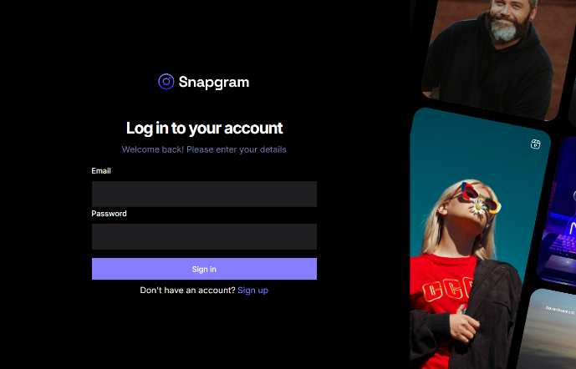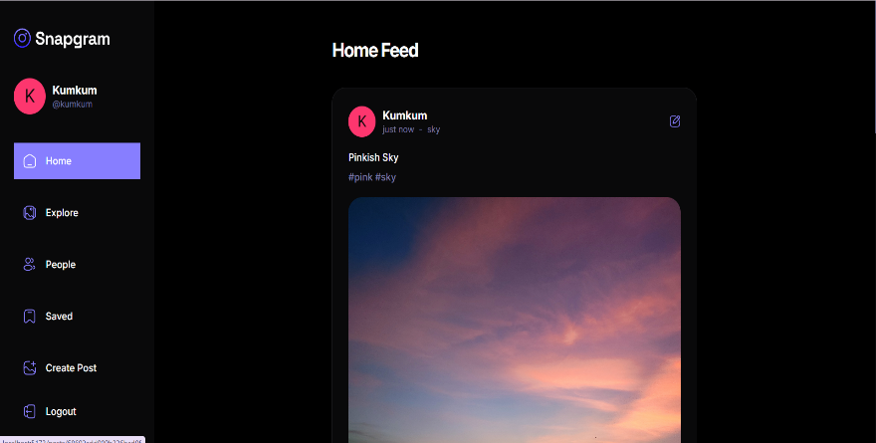
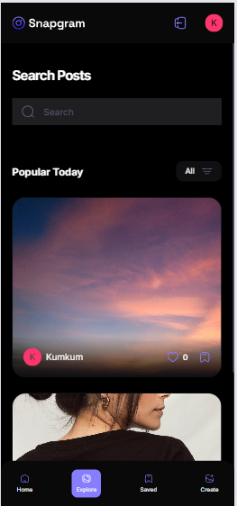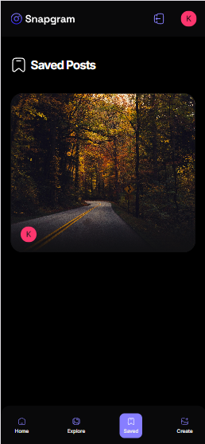
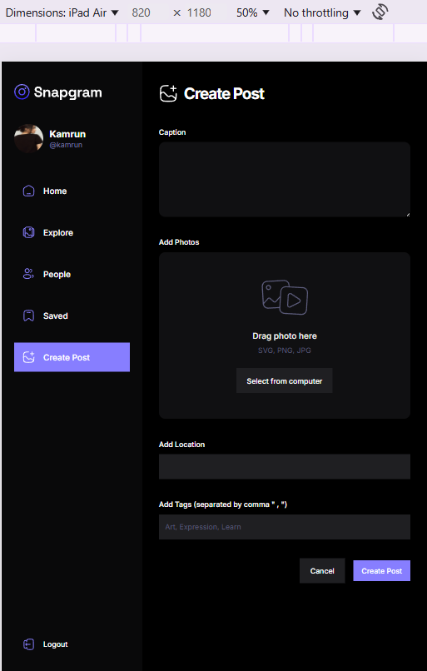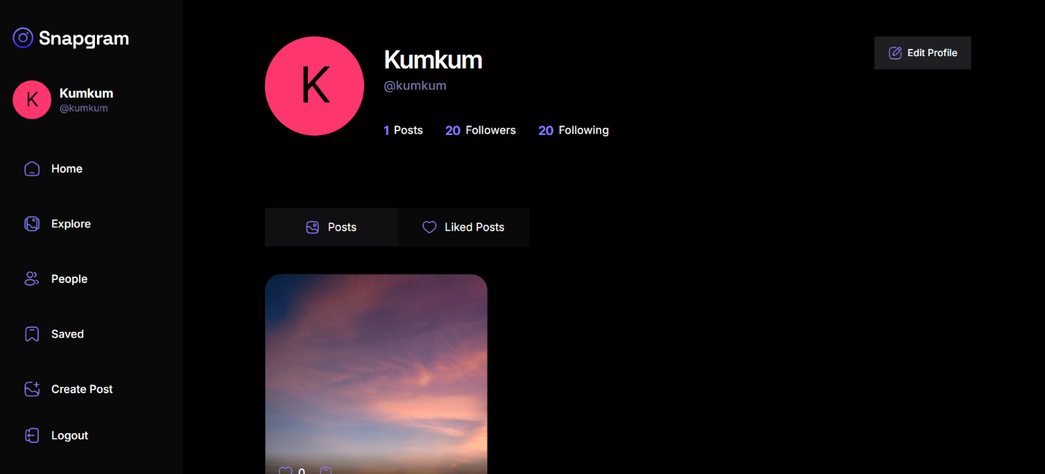

4. Challenges Faced
- Integrating Appwrite: Setting up authentication and handling sessions required in-depth reading of documentation.
- State Management: Ensuring seamless UI updates on user actions was solved using React Query.
- Responsive Design: Tailoring the UI for both desktop and mobile devices took extra time and testing.

5. Outcome & Learning
This project deepened my practical knowledge of:
- Component-based UI development with React.
- Managing asynchronous data flows with TanStack Query.
- Implementing backend services via Appwrite.
- Building scalable, responsive, and modern web interfaces.

6. Future Improvements
- Add real-time features (e.g., chat or notifications) using WebSockets or Firebase.
- Implement dark mode and theme toggling.
- Expand profile customization and post sharing options.

7. Conclusion
This project successfully demonstrates my ability to combine frontend and backend technologies to create a full-fledged social media platform. It reflects my understanding of modern web development practices and tools.

