**AI-Enhanced Image Analysis for Creative Color Palette Generation**

# Project Overview

The goal of this project is to design an AI-based tool that can automatically extract dominant colors from any image, generate a corresponding color palette, analyze the mood of the colors, and visualize them as a designer-style mood board.  
This project helps designers, developers, and branding specialists quickly generate color schemes and understand the emotional 'vibe' of an image.

# Tools & Technologies Used

- Google Colab (Python Notebook)  
- Python Libraries:  
 - OpenCV (image processing)  
 - Scikit-learn (clustering using KMeans)  
 - Pillow (image loading and saving)  
 - Webcolors (color name detection)  
 - Matplotlib (visualizations)

# Key Features Implemented

✅ Color Extraction  
- Used KMeans clustering to find dominant colors in an image.  
- Generated a color palette bar showing the main colors visually.  
  
✅ Color Naming & Percentage  
- Converted RGB values to HEX codes.  
- Estimated closest CSS3 color names.  
- Calculated each color's percentage representation in the image.  
  
✅ Mood Analysis  
- Analyzed overall brightness and suggested a mood (e.g., bright and cheerful, dark and moody).  
  
✅ Mood Board Mockup  
- Created a 'mood board' style visualization to represent how the palette might look in design contexts.  
  
✅ Additional Unique Features  
- Generated CSS snippet for using colors directly in web design.  
- Created gradient previews using top colors.  
- Suggested accessibility contrast for text readability.  
- Provided a friendly color story summarizing the emotional tone of the palette.

# How It Works

1️⃣ Upload Image: User uploads an image (e.g., a photo, artwork, or product image).  
2️⃣ Palette Extraction: The code clusters pixel colors to find the top 5 dominant colors.  
3️⃣ Palette Summary: Prints color HEX codes, approximate names, and percentages.  
4️⃣ Mood Board Generation: Displays a creative collage-style arrangement using palette colors.  
5️⃣ Additional Visuals: Shows gradient preview, accessibility suggestions, and web CSS snippet.

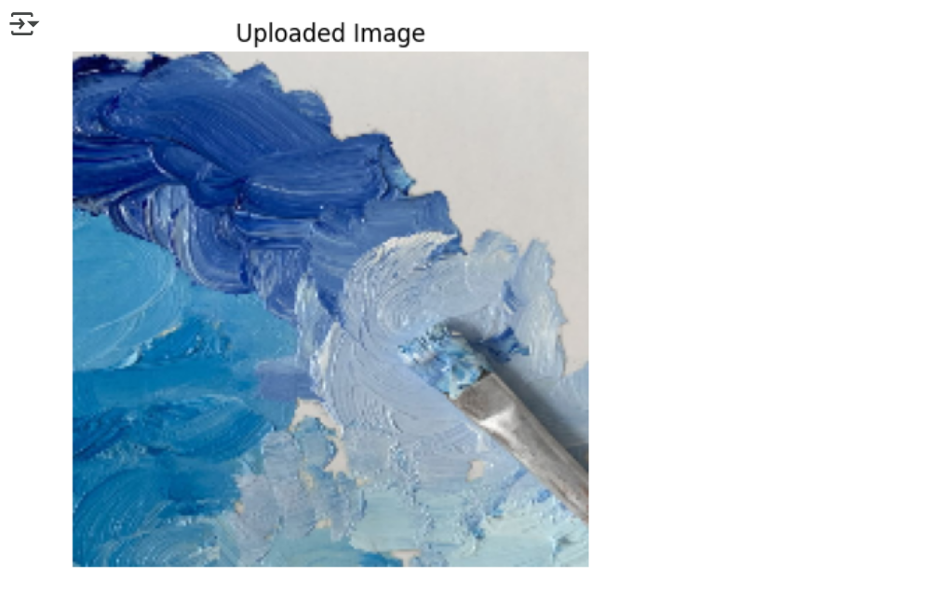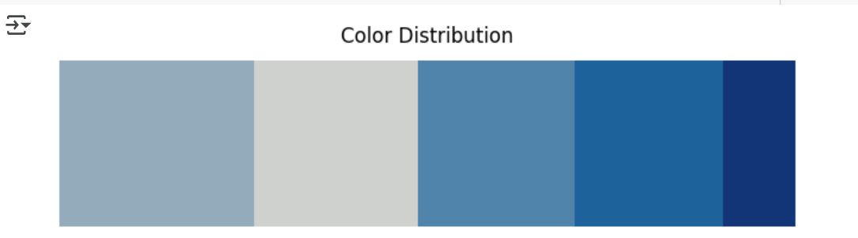

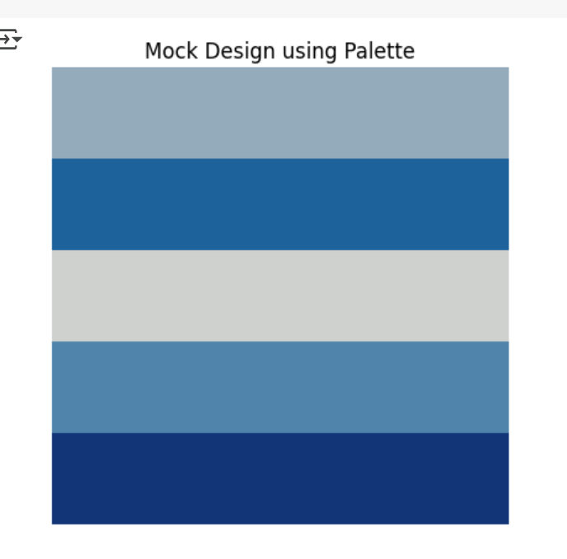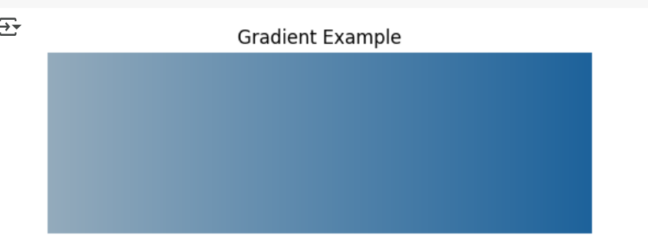

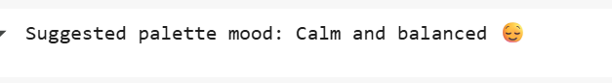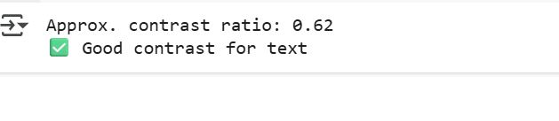

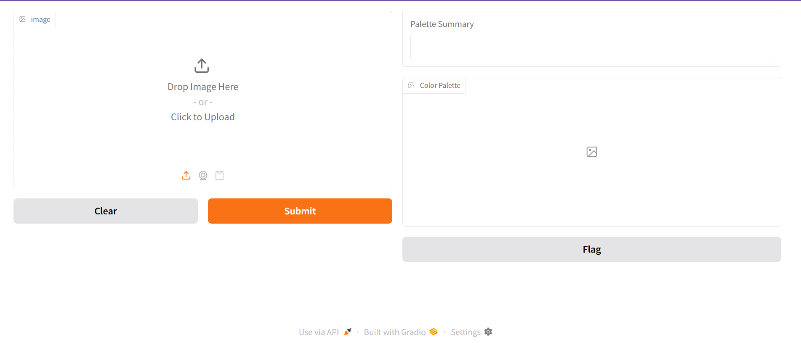

# Applications

- Web and app design  
- Brand identity creation  
- Fashion & interior design mood boards  
- Social media content styling  
- Marketing and advertising visuals

# Project Uniqueness & Value

Unlike simple color extractors, this project:  
- Explains the mood of the palette.  
- Visualizes colors in a designer-friendly mockup.  
- Suggests code for easy use in web development.  
- Checks for accessibility and suggests improvements.  
- Provides a storytelling angle to make the palette more engaging.

# Future Improvements

- Deploy as a web application using Streamlit or Flask.  
- Allow real-time camera capture for palette creation.  
- Add font and text recommendations based on the palette.  
- Generate full brand guidelines (typography, icon style) automatically.

# Conclusion

This AI-based color palette project combines image analysis, clustering, and design visualization to deliver a unique, creative, and practical tool for both technical and creative users.  
It not only simplifies color selection but also guides users towards making aesthetically pleasing and accessible design decisions.