## Figures and Tables

|  |  |  |
| --- | --- | --- |
| ɑ-Diversity | Treatment *df* = 1 | Block *df* = 3 |
| Richness | 1.04 (0.31) | **5.28(0.002)** |
| Inverse Simpson | 0.03 (0.87) | **3.90 (0.01)** |
| Simpson | 0.28 (0.60) | **2.76 (0.046)** |
| Evenness | 1.03 (0.31) | **5.15 (0.002)** |

Table 1 Results from separate ANOVAs to test for Treatment effects on different alpha diversity metrics (ɑ-Diversity Metric) of the rhizosphere microbiome of *I. purpurea* (Num. *I. purpurea* in competition = 73; Num. *I. purpurea* alone = 27). *F-values* are reported with their corresponding *p-values* in parentheses. Each modelǂ evaluated metrics of ɑ-Diversity as response variables, and Treatment and Block as fixed effects. Values in bold indicate a significant *p-value* < 0.05.

ǂ*ɑ-diversity* ~ Treatment + Block

|  |  |  |  |  |  |  |
| --- | --- | --- | --- | --- | --- | --- |
| Effect | DF | SS | MeanSS | *F-value* | *R*2 | *p-value* |
| Treatment | 1 | 0.03 | 0.03 | 0.85 | 0.01 | 0.54 |
| Block | 3 | 0.32 | 0.11 | **3.48** | **0.10** | **0.001** |

Table 2 Results of PERMANOVA of Bray-Curtis distances (community composition) to test for Treatment effects on community composition of the rhizosphere microbiome of *I. purpurea* (Num. *I. purpurea* in competition = 73; Num. *I. purpurea* alone = 27). The modelǂ included community composition as a response variable, with Treatment and Block as fixed effects.

ǂ*Community composition* ~ Treatment + Block

|  |  |  |  |  |
| --- | --- | --- | --- | --- |
| Linear Association Between Rhizosphere Microbiome ɑ-Diversity and Root Traits | | | | |
| ɑ-Diversity | Root topology  (PC1) | Root architecture (PC2) | Root size  (PC3) | Root morphology (PC4) |
| Inverse Simpson | 1.02  ± 1.43 | -0.56  ± 0.73 | 0.53  ± 0.89 | 1.90^  ± 1.09 |
| Simpson | 1.45 e-03  ± 1.26 e-03 | -9.07 e-04  ± 6.32 e-04 | 9.58 e-04 ± 7.58 e-04 | **2.48 e-03\*\***  **± 9.04 e-04** |
| Richness | 3.38  ± 4.65 | **-5.73\***  **± 2.22** | 2.00  ± 2.81 | 3.50  ± 3.52 |
| Evenness | -6.20e-06  ± -6.62 e-05 | 7.25 e-05  ± 3.19 e-05 | 2.84 e-06  ± 4.00 e-05 | 2.62 e-05  ± 5.02 e-05 |

Table 3 Results of separate linear regression between different metrics (ɑ-Diversity Metric) of the rhizosphere microbiome (Inverse Simpson, Simpson, Richness and Evenness) and four root traits (Root topology, Root architecture, Root size and Root morphology) examined in *I. purpurea*. ɑ-Diversity metrics were treated as response variables for each root trait, and Block and Treatment were included in the final modelǂ as fixed main effects.Linear regression coefficient slopes (𝛣) are reported with ± 1 standard error.

*p-value* < 0.05 *; *p-value* <0.01 **; *p-value* <0.001***; *p-value* =0.09 ^

ǂModel: ɑ-Diversity ~ Root trait + Block +Treatment

|  |  |  |
| --- | --- | --- |
| Table 4 Mantel test Bray-Curtis and root phenotypes within *I. purpurea* | | |
| Root trait | *r2* | *p-value* |
| Root topology | -0.04 | 0.76 |
| Root architecture | 0.07 | 0.07^ |
| Root size | 0.07 | 0.13 |
| Root morphology | -0.04 | 0.76 |

*p-value* =0.07 ^

|  |  |  |  |  |
| --- | --- | --- | --- | --- |
| **Fixed effect** | **DF** | **SS** | **F-value** | **P-value** |
| Treatment | 1 | 0.02 | 0.27 | 0.61 |
| Block | 3 | 0.71 | 4.08 | **0.01** |
| Treatment × Block | 3 | 0.20 | 1.17 | 0.33 |
| Root topology × Treatment | 1 | 0.13 | 2.28 | 0.14 |
| Root size × Treatment | 1 | 0.06 | 0.97 | 0.33 |
| Richness × Treatment | 1 | 0.29 | 5.03 | **0.03** |
| Evenness × Treatment | 1 | 0.08 | 1.34 | **0.25** |
| Root topology × Block | 3 | 0.84 | 4.85 | **0.004** |
| Root architecture × Block | 3 | 0.26 | 1.48 | 0.23 |
| Root size × Block | 3 | 0.26 | 1.47 | 0.23 |
| Root morphology × Block | 3 | 1.15 | 6.60 | **0.001** |
| Richness × Block | 3 | 0.60 | 3.42 | **0.02** |
| Inverse Simpson diversity × Block | 3 | 0.56 | 3.22 | **0.03** |
| Evenness × Block | 3 | 0.61 | 3.50 | **0.02** |

Table 1‑5 Results of ANCOVA to test the effects of root traits (root topology, architecture, size and morphology, respectively), measures of alpha diversity of the rhizosphere microbial community, and their two-way interactions with Treatment and Block on relative fitness of *I. purpurea* (N = 100). Degrees of Freedom (DF), sum of squares (SS) and *F-values* and corresponding *p-value* in parentheses are reported for each fixed effect. For this analysis, we extrapolated observed values of root traits and alpha diversity metrics scaled to a mean of zero and standard deviation of one, onto relative fitness of *I. purpurea* averaged by maternal line and treatment. The final model included all the Fixed Effects listed in the table regressed onto relative fitness and *F-tests* with Type III Sums of Squares were used to estimate their statistical significance. *p-value* < 0.05 *; *p-value* <0.01 **; *p-value* <0.001***

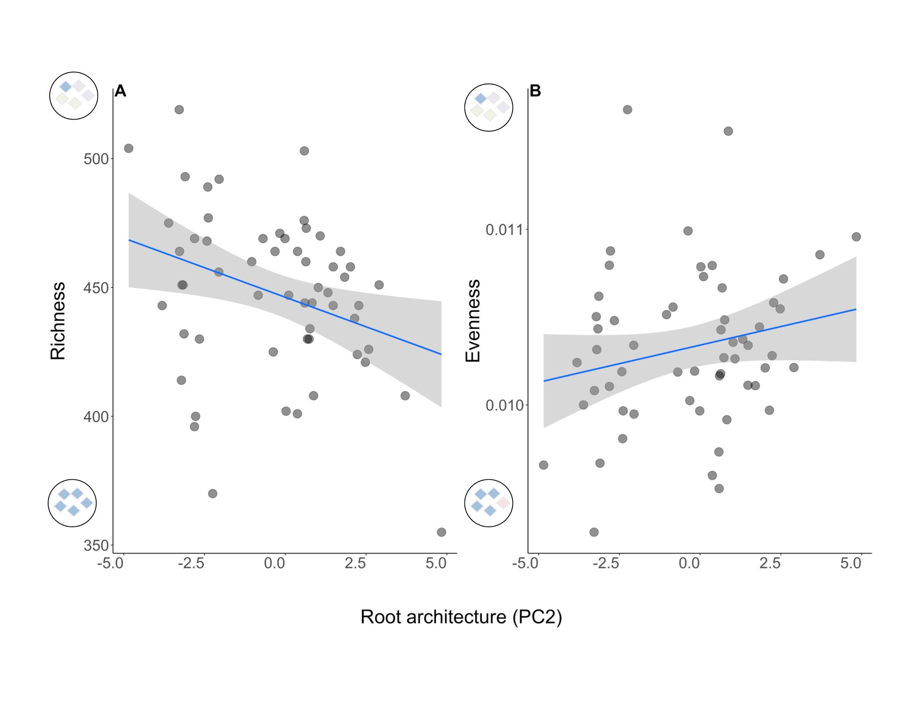

Figure 1 Linear regression plots between root architecture, and rhizosphere bacterial richness (A) and evenness (B). Plotted linear regression line, colored blue, and grey shading represent the linear regression slope and ± 1 standard error of the linear regression between root trait (predictor X variable) and alpha diversity metric (response Y variable). We found a significant negative relationship between root architecture as a modular trait (PC2, *i.e.,* collective increase in root tissue angle traits, horizontal/vertical distribution, root system width and root system length) and Species richness (*R*2 = 0.18, 𝛣 = -5.54 ± 2.24, *p-value* = 0.02; Table 4-3), and a significant positive relationship with Species evenness (*R*2 = 0.12, 𝛣 = 7.29 e-05 ± 3.28 e-05, *p-value* = 0.03; Table 4-3). Near the Y-axis are schematic representations of the corresponding community composition variable according to low (bottom) and high (top) values, respectively, where each diamond represents an OTU, and the color a unique OTU.

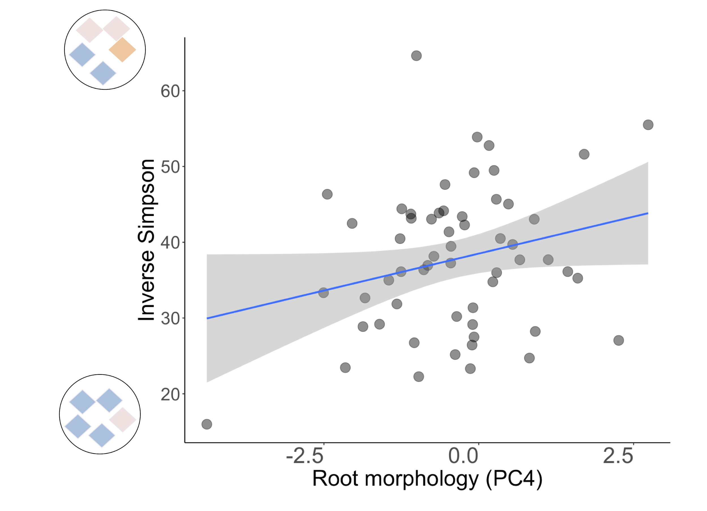

Figure 2 Linear regression plot between root morphology, and rhizosophere bacterial Inverse Simpson diversity indices. Plotted linear regression line, colored blue, and grey shading represent the linear regression slope and ± 1 standard error of the linear regression between root trait (predictor X variable) and alpha diversity metric (response Y variable). We found a significant positive relationship between root morphology as a modular trait (PC4, *i.e.,* collective increase in root diameter, basal root number and adventitious root number) and Inverse Simpson diversity (*R*2 = 0.10, 𝛣= 2.08 ± 1.05, *p-value* = 0.053; Table 4-3). Near the Y-axis are schematic representations of the corresponding community composition variable according to low (bottom) and high (top) values, respectively, where each diamond represents an OTU, and the color a unique OTU.

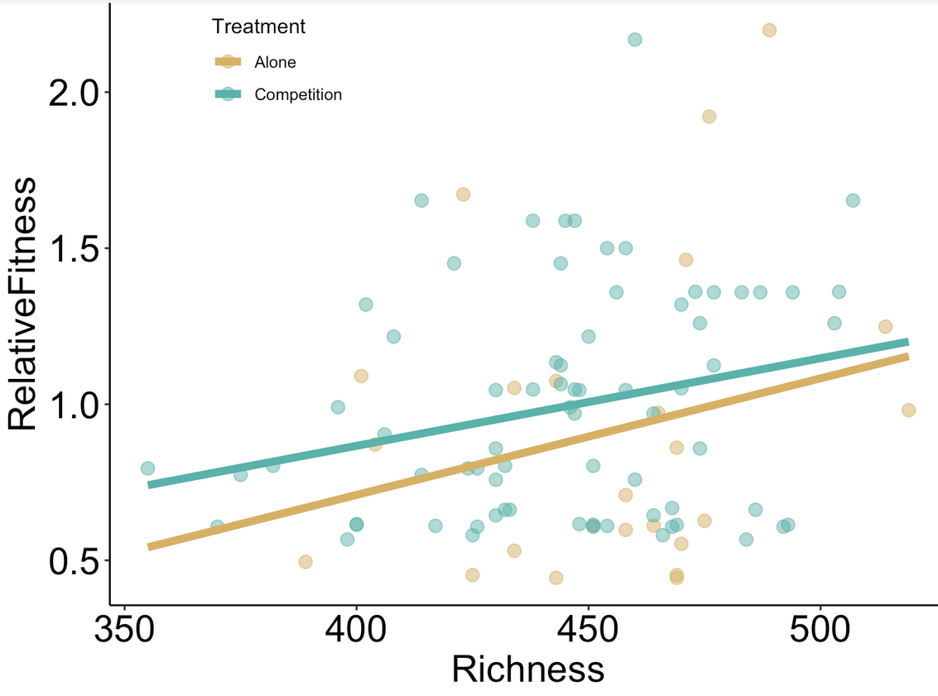

**Figure 1‑3** Linear regression plot between relative fitness and untransformed values of microbial species Richness from *I. purpurea* grown in the absence of competition, or ‘Alone’, (golden points) and in the presence of competition, or ‘Competition’, (green points) treatments, respectively. The gold and green line shows the corresponding linear regression slope between Richness and relative fitness estimated within the Alone and Competition treatments, respectively. We uncovered a significant positive relationship between Richness and relative fitness in the Competition treatment (𝛣 = -0.28 ± 0.17, *p-value* = 0.08), and no evidence of a significant linear relationship in Alone treatment (𝛣 = -0.47 ± 0.75, *p-value* = 0.54). ANCOVA demonstrated that the regression slope between Richness and relative fitness was significantly different according to treatment (*F-value*1,57= 3.26, *p-value* = 0.08; Table 4-5).