Analyse Exploratoire des Données (EDA) - Diabetes

1. Informations générales
None
id Age ... Previous_Gestational_Diabetes Diabetes
count 10000.00000 10000.000000 ... 10000.000000 10000.000000
mean 4999.50000 44.620400 ... 0.516500 0.440800
std 2886.89568 14.343489 ... 0.499753 0.496508
min 0.00000 20.000000 ... 0.000000 0.000000
25% 2499.75000 32.000000 ... 0.000000 0.000000
50% 4999.50000 45.000000 ... 1.000000 0.000000
75% 7499.25000 57.000000 ... 1.000000 1.000000
max 9999.00000 69.000000 ... 1.000000 1.000000
[8 rows x 16 columns]

2. Distribution de la variable cible
Diabetes
0 5592
1 4408
Name: count, dtype: int64
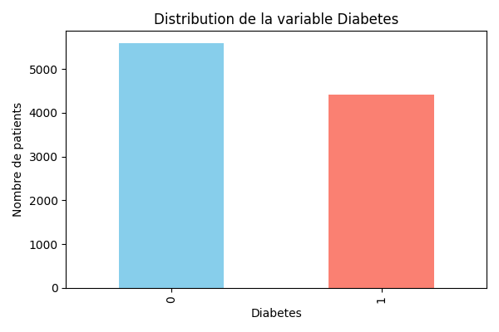

3. Corrélation des variables numériques
id Age ... Previous_Gestational_Diabetes Diabetes
id 1.000000 -0.001209 ... -0.006914 -0.000745
Age -0.001209 1.000000 ... -0.000354 -0.004897
BMI -0.018955 0.009352 ... -0.001130 -0.015505
Waist_Circumference 0.007566 -0.002602 ... -0.015168 0.010620
Fasting_Blood_Glucose -0.003420 0.002696 ... -0.023421 0.662917
Blood_Pressure_Systolic -0.011905 0.002470 ... -0.008987 0.006730
Blood_Pressure_Diastolic -0.003810 0.011472 ... 0.008571 -0.003655
Cholesterol_Total -0.000264 -0.005088 ... 0.003354 -0.011949
Cholesterol_HDL -0.011446 -0.005920 ... -0.001403 0.002948
Cholesterol_LDL -0.008150 0.013345 ... -0.011008 0.008313
GGT 0.004786 -0.001156 ... 0.005011 -0.008407
Serum_Urate 0.003517 -0.014950 ... 0.005458 -0.007727
Dietary_Intake_Calories 0.000554 -0.006665 ... 0.009055 -0.009285
Family_History_of_Diabetes 0.009104 -0.004413 ... 0.004141 -0.008805
Previous_Gestational_Diabetes -0.006914 -0.000354 ... 1.000000 -0.007147
Diabetes -0.000745 -0.004897 ... -0.007147 1.000000
[16 rows x 16 columns]
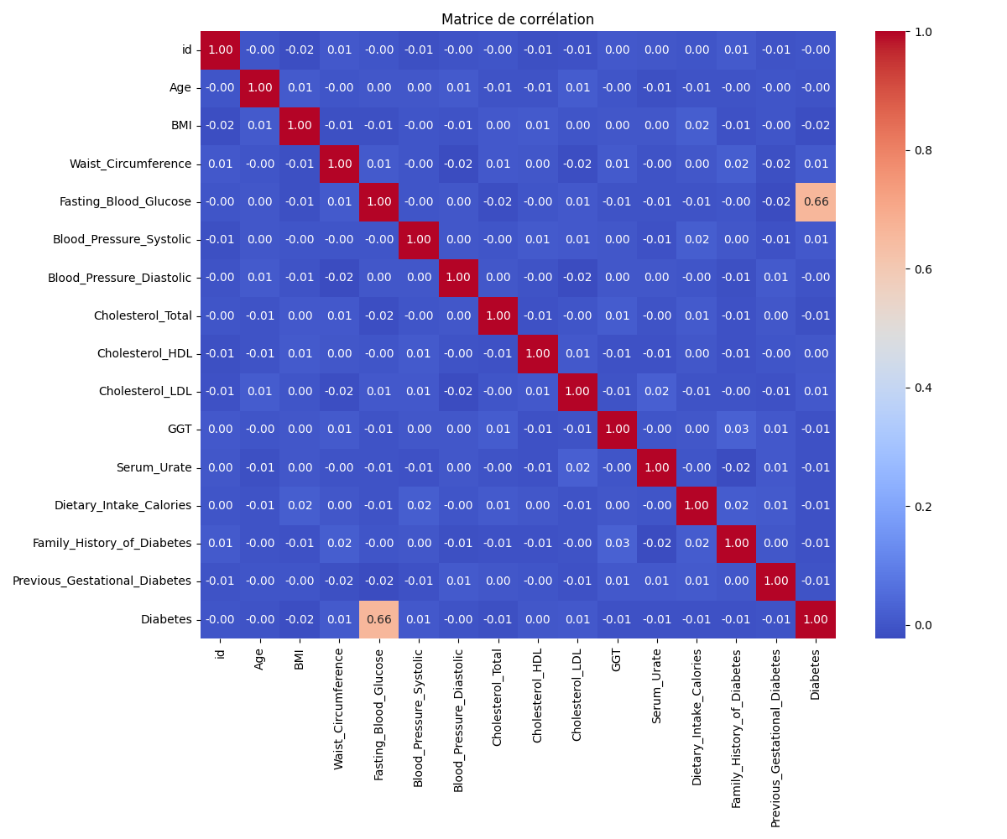

4. Boxplots des variables clés vs Diabetes
Boxplot : BMI selon Diabetes
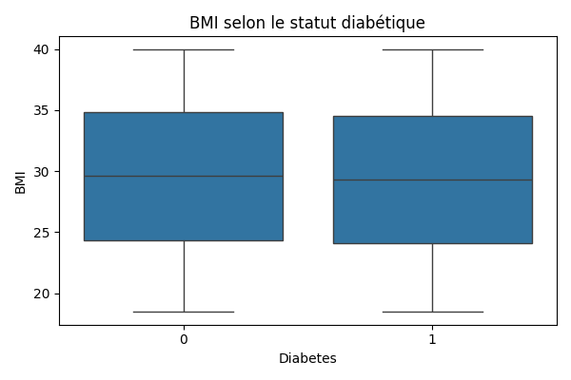
Boxplot : Waist_Circumference selon Diabetes
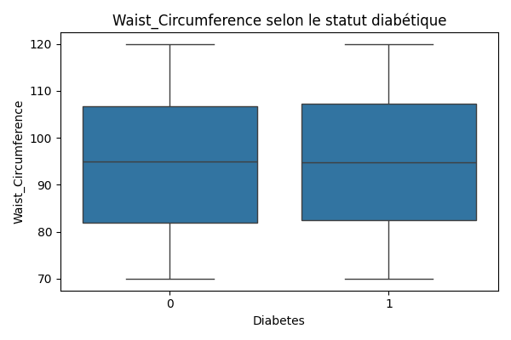
Boxplot : Fasting_Blood_Glucose selon Diabetes
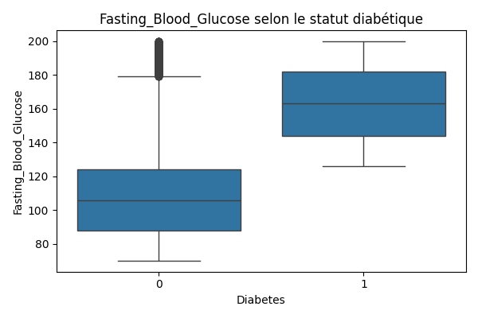
Boxplot : Blood_Pressure_Systolic selon Diabetes
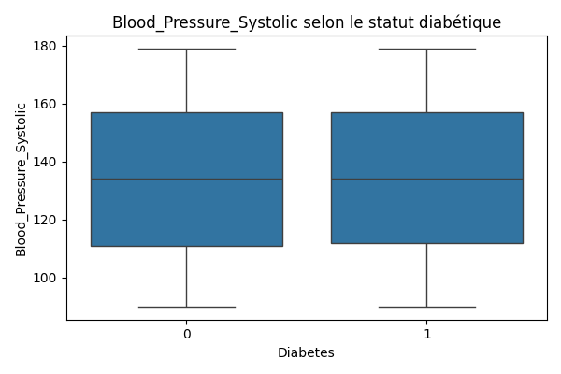
Boxplot : Blood_Pressure_Diastolic selon Diabetes
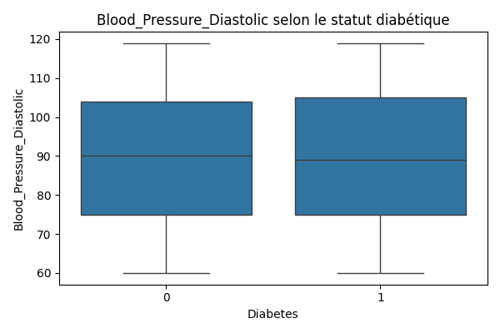

5. Variables catégorielles vs Diabetes
Tableau croisé Sex vs Diabetes (%) :
Diabetes 0 1
Sex
Female 56.66 43.34
Male 55.18 44.82
Tableau croisé Ethnicity vs Diabetes (%) :
Diabetes 0 1
Ethnicity
Asian 54.97 45.03
Black 55.73 44.27
Hispanic 56.26 43.74
White 56.73 43.27
Tableau croisé Physical_Activity_Level vs Diabetes (%) :
Diabetes 0 1
Physical_Activity_Level
High 56.51 43.49
Low 55.72 44.28
Moderate 55.52 44.48
Tableau croisé Alcohol_Consumption vs Diabetes (%) :
Diabetes 0 1
Alcohol_Consumption
Heavy 56.00 44.00
Moderate 56.18 43.82
Tableau croisé Smoking_Status vs Diabetes (%) :
Diabetes 0 1
Smoking_Status
Current 56.15 43.85
Former 55.35 44.65
Never 56.26 43.74
Tableau croisé Family_History_of_Diabetes vs Diabetes (%) :
Diabetes 0 1
Family_History_of_Diabetes
0 55.48 44.52
1 56.35 43.65
Tableau croisé Previous_Gestational_Diabetes vs Diabetes (%) :
Diabetes 0 1
Previous_Gestational_Diabetes
0 55.55 44.45
1 56.26 43.74

