NWB – Neurodata Without Borders

Notes taken from: <http://nwb-schema.readthedocs.io/en/latest/index.html> and <http://alleninstitute.github.io/AllenSDK/brain_observatory_nwb.html>

-HDF5 file with data organized in a certain way

-become familiar with HDFView

-data is usually stored within a Timeseries

-organized in 6 top level folders or **groups** 

-acquisition (acquired data)

-stimulus (stimulus data)

-general (general metadata)

-epochs (experiment organization)

-processing (processed data)

-analysis (analysis data)

-and organized in 5 top-level **datasets** 

-NWB file designed to store data from a single experimental session in a single animal

**Neurodata_type**

-similar to a class

-groups or data sets are given a unique neurodata_type

-**NWBContainer** – group, container for storing data

-**NWBData** – dataset

-important one could be **ElectrodeTable,** used for storing queryable information about electrodes

**TimeSeries**

-neurodata_type

-for storing time series data

-contains a data element and a time element

-data element typically an array

-time elements

-timestamps – to store time information from time base

-sync – (optional) store sample times from acquisition/stimulus hardware

**ProcessingModule**

-for organizing processed data

-store data for and represent results of data processing steps like spike sorting

-stored in the **processing** group, where the data is specified by an **NWBContainer**

-the **NWBContainer** contains a **neurodata_type**, which describes the data within the **NWBContainer**

**\*NWB allows users to optionally define custom names as well**, user has the option of extending the format and can create new neurodata_types for storing custom data

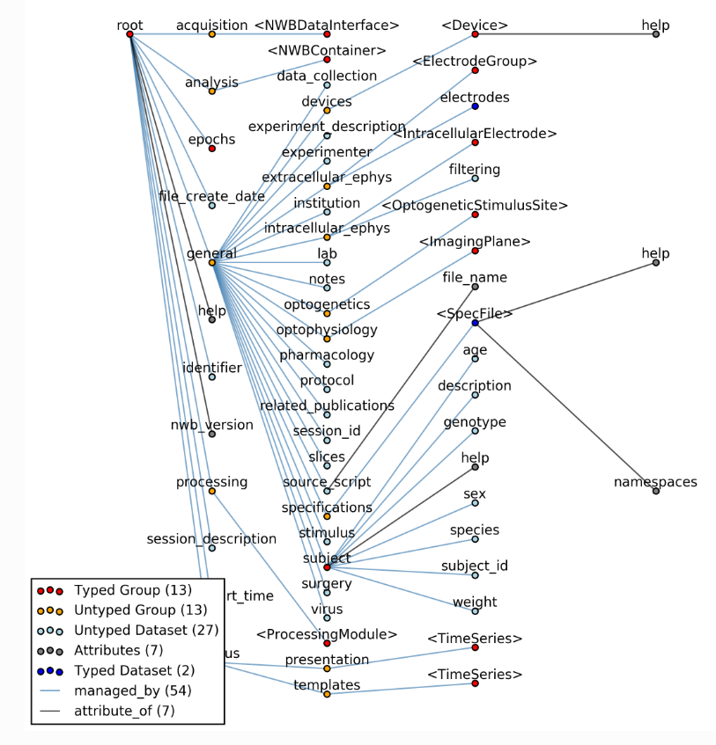

Figure 1: NWB File hierarchy