
1

Web Design Document

Student Name:  Sara Mehrem | Instructor Name:  Dr. Razan Alquran
Section Number:  Section 3 | Course Name:  Website Design and Development

Contents
Web Application Goal 3
Who is the web application for? 3
What the users expect to find or do there? 3
Web application's primary aim 3
Scope 3
Requirements 4
Passenger Sign up 4
Passenger Login 4
Passenger Logout 4
Passenger Transactions 4
Information About the Airline 4
Contact Ways 4
Sitemap 4
Wireframe 5
For Desktop 5
Home 5
Reserve 6
My Flights 7
Booking 8
Update Flight 8
Login 9
Sign up 10
For Mobile 11
Lunching 13
Domain Name and Hosting 13
The Process to Publish My Web Application 13

Web Application Goal

This web application (airline web application) will be created to serve the people who want to travel (passengers) by view the list of flights, and booking for the required flights through this web application.
So, it provides a service which is enabling the user to book for the demand flights.

Who is the web application for?
This airline web application mainly for users who want to travel (the passengers who are booked for the flights).

What the users expect to find or do there?
In the web application are expected to see an information about the airline, contact ways, see the flights list and book on the flight that is required, also they can edit the dates of their flights or delete them.
Also, is expected to find a sign up and log in (for passengers), with the possibility to log out.

Web application's primary aim
Mainly the primary aim of the web application is to provide a service which is booking service for the organized flights.

Scope

The airline web application covers the transportation scope.

The scenarios of the airline web application:
The airline web application involves one user, the passengers who can sign up, login, logout accounts and view existed flights, add bookings of these flights and update (departure and return dates) or delete/cancel any booking of the flights so there are clear functionalities of this web application. The scenarios,
- Information about the airline
- information about the flights
- Flight booking service
- Passenger sign up, log in and logout
- Add, delete, update (departure and return dates), and view bookings by passengers
- No payment (when the passenger book), the payment will be in the airline itself
- Contact ways (Facebook and Instagram)

Requirements

There are many requirements for this web application:

Passenger Sign up
Passengers can sign up by clicking on the place specified for this from login page and then click on the create new account so they can enter their first name, last name, username, email, and password to sign up.

Passenger Login
Passengers can login by clicking on the place specified for this from the navigation bar (click on the login button) and then on the login page they can enter their email and password to log in.

Passenger Logout
Also, the passenger can log out their accounts by clicking on the log out button in the navigation bar.

Passenger Transactions
View the existing flights, add (book) flights from them, update the departure and return dates, and they can cancel (delete) any of the booked flights.
The passengers can see the flights menu and choose any flights to book (add flights), they can view of the list of flights that are booked also they can update (departure and return dates) or delete it.

Information About the Airline
In the home page there are information about the airline (about the airline).

Contact Ways
In the footer they can view the contact ways (contact us) which are through Facebook and Instagram.

Sitemap

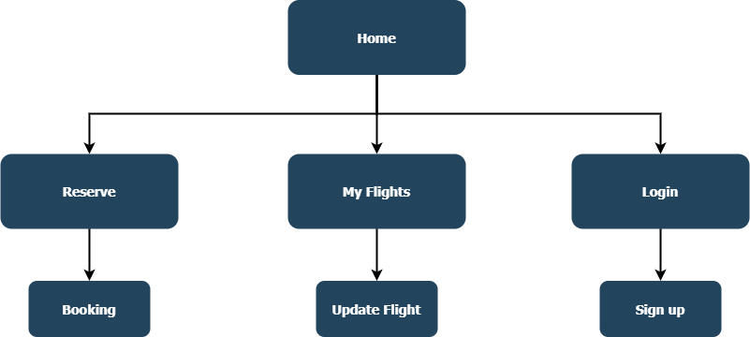
The airline web application sitemap,

Wireframe

The wireframe for the airline web application,

For Desktop

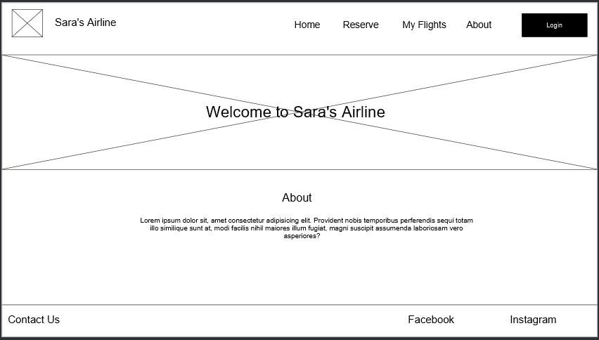
Home

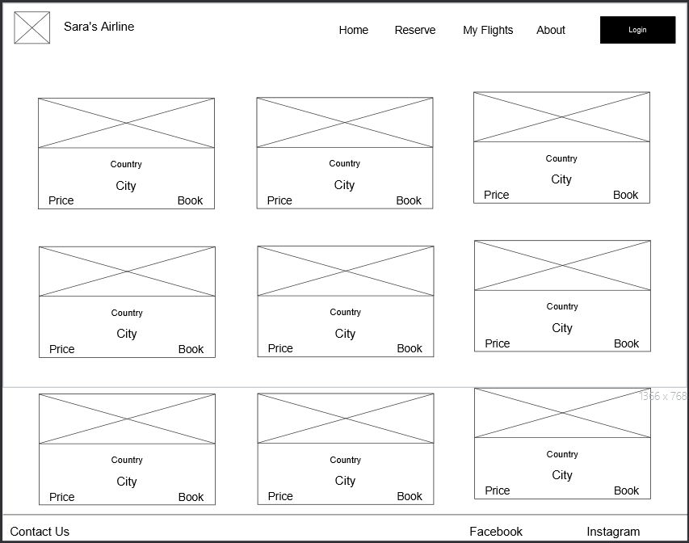
Reserve

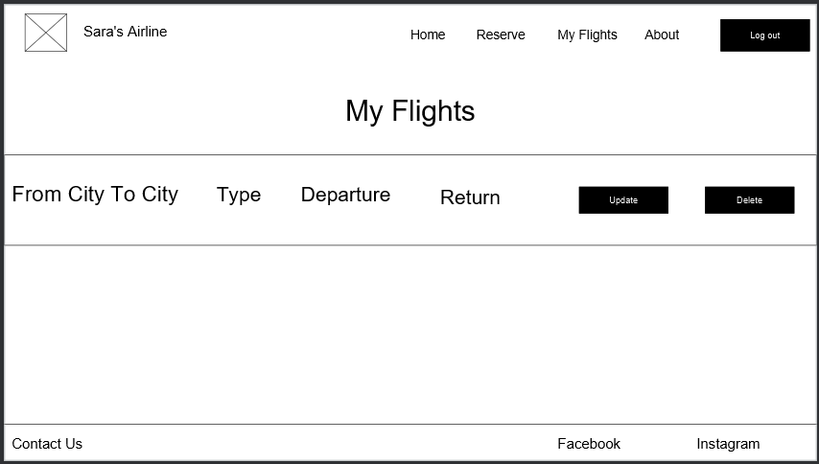
My Flights

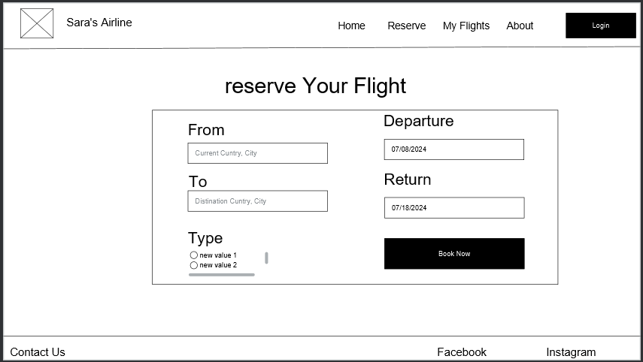
Booking

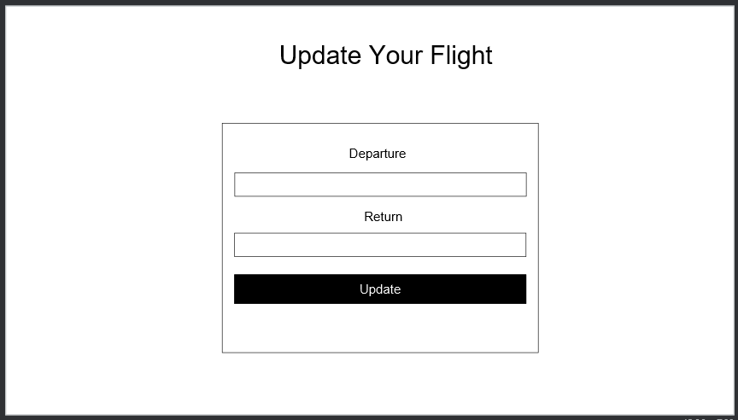
Update Flight

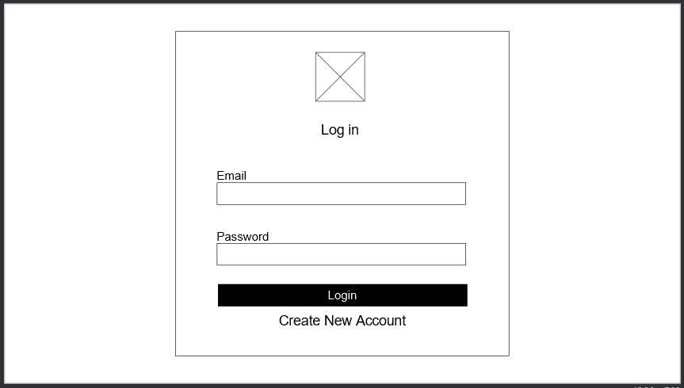
Login

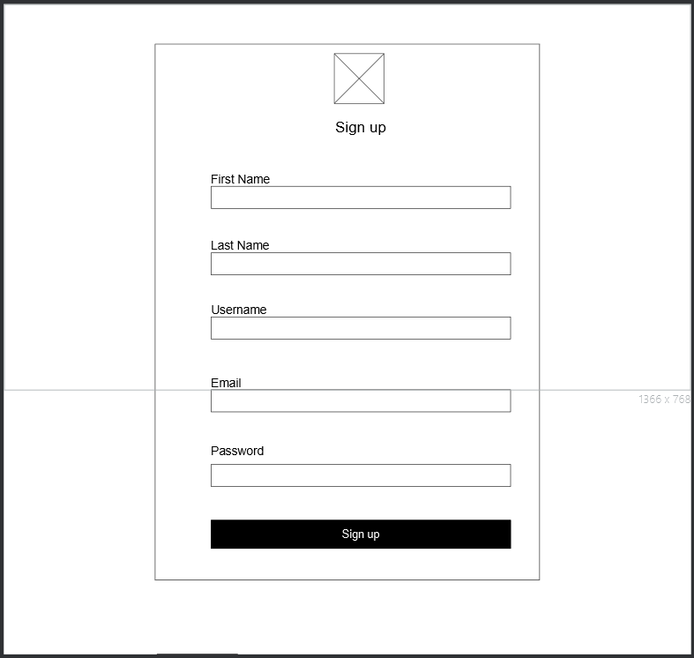
Sign up

For Mobile
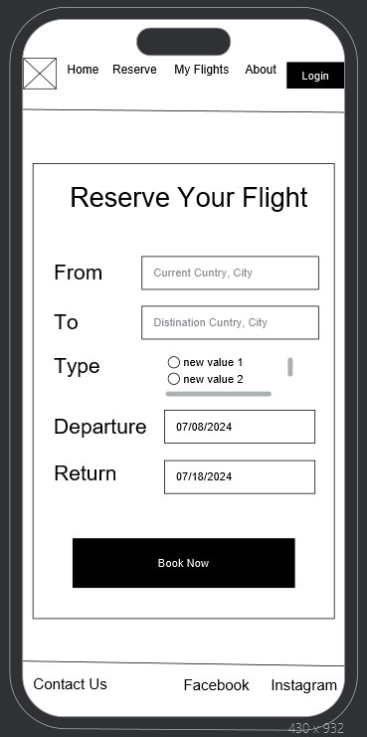
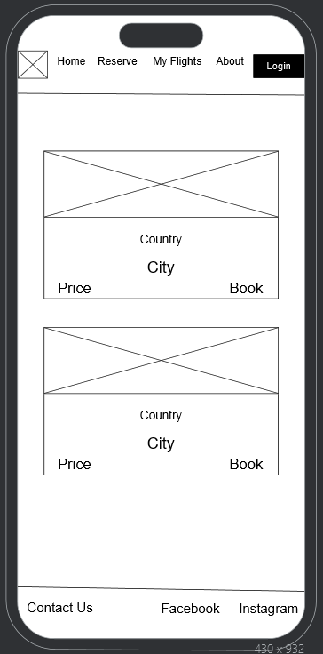
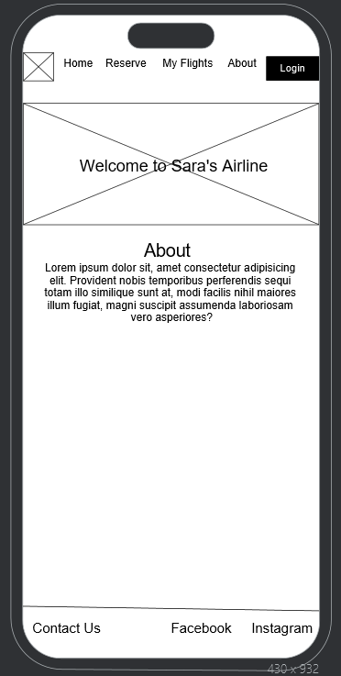

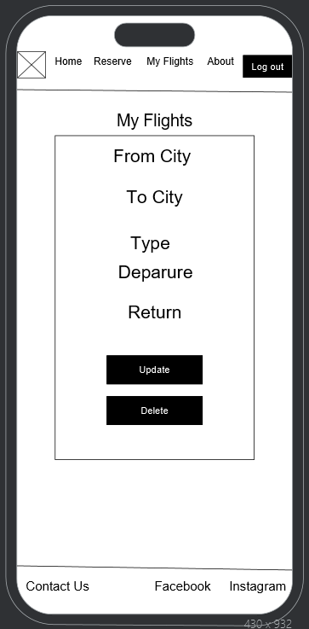
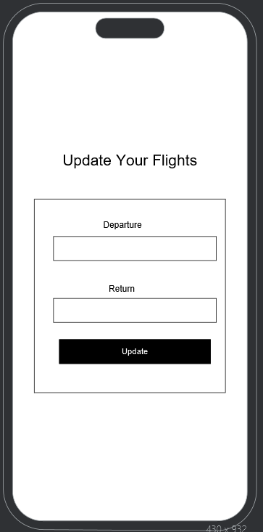

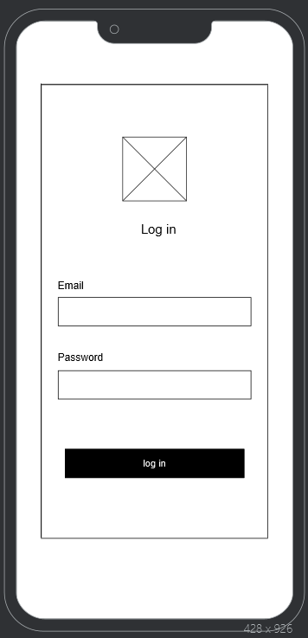
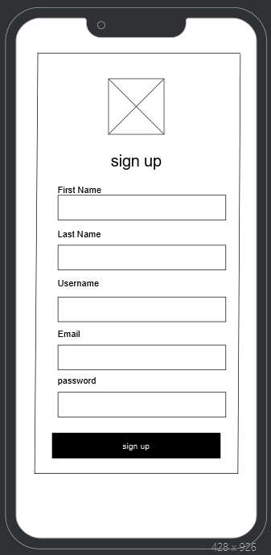

Lunching

Domain Name and Hosting

Domain Name | Host Name
sarasairline.wuaze.com | InfinityFree

The Process to Publish My Web Application
- Register on InfinityFree.com, and log in.

- Click on Create Account.

- At the host plan stage, click on Create Now button.

- At the domain name stage, choose a subdomain, then write the chosen domain name by me which is (sarasairline) and choose the domain extension (.wuaze.com), so the domain name will be sarasairline.wuaze.com. then check the availability by click on Check Availability button
(it is available).

- At the additional information stage, fill the required fields then click on Create Account button, after that click on finish.

- Click on Control Panel button, then click on MySQL Databases, create a database naming it airline, then click on Admin to import the required database.

- Back to the previous page and click on File Manager, click on htdocs, delete the files that are in it, and upload my project files.

- After these steps, the domain name was ready.

