j


Student Name: Sara Mehrem
Student ID: 21110331
Section Number: 2

Database Design and Development
Technical Document

Contents
Technical Documentation 2
Introduction 2
Physical Design 4
Database Development 5
Database Overview 5
Tables in the database 5
Views in the database 6
Procedures in the database 7
Security 8
User Interface 9
Data Movement Diagram 9
For employee user 9
For passenger user 9
Flowchart for employee user 10
Interfaces Development 11
Testing 13
Data Validation 13
PK Cases 13
FK Cases 13
Unique Constraint 14
Check Constraint 14
Default Constraint 15
Output Validation 16
Security Validation 17
GUI Validation 18
Assess whether meaningful data has been extracted 19
Assess the Effectiveness of Testing 20
Data Validation 20
Output Validation 21
Security Validation 21
GUI Validation 22
Database Maintenance 23
Database Recovery & Backup 23
Database Recovery 23
Database Backup 24
Database maintenance 25
Evaluation of Database Solution 26
Effectiveness of the Database Solution based on user and system requirement 26
Suggested Improvements 27
Evaluation based on improvements needed 28

Technical Documentation

Introduction
Sky International Airport, it is a big, modern and efficient airport in Jordan, Amman. It is a well-known airport on the world level, it contains several buildings, multiple terminals, waiting areas, tarmac, series of gates and everything an efficient airport needs, Everyday hundreds of planes fly to and land in, so there are thousands of passengers arriving and departing from it of the all nationalities. The airport has a good reputation and it has a high global rating.
The last time of developed the database system that is long time ago. These days, the airport management decides to design and develop more efficient database system to keep up the good reputation, the high rating and good serve to the passengers.
This airport system consists information about the passengers, airplanes, flight bookings, flights and the employees who are responsible for creating the flights and put details on it. Each flight is created by one employee while each employee can create many flights, as well as, each airplane has multiple flights and the flight belongs to one airplane.
Each flight can have many flight bookings, but the flight booking can only belong to one flight. The passenger can book one or more flight bookings, and the booking for one passenger.

In this database, there are six tables: employee, flight, flight booking, passenger, airplane tables, and address table:
- Employee table with one to many relationship, with the flight table. Also, it contains attributes which are employee id, first name, last name, email, password, salary, and phone number.
- Flight table with one to many relationship, with the employee table, one to many relationship, with the flight booking table, and one to many relationship, with the airplane table. Also, it contains attributes which are fight number, destination, date, time, employee id, and airplane id.
- Flight booking table with one to many relationship, with the flight table, and one to many relationship, with the passenger table. Also, it contains two attributes which are fight number and passenger SSN.
- Passenger table with one to many relationship, with the flight booking table, and one to many relationship, with the address table. Also, it contains attributes which are passenger SSN, first name, last name, email, and password.
- airplane table with one to many relationship, with the flight table. Also, it contains attributes which are airplane id, model, capacity, status.
- Address table with one to many relationship, with the passenger table. Also, it contains attributes which are passenger SSN and its address.

Physical Design
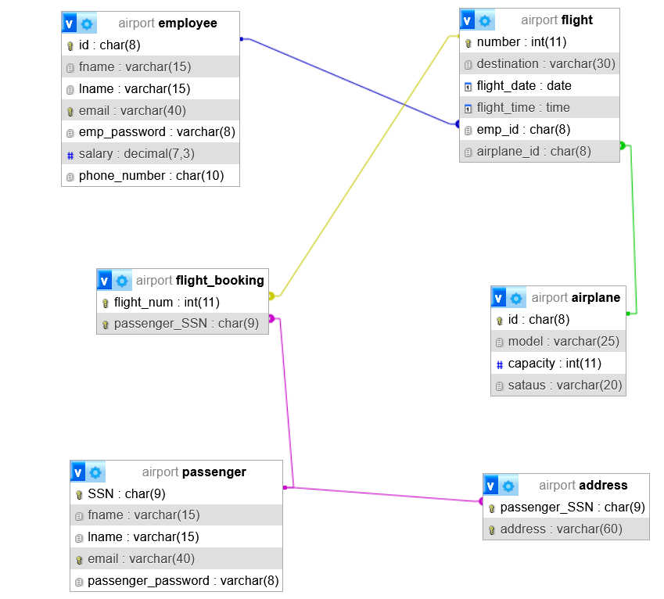

Database Development

Database Overview

Tables in the database
Table | Name | Description
1. | Employee | Employee table stores the employees information
2. | flight | Flight table stores the flights details, the employee who added the flight, and the airplane id for the airplane that will fly to this flight
3. | flight_booking | Flight_booking table this is an intermediate table to connect the flight table with the passenger table, to represent the bookings for passengers in the flights. So, it stores the passenger SSN and the flight number to represent the bookings
4. | passenger | Passenger table stores the passengers information
5. | address | Address table stores the addresses for passengers  (one or more address for each passenger)
6. | airplane | Airplane table stores the airplane information

View | Name | Description | View query
1. | Passenger_info | This view allowed to show/view the first and last name, email (from passenger table) and the address (from address table)  (window of these values) | 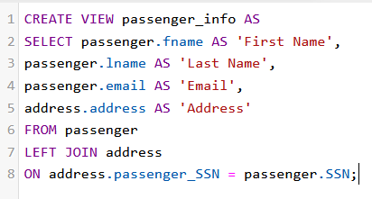
2. | view_flights | This view allowed to show/view the general information of the flights like flight number, destination, date, and time  From flight table  (window of these values) | 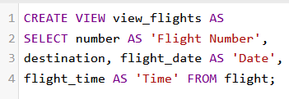
3. | emp_info | This view allowed to show/view the employee information when the salary greater than 1000 and ASC ordered by id  (window) | 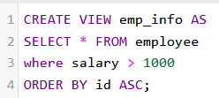
4. | info | This view allowed to show/view the passenger first and last name (from passenger table) and the flight destination (from flight table) and date that are booked by the passenger through the flight_booking table | 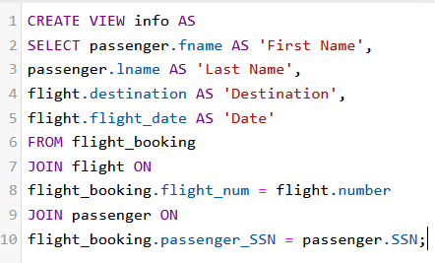

Views in the database

Procedure | Name | Description | Procedure query
1. | update_salary | Procedure to update the employee salary by increasing it by 100 based on employee id | 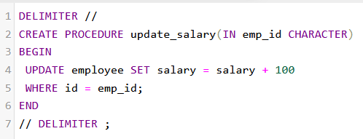
2. | Select_airplanes | Procedure to select/retrieve all the attributes of airplanes | 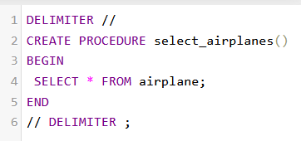
3. | passenger_num | Procedure to select/retrieve the total number of the passengers | 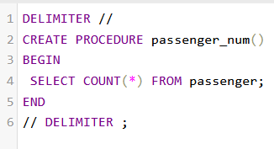
4. | passengerInfo | Procedure to select/retrieve the passenger information based on passenger SSN | 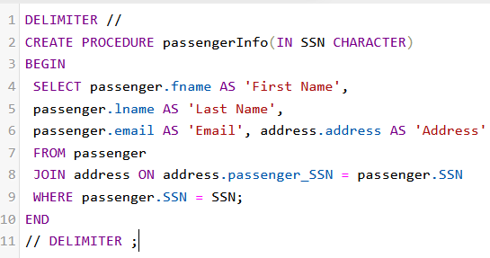
5. | airplane | Procedure to select the airplane id and the number of the airplanes according to model when the number of the airplanes (based on the model) greater or equal than 1 | 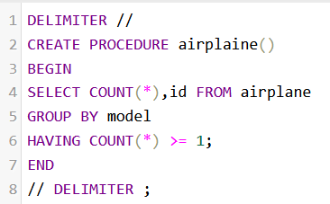

Procedures in the database

User Name | password | Privilege Command | Description | Screenshot
employee | 123 | GRANT SELECT, INSERT, DELETE ON flight TO employee; | The employee user has a privileges such as retrieve data (all flights), insert data(flights), and delete flights from flight table | 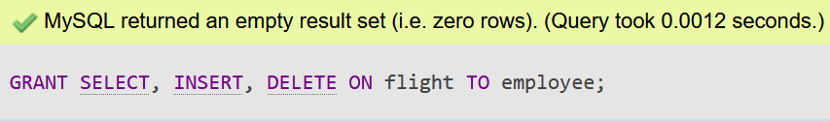  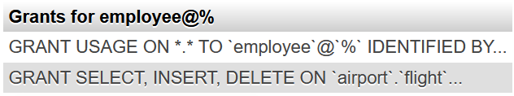
passenger | 321 | GRANT SELECT(fname,  lname,email),  INSERT(SSN,  Fname,lname,  email,password),  UPDATE(fname,  lname,email) ON  passenger TO passenger;  GRANT SELECT ON passenger TO passenger; | The passenger user has a privileges such as, insert all of the attributes of passenger, retrieve the all attributes for the passenger also the passenger user can be able to update the first, last name and email | 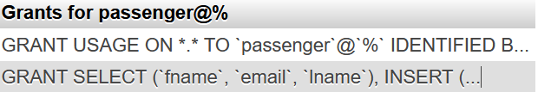
 | 321 | GRANT SELECT  (passenger_SSN,  address),  INSERT  (passenger_SSN,  address),  UPDATE(address) ON  address TO passenger; | Also, the passenger user has a privileges such as insert the SSN and address for the passenger, and retrieve the passenger SSN and its address, and update the address for the passenger | 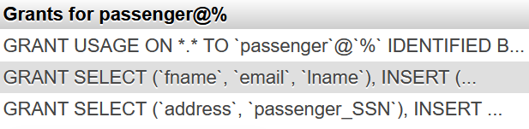

Security

User Interface

Data Movement Diagram

For employee user
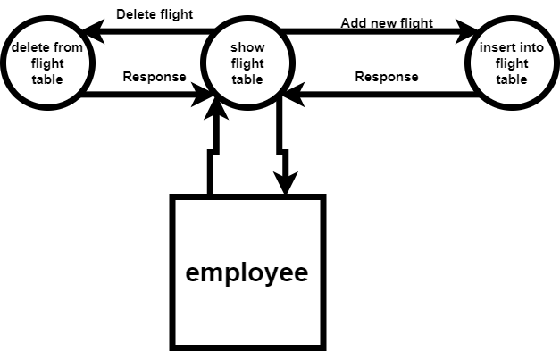

For passenger user
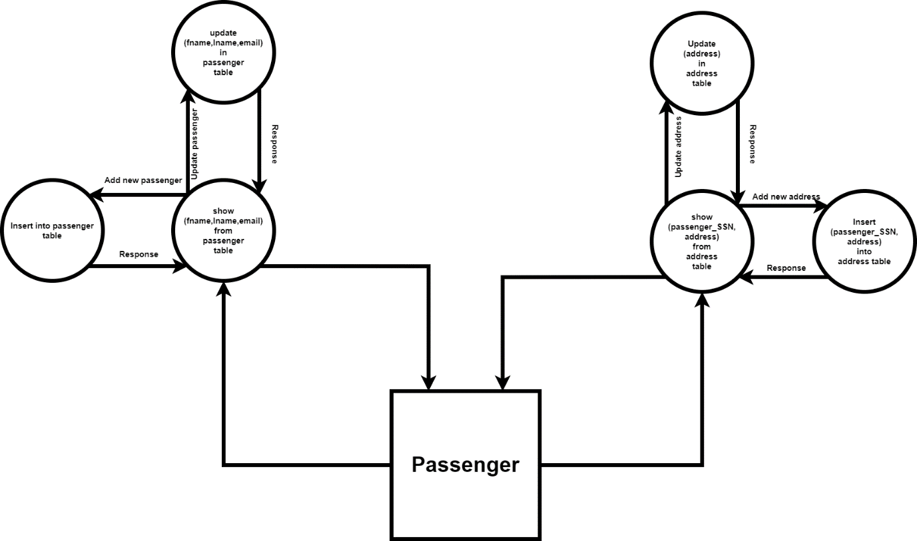

Flowchart for employee user
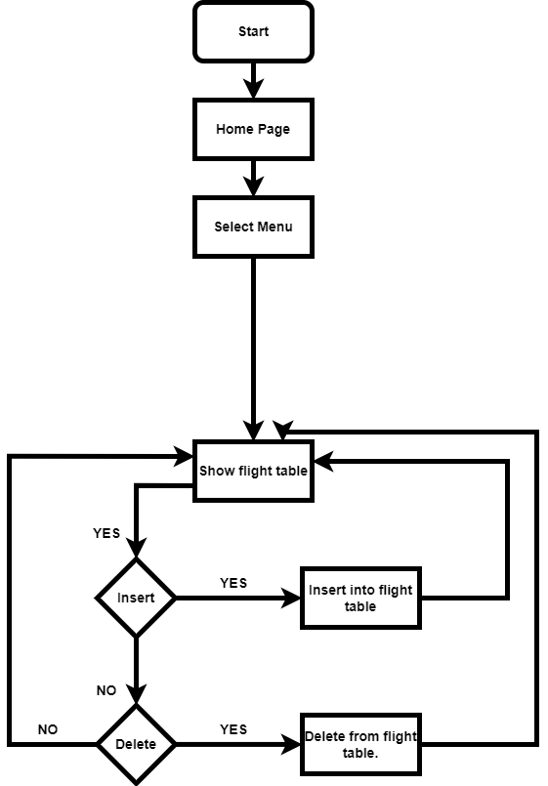

Interfaces Development
Page id | Title | Description | Screenshot
1. | index | The main menu | 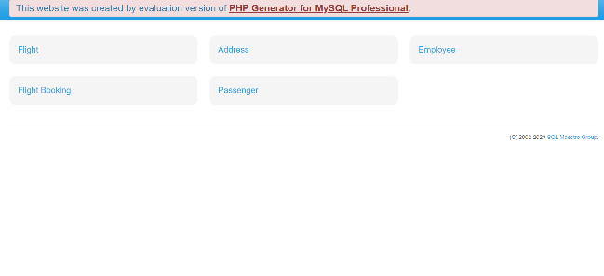
2. | Flight | The flight page that is display the flights information that is exists | 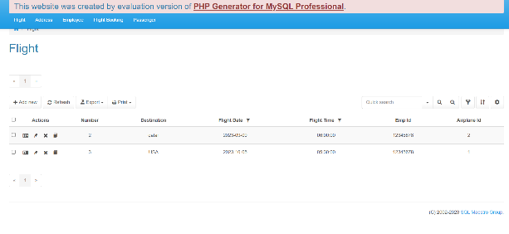
3. | passenger | The passenger page that is display the passenger information | 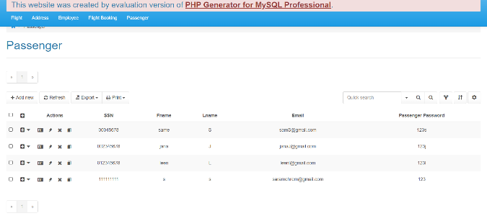
4. | Address | The address page that display the passenger SSN and its address | 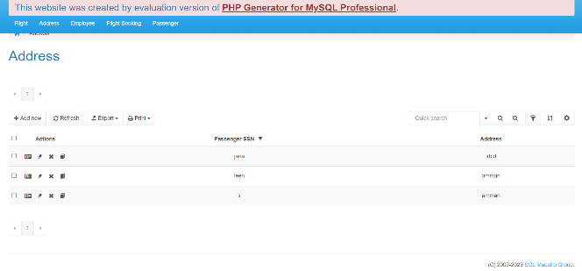
5. | Flight Booking | The flight booking page that display the passenger SSN and the flight number for the flight that has been booked | 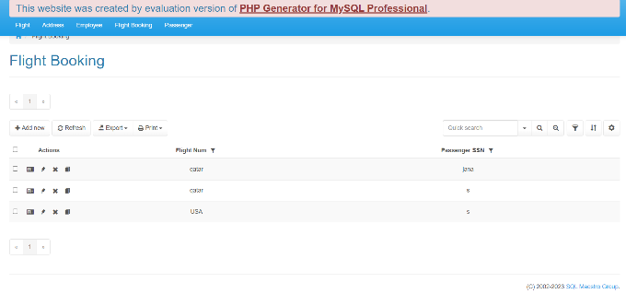
6. | employee | The employee page that display the employee information | 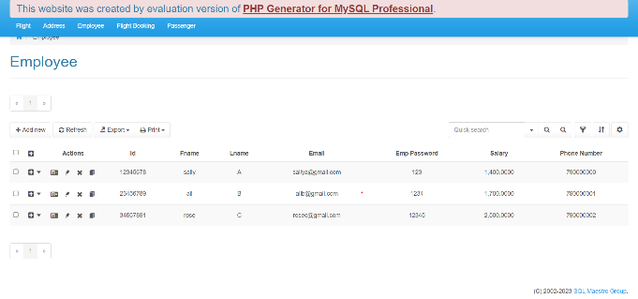

Testing

Data Validation

PK Cases
Number | Type | Description | Screenshot
1. | PK | The airplane id determines the airplane (determines the attributes)  Trying to validate the PK by duplicate it | 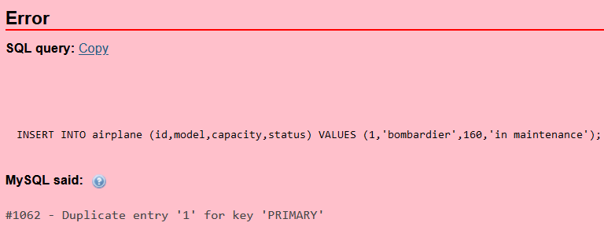
2. | PK | The employee id determines the employee (determines the attributes)  Trying to validate the PK by duplicate it | 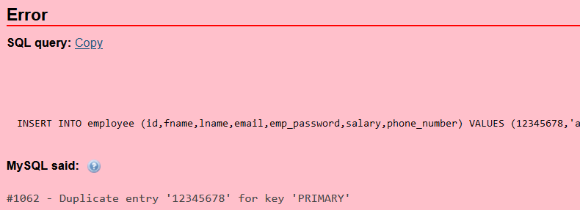

FK Cases
Number | Type | Description | Screenshot
1. | FK | Emp_id FK in the flight table to connect the flight table with the employee table  Trying to validate the FK by enter a value that is not exist in the parent table | 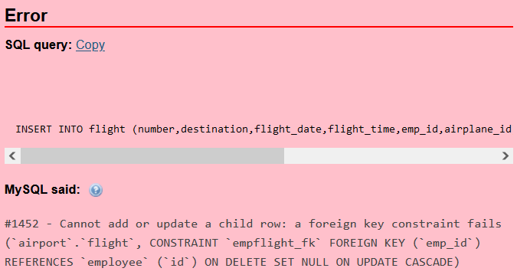
2. | FK | Passenger SSN FK in the address table to connect the address table with the passenger table  Trying to validate the FK by enter a value that is not exist in the parent table | 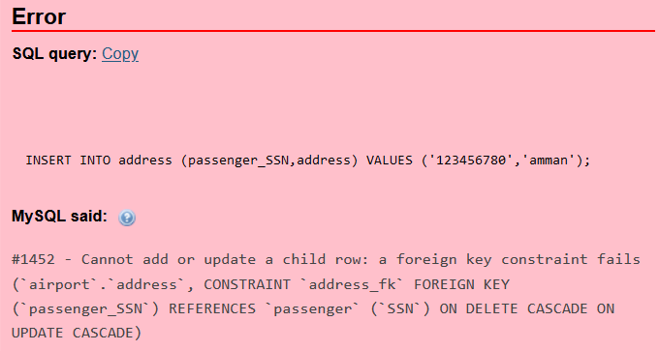

Unique Constraint
Number | Type | Description | Screenshot
1. | unique | Unique constraint for the employee email  Trying to validate the employee email (unique) by enter duplicate email | 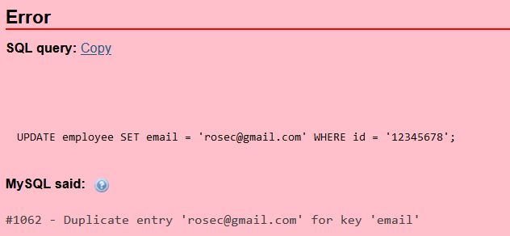

Check Constraint
Number | Type | Description | Screenshot
1. | check | Check constraint for the employee salary to ensure the salary greater than zero  Trying to validate the employee salary by enter a zero value in the salary column | 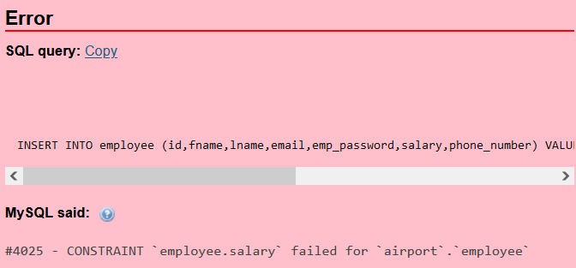

Default Constraint
Number | Type | Description | Screenshot
1. | default | Default constraint for the model attribute in the airplane table to set the default value 'unknown' | 

Output Validation
Number | Query Description | Screenshot (query and result) | Result Validation
1. | This select statement  Selects/retrieves the average of the salaries from employee table | 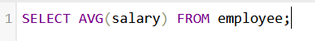  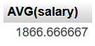 | This select statement retrieves correct average of the salaries from employee table (successfully retrieving data)
2. | This select statement selects/retrieves the first name for those whose email ends with .com from employee table | 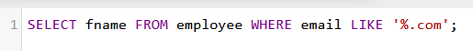  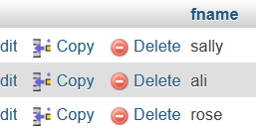 | This select statement retrieves the first names of the employees who their emails end with .com  correct values of retrieval  (successfully retrieving data)
3. | This select and join statement, selects/retrieves the first and last name and email of the passengers (passenger table) and their address (address table)  Retrieve all values even if the address is null  1:N relationship | 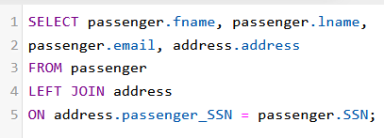  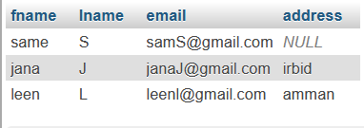 | This select and join statement,  retrieves the first and last name and email of the passengers and their address  correct values of retrieval  (successfully retrieving data)
4. | This select and join statement,  Selects/retrieves the destination and date from flight table and selects/retrieves the first name and email from passenger table,  Passengers who book in the flight  when the destination is Qatar  1:N relationship | 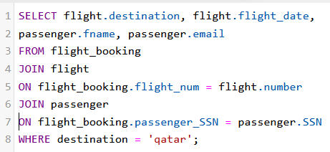  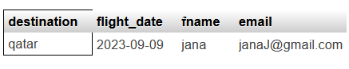 | This select statement retrieves the destination and date of the flights and the first name and email of passenger who booking in the flights when the destination is Qatar  Correct values of retrieval  (successfully retrieving data)

Security Validation
Number | User Name | Description of privilege/no privilege | Screenshot  (query + result)
1. | Employee | The employee user has a privilege to select, insert, and delete on flight table.  And no privilege to drop the flight table | 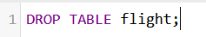  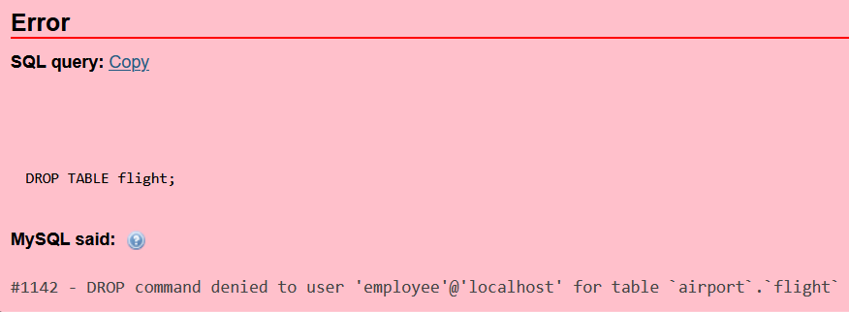
 |  | The employee user has a privilege to select, insert, and delete on flight table.  And no privilege to insert into airplane table | 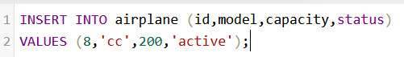  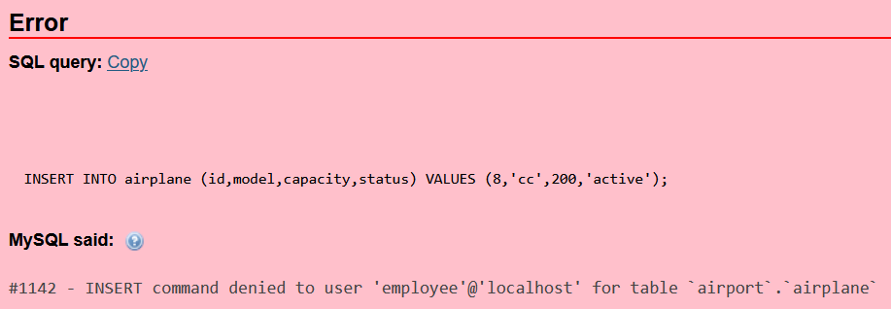
2. | Passenger | The passenger user has a privilege to select the passenger first name, last name, and email.  Insert the passenger SSN, first name, last name, email, and password to passenger table.  And no privilege to update the flight destination on the flight table. | 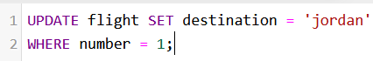  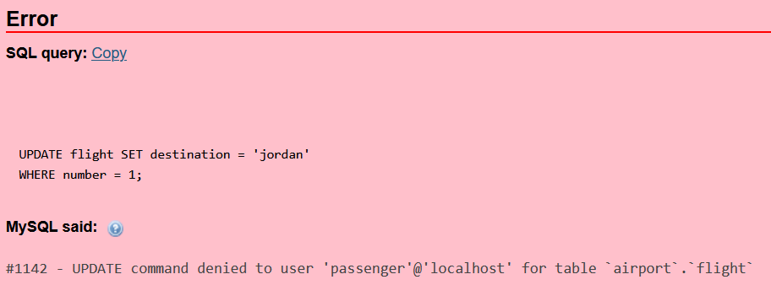
 |  | The passenger user has a privilege to the passenger SSN and address.  Insert the passenger SSN and address and update the passenger address from address table.  And no privilege to delete the passenger SSN from passenger table. | 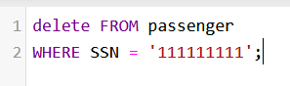  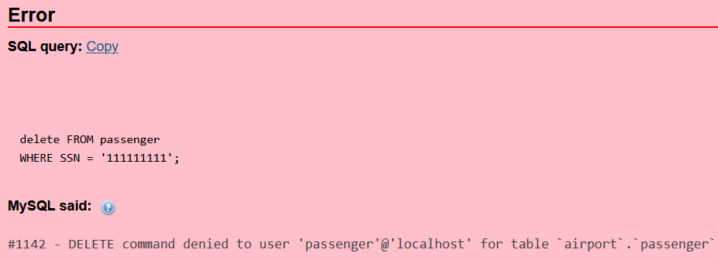

GUI Validation
Number | Description | Screenshot
1. | The employee trying to update the destination of the flight that have number 2  (the employee user has no privilege to update any attributes from the flight table) | 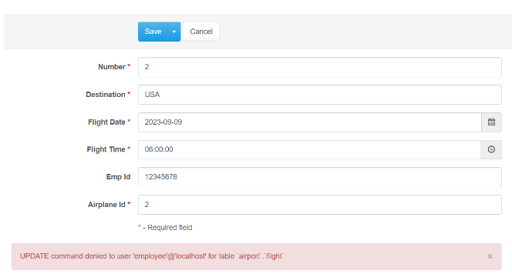
2. | The passenger user has a privileges to insert for all attributes and update the first name, last name,  (and email from passenger table and no privilege to delete any record/row) | 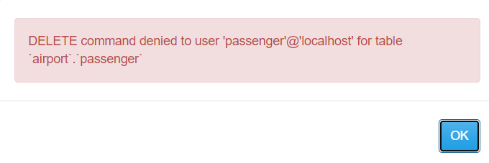
3. | The passenger user has a privileges to select the passenger SSN and the address and update the address from address table  (and no privilege to update the passenger SSN) | 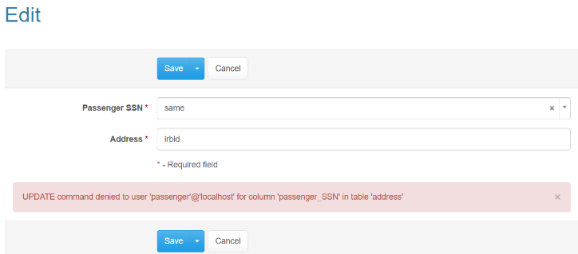
4. | The passenger user has a privileges to select the passenger SSN and the address and update the address from address table  (and no privilege to delete any record/row from the address table) | 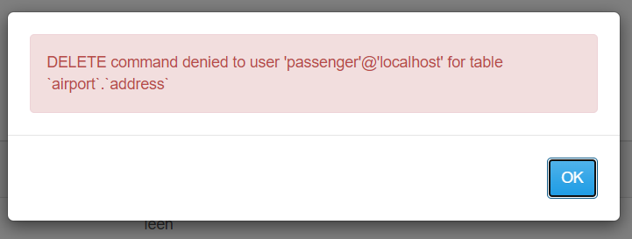

Assess whether meaningful data has been extracted
in the select statement which is retrieve the first name, last name, email, address of the passengers which are meaning information to the passengers so they can see their information, the users (passengers) have the right to see their data and information, so this select statement retrieves the passenger's information which it is useful to the passengers (view information) and they could have transaction on their information like, update it (edit it), or maybe delete it.
This information/data almost reflect the user (passenger), maybe it is need another information and data but the first name, last name, email, and address are enough to reflect the passenger. So it is make sense to reflect the passenger information with the first name, last name, email, and address.
so, this select statement is created to retrieve the passenger information which is meaning to the passengers because this information reflects the passengers. Also, it is useful, so the passengers can see/view their information and maybe they can have transactions on it.

the select statement, select/retrieve data from two different tables (passenger and address with 1:N relationship), because it is needed to retrieve the first name, last name, and email from passenger table, and the passenger's addresses from address table for data integration.
So, it is done using left join (select with left join) to retrieve data from two different tables (join useful) even if the values are null (left useful).
The data that is retrieved is meaningful for the users (passengers), and it is reflected the passengers, and it is enough to reflect them. Also, it is useful for passengers because they have the right to see their information.

Assess the Effectiveness of Testing
Assess the effectiveness of testing (including the data validation, output validation, security validation, and GUI validation) is a very important thing to ensure the efficiently and reliability database. The effectiveness of testing helps to identify the problems, reduce risk, and it is also for improving the user experience (UX).

Data Validation
Data validation prove to be effective through the results of the validation that have been made such as, trying to duplicate the primary key (which is id) on the airplane table by insert the duplicate id, specifically insert this insert statement

( INSERT INTO airplane (id,model,capacity,status) VALUES (1,'bombardier',160,'in maintenance'); )
The PK id (1) already exists in the airplane table, so the database will give an error for this duplicated PK
the database gives this error message for PK duplicated
successful and effective testing (data validation) because when it is inserted a duplicate PK (airplane id), the database gives an error for this duplicated (the PK will be never be duplicate).
By this error, the database prove that it is effective and solid because the database will never accept the duplicated PK such as the example above.
Also, when that is inserted a value in the foreign key that is not exist in the parent table, the database will give an error which is cannot add or update a child raw : a foreign key constraint fails such as the above table of the FK cases, so also it is an effective validation.
Even when try to break any constraint such as (check, unique), the database will give an error like the above examples in the tables, so it is effective data validation.
Also, the attribute with default constraint is not inserted when insert data, will take the default value, after that select these values, also the default value was included such as the default constraint table. So, it is effectiveness validation.

Output Validation

Output validation prove to be effective through the correct retrieval data by the select statement such as, this select statement
It is retrieve first name, last name, email, and address from two different tables even if the address of any passenger is null (using left join), the select statement will retrieve the all information (first name, last name, email, and address)

So, ensure that is retrieving correct data,
it is effective output validation, validate the retrieving data using select, and it is retrieve the data is required (retrieving the first name, last name, email addresses (passenger information)), it is effective because it is retrieve correct data.
In the example above, the output validation proves to retrieve the correct data (first name, last name, email, and address of the passenger) from passenger and address tables. So, by this validation, it has been confirmed that the database is able to retrieve the correct data through the output validation. It is an efficient way to validate the retrieval data.

Security Validation
in the security validation, the database proves that each user has specific privileges can access only them, so the employee user has a privileges to select, insert, and delete the flights from flight table (GRANT SELECT, INSERT, DELETE ON flight TO employee;).

Also, the employee user has no privilege to drop the flight table, and when the employee trying to drop the flight table, this error will appear.
So, the employee has been not allowed to drop the table, and the employee user cannot do this because this is not from his privileges.

The employee user has an access to show, add, and delete from the flight table. By this validation, is proved that each user has been created and given specific privileges, the user cannot access another privileges, and this is effective security validation because, I made sure that each user only has the specified privileges and the user cannot access other privileges such as the employee user, also the employee user has no privilege to insert into the airplane table, and if he/she trying this the error message that will be appeared.
By this effective validation in terms of the security I am sure that the employee user cannot access any privileges expected the privileges that the admin given for this user. In the database environment, not in the graphical user interfaces.
this is effective validation so that I can make sure that every user can only access on his/her privileges through the database environment.

GUI Validation
GUI validation prove that is each user has specific privileges to access them and no allowed to access the other privileges in terms the user interfaces not on the same database. such as the employee user has privileges to select/retrieve, insert and delete data on the flight table through the GUI.
(GRANT SELECT, INSERT, DELETE ON flight TO employee;)

And has no privileges to update the attributes from the flight table through the GUI, while trying to update the destination of the flight that have number 2 through the GUI (the employee user has no privilege to update any attributes from the flight table in database and through the GUI) this error will be disappeared
So, now I am sure that each user has specific privileges to access them and if trying to break them, will appear an error for this. This is effective validation means that each user has only specific privileges to access them and the user cannot break them. Such as the employee user, he/she cannot to update the destination for the flight number 2 even through the GUI. That means the database is effective, solid, and each employee has privileges can only access them, so by this validation, proved that I can depend on the database in terms the user privileges and no privileges, this is effective validation so that I can make sure that every user can only access on his/her privileges through the GUI.
At the end of this question, each validation proves different thing that can make sure that I have solid an efficient database by some validations, data, constrains, output, security, and GUI validations. All these validations help to prove that I have good and efficient database by these effective validations.

Database Maintenance

Database Recovery & Backup

Database Recovery
Database recovery is a database restoring process to consistent status after failure or data corruption. Depend on the failure type and the DBMS that is used, the steps of the database recovery could be different (depend on failure type and DBMS that is used).
How to recover the database?
- Identify the failure type, whether it is a hardware failure, software failure, or data corruption, ….
This step to choose the suits recovery strategy

- Restore/recover the last (the recent) full backup for the database, restore the full back up to the separate location.

- Apply/Implement incremental backup or differential backup (if exists), apply it from the last full backup.

- Apply/implement the transaction logs, the most DBMS saves the transaction logs that are record the last changes of the database. Apply it to replay the transactions and the changes that happened after the last database backup.

- If the failure happened during the running the transactions on the database, it should be rollback uncommitted transactions because the failure could be left with inconsistent status to the database.

- Verify data matchmaking, to ensure the recovered data is reliable.

- Test the functionality of the database, test the recovered database to ensure that it is work efficiently and without any error.

- After the successfully recovered database, communicate with the stakeholders to tell them about the database recovery process.

- After database recovery, it is very important to identify the reason of the failure and take/implement preventive measures to avoid the same and similar fails and problems in the future.

Database Backup
Backup the database to save and protect it from data lose or corruption by creating a copy of its data and structure. The steps of the backup process can be different based on the DBMS that be used.
How to back up the database?
- The first step, which is, connecting to the database

- Then, it should be chosen the type of the backup
(full backup, incremental backup, differential backup)

- Choosing the backup method, the DBMSs have different methods to database backup include, graphical interfaces, scripting, and command-line utilities, so should be use the suits method

- To full backup,
Using graphical interface, in a lot of DBMSs it could be navigated to backup section then start full back up by choosing the suit options
Using command-line utilities, running a command that determines the backup type full and other related options.

- Incremental backup or differential backup, if needed
To incremental backup, backup the changes since last full-backup or incremental backup.
To differential backup, backup the changes since last full-backup

- Determine the backup destination, choosing place to store the backup file, it could be on a local directory, cloud, or on a network location. Ensuring that the destination has an enough space and it is secure.

- Start backup, by the chosen method (graphical user interface, scripting, command-line utilities). Depends on the database size, the process could be take some time.

- Monitor the progress of the backup, for ensuring the backup will be completed without errors. DBMS could be provided a progress indicators or could be provided logs.

- Verify the integrity of the backup, after completing the backup, it is so necessary to verify the integrity of the backup to ensure that is the backup file is not corrupted and it could be used for recovery.

- Test restoration, to test the restoration process for the backup. This step to ensure a successfully recovering data (this step is optional).

- Backup documentation, documenting the backup steps those are followed.

- Creating an organized backup schedule.

Database maintenance
Database maintenance is an important thing of manage the system of the database to ensure the efficient performance and data integrity. Database maintenance helps to prevent problems, optimize performance, and reliable database.
There are many database maintenance technics, like:
- Planning to database maintenance and create a schedule for organized maintenance.

- Recovery and backup
Regular schedule for recovery and backup database to prevent data loss, implement a strategy for backup includes the types of backup (full, incremental, or differential backups).
Periodically, testing the restoration process.

- Index maintenance
Managing and monitoring the database indexes to ensure good data retrieval, rebuilding and reorganizing indexes for improving the query performance.

- Cleaning old data
Removing old and unnecessary data to free up the storage spaces and improve the query performance, implement data deletion strategies based on the client requirements.

- Monitor the database system and identify the problems and issues using monitor tools.

- Monitor performance
Organized monitoring the database performance and take action using tools if needed.

- Database checks
Running organized checks to identify the integrity problems and fix it.

- Review security
Review user access rights for ensuring data security

- Security auditing
Review the user access and audit it for data security, and review the user roles and update it according to business requirements.

- Log management
Monitor the database logs to track the errors. Also, review logs for security breaches.

- System update
Implement updates to the database software these are provided by the DBMS vendor.
- Documentation
Document the database structure, configurations and maintenance procedures, the documentation is for troubleshooting.
- And more things
References: https://chat.openai.com

Evaluation of Database Solution

Effectiveness of the Database Solution based on user and system requirement
in this database I have mainly two users, employee and passenger users.
- Employee User
Let's start with the employee user, I gave this user the follow privileges select/retrieve the information in the flight table, insert to the all attributes (number, destination, flight_date, flight_time, emp_id, airplane_id) in the flight table, and delete any record/row in the flight table. And it is actually these privileges are the privileges that the employee deserves, because the job of this user, show the flights that have been created, insert/create new flights (insert into the flights attributes), and delete any flight for any reason.
Also, the employee user has only access his/her privileges that are mentioned above, and this has been proven in the security table and security, GUI validations. So, the employee user benefited from these privileges that the user can see the flights, insert/add flights, and delete any flight for any reason. And all of this to accomplish the mission of flights until the other user (passenger) sees the flights and book on it. The employee user has a clear benefit from these privileges.
- Passenger User
The passenger user, I gave this user the follow privileges select/retrieve the information of the passenger table, update the first name, last name, and email from the passenger table. Also, select/retrieve the passenger SSN and address from the address table, insert/add the passenger SSN and address from address table, and update the address from address table. And it is actually these privileges that this user need to register, login, log out and update the first name, last name, email, and address.
The passenger user has only access his/her privileges that are mentioned above, and this is has proven in the security table and security, GUI validations. So, the passenger user benefited from these privileges that the passenger can see his/her information (including the passenger address), update the first name, last name, email and address. The benefit of the passenger from these privilege is that the passenger user can register on the future efficient website by add his/her information, after that this user can login and log out.
And there is another privileges (select on the flight table mainly for these attributes (number, destination, flight_date, flight_time) from the flight table, add/insert the flight number with the SSN (booking in the flight) into the flight_booking table, and delete any booking that the user wanted), these privileges that I would to grunt/add to the passenger user in the next time (in the future) but within the short time in this "semester 2023" I didn’t grunt/add it. I want to add these privileges to complete the privileges to the passenger user so, the user can do all the privileges that required from him/her. Finally, full functionality to this user.
By adding the privileges to the employee user and the passenger user (including the privileges that I will add to the passenger user in the future), there will be a complete functionality airport system according to the required user and system requirements.

Suggested Improvements
There are many improvements that I want to add but within the short time I didn’t add it,
such as:
- Adding new table, pilot with the attributes (id, fname, lname, experience, DOB, email, password, phone-number, gender).

- Adding new table, co-pilot with the attributes (id, fname, lname, DOB, email, password, phone-number, gender, pilot_id).

- Adding new table, aviation_host with the attributes (id, fname, lname, DOB, email, password, phone-number, airplane_id).

- Adding new table, department with the attributes (id, name, description, phone_number).

- Adding new table manager, with the attributes (id, fname, lname, DOB, email, password, phone-number, dept_id).

- Adding new table, bag with the attributes (id, passenger_SSN).

- Adding new table, ticket with the attributes (id, destination, leave_date, passenger_SSN, passenger_fname, passenger_Lname).

- Also, adding these new tables (passport, clean-staff, custom, coming–airplane, outgoing-airplane, pharmacy, café, restaurant, map, duty-free) with its attributes for each table.

- With each table the attributes that determine the table (entity).

- Increasing the attributes of the passenger's table such as, gender, age, and nationality.

- Increasing the attributes of the airplane's table such as, year.

- Increasing the attributes of the flight_booking's table such as, seat number.

- Increasing the attributes of the employee's table such as, SSN.

- Adding new constraint on the passenger password, that cannot be less than 8 characters.

- Adding new constraint on the employee password, that cannot be less than 8 characters.

- Changing the password for the passenger and employee attribute's data type size to varchar(20).

- Creating pilot user and give this user the appropriate privileges.

- Creating co-pilot user and give this user the appropriate privileges.

- Creating aviation host user and give this user the appropriate privileges.

- Creating clean-stuff user and give this user the appropriate privileges.

- Creating new view to view the flight-booking table (schedules) to each passenger and make a grunt to each passenger to select it.

- Creating new view to view the airplane table and make a grunt to each employee to select it.

- Creating new view to view the employee table and make a grunt to the manager to select it.

- Creating a new procedure, to add to the salary of the employee by 200 when sent the employee id in the argument.

- Creating the new procedure, to calculate the number of the passengers.

Evaluation based on improvements needed
Even after these improvements, the database still is not scalable and not applicable, and it impossible to use it in the real airport/real life because definitely there are many things missing because I know the general information (the information that the all people know) about the airports while I don’t have any knowledge about the details of the airports including the all people who works on, job titles, departments, ….
It is not applicable because I need to sit with the people with knowledge and competence in airports to learn and collect all the necessary information.
Also, I need to understand the business cycle (how it is going), understand the all things that should be edited, understand and collect the all missing things (tables, attributes, views, procedures, users, constraint, …) to apply it on the database to be scalable and applicable.
So, the database can be applicable if doing all are mentioned above and apply/implement it then the database will be applicable and scalable if there are had a correct understanding and no missing things.

