j


Student Name: Sara Mehrem
Student ID: 21110331
Section Number: 2

Database Design and Development
User Document

Contents
User Documentation 2
System Overview 2
Using The System 2
Home page 2
Address page 3
Passenger page 4
Flight Booking page 6
Flight page 7
Employee page 9
Frequently Asked Questions 10
Contact Information 10

User Documentation

System Overview
Sky International Airport, it is a big, modern and efficient airport in Jordan, Amman. It is a well-known airport on the world level, it contains several buildings, multiple terminals, waiting areas, tarmac, series of gates and everything an efficient airport needs, Everyday hundreds of planes fly to and land in, so there are thousands of passengers arriving and departing from it of the all nationalities. The airport has a good reputation and it has a high global rating. Also, Sky Airport has a good website to do many functionalities.

Using The System

Home page
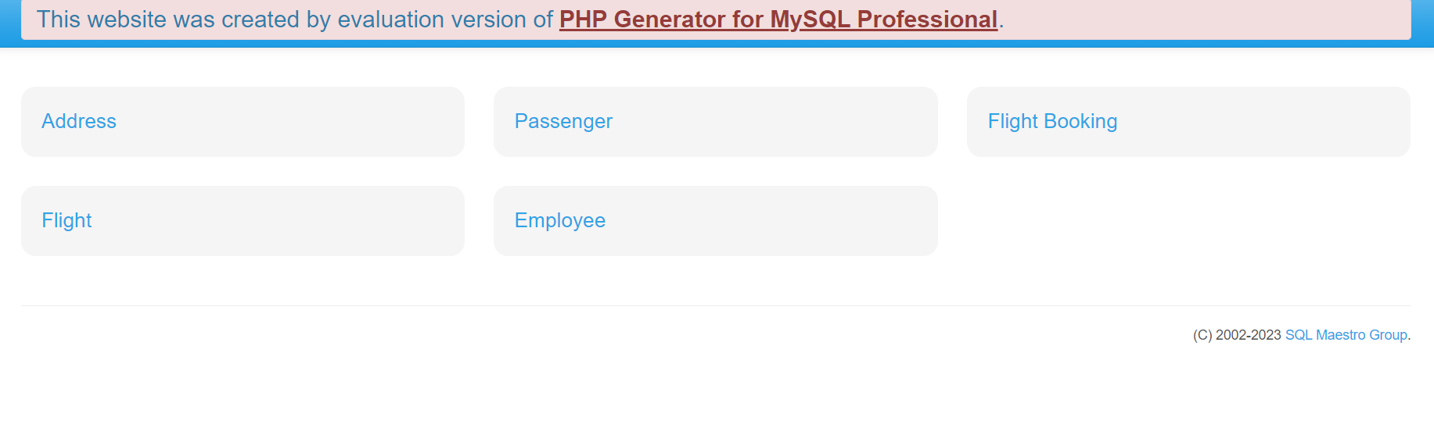
This page presents/shows the main menu, so
- When click on the Address, you will be redirected to address page.
- When click on the Passenger, you will be redirected to passenger page.
- When click on the Flight Booking you will be redirected to flight booking page.
- When click on the Flight, you will be redirected to flight page.
- When click on the employee, you will be redirected to employee page.

Address page
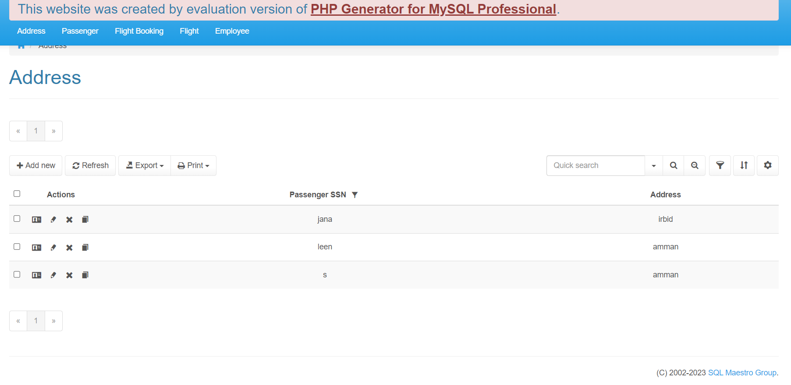in the address page, you will see the all Passenger SSN and the Address (that are related to the Passenger SSN).
- Navbar
- Click here to the record that are want to choose.
- Click here to see/show the specific passenger SSN and its address.
- Click her to edit specific passenger SSN and its address.
- Click here to delete any s passenger SSN and its address.
- Click her to copy the specific passenger SSN and its address
- click at "+ Add new" to add the passenger SSN and their address by this page
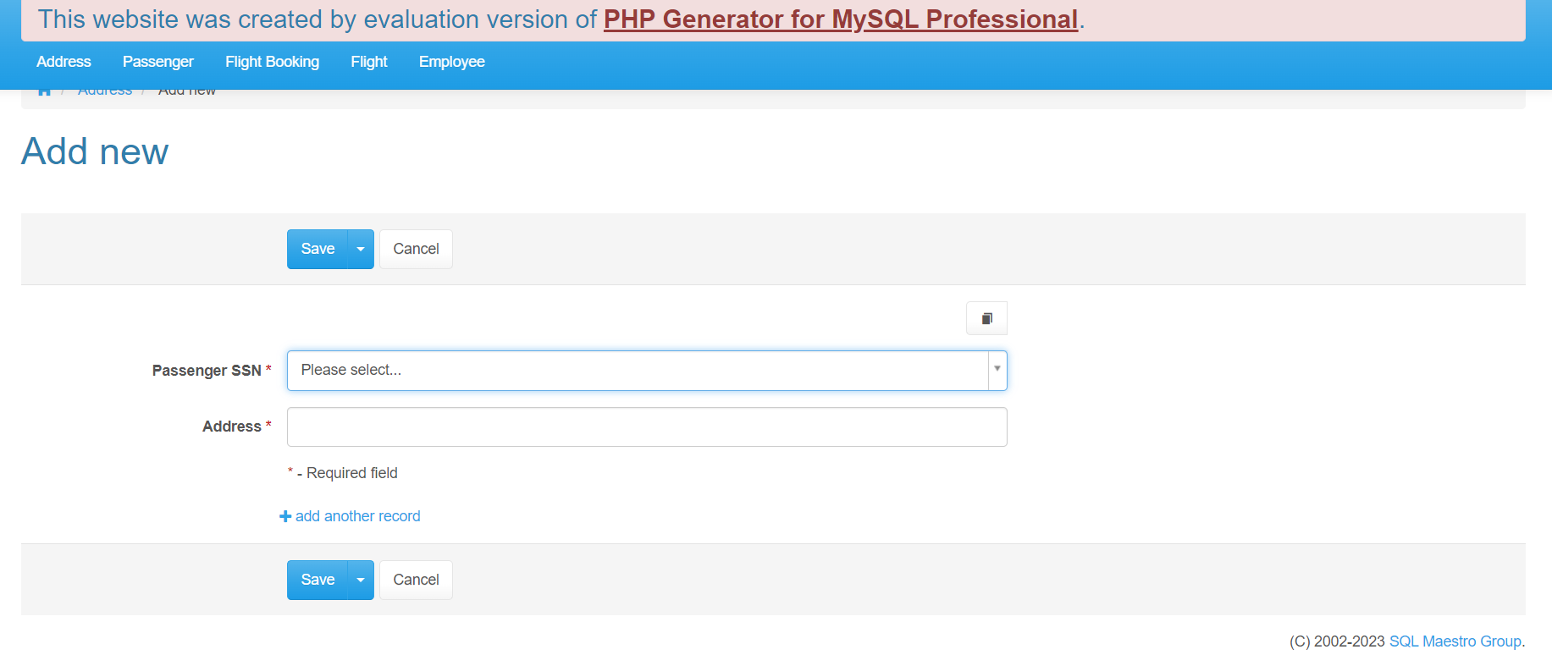
You can choose the passenger SSN the list that will appeared when you click on this words "Please select…" or in the arrow that is on the right side of the first field.
Then, write the address on the address field.
Click on the button save to save the information, or cancel if you want to cancel or ignore the information.
Click on the "+ add another record" to add another passenger SSN and address fields.
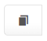
Click on to copy the information.

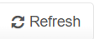
- Click on "Refresh" to refresh the web page.
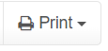
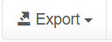
- Click on "export" to export files.
- Click on "print" to print the information.
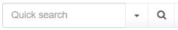
- here to search.
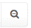
- Click here to clear.
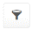
- Click here to filter.

- Click here to sort data.

- Click here to go to the setting page.

Passenger page
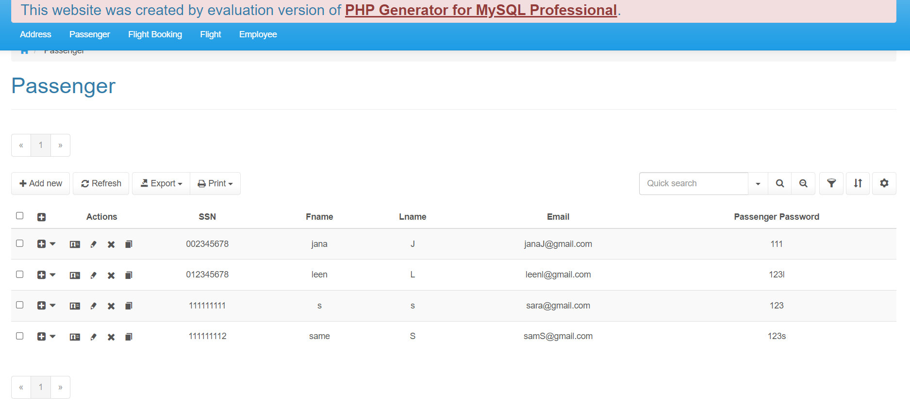
in the passenger page, you will see the all Passenger (passenger information), SSN, first name, last name, email, and passenger password.
- Navbar
- Click here to the record that are want to choose.
- Click here to see the that passenger SSN with the address or flight bookings (passenger SSN and flight number) for this passenger.
- Click here to see/show the specific passenger information.
- Click her to edit specific passenger information.
- Click here to delete any passenger information.
- Click her to copy the specific passenger information.

- click at "+ Add new" to add the new passenger information by this page
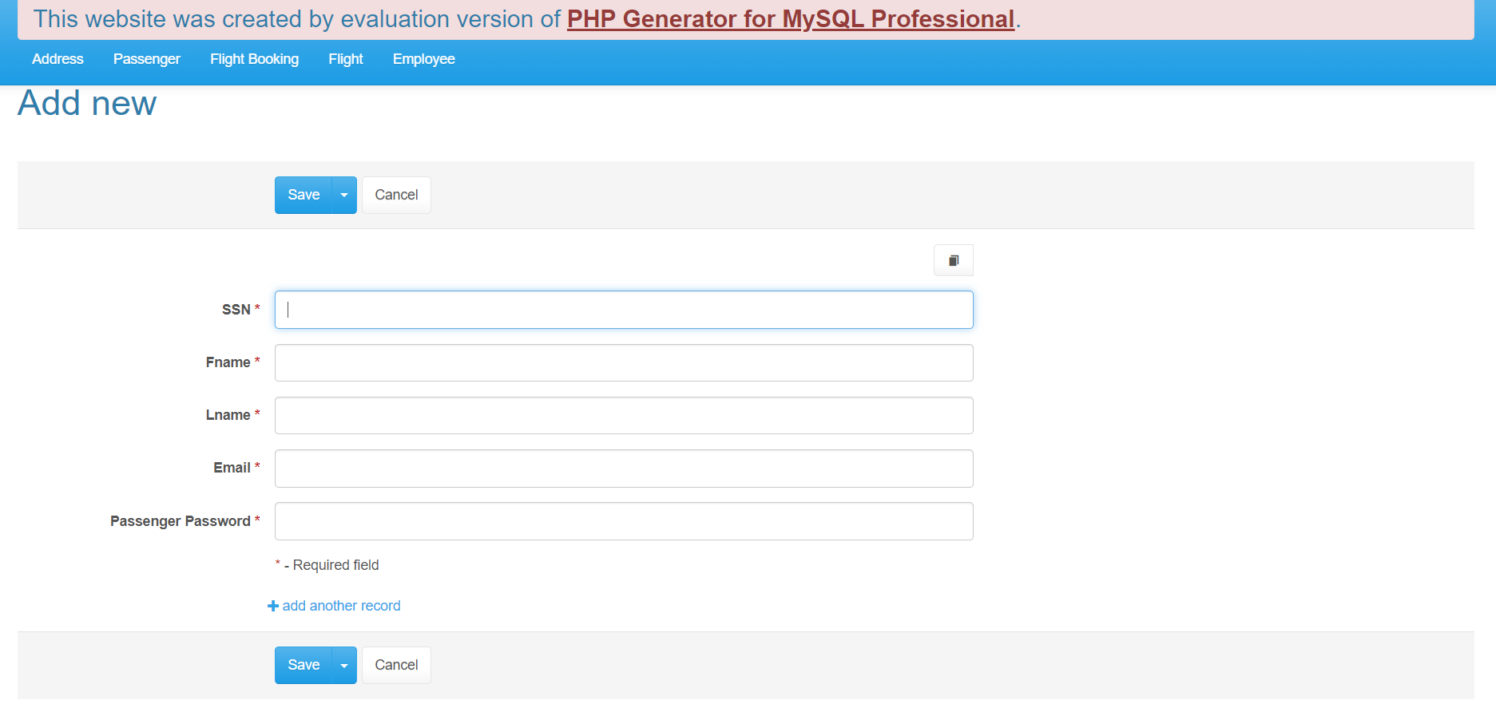
You can fill and write each information in the required input field to add new passenger
Click on the button save to save the information, or cancel if you want to cancel or ignore the information.
Click on the "+ add another record" to add another passenger fields.

Click on to copy the information


- Click on "Refresh" to refresh the web page.


- Click on "export" to export files.

- Click on "print" to print the passenger information.
- Click here to search.

- Click here to clear.

- Click here to filter.

- Click here to sort data.

- Click here to go to the setting page.

Flight Booking page
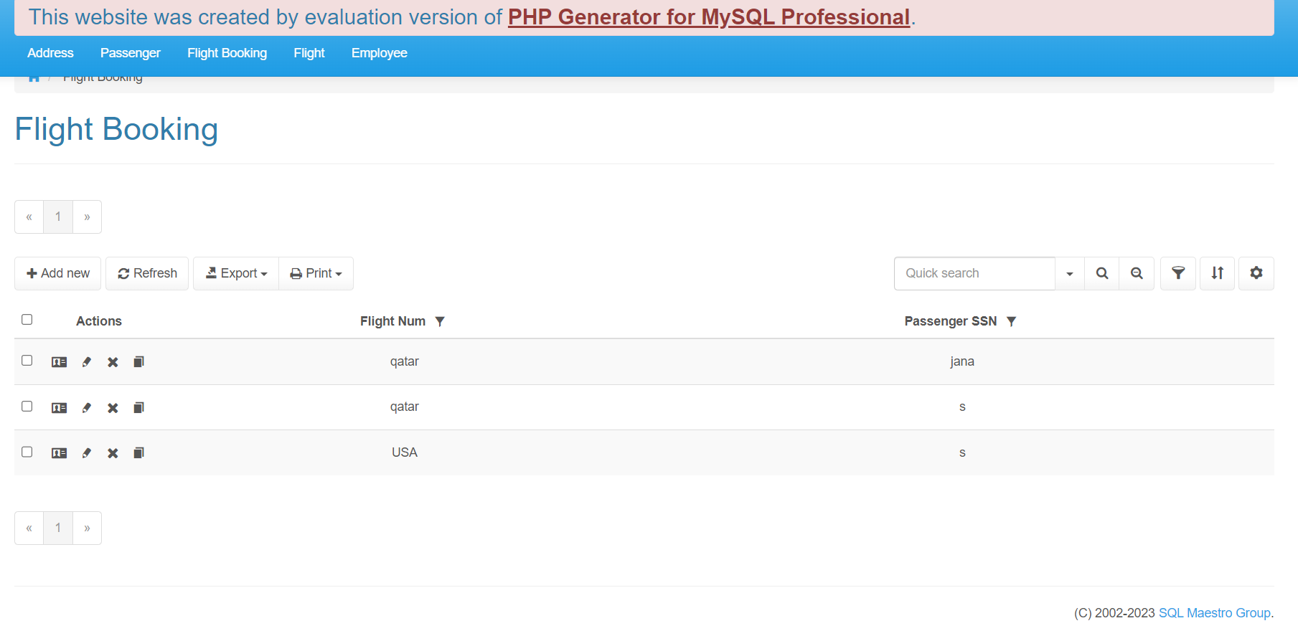 in the Flight Booking page, you will see the all Passenger SSN with the flight number that is booked in.
- Navbar
- Click here to the record that are want to choose.
- Click here to see/show the specific passenger SSN with the flight number of the flight that is booked.
- Click her to edit specific flight booking.
- Click here to delete any flight booking.
- Click her to copy the specific flight booking.
- click at "+ Add new" to add the new flight booking by this page
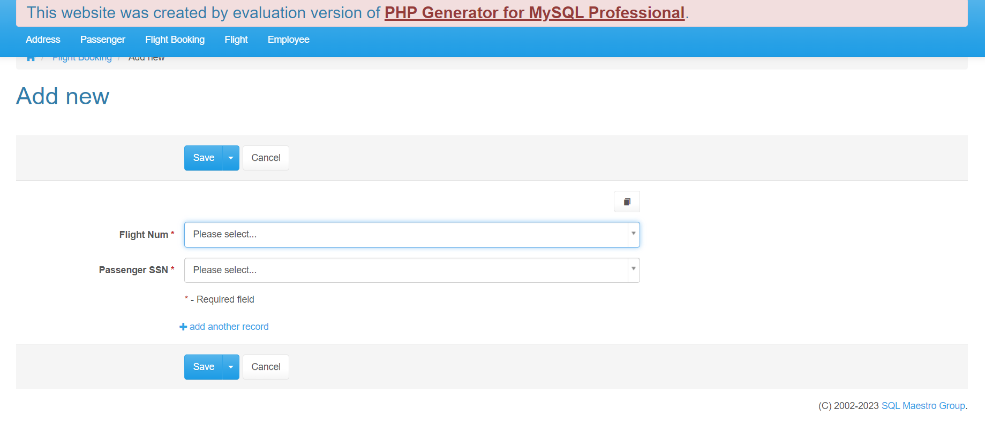 You can choose the passenger SSN and the flight number by the lists that will appeared when you click on this words "Please select…" or in the arrow that is on the right side of the fields.
Click on the button save to save the flight booking, or cancel if you want to cancel or ignore the flight booking.
Click on the "+ add another record" to add another flight booking fields.

Click on to copy the flight booking information.


- Click on "Refresh" to refresh the web page.


- Click on "export" to export files.

- Click on "print" to print the flight booking information.
- Click here to search.

- Click here to clear.

- Click here to filter.

- Click here to sort data.

- Click here to go to the setting page.

Flight page
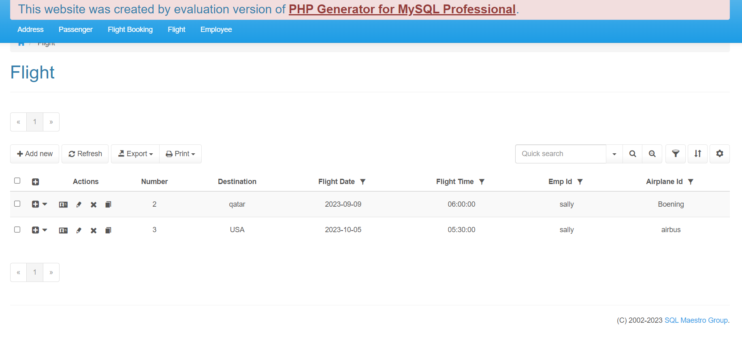 in the Flight page, you will see the all flights that are created with their information
- Navbar
- Click here to the record that are want to choose.
- Click here to see the flight bookings for the specific flight.
- Click here to see/show the specific flight information.
- Click her to edit specific flight information.
- Click here to delete any flight information.
- Click her to copy the specific flight information.

- click at "+ Add new" to add the new flight by this page
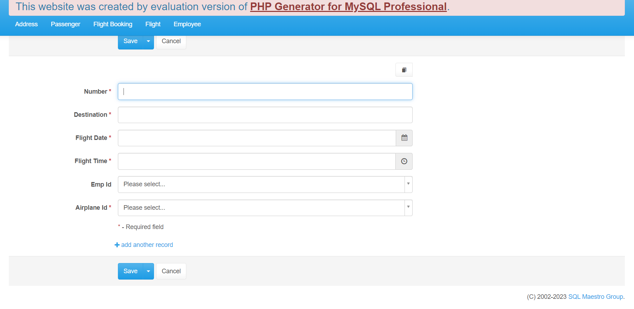you can fill the number and destination by write them, fill the flight date and flight time by determine the date and time, and you can choose the employee id and the airplane id by the lists that will appeared when you click on these words "Please select…" or in the arrow that is on the right side of the fields.
Click on the button save to save the flight, or cancel if you want to cancel or ignore the flight.
Click on the "+ add another record" to add another flight fields.

Click on to copy the flight information.


- Click on "Refresh" to refresh the web page.


- Click on "export" to export files.

- Click on "print" to print the flight information.
- Click here to search.

- Click here to clear.

- Click here to filter.

- Click here to sort data.

- Click here to go to the setting page.

Employee page
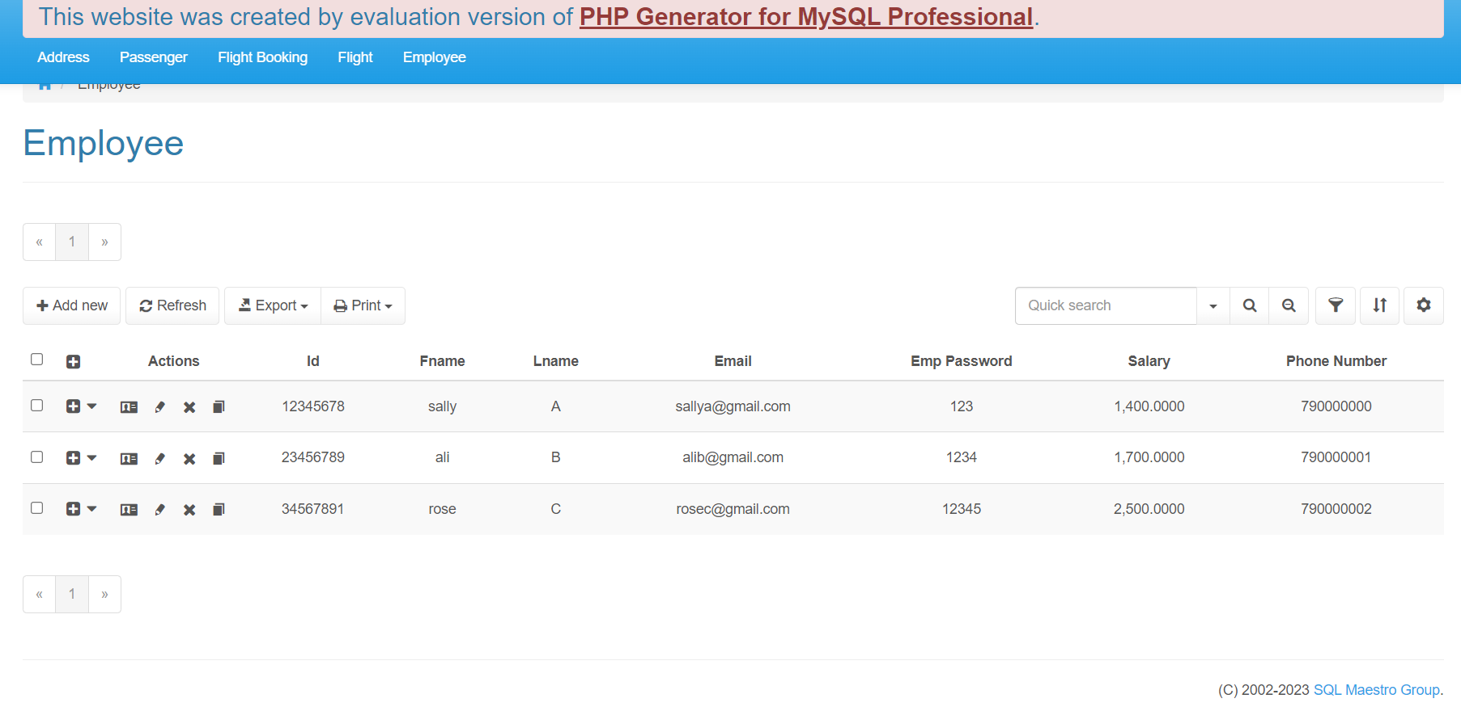 in the employee page, you will see the all employee with their information, id, first name, last name, email, and employee password, salary, and phone number.
- Navbar
- Click here to the record that are want to choose.
- Click here to see the flights that the employee created.
- Click here to see/show the specific employee information.
- Click her to edit specific employee information.
- Click here to delete any employee information.
- Click her to copy the specific employee information.
- click at "+ Add new" to add the new employee information by this page
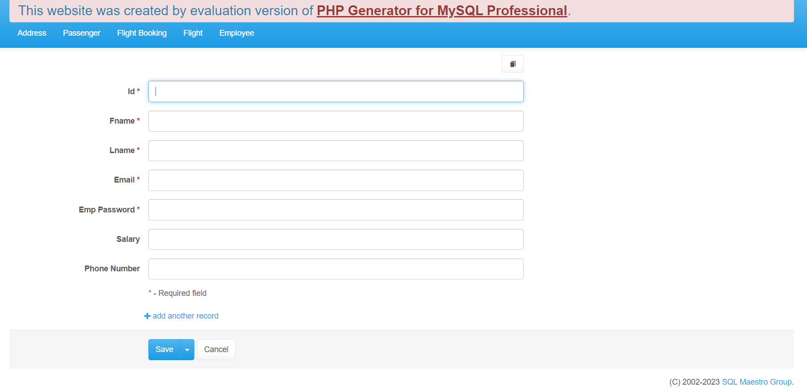 You can fill and write each information in the required input field to add new employee
Click on the button save to save the information, or cancel if you want to cancel or ignore the information.
Click on the "+ add another record" to add another employee fields.

Click on to copy the information.


- Click on "Refresh" to refresh the web page.


- Click on "export" to export files.

- Click on "print" to print the employee information.
- Click here to search.

- Click here to clear.

- Click here to filter.

- Click here to sort data.

- Click here to go to the setting page.

Frequently Asked Questions
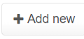
- How to add another new record?
After click on "+ add new" , click on "+ add another record"
- ow to search on specific record according to specific constraint?
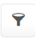
By click on the filter icon then determine according to what.

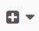
- From where could show the passenger address in the passenger page?
By click on this icon then choose address choice.

Contact Information
For any another question or failure in the system, you can contact me at "21110331@htu.edu.jo".

