**Predictive Coding in the Brain: Exploring the Role of Frontotemporal Circuits in Complex Object Representation**

By: Sara Rostami Supervisor: Dr. Mohammad-Reza Abolghasemi Dehaqani Date: 11/14/2023

1. **Introduction**

We, as humans, constantly try to predict the future. The ability to predict incoming information is crucial to function in a dynamic world. How and why our brain makes predictions is explained by the theory of predictive coding. Predictive coding theories argue that recent experience establishes expectations in the brain that generate prediction errors when violated. Prediction errors provide a possible explanation for Repetition Suppression (RS), where the neural response to a stimulus decreases with repeated presentations of the stimulus. The predictive coding account argues repetition suppression arises because repeated stimuli are expected, whereas non-repeated stimuli are unexpected and thus elicit larger neural responses [6]. However, there is one phenomenon that is frequently presented as evidence for predictive coding over other accounts of perception; Expectation suppression (ES) is defined as a reduction in a measure of neural activity following the presentation of a stimulus that is subjectively expected to appear (i.e. a predicted stimulus), compared to when the same stimulus is presented but is neither expected nor surprising [2][3].

the notion of ‘suppression’ as used within many predictive coding frameworks implies that activity of stimulus-selective neurons is suppressed or inhibited (e.g., via input from other neurons) when an observer’s expectations are fulfilled, compared to when there are no biased expectations in favor of seeing a specific stimulus [3].

Considering the dynamic involvement of the prefrontal cortex in predicting incoming visual signals and the distinguished role of temporal cortices in encoding complex visual stimuli, we posit a distinctive contribution of frontotemporal circuits in the representation of complex objects within the context of expectation.

In our study, we utilized electroencephalography to investigate repetition suppression by presenting sequences of complex visual stimuli (houses, faces) that were either expected or unexpected across different trial blocks.

Next, I offer a concise overview of the ongoing work in this project and highlight some of the potential methodologies we intend to use to address our research question.

1. **Task Description**

The task consists of 1800 trials divided into four blocks, each employing a specific trial structure. Subjects are required to observe the presented images while seated. Each trial commences with presenting a fixation cross with a duration uniformly distributed between 800 and 1200 milliseconds, followed by a 250 ms display of an image. After a 500 ms delay (blank screen), a second image is presented for 250 ms. The images are comprised of three categories, faces, inverted faces, and houses. The types of the first and the second image within each trial is the same.

Two of the blocks are categorized as "match blocks" while the remaining two are referred to as "non-match blocks". The match blocks primarily consist of pairs of identical images, which account for 80% of the trials (4 pairs per each category); we call this type of trial "Match Trials". The remaining trials involve non-identical pairs within the same category; we call this type of trial "Non-Match Trials". Conversely, the non-match blocks predominantly feature non-identical image pairs. Additionally, 10% of the trials in each block involve the presentation of colored images (green or red), prompting subjects to press the space bar to indicate their detection in within the fixation presentation of the next trial. These colored trials are intended to sustain subjects’ attention and are excluded from subsequent data analysis.

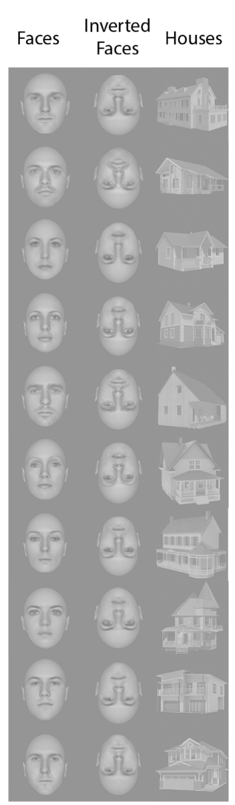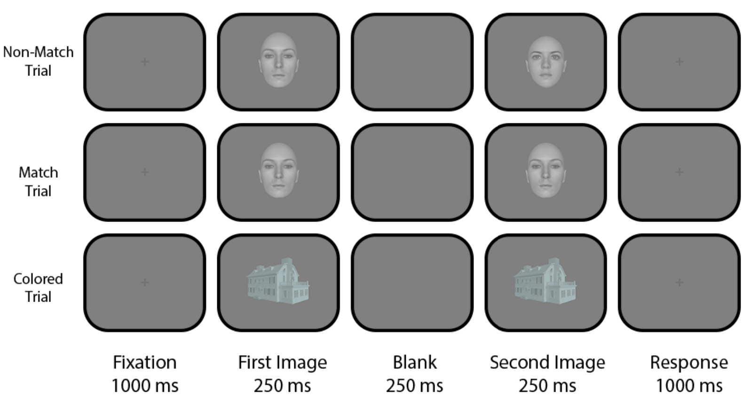

**Figure 1:** Experimental Task Paradigm

To ensure an equal distribution of image presentations, we employ a set of 15 images (5 per category) for each consecutive match and non-match block. We use 5 identical pairs of images for each category to prepare our match trials. To construct the non-match trials, we randomly select 5 non-identical combinations of images for each category. In the match blocks, identical pairs are presented 24 times, whereas nonidentical pairs are repeated 6 times. Conversely, in the non-match blocks, the presentation frequencies are reversed. Identical pairs are shown 6 times, while non-identical pairs receive 24 presentations.

**Figure 2:** Images used in the task

The task was implemented using the Psychtoolbox in the MATLAB.

1. **EEG Recording and Pre-processing**

EEG data from 10 subjects was recorded at the National Brain Mapping Lab (NBML) during the presentation of stimuli. The recording of EEG signals was facilitated using the g.HIAMP device in conjunction with the 128-channel g.GAMMASYS cap. The sampling frequency of the device is equal to 1200 Hz. We are currently in the process of conducting offline pre-processing using the EEGLAB plugin in the MATLAB environment.

***3.1 Preprocessing for Decoding***

For the decoding part, the data is downsampled to 256 Hz. A Finite Impulse Response (FIR) high-pass filter is used to remove frequencies lower than one hertz from the signal. Also, a similar low-pass filter is applied to the signal to only keep data with a frequency lower than 100 Hz.

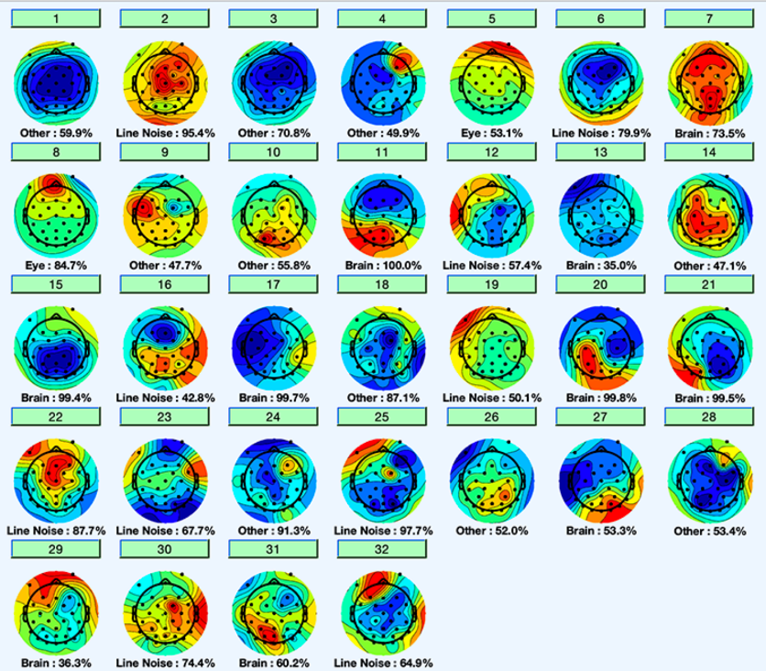Furthermore, a band-stop filter (48-52 Hz) was applied to eliminate city electricity noise. Signals were referenced to the mean value, obtained by subtracting the mean of all electrode signals. High-noise intervals were visually identified and removed. Independent component analysis (ICA) isolated noise components based on a noise index, which were then excluded from the original signals. This process enhances the accuracy of recorded electrode signals by isolating brain activity from noise.

Following the signal cleaning process, the data is epoched into an 800-millisecond window, consisting of 200 milliseconds before and 600 milliseconds after stimulus presentation. To enhance precision, baseline normalization is performed by subtracting the average value of the pre-stimulus period from these segments. This step is crucial in mitigating the impact of cognitive activities unrelated to our analysis, which may occur during each trial.

***3.2 Preprocessing for Functional Connectivity***

In the preprocessing phase for functional connectivity analysis, specific steps are undertaken to assess phase locking. The decoding preprocessing steps are fully implemented, and during the segmentation stage, a time interval of 3 seconds before and after stimulus presentation is chosen. This extended interval is essential for breaking down the signal into distinct frequency ranges using the Hilbert transform, a requirement for accurate phase locking analysis.

Figure : An example of displaying components after applying independent component analysis

Given that low frequencies necessitate at least 2.5 cycles for accurate power and phase estimation, enlarging the investigated signal interval is critical. This expansion minimizes frequency calculation errors and ensures a more precise assessment of phase locking dynamics [1].

In Granger causality analysis, signal stationarity is crucial for obtaining reliable results. Stationarity implies that the statistical properties of the time series remain constant over time. To achieve this, the raw signal undergoes preprocessing steps, including passing through a 100 Hz low-pass filter and eliminating linear noise with a 48-50 Hz low-pass filter. The resulting signal is then referenced to its average value [5].

For the Granger causality analysis, the signals are further segmented into a time interval of [-0.2, 0.6 seconds] aligned with stimulus presentation. Notably, noise and inappropriate signal removal methods are not applied in this phase. Additionally, the high-pass filter is omitted to maintain signal dependence consistency across past times for Granger causality analysis. This ensures that the temporal relationship between signals and their past states remains unchanged throughout the analysis.

1. **Anticipated Procedures:**

***4.1 Event-Related Potential***

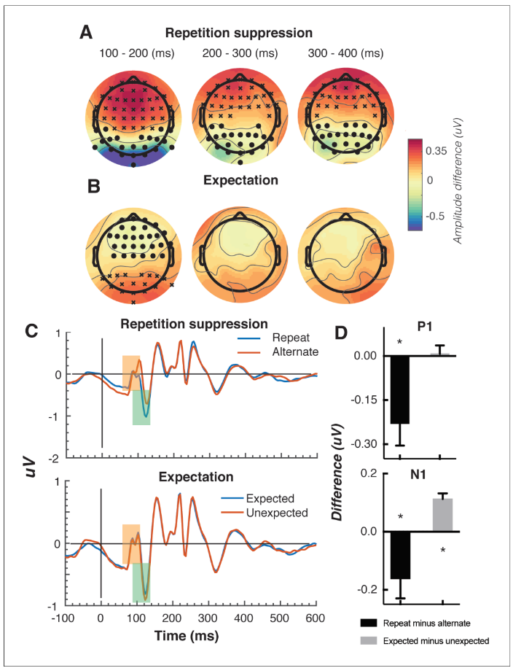We plan to investigate the temporal and spatial effects of expectation on neural responses using Event-Related Potentials (ERPs) analysis. Since ERPs are time-locked, they can precisely capture the brain's response to stimuli with millisecond accuracy. According to previous studies, we expect to see a significant repetition suppression and expectation effect [6] over a cluster of occipital-parietal electrodes. Moreover, we plan to conduct a traditional peak analysis on two classic early components – the N1 and P1, to aid comparison with previously published studies on the mismatch negativity.

In Figure 4, you can see the results of ERP analysis done by Tang et al., 2016. Panels A and B depict the main effects of repetition suppression and expectation, respectively, across three post-stimulus epochs (100–200 ms, 200–300 ms, 300–400 ms) and all electrodes. The main effect of repetition suppression can be observed with circles denoting clusters of electrodes showing significantly reduced activity and crosses indicating clusters with significantly increased activity.

Figure : Results of ERP analysis for the effect of repetition suppression and expectation on the second stimulus in a pair [6]

Similarly, the main effect of expectation is displayed in panel B. Panel C presents bandpass-filtered (2–40 Hz) event-related potentials (ERPs) averaged over occipital-parietal electrodes, with peak analysis markers denoting the P1 and N1 components. The orange shading highlights the P1 component, while the green shading indicates the N1 component. Panel D displays the results of the peak analysis for P1 and N1 components, with asterisks denoting statistical significance (p < 0.05). It's important to note that the plotted values represent differences between conditions rather than condition-specific evoked responses.

***4.2 Multivariate Pattern Analysis (MVPA)***

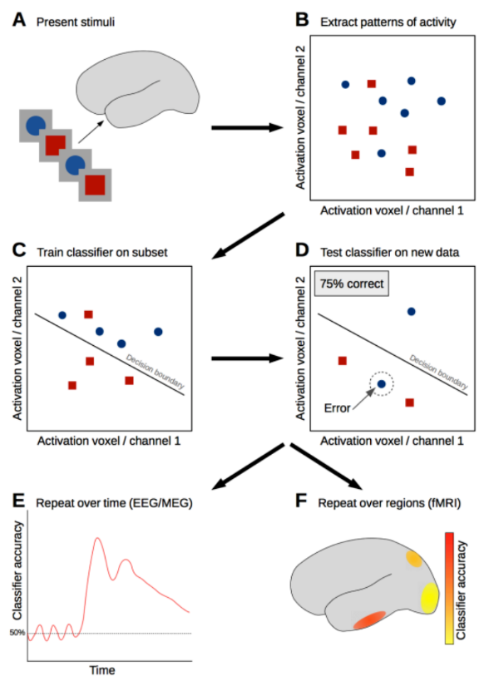For the next step, we endeavor to elucidate the temporal and spatial trajectory of stimuli representations during expected vs. unexpected conditions using multivariate pattern analysis (MVPA enables the determination of when decoding occurs (temporal analysis) and the specific brain regions involved in decoding based on channel response, contingent upon the chosen feature selection method. The MVPA technique involves employing multiple classification machines for each time point in the signal. At each time point, the classification machine utilizes sensor values (channels) as features and undergoes training based on the provided data. Subsequently, testing the classifiers with new data yields a performance measure, and combing these measures across the series of classifiers produces a graph illustrating the decoding rate over time.

Figure : The general decoding approach. (A) Brain responses to stimuli (B) Patterns of activation evoked by the two stimulus conditions are represented in multiple dimensions (channels in EEG/MEG or voxels in fMRI); here only two dimensions are illustrated for simplicity. (C) A classifier is trained on a subset of the neuroimaging data, with the aim of distinguishing a reliable difference in the complex brain activation patterns associated with each stimulus class. (D) The performance of the classifier in distinguishing between the stimulus classes is evaluated using test set (E, F) Steps B–D may then be repeated for different time points (when using EEG/MEG) to study the temporal evolution of the decodable signal or repeated for different brain areas (in fMRI) to examine the spatial location of the decodable information [4].

* ***Statistical Analysis***

To achieve statistical evaluation and generalization, the analyses will undergo inter-subject level testing. This involves conducting the Wilcoxon signed-rank test on data from 10 subjects in both temporal and spatial domains to ascertain the significance of the obtained results. This test is applied to assess the evaluation criteria for all categories, giving rise to the issue of multiple comparisons. The essence of this problem lies in the consideration that if a 5% level of randomness occurs in one category and adjacent categories exhibit a similar pattern, the interval might be misconstrued as meaningful and reliable, though it may not be the case in reality. This situation could also be the opposite, where some results may be inaccurately deemed invalid, despite being valid [4]. To address this problem, corrective methods, such as the clustering method, have been proposed.

The clustering method involves determining whether clusters of decoding time points surpass chance levels. By setting a threshold, values exceeding it are grouped together in a cluster. Subsequently, clusters surpassing a certain value are deemed as the final answer [1]. In this section, cluster correction is implemented to address the multiple comparison problem.

***4.3 Functional Connectivity***

For the functional connectivity analysis, we plan to apply different methods to characterize the statistical dependencies between two or more regions during various neurophysiological events with minimal assumptions about the underlying mechanism structure and connections. Functional connectivity methods operate under the assumption that neuronal oscillations in a particular brain area can be synchronized. These analyses may occur in either the time domain or the frequency domain [5]. Two widely employed functional connectivity methods are Granger Causality and Phase-Locking Value (PLV).

[1] M. X. Cohen, "Analyzing neural time series data: theory and practice." MIT press, 2014.

[2] T. Egner, J. M. Monti, and C. Summerfield, "Expectation and surprise determine neural population responses in the ventral visual stream," Journal of Neuroscience, vol. 30, no. 49, pp. 16601-16608, 2010.

[3] D. Feuerriegel, R. Vogels, and G. Kovács, "Evaluating the evidence for expectation suppression in the visual system," Neuroscience & Biobehavioral Reviews, vol. 126, pp. 368-381, 2021.

[4] T. Grootswagers, S. G. Wardle, and T. A. Carlson, "Decoding dynamic brain patterns from evoked responses: A tutorial on multivariate pattern analysis applied to time series neuroimaging data," Journal of cognitive neuroscience, vol. 29, no. 4, pp. 677–697, 2017.

[5] A. K. Seth, A. B. Barrett, and L. Barnett, "Granger causality analysis in neuroscience and neuroimaging," Journal of Neuroscience, vol. 35, no. 8, pp. 3293–3297, 2015.

[6] M. F. Tang, C. A. Smout, E. Arabzadeh, and J. B. Mattingley, "Prediction error and repetition suppression have distinct effects on neural representations of visual information," Elife, vol. 7, p. e33123, 2018.