Information and Communication Technologies (ICT)

Final Project

Wednesday, January 3, 2024

* Class 2023-2024 /Info ING / Section A
* By :
* Racha Laslouni
* Imene Benmeridja
* Samia Menzou
* Sara Khelil
* Mariem Chebab

# **Executive Summary**

The information and communications technology (ICT) sector play a pivotal role in shaping the modern landscape of business, education and everyday life. This report aims to provide a comprehensive overview of ICT, and highlights key technologies associated with ICT, including Google services, Microsoft tools, and Git/GitHub. The integration of these technologies has greatly impacted various sectors, leading to enhanced communication, collaboration and innovation.

* 1. Objective of the Report:
     + 1. **Comprehensive Analysis of ICT:**

The report seeks to comprehensively analyze the multifaceted role of ICT, encompassing its influence on communication, information dissemination, and overall societal development.

* + - 1. **Exploration of ICT-Related Technologies:**

An essential objective is to identify and examine the technologies closely associated with ICT, such as artificial intelligence, blockchain, and the Internet of Things (IoT), to understand their applications and impact.

* + - 1. **Assessment of Technological Trends:**

The report aims to highlight current and emerging trends in ICT-related technologies, providing a forward-looking perspective on how these innovations may shape the future.

* 1. Data used of the Report:

1. **Primary Data:**

The report incorporates primary data obtained through surveys, interviews, or observations. This data may include user experiences, preferences, and feedback regarding the utilization of ICT in specific contexts.

1. **Secondary Data:**

Utilization of secondary data sources such as industry reports, government publications, and organizational data to validate and complement primary findings. This could involve statistical information, market trends, or case studies.

* 1. Conclusion:

In conclusion, this report provides a comprehensive overview of ICT and its associated technologies. The dynamic evolution of ICT has not only transformed the way we communicate but has also given rise to groundbreaking technologies like AI, blockchain, and IoT. Understanding these technologies is crucial for businesses, policymakers, and individuals navigating the rapidly changing digital landscape. As we move forward, embracing these innovations responsibly is key to unlocking their full potential while addressing ethical and societal considerations. This report serves as a valuable resource for stakeholders seeking to navigate the complexities of ICT and its technological counterparts.

## Introduction

Information and Communication Technologies (ICT) encompass a broad range of technologies used for collecting, storing, processing, transmitting, and presenting information. ICT has become integral to modern society, influencing communication, business operations, education, and research.

* 1. Definition of ICT:

ICT, an all-encompassing term, refers to the integrated use of diverse technologies for the purpose of managing and processing information. It involves the convergence of computing, telecommunications, and audiovisual media, creating a unified framework that enables the acquisition, storage, processing, and exchange of data. ICT goes beyond individual technologies, encompassing a broad range of tools and platforms, including computers, software applications, networks, and communication devices. Its primary goal is to enhance communication, facilitate collaboration, and streamline the flow of information in various personal, business, and societal contexts. In essence, ICT plays a pivotal role in shaping the modern digital landscape by providing the infrastructure and tools that underpin our interconnected and technology-driven world.

* 1. Importance of ICT in modern society:

1. **Communication and Connectivity :**

ICT facilitates instant communication and connectivity globally through email, social media, messaging apps, and video conferencing, fostering collaboration and reducing geographical barriers.

1. **Access to Information :**

ICT provides easy access to a vast amount of information through the internet, enabling individuals to stay informed, learn, and make informed decisions.

1. **Business and Economy :**

Businesses rely on ICT for operations, marketing, and customer engagement. E-commerce, online banking, and digital transactions contribute to economic growth and efficiency.

1. **Education and E-Learning :**

ICT transforms education by providing online learning platforms, digital resources, and interactive tools, enhancing the learning experience and expanding educational opportunities.

1. **Healthcare Advancements :**

ICT plays a crucial role in healthcare through electronic health records (EHRs), telemedicine, and health information systems, improving patient care, diagnosis, and medical research.

1. **Innovation and Research :**

ICT accelerates innovation by providing tools for research, development, and collaboration. Technologies like artificial intelligence, data analytics, and robotics have transformative effects on various industries.

1. **Efficiency and Productivity :**

Businesses and individuals benefit from ICT tools and software, such as project management systems, collaboration platforms, and productivity software, leading to increased efficiency and productivity.

* 1. Overview of how ICT has transformed communication and information sharing:

**1. Instantaneous Communication :**

* **Before ICT:** Traditional communication methods involved letters, telegrams, and face-to-face interactions, often leading to delays.
* **After ICT:** Real-time communication is facilitated through emails, instant messaging, and video conferencing, allowing people to connect instantly regardless of geographical distances.

**2. Global Connectivity:**

* **Before ICT:** Communication was limited to local and regional levels, with challenges in reaching a global audience.
* **After ICT:** The internet and social media platforms enable global connectivity, allowing individuals and businesses to communicate and share information on a worldwide scale.

**3. Social Media Revolution:**

* **Before ICT:** Social interactions were predominantly face-to-face, and information dissemination relied on traditional media.
* **After ICT:** Social media platforms like Facebook, Twitter, and Instagram have transformed social interactions and information sharing, enabling real-time updates, user-generated content, and viral dissemination of information.
  1. A Deep Dive into Google Services, Microsoft Tools, Git, and GitHub:

In the contemporary digital paradigm, collaboration and efficiency are paramount. This report centers on the technological bedrock that facilitates seamless collaboration and information management. From the expansive suite of Google services, empowering real-time collaboration and data accessibility, to the indispensable tools of Microsoft, shaping the landscape of modern productivity, and the collaborative version control system offered by Git, culminating in the collaborative development platform GitHub—these technologies form the nexus of our exploration. This report navigates through the functionalities, integrations, and transformative capabilities of these tools, shedding light on how they collectively redefine the way we work, create, and innovate.

### Key Technologies in ICT

1. **Google Sevices:**

Google, a multinational technology company, offers a diverse range of services that have become integral to the daily lives of individuals, businesses, and educational institutions. This report provides an overview of key Google services and their impact on information management, communication, and collaboration in the digital landscape.

|  |  |  |  |
| --- | --- | --- | --- |
| Service | Description | Key Features | Impact |
| Google Search | Google Search is the world's most widely used search engine, providing users with quick and accurate results across the vast expanse of the internet. | * Advanced algorithms for precise and relevant search results. * Constantly evolving to meet user needs, incorporating features like voice search and personalized suggestions. * Knowledge Graph for instant access to information about people, places, and things. | Google Search has transformed how individuals access information, offering a gateway to the wealth of knowledge available online. |
| Gmail  [This Photo](https://www.wired.it/internet/web/2019/01/23/nuove-funzioni-gmail/) by Unknown Author is licensed under [CC BY-NC-ND](https://creativecommons.org/licenses/by-nc-nd/3.0/) | Gmail is a popular email service offered by Google, known for its user-friendly interface, powerful features, and integration with other Google services. | * Large storage capacity for emails and attachments. * Robust spam filtering and security features. * Seamless integration with Google Drive, allowing for easy file sharing. | Gmail has streamlined email communication, both for personal use and as a preferred choice for businesses and organizations. |
| Google Drive | Google Drive is a cloud-based storage and collaboration platform that enables users to store, share, and collaborate on documents and files. | * Real-time collaboration on documents, spreadsheets, and presentations. * Integration with third-party apps through Google Workspace. * File version history and advanced sharing settings. | Google Drive has revolutionized document collaboration, fostering teamwork and enabling remote collaboration across the globe. |
| Google Docs, Sheets, and Slides  [This Photo](https://freepngimg.com/png/66809-google-docs-drive-plus-android-document) by Unknown Author is licensed under [CC BY-NC](https://creativecommons.org/licenses/by-nc/3.0/) | These are online productivity tools that form part of Google Workspace, allowing users to create and edit documents, spreadsheets, and presentations collaboratively. | * Simultaneous editing by multiple users in real-time. * Automatic saving and version history tracking. * Offline access and synchronization across devices. | These tools have redefined collaborative work, making it seamless for teams to create, edit, and present documents without the need for physical proximity. |
| Google Meet  [This Photo](https://badinerbytes.blogspot.com/2020/11/remove-unused-google-meet-extensions.html) by Unknown Author is licensed under [CC BY-NC](https://creativecommons.org/licenses/by-nc/3.0/) | Google Meet is a video conferencing platform that facilitates virtual meetings, webinars, and collaborative discussions. | * HD video and audio quality. * Screen sharing and real-time collaboration on documents. * Integration with Google Calendar for scheduling meetings. | Especially significant in the era of remote work, Google Meet has become a key player in virtual communication and collaboration. |
| Google Maps  [This Photo](https://www.pngall.com/google-maps-png/) by Unknown Author is licensed under [CC BY-NC](https://creativecommons.org/licenses/by-nc/3.0/) | Google Maps is a web mapping service that provides users with detailed maps, satellite imagery, street views, and route planning for navigation. | * **Real-Time Traffic Updates:** Google Maps offers live traffic data for efficient route planning. * **Local Business Information:** Users can explore nearby businesses, restaurants, and attractions. * **Street View:** Detailed street-level imagery allows users to virtually explore locations. | Google Maps has revolutionized navigation and location-based services, aiding travelers, businesses, and individuals in finding and reaching destinations efficiently. |
| Google Photos | Google Photos is a cloud-based photo and video storage service that offers users a platform to organize, share, and back up their visual memories. | * **Automatic Backup:** Photos and videos are automatically backed up to the cloud. * **AI-Powered Organization:** Machine learning categorizes photos, making them easy to search and browse. * **Shared Albums:** Users can collaborate and share albums with friends and family. | Google Photos simplifies photo management and sharing, leveraging cloud technology to create a centralized repository for users' visual content. |
| Google Translate | Google Translate is a language translation service that allows users to translate text, speech, and images between different languages. | * **Neural Machine Translation:** Advanced algorithms for more accurate and context-aware translations. * **Offline Mode:** Users can download language packs for offline translation. * **Real-Time Conversation Translation:** Translate spoken conversations in real-time. | Google Translate has broken down language barriers, facilitating cross-cultural communication and information exchange on a global scale. |
| Google Assistant | Google Assistant is a virtual assistant powered by artificial intelligence that responds to voice commands, providing information and performing tasks. | * **Natural Language Understanding:** Google Assistant comprehends and responds to natural language queries. * **Personalized Recommendations:** The assistant learns user preferences over time. * **Integration with Smart Devices:** Control of smart home devices through voice commands | Google Assistant exemplifies the evolution of virtual assistants, showcasing the potential of natural language interaction and personalized AI-driven assistance. |

1. **Microsoft office:**

Microsoft, a global technology giant, offers a suite of tools and applications that play a pivotal role in the realm of Information and Communication Technology (ICT). This report provides an overview of key Microsoft tools, detailing their descriptions, key features, and impact on various aspects of information management, collaboration, and productivity.

* + - 1. **Microsoft Office Suite**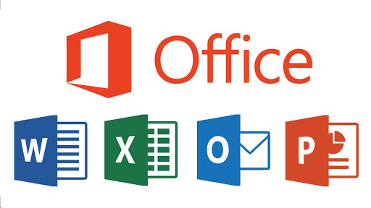

**Description:**

The Microsoft Office Suite is a collection of productivity applications, including Word, Excel, PowerPoint, Outlook, and more. These applications serve as essential tools for creating documents, spreadsheets, presentations, and managing communication.

**Key Features :**

* **Word:** Document creation and editing with advanced formatting options.
* **Excel:** Powerful spreadsheet software for data analysis and visualization.
* **PowerPoint:** Presentation software with rich multimedia capabilities.
* **Outlook:** Email client with calendar and task management features.

**Impact:**

The Microsoft Office Suite is widely used in business, education, and personal contexts, setting the standard for document creation and office productivity.

* + - 1. **Microsoft Azure**

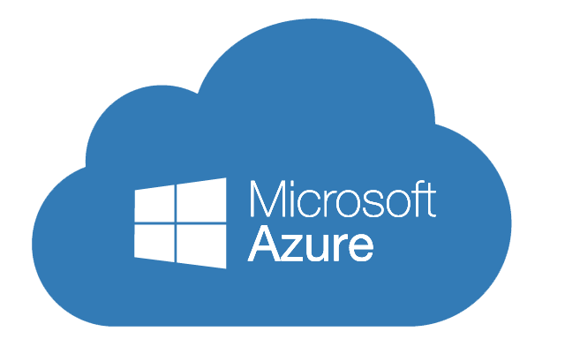

**Description:**

Microsoft Azure is a comprehensive cloud computing platform offering a wide range of services, including virtual machines, databases, AI, and analytics tools.

**Key Features :**

* **Infrastructure as a Service (IaaS) and Platform as a Service (PaaS):** Flexible cloud solutions for hosting and developing applications.
* **Azure AI:** Services for building, training, and deploying machine learning models.
* **Azure Database:** Scalable and secure cloud-based database solutions.

**Impact:**

Azure empowers organizations to scale their operations, innovate, and deploy applications globally through a secure and robust cloud infrastructure.

* + - 1. **Windows Operating System**

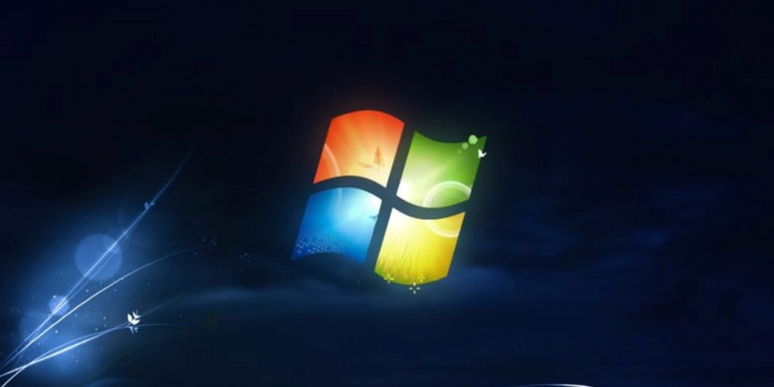

**Description:**

The Windows operating system is a family of operating systems developed by Microsoft, providing a user-friendly interface for personal computers and servers.

**Key Features:**

* **Graphical User Interface (GUI):** Intuitive interface for ease of use.
* **Compatibility:** Supports a vast array of software applications.
* **Security Features:** Regular updates and built-in security measures.

**Impact:**

Windows OS is one of the most widely used operating systems, providing a stable and familiar platform for personal and professional computing.

* + - 1. **Microsoft Teams**

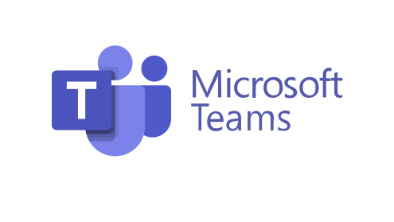

**Description:**

Microsoft Teams is a collaboration platform that integrates chat, video conferencing, file sharing, and application integration for seamless teamwork.

**Key Features:**

* **Channels:** Organized spaces for team communication and collaboration.
* **Meetings:** Video conferencing with screen sharing and real-time collaboration.
* **Integration:** Connects with other Microsoft 365 applications and third-party tools.

**Impact:**

Especially in the era of remote work, Microsoft Teams facilitates communication and collaboration, offering a centralized platform for teamwork.

* **Git and GitHub:**

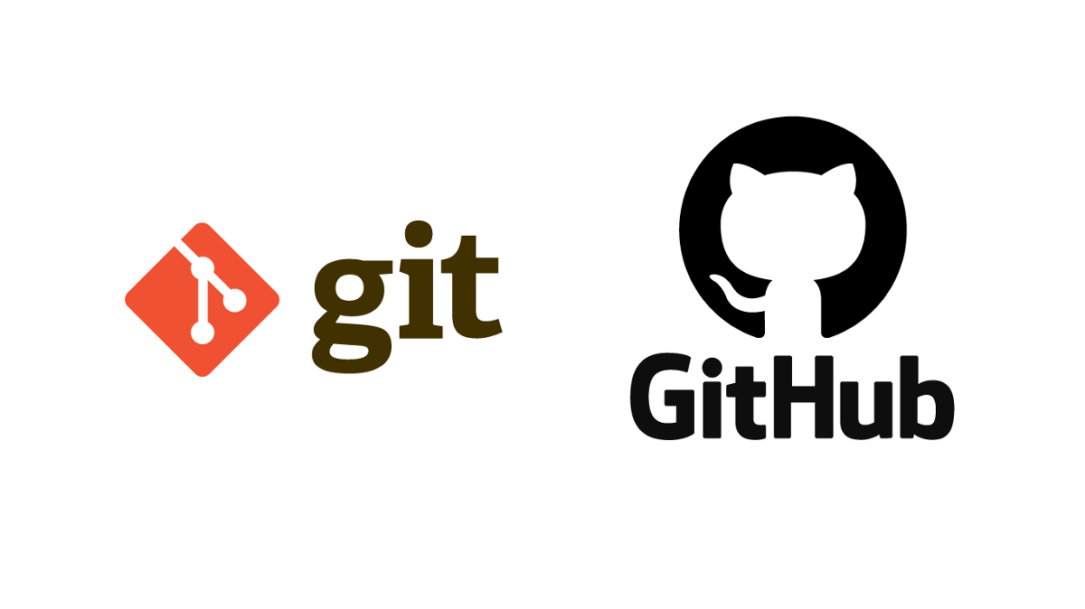

Git and GitHub are indispensable tools in the field of Information and Communication Technology (ICT), playing a crucial role in version control, collaborative software development, and project management. This report provides an overview of Git, the version control system, and GitHub, the platform built around Git, highlighting their descriptions, key features, and impact on modern software development practices.

1. **Git**

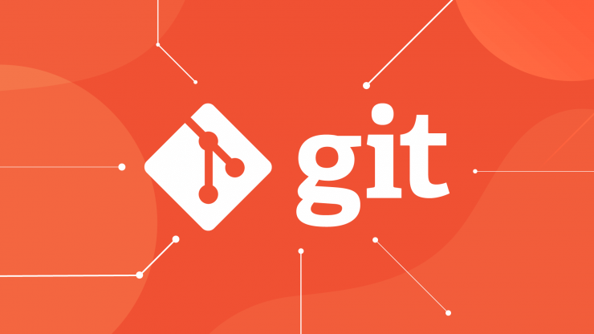

**Description:**

Git is a distributed version control system that enables developers to track changes in source code during software development. Created by Linus Torvalds, Git provides a decentralized and efficient mechanism for managing code repositories.

**Key Features :**

* **Distributed Version Control:** Each developer has a local copy of the entire project history.
* **Branching and Merging:** Easy creation and merging of branches, facilitating parallel development.
* **Speed and Efficiency:** Git operates locally, minimizing the need for constant communication with a central repository.

**Impact:**

Git has revolutionized collaborative software development, offering a robust and flexible version control system that enhances code stability and fosters efficient collaboration among developers.

1. **GitHub**



**Description:**

GitHub is a web-based platform built around Git, providing a centralized hub for hosting, collaborating on, and managing Git repositories. It offers a social coding experience, integrating features that extend beyond version control.

**Key Features:**

* **Repository Hosting:** Git repositories can be hosted on GitHub, providing a central location for collaboration.
* **Pull Requests:** Mechanism for proposing changes, reviewing code, and merging contributions.
* **Issues and Project Management:** Tools for tracking and managing tasks, bugs, and project milestones.

**Impact:**

GitHub has become a cornerstone in the development workflow, facilitating collaboration, code review, and project management on a global scale. It has greatly contributed to the rise of open-source development.

1. **Git and GitHub in Action**

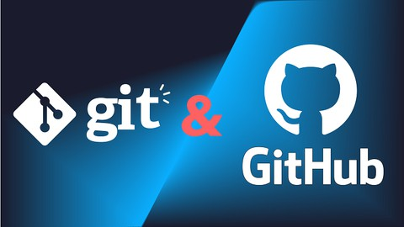

**Collaborative Development:**

Developers can work simultaneously on different branches, merging changes seamlessly through pull requests on GitHub. This promotes parallel development and effective collaboration.

**Code Review and Quality Assurance:**

GitHub's pull request feature allows for comprehensive code reviews, ensuring code quality and providing a structured process for incorporating changes into the main codebase.

**Open Source Contribution:**

GitHub has played a pivotal role in the growth of open-source software by providing a platform for developers worldwide to contribute to projects, share code, and collaborate on a massive scale.

**Continuous Integration/Continuous Deployment (CI/CD):**

Integrating Git with CI/CD pipelines automates testing and deployment processes, ensuring the reliability of code changes before reaching production.

#### **Core Technologies in ICT**

|  |  |  |  |
| --- | --- | --- | --- |
| **Description** | | **Key Components** | **Impact** |
| **Cloud Computing** | Cloud computing involves the delivery of computing services, including storage, processing power, and applications, over the internet. It provides on-demand access to resources without direct user management. | * **Infrastructure as a Service (IaaS):** Virtualized computing infrastructure. * **Platform as a Service (PaaS):** Development and deployment platforms. * **Software as a Service (SaaS):** Software applications delivered over the internet. | Cloud computing offers scalability, flexibility, and cost-effectiveness for businesses and individuals, enabling the storage and processing of large volumes of data. |
| **Internet of Things (IoT)** | The Internet of Things (IoT) connects physical devices and objects to the internet, allowing them to collect and exchange data. IoT extends connectivity beyond traditional computing devices. | * **Sensors and Actuators:** Devices that collect and transmit data. * **Connectivity Protocols:** Standards like MQTT and CoAP for device communication. * **Edge Computing:** Processing data closer to the source. | IoT is transforming industries by enabling smart cities, healthcare monitoring, industrial automation, and connected consumer devices. |
| **Artificial Intelligence (AI)** | Artificial Intelligence (AI) involves the development of systems that can perform tasks that typically require human intelligence. This includes machine learning, natural language processing, and computer vision. | * **Machine Learning Algorithms:** Algorithms that enable systems to learn and improve from experience. * **Natural Language Processing (NLP):** Understanding and processing human language. * **Computer Vision:** Teaching machines to interpret and understand visual information. | AI is revolutionizing automation, decision-making, and problem-solving across industries, leading to advancements in robotics, healthcare, finance, and more. |
| **Data Analytics** | Data analytics involves the extraction of insights and knowledge from large sets of structured and unstructured data. It encompasses various techniques, including descriptive, predictive, and prescriptive analytics. | * **Big Data Technologies:** Tools for processing and analyzing large datasets. * **Data Visualization:** Representing data in graphical or visual formats. * **Machine Learning in Analytics:** Predictive modeling and pattern recognition. | Data analytics empowers organizations to make informed decisions, optimize processes, and uncover valuable insights from vast amounts of data. |
| **Cybersecurity** | Cybersecurity technologies focus on protecting systems, networks, and data from unauthorized access, attacks, and damage. | * **Firewalls and Intrusion Detection Systems (IDS):** Monitor and control network traffic. * **Encryption Technologies:** Secure data transmission and storage. * **Endpoint Security:** Protecting individual devices from cyber threats. | In an era of increasing cyber threats, cybersecurity technologies are crucial for safeguarding sensitive information and ensuring the integrity of digital systems. |
| **Networking Technologies** | Networking technologies form the basis for communication and data exchange within and between systems. This includes both wired and wireless networking technologies. | * **Internet Protocols (IP):** IP addresses, IPv4, and IPv6 are fundamental for identifying and locating devices on a network. * **Ethernet and Wi-Fi:** Wired and wireless networking technologies that enable device connectivity. * **Routing and Switching:** Technologies that facilitate the routing of data packets between devices on a network. | Networking technologies are essential for the internet, intranets, and local area networks (LANs), enabling global connectivity and communication. |

##### **Impact on Various Sectors**

1. **Business and Collaboration:**

The integration of Google services and Microsoft tools has transformed business operations, enhancing communication, collaboration, and project management. Cloud-based solutions have streamlined workflows, enabling remote work and increasing productivity.

1. **Software Development:**

Git and GitHub have revolutionized the software development lifecycle. Version control allows developers to work collaboratively, track changes, and manage code efficiently. GitHub's features, such as pull requests and issue tracking, enhance project management.

###### **Challenges and Considerations**

While these technologies offer immense benefits, there are challenges and considerations to address:

* **Security Concerns:**
* Data security and privacy are critical, requiring robust measures to protect sensitive information.
* **Integration Issues:**
* Seamless integration of diverse tools can be challenging and requires careful planning.
* **Training and Adoption:**
* Users may face a learning curve, necessitating effective training programs for optimal utilization.

1. **Future Trends**

Looking ahead, emerging trends include:

* **Artificial Intelligence Integration:**
* AI applications will become more prevalent in Google services, Microsoft tools, and software development practices.
* **Advancements in Cloud Computing:**
* Continuous enhancements in cloud computing technologies, with a focus on scalability and flexibility.
* **Git and DevOps Integration:**
* Further integration of Git and GitHub into DevOps practices for enhanced collaboration and automation.

1. Conclusion

As we conclude this report, I want to extend an invitation to our audience. Your questions, thoughts, and perspectives are invaluable in fostering a deeper understanding of ICT and its implications. If there are aspects of the report that you'd like to explore further or if you have insights to share, we welcome your engagement. Thank u!