Activity_Data

Sara Michele Schaal

6/2/2017

##   
## Attaching package: 'dplyr'

## The following objects are masked from 'package:plyr':  
##   
## arrange, count, desc, failwith, id, mutate, rename, summarise,  
## summarize

## The following objects are masked from 'package:stats':  
##   
## filter, lag

## The following objects are masked from 'package:base':  
##   
## intersect, setdiff, setequal, union

# Data Manipulation

# Read in data files  
 full.act <- read.csv("data/Activity/20171127_ActivityData.csv")  
 black.temps <- read.csv("data/black_exp_temps.csv")  
 copper.temps <- read.csv("data/copper_exp_temps.csv")  
  
# Subset data into two experiments   
 black.act <- full.act[full.act$Species == "Black", ]  
 copper.act <- full.act[full.act$Species == "Copper", ]  
   
# Reorder data to be in numerical ascending order   
 # **(only way for loop to work properly)  
 black.temps.asc <- black.temps[order(black.temps$Bucket), ]  
 copper.temps.asc <- copper.temps[order(copper.temps$Bucket_ID), ]  
   
# Fill in actual mean temperature data from experiment  
 #black  
 for(i in 1:16){  
 for(j in 1:nrow(black.act)){  
 if(black.act$Bucket[j] == i){  
 black.act$Temperature[j] <- black.temps.asc$mean[i]  
 }  
 }  
 }  
   
 #copper  
 for(i in 1:16){  
 for(j in 1:nrow(copper.act)){  
 if(copper.act$Bucket[j] == i){  
 copper.act$Temperature[j] <- copper.temps.asc$mean[i]  
 }  
 }  
 }  
  
   
 # take the mean of the two watches of the same fish per viewer  
 black.act$Act_Mean_Julia <- rowMeans(black.act[, 8:9])  
 black.act$Act_Mean_Sandi <- rowMeans(black.act[, 10:11])

# Calculate averages per bucket per timepoint

# create empty data frames for mean bucket activity values  
 Mean.Activity <- matrix(NA, nrow(unique(black.act[c("Date", "AM_PM", "Bucket")])),3)  
 bucket.act.average <- unique(black.act[c("Date", "AM_PM", "Bucket", "Temperature")])  
 complete.act.data <- cbind(bucket.act.average, Mean.Activity)  
 colnames(complete.act.data) <- c("Date", "AM_PM", "Bucket", "Temperature",   
 "mean.julia", "mean.sandi", "mean.both")  
   
 # initialize the vectors that will be used in the forloop ** NOTE data in these vectors is written  
 # over in each loop.. they are TEMPORARY vectors **  
 bucket.act.julia <- NULL  
 bucket.act.sandi <- NULL  
 bucket.act.both <- NULL  
   
 # initialize the counter for stepping through the output matrix  
 j <- 1  
   
 # For loop to step through data frame to get activity averages  
 for(i in 1:nrow(black.act)){  
   
 # looping through majority of data to grab all those rows that are not the last row  
 # but are all those that equal the same bucket from the same day and getting activity averages  
 if(i != nrow(black.act) && i == 1 ||   
 black.act$Bucket[i] == black.act$Bucket[i-1] && i != nrow(black.act)){  
   
 bucket.act.julia <- c(bucket.act.julia, black.act$Act_Mean_Julia[i])  
 bucket.act.sandi <- c(bucket.act.sandi, black.act$Act_Mean_Sandi[i])  
 bucket.act.both <- c(bucket.act.both, black.act$Act_Mean_Julia[i], black.act$Act_Mean_Sandi[i])  
   
 # special case for last row   
 } else {  
 if(i == nrow(black.act)){  
  
 # Remove any NAs before taking mean for a bucket at a timepoint  
 bucket.act.both.noNA <- bucket.act.both[!is.na(bucket.act.both)]  
 bucket.act.julia.noNA <- bucket.act.julia[!is.na(bucket.act.julia)]  
 bucket.act.sandi.noNA <- bucket.act.sandi[!is.na(bucket.act.sandi)]  
 complete.act.data$mean.julia[j] <- sum(bucket.act.julia.noNA)/length(bucket.act.julia.noNA)  
 complete.act.data$mean.sandi[j] <- sum(bucket.act.sandi.noNA)/length(bucket.act.sandi.noNA)  
 complete.act.data$mean.both[j] <- sum(bucket.act.both.noNA)/length(bucket.act.both.noNA)  
 j <- j + 1  
   
 } else {  
   
 # Remove any NAs before taking mean for a bucket at a timepoint  
 bucket.act.both.noNA <- bucket.act.both[!is.na(bucket.act.both)]  
 bucket.act.julia.noNA <- bucket.act.julia[!is.na(bucket.act.julia)]  
 bucket.act.sandi.noNA <- bucket.act.sandi[!is.na(bucket.act.sandi)]  
   
 # Take mean of that bucket for that day and insert into complete.data dataframe  
 complete.act.data$mean.julia[j] <- sum(bucket.act.julia.noNA)/length(bucket.act.julia.noNA)  
 complete.act.data$mean.sandi[j] <- sum(bucket.act.sandi.noNA)/length(bucket.act.sandi.noNA)  
 complete.act.data$mean.both[j] <- sum(bucket.act.both.noNA)/length(bucket.act.both.noNA)  
 bucket.act.julia <- black.act$Act_Mean_Julia[i]  
 bucket.act.sandi <- black.act$Act_Mean_Sandi[i]  
 bucket.act.both <- c(black.act$Act_Mean_Julia[i], black.act$Act_Mean_Sandi[i])  
 # counter to step through inputting data into the complete.data dataframe  
 j <- j + 1  
   
 } # close else  
 } # close if else  
 } # close for loop

# Plotting

## Plot activity across time & as a single value across experiment

complete.act.data$Date <- as.factor(complete.act.data$Date)  
 complete.act.data$Date_Time <- as.factor(paste(complete.act.data$Date, complete.act.data$AM_PM))  
  
 # Round temperature data to one significant figure after decimal place  
 complete.act.data$RTemperature <- round(complete.act.data$Temperature, 1)  
   
 # ggplot to look at activity across time across bucket treatments  
 bucket.plot <- ggplot(data=complete.act.data,   
 aes(x=Date_Time, y=mean.both,   
 group=as.factor(RTemperature),   
 color = as.factor(RTemperature))) + geom_point() + geom_smooth(method = "lm")  
 bucket.plot + facet_wrap(~RTemperature)

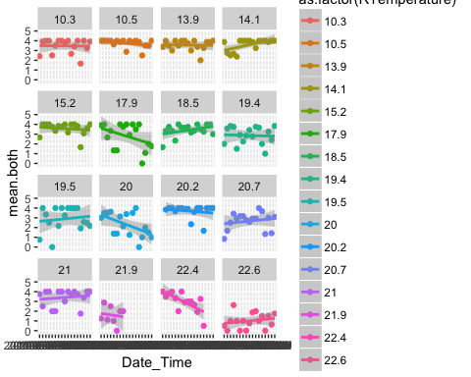

# Get bucket averages across entire experiement  
 mean.black.activity <- aggregate(complete.act.data$mean.both,   
 list(complete.act.data$RTemperature), mean)  
 colnames(mean.black.activity) <- c("Temperature", "Mean_Activity")  
   
 # Plot averages  
 plot(mean.black.activity$Temperature, mean.black.activity$Mean_Activity, ylim = c(0,4),  
 xlab = "Temperature", ylab = "Mean Activity", pch = 19, bty = "l",  
 main = "Black Rockfish Activity")

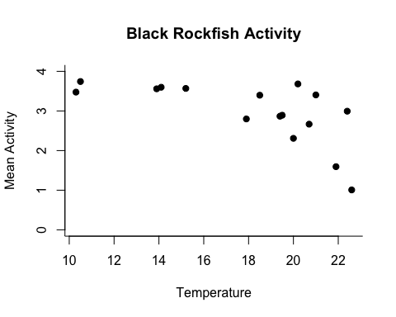

# ANALYSIS

## Negative Exponential

black.act.mod1 <- lm(mean.black.activity$Mean_Activity~mean.black.activity$Temperature)  
summary(black.act.mod1)

##   
## Call:  
## lm(formula = mean.black.activity$Mean_Activity ~ mean.black.activity$Temperature)  
##   
## Residuals:  
## Min 1Q Median 3Q Max   
## -1.39596 -0.24397 0.07294 0.30803 0.98171   
##   
## Coefficients:  
## Estimate Std. Error t value Pr(>|t|)   
## (Intercept) 5.20260 0.74129 7.018 6.07e-06 ***  
## mean.black.activity$Temperature -0.12386 0.04025 -3.078 0.00819 **   
## ---  
## Signif. codes: 0 '***' 0.001 '**' 0.01 '*' 0.05 '.' 0.1 ' ' 1  
##   
## Residual standard error: 0.6244 on 14 degrees of freedom  
## Multiple R-squared: 0.4035, Adjusted R-squared: 0.3609   
## F-statistic: 9.472 on 1 and 14 DF, p-value: 0.008187

#abline(black.act.mod1)  
  
  
x <- mean.black.activity$Temperature  
y <- mean.black.activity$Mean_Activity  
b <- 4  
m <- 0.01  
#y = b - exp(m*x)  
m1 <- nls(y~b-exp(m*x), start = c(b = b, m = m))  
cor(y,predict(m1))

## [1] 0.6627362

plot(mean.black.activity$Temperature, mean.black.activity$Mean_Activity, ylim = c(0,4),  
 xlab = "Temperature", ylab = "Mean Activity", pch = 19, bty = "l",  
 main = "Black Rockfish Activity")  
lines(x,predict(m1),col="black",lty=1,lwd=1)

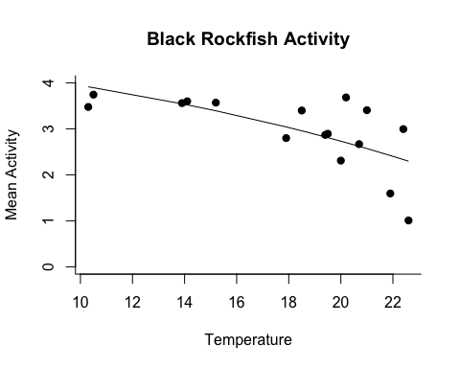

summary(m1)

##   
## Formula: y ~ b - exp(m * x)  
##   
## Parameters:  
## Estimate Std. Error t value Pr(>|t|)   
## b 5.647556 0.440573 12.819 3.99e-09 ***  
## m 0.053519 0.008251 6.487 1.43e-05 ***  
## ---  
## Signif. codes: 0 '***' 0.001 '**' 0.01 '*' 0.05 '.' 0.1 ' ' 1  
##   
## Residual standard error: 0.6056 on 14 degrees of freedom  
##   
## Number of iterations to convergence: 6   
## Achieved convergence tolerance: 3.694e-07