Freight Rate Prediction

Machine Learning Engineer Assessment (Spotter)

1. Objective
The objective of this assessment was to develop a machine learning model for predicting freight rates for transportation loads.
The task involved exploring and cleaning the provided historical load data, engineering relevant features, selecting an appropriate validation strategy, comparing regression models, and training a final model to generate freight rate predictions for unseen loads.
The final workflow also included generating predictions for a fixed December 2025 scenario and producing the required prediction file and visualization.

2. Dataset Overview
The development dataset contained 48,000 freight loads and 14 original features. The data covered the period from January 1, 2025, to October 31, 2025.
The target variable was posted_rate, representing the freight rate for each load.
The dataset included information about:
- Pickup and delivery locations
- Pickup and delivery coordinates
- Shipment distance
- Equipment type
- Load weight
- Market index
- Quote signal
- Load date
There were 64 unique pickup locations, 64 unique delivery locations, and 3 equipment types: Dry Van, Reefer, and Flatbed.
The dataset was used as the labeled development data for model training and validation.

3. Data Quality and Cleaning
The dataset was checked for missing values, duplicate records, invalid values, and basic statistical inconsistencies before model development.
No duplicate rows were found. However, missing values were identified in weight and market_index.
- weight: 300 missing values
- market_index: 374 missing values
In addition, 292 weight values were non-positive, which were considered invalid for freight loads.
To avoid introducing information from the validation period into the training process, the cleaning parameters were calculated from the training data only. Non-positive weight values were treated as missing and imputed using the training-set median. Missing market_index values were also imputed using the training-set median.
After preprocessing, no missing values remained in the model input features.

4. Time-Based Validation Strategy
Because the model is intended to predict future freight loads, a time-based validation strategy was used instead of a random train-validation split.
The data was divided chronologically:
- Training period: January 1, 2025 – September 30, 2025
- Training samples: 43,147 loads
- Validation period: October 1, 2025 – October 31, 2025
- Validation samples: 4,853 loads
October data was kept completely separate from model training and was used to evaluate how well the models could generalize for a future period.
This approach better reflects the expected real-world prediction scenario and reduces the risk of overly optimistic validation results caused by randomly mixing observations from different time periods.
5. Feature Engineering
Several additional features were created to provide the models with more useful information about the timing and characteristics of each shipment.
The final feature set contained 16 features, including the original shipment attributes and engineered features.
Temporal Features
Two features were extracted from the load date:
- month
- day_of_week
These features allow the model to capture potential monthly and weekly patterns in freight rates.
Geographic Features
The differences between delivery and pickup coordinates were calculated:
- lat_diff
- lon_diff
These features provide additional information about the geographic direction of each shipment.
Route Feature
A combined categorical feature was created from the pickup and delivery locations:
pickup → delivery
This represents each origin-destination pair as a single route feature, allowing the model to learn route-specific pricing patterns.
Final Feature Groups
The final model used:
- Categorical features: pickup, delivery, equipment, route
- Numerical features: coordinates, distance, weight, market index, quote signal, month, day of week, latitude difference, and longitude difference
Categorical features were encoded using one-hot encoding with unknown categories handled safely during prediction.

6. Model Development and Comparison
Several regression models were evaluated using the same time-based validation set. Mean Absolute Error (MAE) was used as the primary evaluation metric because it provides an interpretable measure of the average prediction error in the original freight-rate units. Root Mean Squared Error (RMSE) was used as a secondary metric because it gives greater weight to larger prediction errors.
Model | Validation MAE | Validation RMSE
Decision Tree | 198.18 | 927.79
Random Forest | 168.00 | 725.18
HistGradientBoosting | 133.79 | 655.78
HistGradientBoosting + Log Target | 114.56 | 650.93

The Decision Tree provided a baseline but produced the highest errors among the evaluated models. Random Forest improved the results, while HistGradientBoosting achieved a further reduction in both MAE and RMSE.
The target variable was positively skewed, with a skewness of approximately 1.90. Because of this skewness and the presence of high-rate observations, an additional HistGradientBoosting model was trained using a log1p transformation of the target variable. Predictions were transformed back to the original scale using expm1.
The log-transformed target approach produced the best validation performance, achieving a validation MAE of 114.56 and RMSE of 650.93. It was therefore selected as the final model.
7. Final Model Training
After comparing the candidate models, the HistGradientBoostingRegressor with a log-transformed target was selected based on its validation performance.
The selected model was then retrained using the complete labeled development dataset of 48,000 loads. The same preprocessing and feature engineering steps used during validation were applied to the full dataset.
For the final training process:
- Non-positive weight values were treated as missing.
- Missing weight and market index values were imputed using medians calculated from the complete labeled dataset.
- The engineered temporal, geographic, and route features were created.
- The target variable was transformed using log1p before training.
After training on all available labeled observations, the model was used to generate predictions for the 12,000 unseen validation loads provided by the assessment.
8. Final Validation Predictions
The final trained model was applied to the 12,000 unseen loads in data/validation.csv.
The validation dataset covered loads dated from November 1, 2025, through December 31, 2025. The same preprocessing and feature engineering pipeline used during model development was applied before generating predictions.
The resulting predictions were saved in the required format:
validation_predictions.csv

The file contains two columns:
- load_id
- predicted_rate
A total of 12,000 predictions were generated, with no missing prediction values.
The predicted freight rates had the following distribution:
Metric | Predicted Rate
Minimum | 213.45
Mean | 2,352.31
Maximum | 6,655.72

The prediction file was also checked to confirm that it contained the expected number of rows and that all required predictions were present.
9. December Scenario
The final model was also evaluated on the fixed December 2025 scenario provided with the assessment.
The scenario represents a shipment from Lexington to Fort Wayne with the following fixed characteristics:
- Route: Lexington → Fort Wayne
- Distance: 360
- Equipment: Dry Van
- Weight: 32,000
- Period: December 1–31, 2025

For input fields that were not provided directly in the December scenario file, the model inputs were completed using the corresponding historical route information and training-data medians.
The model generated 31 daily predictions for December 2025.
The predicted rates were highly stable across the month:
Metric | Predicted Rate
Minimum | 840.02
Mean | 841.91
Maximum | 842.19

The daily variation was mainly associated with the day_of_week feature, with the model producing slightly lower predictions on Sundays.
The required visualization was generated and saved as:
scorer_results/candidate_december.png
This scenario was also validated using the provided assessment scoring script.

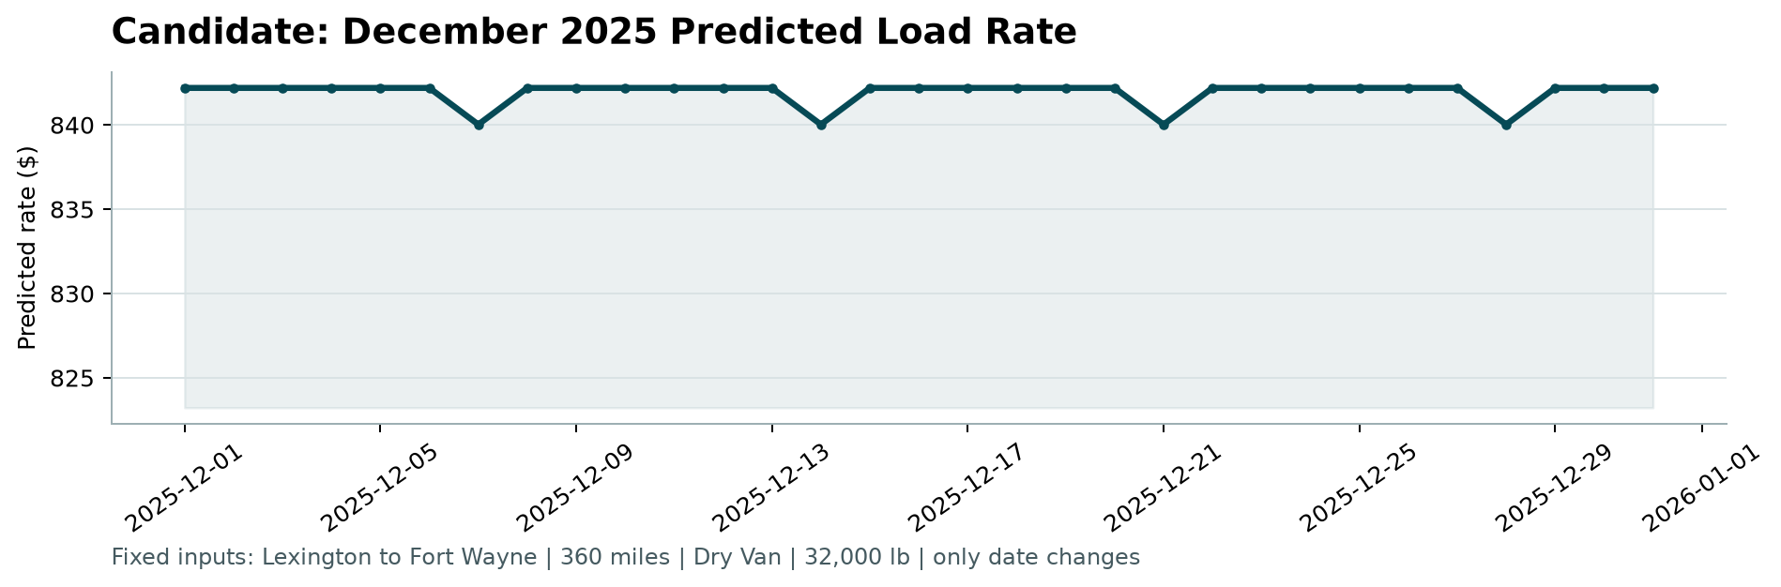

10. Final Verification
Before completing the assessment, the required outputs were verified using the provided scoring script.
The following command was executed:
python score.py --predictions validation_predictions.csv --december-predictions data/december_chart_inputs.csv
The scorer confirmed:
- 12,000 final predictions validated successfully
- 31 December predictions validated successfully
- The required December chart was created at scorer_results/candidate_december.png
The final validation metrics for the unseen validation loads are calculated by Spotter after submission.
11. Limitations and Conclusion
The final model achieved strong performance on the October time-based validation period, with a validation MAE of 114.56 and RMSE of 650.93. The log-transformed target approach provided the best performance among the evaluated models.
One limitation is that freight rates can contain rare high-value observations that are more difficult for the model to predict accurately. The right-skewed target distribution also indicates that prediction errors may vary substantially across different rate ranges.
Another limitation is that some features required for the final December scenario were not directly available in the provided scenario file. These inputs were therefore completed using historical route information and training-data statistics.
Overall, the workflow followed a structured machine learning process: data quality assessment, leakage-aware preprocessing, time-based validation, feature engineering, model comparison, final retraining, and generation of the required predictions and scenario visualization.
The final prediction file and December scenario outputs were successfully validated using the provided scoring script. Official performance on the unseen validation set will be determined by Spotter after submission.

Prepared by Sara Shawabka
October 2026

