# User Testing with Selenium IED:

All user testing was done through Selenium IED, using Selenium allowed me to automate the testing phase for each page of the web application. Selenium allowed me to create test scripts which would automatically insert test text into each text field for the teacher and student registration pages and the lesson application pages; this saved me time and allowed me to complete the same action several times over in a short period of time to allow for any bugs to show up.

## Testing Log

|  |  |  |  |
| --- | --- | --- | --- |
| **Date** | **Description** | **Problems** | **Approx. Time Taken** |
| Monday 5th  September | Set up local environment, server and Selenium IED. |  | 45 minutes |
| Monday 5th | Began testing unfinished student and teacher registration pages. |  | 20 minutes |
| Tuesday 6th | Did further testing on updated student and teacher registration changes after they were merged with the master branch. Also started testing on lesson application page. | Received “email already in use error” even when that email had never been used on student and teacher registration pages. | 17 minutes |
| Wednesday 7th | Confirmed which pages email error was in. Also confirmed if I could still log in even if the error appeared. |  | 8 minutes |
| Wednesday 14th | Testing conducted on instrument hire. | Different students can hire the same instrument | 38 minutes |
| Sunday 18th | Began testing on AALV-58, 59 and 29 | Incorrect account deleted in AALV-29 and couldn’t find required pages to test AALV-58. | 45 minutes |
| Monday 19th | Continued on AALV-29 and started on AALV-15, 32 and 35. General website testing. | AALV-15: Filler text ‘No Requested Instruments to display’ is still shown next to requested instrument information. AALV-32: Requested instrument hire not appearing in list. | 1.5 Hours |
| Monday 19th | Continued testing after bug fixes. AALV-15 and 32 and general site tests. | Single page able to be access without being logged in. | 32 minutes |
| Friday 14th  October | Began testing on AALV-12, AALV-5 and AALV-1. | Several errors with AALV-1 and timetable errors with AALV-12. | 30 minutes |
| Monday 17th October | Continued testing on AALV-12, AALV-5, AALV-1 and general website testing. | No new errors. | 20 minutes |
| Wednesday 18th October | Began testing on AALV-24 and AALV-25. | No new errors. | 50 minutes |
| Sunday 23rd October | Began testing on AALV-13, AALV-51 and AALV-200. | Student application not accepting dates. | 2 hours 30 minutes |
| Monday 24th October | Finished testing on AALV-24 and AALV-25. | No new errors. | 45 minutes |
| Tuesday 25th October | Began testing on AALV-30, AALV-49 and general website testing. | Blank data fields in AALV-30. | 2.5 hours |

## AALV-1 Teacher – Apply

|  |  |  |
| --- | --- | --- |
| **Steps** | **Description** | **Problems Encountered** |
| Enter “Apply for Job” page |  |  |
| Have teacher apply for job by filling in all fields |  | Only certain phone number combinations able to be used, mobile and landline only without area codes. |
| Press “Submit” |  | Received the following errors: *“An error has occured. Please try again later or contact an administrator”* and *“Email already in use. If you believe this is incorrect and the issue persists, contact an administrator.”.* |
| Repeat above steps. |  |  |

|  |  |
| --- | --- |
| **Acceptance Criteria** | **✓** accepted or **×** rejected |
| Upload resume (see comment below list) | **✓ -** Unable to upload due to technical limits (see below) |
| List Instruments played and your skill in them | **✓ -** Able to list instruments and skill |
| Input Contact information (Name, Email, Phone number, address) | **✓ -** Able to input contact information |
| Cover letter text box for input | **✓ -** Cover letter input box available |
| Emails thank you to applicant on submit | **✓ -** Email successfully sent |
| **NB:**  Cannot do file uploads as it would require us to rewrite half of the site  Requirement for resume upload is now changed to simply adding references and selecting a rough hour per week preference. | |

*Screenshot of email confirmation sent after application.*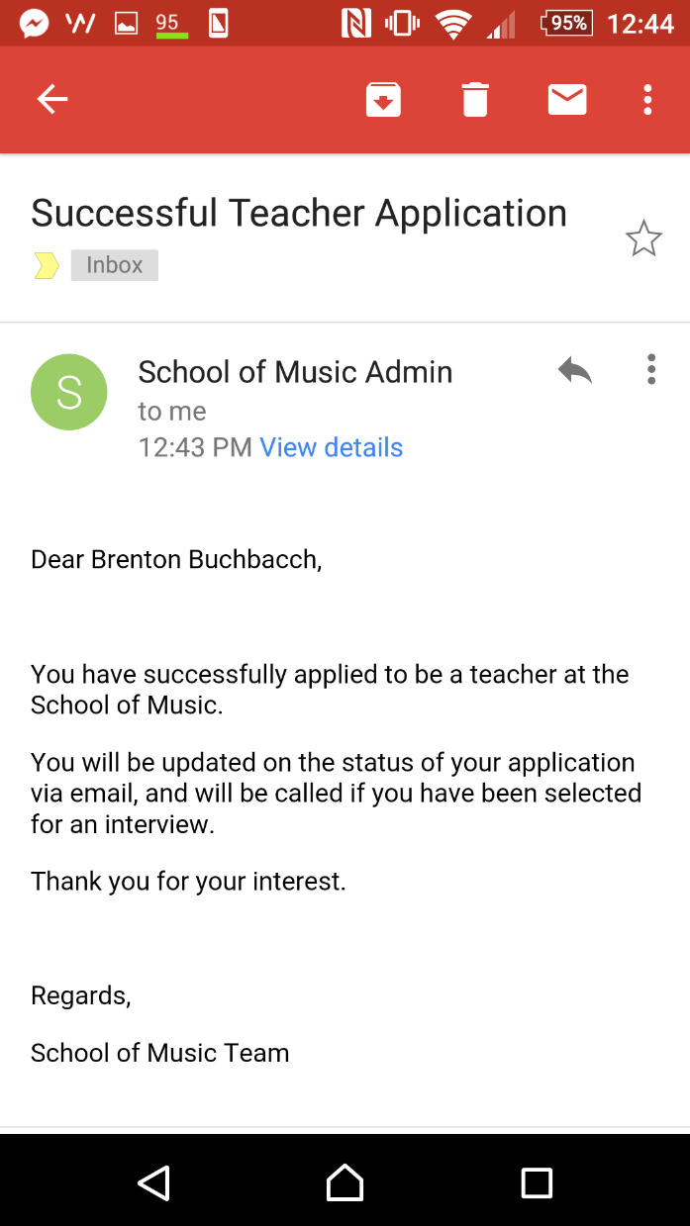

## AALV-5 Teacher – View Lessons Booked

|  |  |  |
| --- | --- | --- |
| **Steps** | **Description** | **Problems Encountered** |
| Login as teacher |  |  |
| Open “View Timetable” | The timetable should show all future lessons for this teacher. |  |
| Ensure that timetable is appearing correctly | Make sure that the timetable fields are viewable and all information is correct. | Timetable wasn’t styled correctly and didn’t sort lessons properly. |
| Repeat above steps. |  |  |

|  |  |
| --- | --- |
| **Acceptance Criteria** | **✓** accepted or **×** rejected |
| Able to view own lessons | **✓ -** Own lessons are viewable |
| Can’t view other teachers’ lessons | **✓ -** Only able to see own lessons |
| Information displayed is correct | **✓ -** All information is correct |
| Shows Time, Student, Room and Instruments | **✓ -** Information is present |

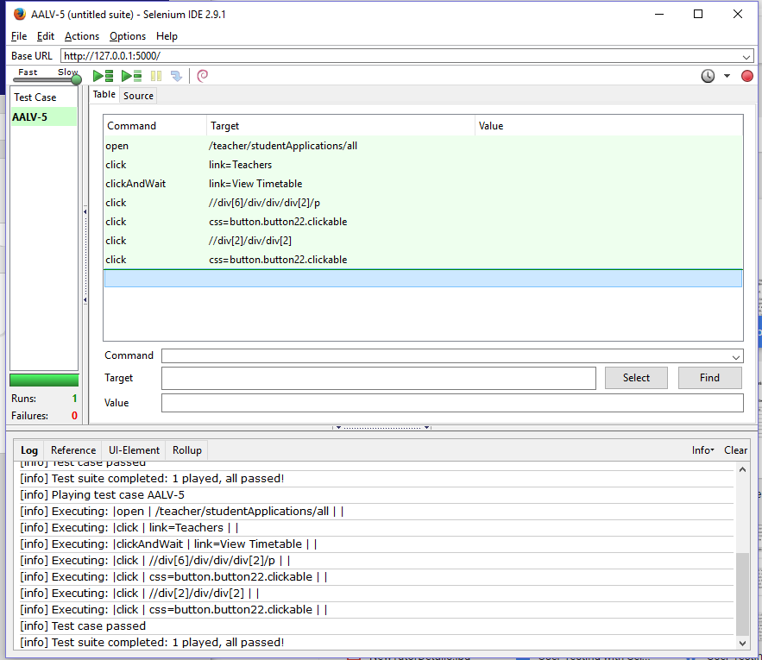

*AALV-5 testing using Selenium.*

## AALV-12 Student – Request Specific Teacher

|  |  |  |
| --- | --- | --- |
| **Steps** | **Description** | **Problems Encountered** |
| Login as student |  |  |
| Apply for a lesson under “Apply for Lessons” and request a specific teacher | Apply for lessons as usual by entering information in all the available fields but while applying request a teacher from the drop-down menu. |  |
| Login as teacher |  |  |
| Enter “View Student Lessons” and confirm a lesson request has been made | This page shows all requested student lessons for that teacher. |  |
| Repeat above steps. |  |  |

|  |  |
| --- | --- |
| **Acceptance Criteria** | **✓** accepted or **×** rejected |
| Assign preferred teacher in the class registration page | **✓ -** Able to select specific teacher |
| Request is considered/sent to that teacher first | **✓ -** Request is handled by teacher |

## AALV-13 Student – View Lessons

|  |  |  |
| --- | --- | --- |
| **Steps** | **Description** | **Problems Encountered** |
| Login and apply for a lesson as student | Apply as usual by filling in all fields. |  |
| Login as teacher |  |  |
| Navigate to “View Student Applications” and accept the lesson | This page shows all pending student applications for that teacher. |  |
| Login as student and navigate to “View Timetable” | The timetable view shows all future lessons for the student. |  |
| Ensure the approved lessons appears and is the only one visible | Ensure only visible lessons are ones that have been approved by the teacher. |  |
| Repeat above steps |  |  |

|  |  |
| --- | --- |
| **Acceptance Criteria** | **✓** accepted or **×** rejected |
| Able to see student booked lessons | **✓ -** Able to see all booked lessons |
| Able to see any lessons that haven’t been accepted yet | **✓ -** Able to see unaccepted lessons |
| Shows date, time, location, teacher and instrument | **✓ -** All information is show and correct |
| Can’t see anyone else’s lessons | **✓ -** Only able to see own lessons |

## AALV-14 Student – Hire Instrument

|  |  |  |
| --- | --- | --- |
| **Steps** | **Description** | **Problems Encountered** |
| Click on ‘Students’ and then ‘Register’ to register for student account. | The students’ dropdown box should display ‘Lesson Info, Register and Apply for Lessons’. |  |
| Complete account registration. | Account registration includes providing a name, address, mobile number, email and password. |  |
| Log into website using new account. | Account log in using email and password provided in previous step. |  |
| Click on ‘students’ and then ‘Apply for Lessons’. | ‘Apply for Lessons’ should let the student select the instrument they wish to use as well as the start time and day for that lesson. |  |
| Select ‘Triangle’ from instrument type and then ‘Hire’ from BYO or Hire. | By selecting ‘Hire’ the student indicated they wish to hire that instrument. A new list of hirable instruments should appear below. |  |
| Select the triangle with serial ‘T000001’ from the instrument to hire list. | This list of instruments should show all hired out and available instruments. |  |
| Select a day and start time for the lesson. | The student indicated the day of the week and time they want the lesson to commence. |  |
| Click ‘submit’. | The status of the selected instrument should now be ‘hired’. |  |
| Repeat above steps. | Other students should not be able to hire out the same instrument during that timeslot. | Different students are able to hire out the same item during the same timeslots. |

|  |  |
| --- | --- |
| **Acceptance Criteria** | **✓** accepted or **×** rejected |
| Instrument Filtering for a specific instrument | **✓ -** Filters available |
| Can't request a borrowed or broken instrument | **✓ -** Unable to request already booked instrument |
| Must specify length of time | **✓ -** Assumed hire is for whole term |
| Must specify payment method | **× -** Unable to choose payment method |
| Once requested, other students are unable to put in a request for the same instrument. | **✓ -** Unable to book same instrument |

## AALV-15 Student – View Instrument History

|  |  |  |
| --- | --- | --- |
| **Steps** | **Description** | **Problems Encountered** |
| Log in as student. |  |  |
| Hover over ‘Students’ and then click ‘Apply for lessons’. | Apply as usual by filling in all fields. |  |
| Apply for a lesson and request an instrument hire as test student. | Request an instrument for hire. |  |
| Hover over ‘Students’ and then click ‘View borrowed instruments’. | This will show all pending and borrowed out instruments. |  |
| Confirm the requested hire info is under ‘Requested Instruments’. | Ensure a single instrument request is under ‘requested instruments’. | Filler text ‘No Requested Instruments to display’ is still shown next to requested instrument information. |
| Log out as student test and log in as manager. |  |  |
| Approve hire request. | Approve the hire request. |  |
| Log back in as student test and confirm instrument is now under ‘Hired Instruments’. | Ensure instrument is now shown under appropriate heading. | Request not appearing in list. |
| Log back in as manager and approve/deny request. |  |  |
| Log back in as student and confirm request is now approved/denied. | Ensure instrument is now shown under appropriate heading. |  |

|  |  |
| --- | --- |
| **Acceptance Criteria** | **✓** accepted or **×** rejected |
| Only shows instruments previously hired/currently being hired. | **✓ -** Shows previously hired and currently hired |
| Shows name, ID, type and condition | **✓ -** Shows name, ID, type and condition |

## AALV-24 and 25 Manager – View and Filter Teacher Applicants

|  |  |  |
| --- | --- | --- |
| **Steps** | **Description** | **Problems Encountered** |
| Login as manager |  |  |
| Navigate to “View Teacher Applicants” | This view will show all pending applicants. |  |
| Ensure list view is working |  |  |
| Test search by name, language or instrument | Search using the provided search bar. |  |
| Test sorting by rejected and shortlisted applicants | Sorting buttons are located at the bottom of the view. |  |
| Click on random applicant |  |  |
| Click on “Shortlist” if a rejected candidate and vice versa | This will move that applicant to the ‘shortlisted’ view and vice versa. |  |
| Ensure candidate has moved to appropriate list |  |  |
| Ensure email confirmation is sent | An email should be sent each time the teacher is moved around. |  |
| Repeat above steps. |  |  |

|  |  |
| --- | --- |
| **Acceptance Criteria - 24** | **✓** accepted or **×** rejected |
| Able to shortlist an applicant | **✓ -** Shortlisting works |
| On shortlist, marks them as shortlisted for filtering purpose | **✓ -** Marked as shortlisted |
| On shortlist, emails applicant to notify of shortlisting | **✓ -** Email sent |
| Hide or delete applicants | **✓ -** Able to hide but not delete |
| Hidden applicants do not show up on main search | **✓ -** Hidden doesn’t show up on main |
| Emails applicant to notify them that they have not been selected at this time | **✓ -** Email sent |

|  |  |
| --- | --- |
| **Acceptance Criteria - 25** | **✓** accepted or **×** rejected |
| Filters (name, type of instruments known, languages) | **✓ -** Filters work |
| Hides inactive/previously deleted applicants | **✓ -** Able to hide inactive applicants |
| Can view an applicant | **✓ -** Can view applicant |
| Previously Deleted applicants show up | **× -** Unable to delete |
| Non Deleted applicants show up | **✓ -** Applicants show |
| Hired applicants should disappear | **✓ -** Able to hire |
| Other filters should still work | **✓ -** All filters working |

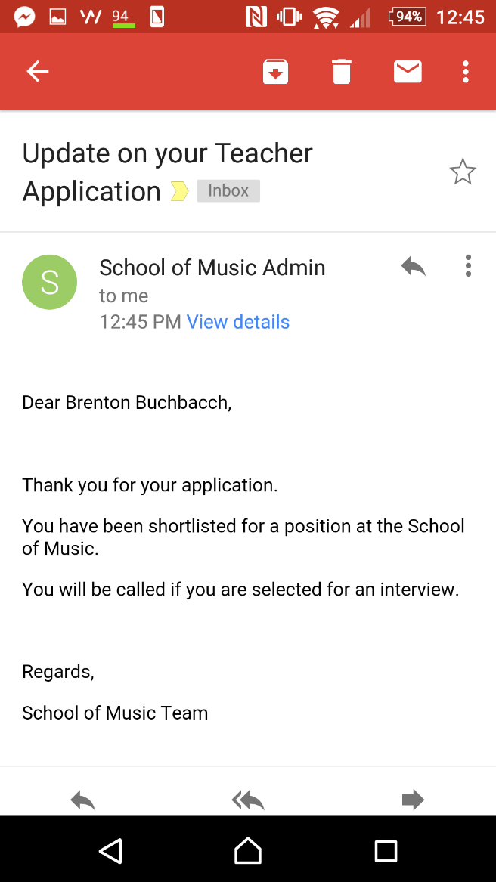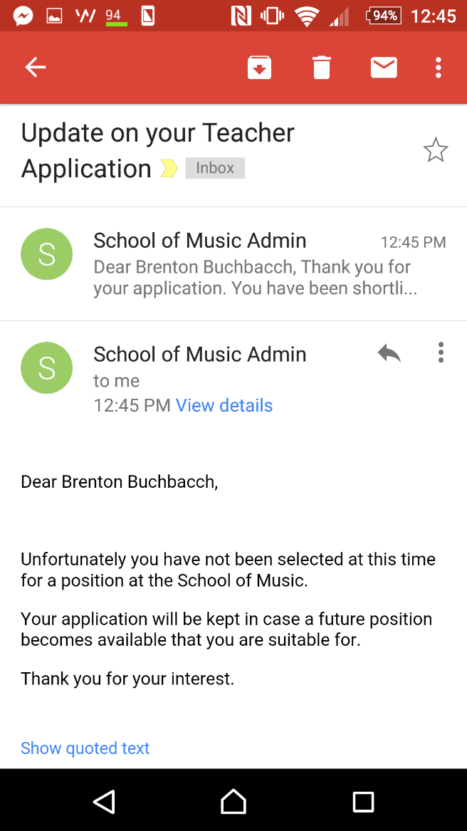

*Above screenshots show sent email regarding status of teacher job application.*

## AALV-29 Manager – Deactivate Old Accounts

|  |  |  |
| --- | --- | --- |
| **Steps** | **Description** | **Problems Encountered** |
| Hover over ‘Techers’ and then click ‘Register’. |  |  |
| Register a new test teacher account by filling in required fields. |  |  |
| Hover over ‘Management’ and then select ‘View Teacher Accounts’. |  |  |
| Click on the test teacher account. |  |  |
| Click on ‘Deactivate’ |  |  |
| Confirm correct account has been deactivated. |  | Incorrect account deactivated. |
| Repeat above steps. |  |  |

|  |  |
| --- | --- |
| **Acceptance Criteria** | **✓** accepted or **×** rejected |
| View every active teacher account | **✓ -** All accounts viewable |
| Ability to delete account | **✓ -** Able to delete account |
| Unable to log into an account that is disabled. | **✓ -** Unable to log into deleted account |

## AALV-30 Manager – Generate Business and IT Reports

|  |  |  |
| --- | --- | --- |
| **Steps** | **Description** | **Problems Encountered** |
| Login as manager |  |  |
| Navigate to ‘Reporting’ under ‘Management’. | This page allows the manager to request various different business and IT reports. |  |
| Select ‘Instrument Summary Report’. | This shows all information regarding instruments owned by the school. |  |
| Ensure report details are correct. | Ensure all details are correct and there are no outliers. |  |
| Click on ‘Go back’ |  |  |
| Select ‘Lesson Summary Report’. | This report shows all information regarding lessons booked and cancelled by the school. |  |
| Ensure report details are correct. | Ensure all details are correct and there are no outliers. | Data fields were blank (not showing number of lessons booked, cancelled etc.) |
| Repeat above steps. |  |  |

|  |  |
| --- | --- |
| **Acceptance Criteria** | **✓** accepted or **×** rejected |
| * Reports to be show on web page since dynamic | **✓ -** Reports are dynamic, info changes correctly |
| * Specify type of report | **✓ -** Different types of reports available |
| It should be accurate | **✓ -** Reports are accurate |

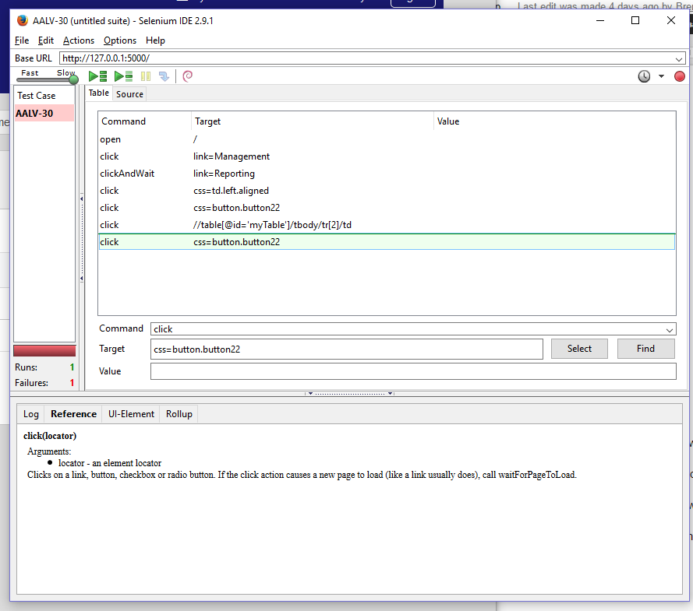

*AALV-30 testing using Selenium.*

AALV-32 Manager – View Instrument Hire Requests

|  |  |  |
| --- | --- | --- |
| **Steps** | **Description** | **Problems Encountered** |
| Have student request an instrument to hire. | Apply as usual by filling in all fields. |  |
| Log in as manager. |  |  |
| Log in as manager and navigate to ‘View hire requests’. | This page should show all instrument hire requests. |  |
| Confirm that approving and denying of request work. | Approving and denying the requests should be reflected in the student account too. | Instrument hire request not appearing in list. |
| Log in as student and confirm instrument request has been denied/approved. | The request should have been moved under its appropriate heading. |  |
| Log into email address and confirm email has been sent | An email will be sent out confirming the request has been dealt with to the student’s email. |  |
| Repeat above steps. |  |  |

|  |  |
| --- | --- |
| **Acceptance Criteria** | **✓** accepted or **×** rejected |
| Various filters (newest request, student asking, type) | **✓ -** Filters work |
| Ability to accept or deny requests | **✓ -** Able to accept and deny |
| If denied, must give reason | **✓ -** Email sent |
| Ability to specify an instrument to give the student or assign randomly. | **✓** - Able to specify instrument |
| Student is informed | **✓**- Student is informed |
| Once instrument is assigned to a student, it must be marked as hired | **✓** - Marked as hired |

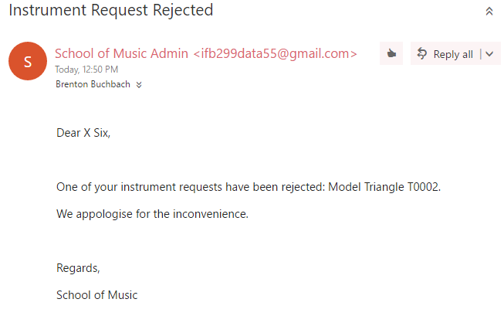

*A screenshot after an instrument request has been denied.*

AALV-35 Manager – Mark Instruments as Returned

|  |  |  |
| --- | --- | --- |
| **Steps** | **Description** | **Problems Encountered** |
| Have student request an instrument to hire. | Apply as student and request an instrument hire. |  |
| Log in as manager. |  |  |
| Log in as manager and navigate to ‘return hired instruments’. | This view will show all currently hired out instruments. |  |
| Click on hired out instrument and then ‘Mark as returned’. | By marking as returned the instrument should move back into the pool of available instruments for hire. |  |
| Confirm via student account that instrument has been marked as returned. | The instrument should have been marked as returned. |  |
| Repeat above steps. |  |  |

|  |  |
| --- | --- |
| **Acceptance Criteria** | **✓** accepted or **×** rejected |
| Shows hired out instruments list | **✓ -** Shows hired |
| Various filters (by date out, by due date, type) default ID | **✓ -** Filters work |
| Can mark as returned | **✓ -** Able to mark |
| Returned instruments show up in the available instrument view | **✓** - Returned show up |
| Notify the student that it has been processed | **✓**- Student is informed |

## AALV-49 User – Update Details

|  |  |  |
| --- | --- | --- |
| **Steps** | **Description** | **Problems Encountered** |
| Login as manager. |  |  |
| Navigate to ‘View Instruments’. | This view shows all current instruments the school owns. |  |
| Click on a random instrument. | This will show more details about the selected instrument. |  |
| Change condition or another value of the instrument and click ‘save’. | This will change the appropriate instrument information. |  |
| Ensure instrument info has changed. | The changed information should appear. |  |
| Click ‘Change Password’ | This will allow the user to change their password. |  |
| Change password | A new password should be entered. |  |
| Ensure password has been changed. | Ensure that the password change has been successful. |  |
| Repeat above steps |  |  |

|  |  |  |
| --- | --- | --- |
| **Steps** | **Description** | **Problems Encountered** |
| Login as manager. |  |  |
| Click on ‘My.Portal’ at the top right | This view shows all current instruments the school owns. |  |
| Click ‘Edit’ next to personal information | This will show more details about the selected instrument. |  |
| Edit one or more fields | This will change the appropriate instrument information. |  |
| Click ‘Save’ | The changed information should appear. |  |
| Ensure information has updated with new info | This will allow the user to change their password. |  |
| Click ‘Change Password’ | A new password should be entered. |  |
| Change password | Ensure that the password change has been successful. |  |
| Ensure password has been changed. | This view shows all current instruments the school owns. |  |
| Repeat above steps |  |  |

|  |  |  |
| --- | --- | --- |
| **Steps** | **Description** | **Problems Encountered** |
| Login as teacher. |  |  |
| Click on ‘My.Portal’ at the top right | This view shows all current instruments the school owns. |  |
| Click ‘Edit’ next to personal information | This will show more details about the selected instrument. |  |
| Edit one or more fields | This will change the appropriate instrument information. |  |
| Click ‘Save’ | The changed information should appear. |  |
| Ensure information has updated with new info | This will allow the user to change their password. |  |
| Click ‘Change Password’ | A new password should be entered. |  |
| Change password | Ensure that the password change has been successful. |  |
| Ensure password has been changed. | This view shows all current instruments the school owns. |  |
| Repeat above steps |  |  |

|  |  |  |
| --- | --- | --- |
| Login as student. |  |  |
| Click on ‘My.Portal’ at the top right |  |  |
| Click ‘Edit’ next to personal information |  |  |
| Edit one or more fields |  |  |
| Click ‘Save’ |  |  |
| Ensure information has updated with new info |  |  |

|  |  |
| --- | --- |
| **Acceptance Criteria** | **✓** accepted or **×** rejected |
| * Able to change personal Info and save it. | **✓ -** Instruments shown |
| If a teacher, able to change languages spoken, instruments and skill levels | **✓ -** Amount of spaces not shown |
| * Changes show up in relevant lists | **✓ -** All changes show up |

## 

*AALV-49 testing using Selenium.*

## AALV-51 Student – Cancel Lesson

|  |  |  |
| --- | --- | --- |
| **Steps** | **Description** | **Problems Encountered** |
| Login and apply for a lesson as student | Apply as usual by filling out all field in application. |  |
| Login as teacher |  |  |
| Navigate to “View Student Applications” and accept the lesson | This view shows all pending student applications to the school. |  |
| Login as student and navigate to “View Timetable” | This should show the students future lessons in a timetable view. |  |
| Ensure the approved lessons appears and is the only one visible then click on the accepted lesson | Ensure that the only visible lessons are those that have been approved. |  |
| Press “Cancel Lesson” | By pressing this the lesson should be cancelled for both the student and teacher. |  |
| Login as teacher and ensure lesson has been cancelled. | Lesson should be cancelled for teacher too. |  |
| Ensure cancellation email conformation is sent out | Email confirmations should be sent out. |  |
| Repeat above steps |  |  |

|  |  |
| --- | --- |
| **Acceptance Criteria** | **✓** accepted or **×** rejected |
| Future lessons listed | **✓ -** Lessons listed |
| Able to cancel selected lesson | **✓ -** Able to cancel |
| Email confirmation sent to student and teacher | **✓ -** Email sent |

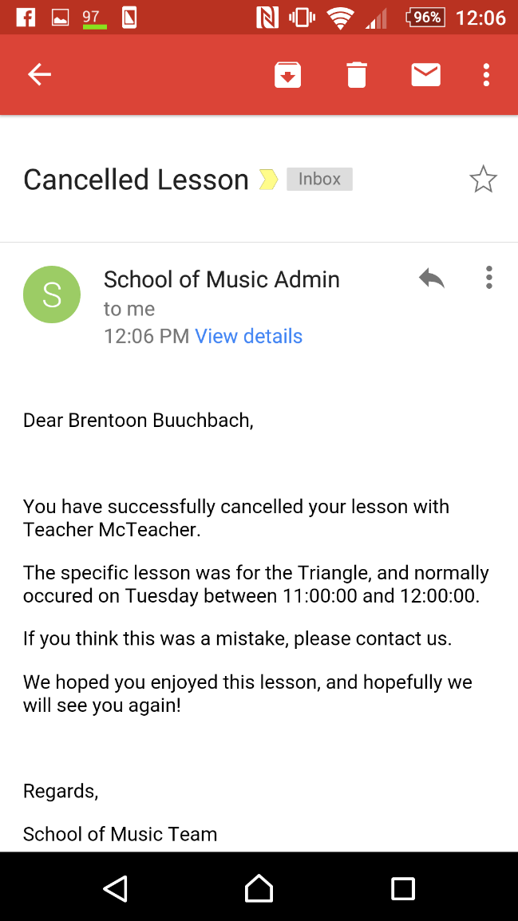

*Screenshot showing email sent out after student lesson cancellation.*

## AALV-58 Student – Lesson Information

|  |  |  |
| --- | --- | --- |
| **Steps** | **Description** | **Problems Encountered** |
| Login as student. |  |  |
| Hover over ‘Students’ and click ‘Lesson Information’ | This page should show all information regarding student lessons (price, list of instruments etc.). |  |
| Ensure that all information is on page and relevant. | Ensure that all information is correct and there is nothing irrelevant. |  |

|  |  |
| --- | --- |
| **Acceptance Criteria** | **✓** accepted or **×** rejected |
| List of instruments taught at school | **✓ -** Instruments shown |
| Amount of spaces available for each instrument | **× -** Amount of spaces not shown |
| Times of lessons | **✓ -** Times shown |
| Teachers available | **✓** - Teachers shown |

## AALV-59 Student – Borrowed Info

|  |  |  |
| --- | --- | --- |
| **Steps** | **Description** | **Problems Encountered** |
| Log in using test student (with borrowed instrument). | Login as a student that is currently borrowing out an instrument. |  |
| Hover over ‘Students’ and then click ‘View Borrowed Instruments’. | This page shows all borrowed out instruments for the student. |  |
| Confirm student has only one borrowed instrument. | Ensure that only one instrument is borrowed out for that student. |  |
| Hover over ‘Students’ and then click ‘Register’. | Register a new student account and don’t borrow out any instruments. |  |
| Create new test student account (nothing borrowed). | As above. |  |
| Log in as test student. | Login as the new student. |  |
| Hover over ‘Students’ and then click ‘View Borrowed Instruments’. | Ensure that no instrument is borrowed out for that student. |  |
| Confirm student has no borrowed instruments. | As above. |  |
| Repeat above steps. |  |  |

|  |  |
| --- | --- |
| **Acceptance Criteria** | **✓** accepted or **×** rejected |
| Lists all equipment borrowed by the student | **✓ -** Equipment shown |
| Does not show anything else | **✓ -** Nothing else is shown |
| Lists accurate due dates for borrowed equipment | **✓ -** Due dates shown |

## AALV-200 Teacher – Cancel Lesson

|  |  |  |
| --- | --- | --- |
| **Steps** | **Description** | **Problems Encountered** |
| Login and apply for a lesson as student | Login as student and apply for a lesson by filling in all fields. | Received this error when applying for a lesson “error: invalid input syntax for integer: “Fri””. |
| Login as teacher |  |  |
| Navigate to “View Student Applications” and accept the lesson | This view allows the teacher to accept students into the school. |  |
| Navigate to “View Timetable” | This view shows all future lessons for the teacher. |  |
| Click on accepted lesson | Each lesson should be able to be clicked on and viewed. |  |
| Press “Cancel Lesson” | By clicking this the teacher cancels that lesson. |  |
| Ensure cancellation email conformation is sent out | Emails should be sent out confirming cancellation. |  |
| Repeat above steps |  |  |

|  |  |
| --- | --- |
| **Acceptance Criteria** | **✓** accepted or **×** rejected |
| Future lessons listed | **✓ -** Future lessons shown |
| Able to cancel selected lesson | **✓ -** Able to cancel |
| Email confirmation sent to student and teacher | **✓ -** Emails sent out |

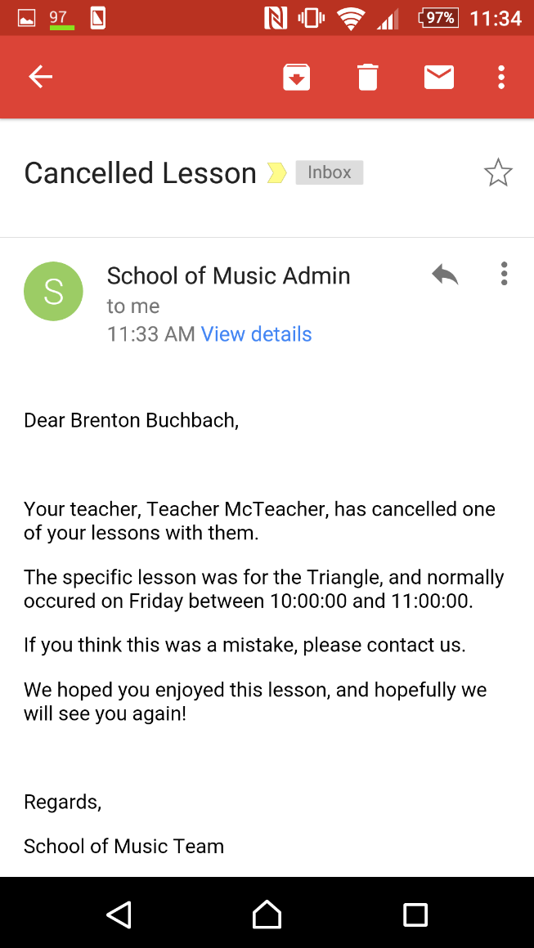

*Screenshot showing email sent out after cancellation of lessons.*

## General Website Testing

General website testing consisted of attending to each page of the website, entering information into all text boxes and fields and attempting to break the website. The below are the finding from any general website testing completed.

## URLS

/teacher/studentApplications

/student/instruments/borrowed

/management/teachers

/management/instrument/requests

/information

/login/student

/login/teacher

/login/manager

/register/manager

/management/instrument/new

/management/instrument/return

/lessons/application

/register/student

/register/teacher

The above URLs were tested to ensure that when a user isn’t logged in, with any accounts, they will be unable to access any pages that they shouldn’t be able to access. Only one, /teacher/student Applications, was able to be accessed when not logged in.

## Phone Numbers

It was also discovered during general website testing that only some variations of phone numbers were accepted. For example, 41553133 would be accepted but not 0741553133 even though they’re the same number, the one difference is that one has an area code and the other doesn’t.

# Error Screenshots

## AALV-1:

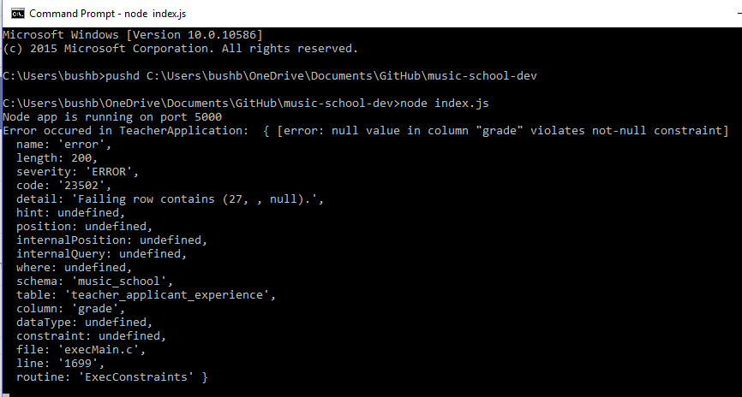

The above is an example of error that would be spit out by the command prompt in windows whenever an error was encountered. This information would be provided to the development team which would be used as vital information in regards to solving any bugs that appeared.