1-Create one main folder called Tuwaiq

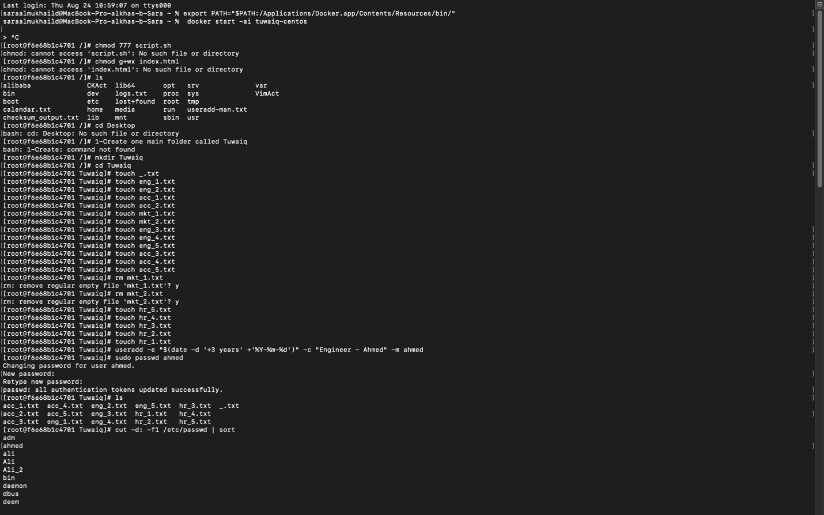

2-Inside Tuwaiq folder create five empty (0 KB) files for each department. The file names should be _.txt, < department first characters >_num.txt, < department first characters >_num+1.txt and so on (you will have 15 files in total). Ex: eng_1.txt, eng_2.txt / acc_1.txt, acc_2.txt



3-Create the following users with description and expiration date (3 years after creation date). No need to add Expiration date for managers and CEO. Users are listed below:

4-Ensure the addition of the users using some Linux utility.

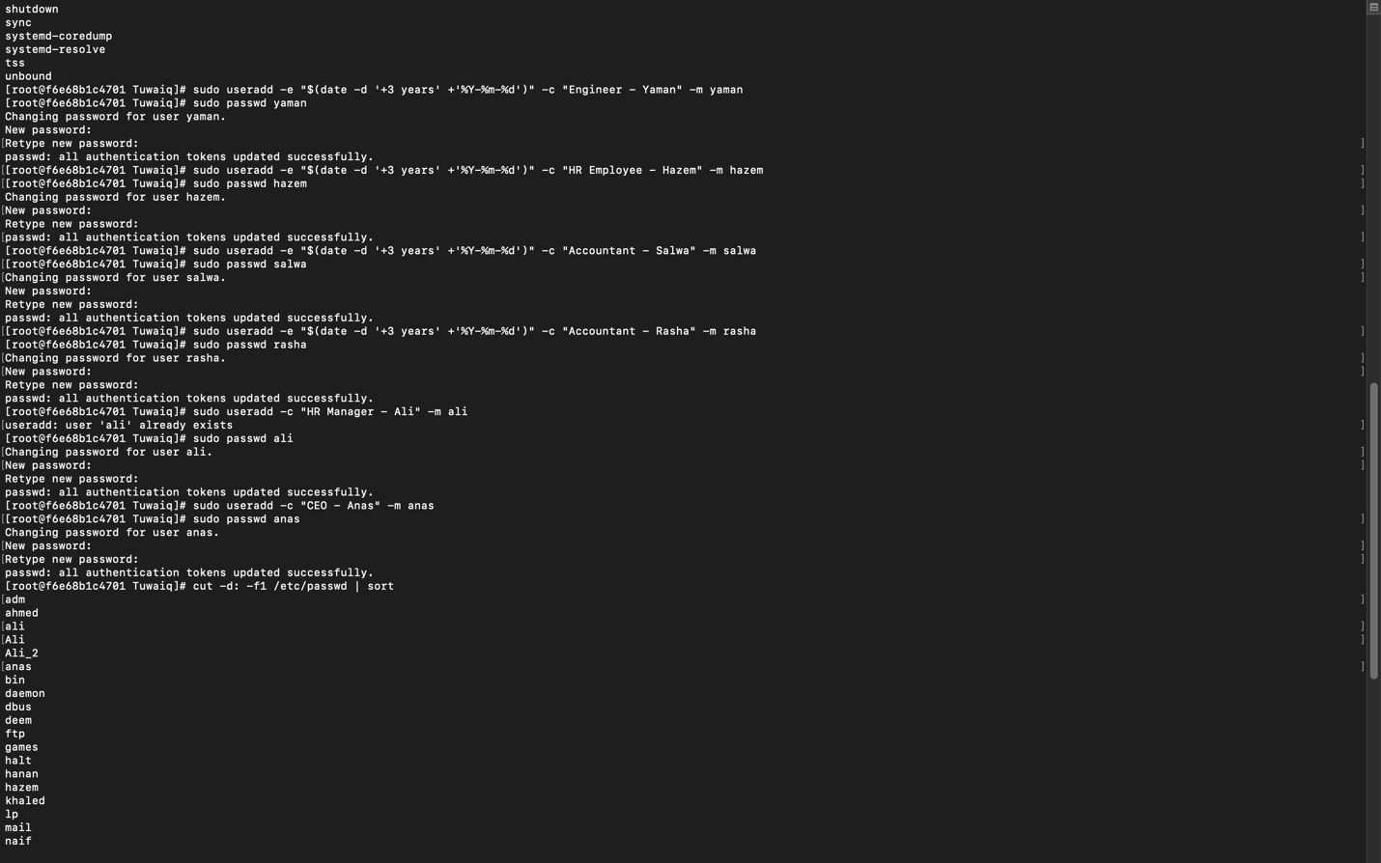

5- Create 3 groups (Engineering, Accounting, HR) then add the users to their relevant group.

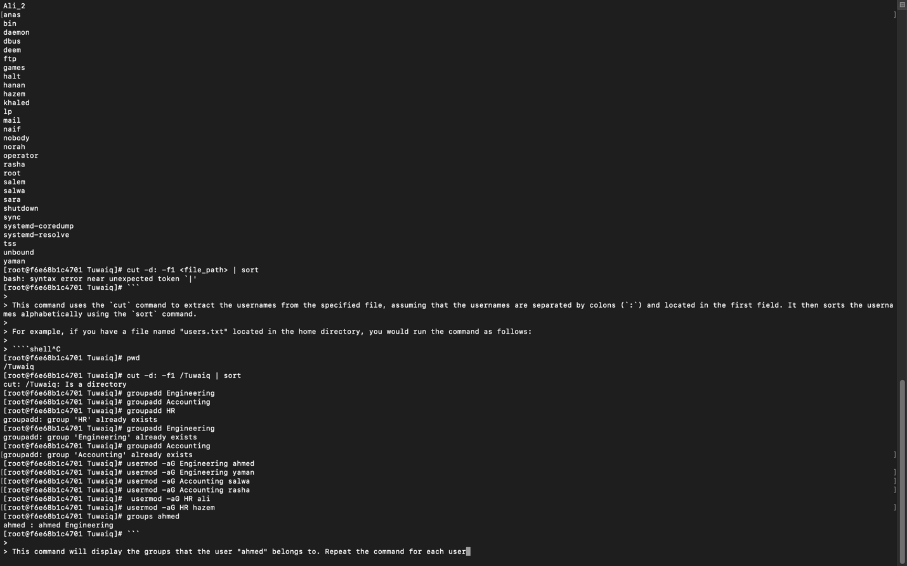

6-Your manager asked you to organize the files into 3 separate sub folders (Engineering, Accounting and HR).

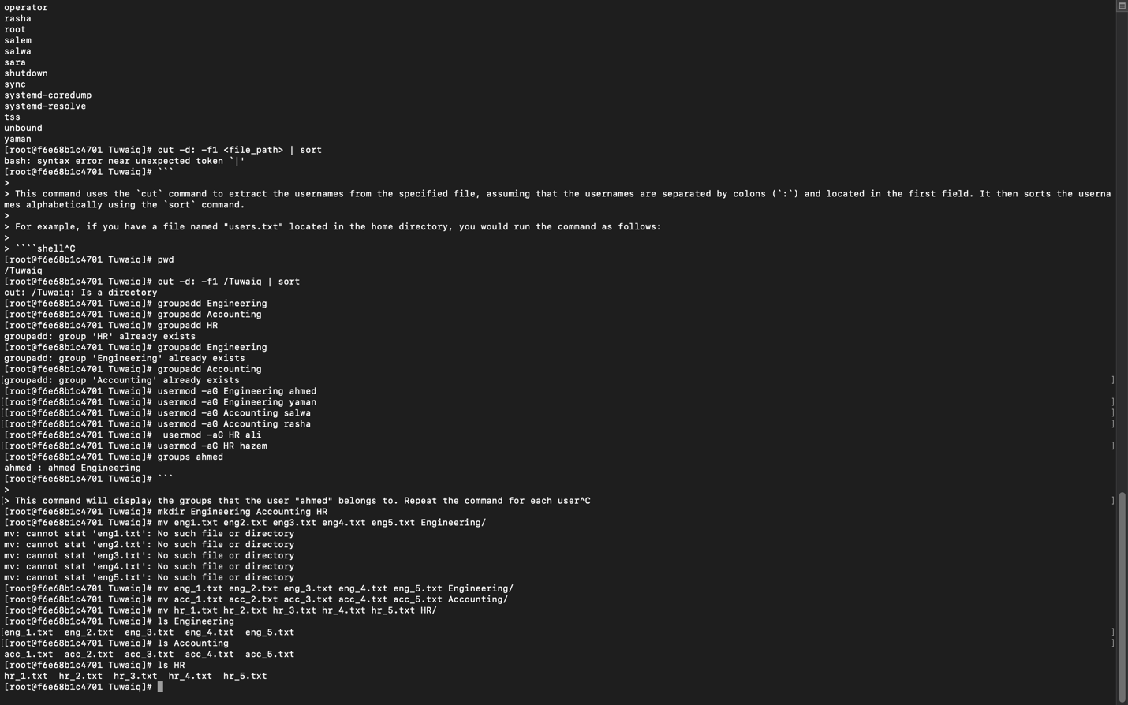

7-Change user and group ownership for each subfolder to the relevant group (use any user from the department as an owner). Ex: Engineering folder should be owned by Engineering group and then ensure the new ownership.

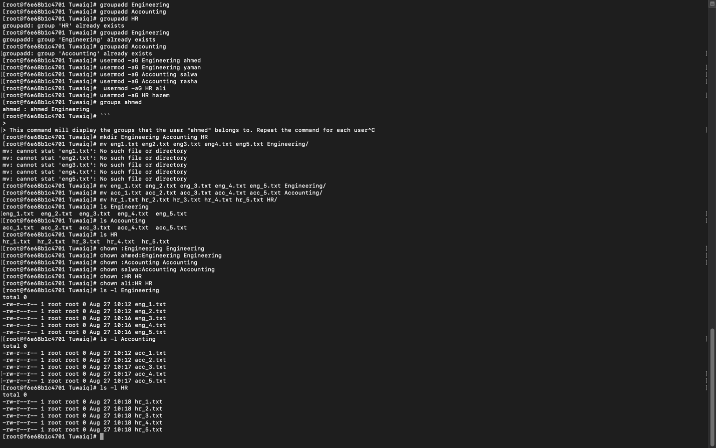

8-Grant the CEO permission to all folders.

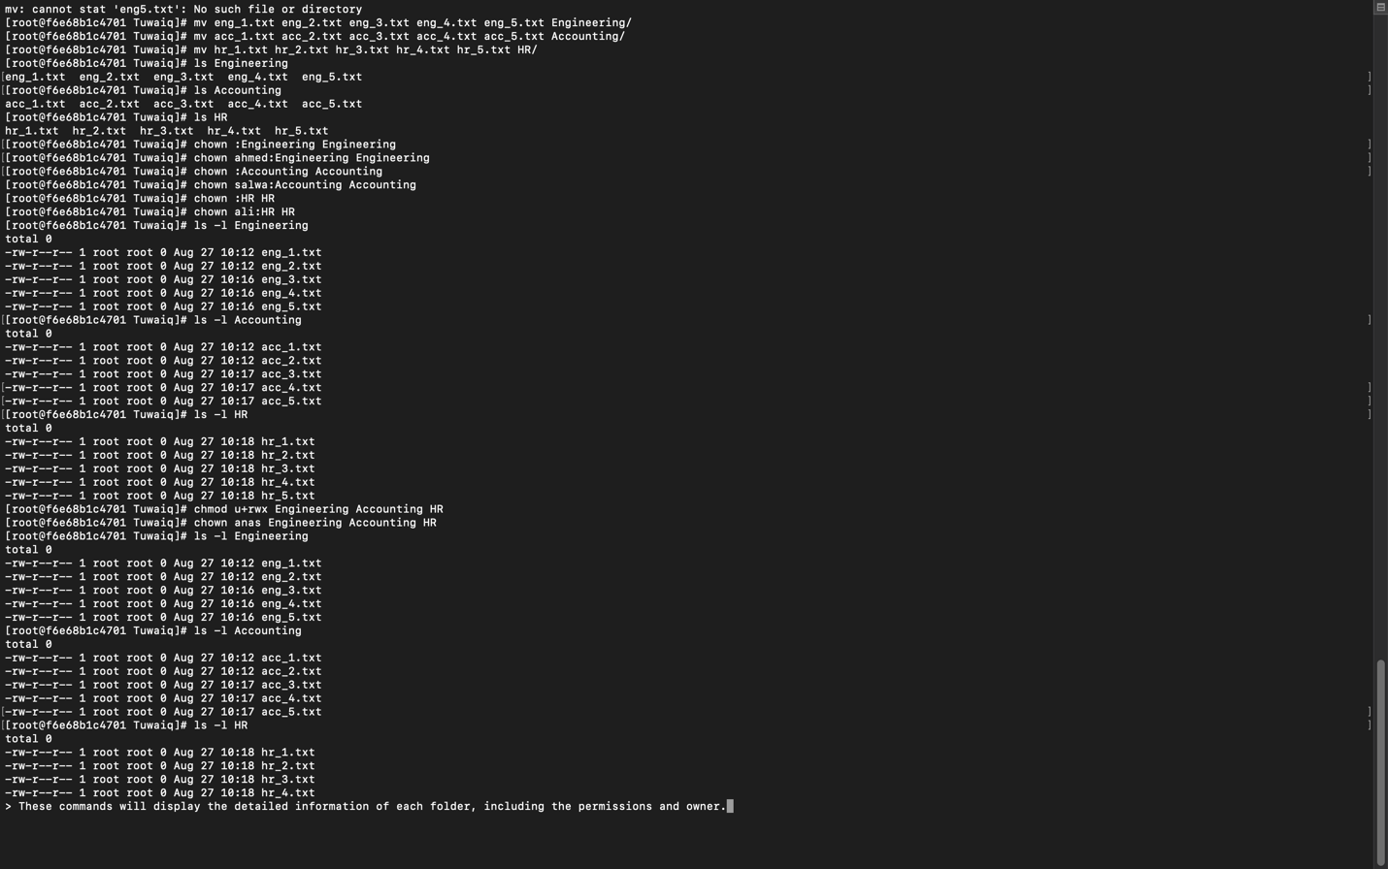

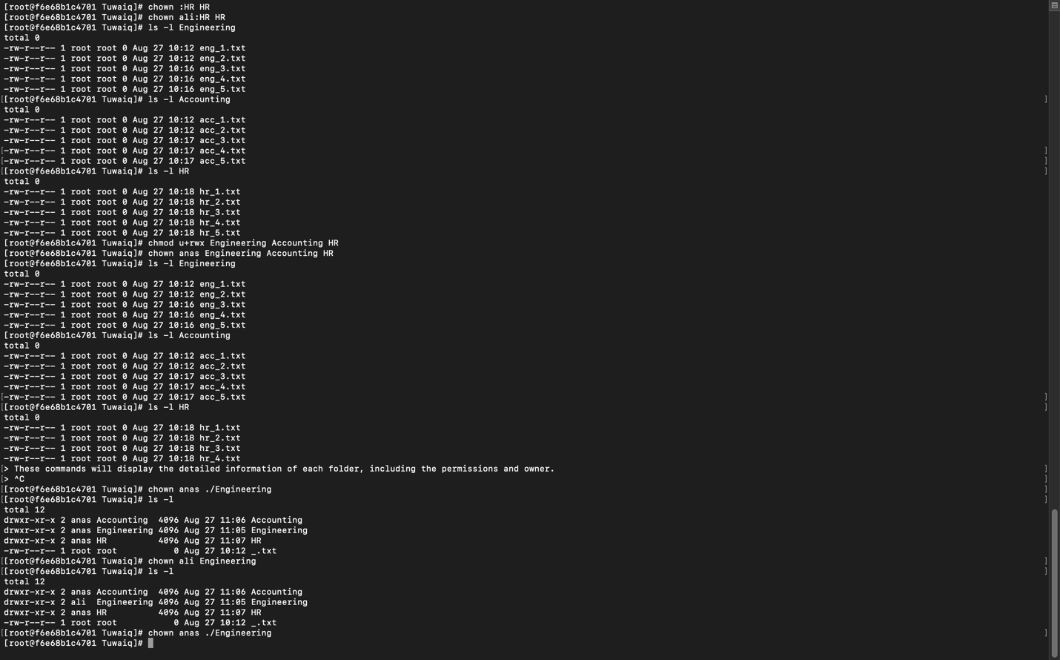

9-Create a Backup folder inside the /tmp folder and then backup the company’s data into the backups folder. Use a meaningful name for the backup folder.

