AI-ASSIST CODING
LAB-12.4

NAME:: RAJESH
BATCH :: 44
ROLL NO:: 2303A52459

Task 1: Bubble Sort for Ranking Exam Scores
PROMPT:
Write a Python program to implement Bubble Sort to sort student scores. Add inline comments explaining comparisons, swaps, and iteration passes. Include early termination when the list is already sorted.Also provide time complexity and sample input/output.
CODE:
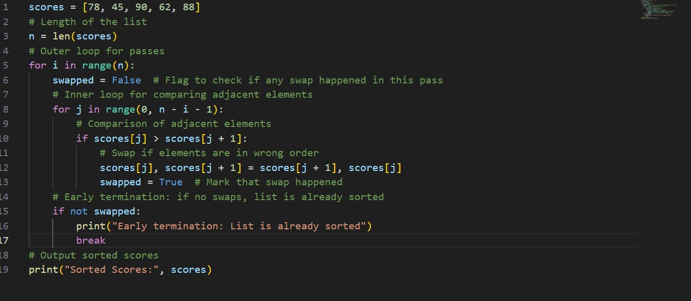
OUTPUT:
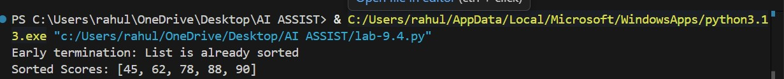
OBSERVATION:
Bubble Sort works by repeatedly comparing adjacent elements in a list and swapping them whenever they are in the wrong order. With each pass of the algorithm, the largest element among the unsorted portion moves to its correct position at the end of the list. The use of early termination makes the algorithm faster when the list becomes sorted before completing all passes, as it stops further unnecessary comparisons. This method is simple and efficient for sorting small datasets, such as classroom student scores.
Task 2: Improving Sorting for Nearly Sorted Attendance Records PROMPT:
Given that attendance roll numbers are nearly sorted, suggest a suitable sorting algorithm. Generate Bubble Sort and Insertion Sort implementations in Python. Explain why Insertion Sort performs better for nearly sorted data.Compare execution behaviour.
CODE:
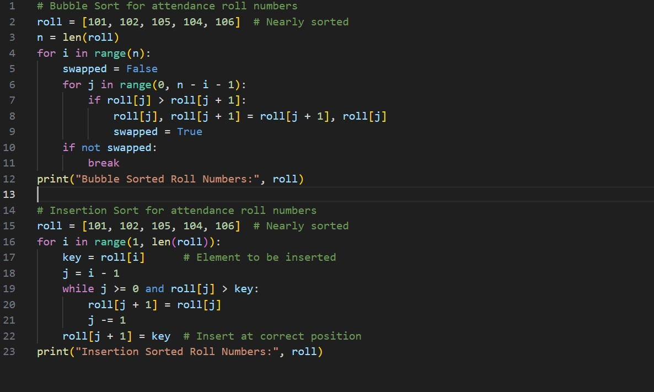
OUTPUT:
OBSERVATION:
Insertion Sort works efficiently for nearly sorted data because it inserts each element into its correct position in the already sorted portion of the list. When only a few elements are misplaced, it performs fewer comparisons and shifts. In contrast, Bubble Sort still compares many adjacent elements even if the list is almost sorted. Therefore, Insertion Sort reduces unnecessary operations and improves performance for partially sorted datasets.

Task 3: Searching Student Records in a Database
PROMPT:
Write Python programs for Linear Search and Binary Search to find student roll numbers. Add docstrings explaining parameters and return values.
Explain when Binary Search is applicable and compare performance.
CODE:
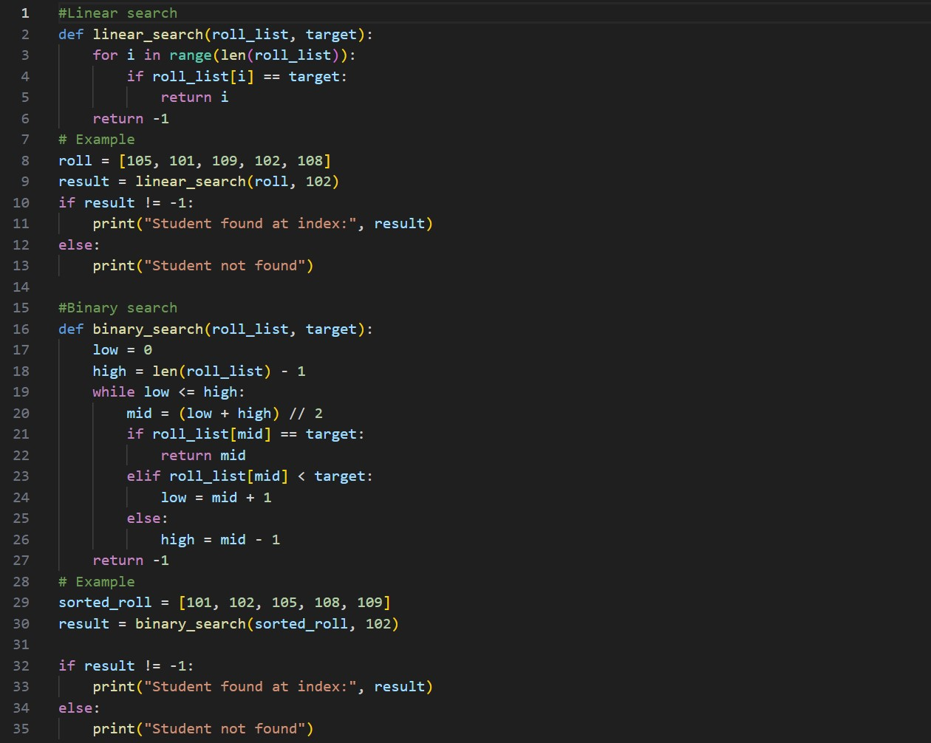
OUTPUT:
OBSERVATION:
Linear Search works for both sorted and unsorted lists but becomes slow when the dataset grows. Binary Search is much faster and efficient but requires the list to be sorted beforehand. Therefore, Binary Search is preferred for large student databases, while Linear Search is suitable for small or unsorted attendance or temporary records. Advanced searching techniques like Hashing can further improve performance in large systems.

Task 4: Choosing Between Quick Sort and Merge Sort for Data Processing
PROMPT:
Complete recursive implementations of Quick Sort and Merge Sort in Python. Add meaningful docstrings. Explain how recursion works in both algorithms. Compare performance for random, sorted, and reverse-sorted data.
CODE:
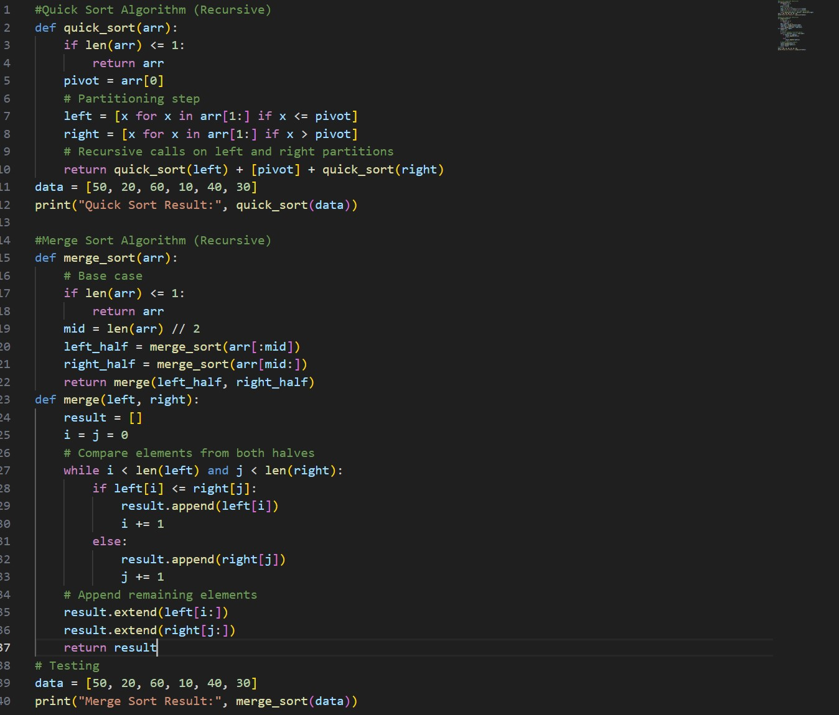
OUTPUT:
OBSERVATION:
Quick Sort performs very fast on random datasets due to its efficient divide-and-conquer approach. However, it may degrade to O(n²) time complexity for already sorted or reverse-sorted data if the pivot selection is poor. On the other hand, Merge Sort provides consistent performance for all types of input because its time complexity remains O(n log n) in the best, average, and worst cases. It is also more stable and predictable for handling large datasets. In comparison, Quick Sort is more memoryefficient since it requires less additional space than Merge Sort, making it suitable when memory usage is a concern.

Task 5: Optimizing a Duplicate Detection Algorithm
PROMPT:
Write a brute-force algorithm to detect duplicate user IDs using nested loops. Analyse its time complexity. Suggest and implement an optimized approach using sets or dictionaries. Compare performance for large datasets.
CODE:
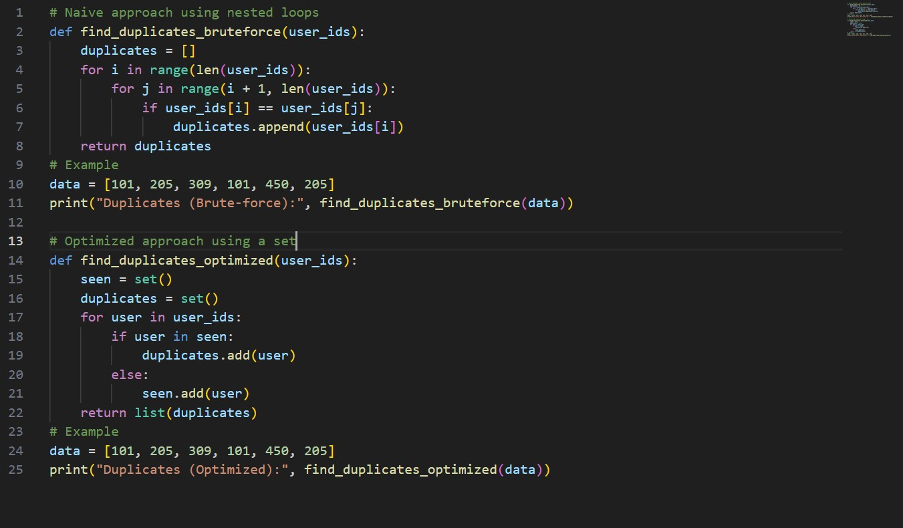
OUTPUT:
OBSERVATION:
The brute-force algorithm is simple but inefficient for large datasets due to its quadratic time complexity. The optimized approach using hashing improves performance by reducing the time complexity to linear time. This makes it suitable for detecting duplicates in large-scale databases and real-world applications where speed and efficiency are important.

